# 

# 

**Appian Fit Assessment Application**

**Utilize this application to assess how well your business use case aligns with Appian.**

# 

**Table of Contents**

# Introduction 3

# Key Features and Functionality 3

# Implementation 3

## New Use Case 3

## Update Use Case 6

## Delete Use Case 8

# 

# 

# 

# 

# 

# 

# 

# 

# 

# 

# 

# 

# Introduction

The Appian Fit Assessment application allows clients to assess how well their business use case aligns with Appian. The Fit Assessment depends on 13 predefined criteria that the client will select values for depending on how well each criteria aligns with their use case. Once the client is able to assess all 13 criteria in respect to their use case, they will submit the use case to receive an Appian Recommendation. The Appian Recommendation is based on predefined ranges and can be one of three options:

1. Consult Architect
2. Good Fit
3. Excellent Fit

Once the client creates a new use case and receives a recommendation from Appian, the Fit Assessment application allows them to further make changes to their use case. At times, a client’s business use case requirements can change which will affect the recommendation. Thus, the Fit Assessment application allows those who created the use case or any Administrators in the application to update or completely delete a use case.

# 

# Key Features/Functionality

The following features describe the functionality and enhancements within the application:

* Seamless navigation when creating a new use case through a wizard
* Users have the ability to upload supporting documentation pertaining to their use case
* Users have the ability to easily track the use cases they have created through a record-centric approach on the landing page
* Users have the ability to see who created a use case and when as well as if it’s been modified and by who
* Improved UI/UX for a created use case
* Ability to update or completely delete a use case

# Implementation

## **New Use Case**

When a user first navigates to the Appian Fit Assessment application, they will land on

the following page:

There are two different types of groups for this application: AFA Users group and AFA Administrators group. These groups have different permission levels for users:

* *AFA Administrators Group*
  + Users in this group are of type System Administrator
  + Users in this group are able to see any use case in the application and have the ability to update or delete any use case in the application.
* *AFA Users Group*
  + Users in this group are of type Basic User
  + Users in this group are able to see any use case in the application *BUT* can only update or delete use cases that they created in the application.

Once a user wants to create a new use case, they will click the “New Use Case” action at the top left of the grid.

Upon clicking that, the following screen will appear:

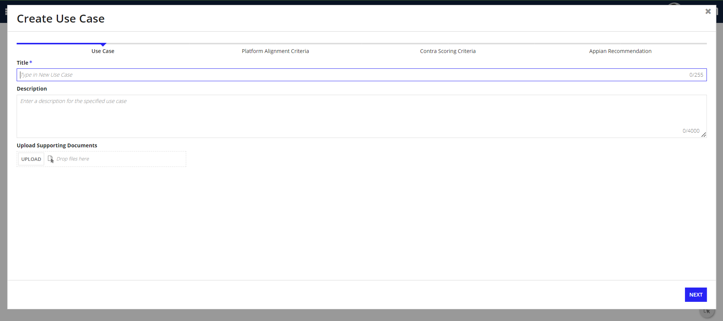

A user can start creating the use case here with a title, description, and any supporting/relevant documentation specific to the use case.

Upon clicking the “Next” button, users will be able to start selecting criteria values based on how well the use case aligns with Appian.

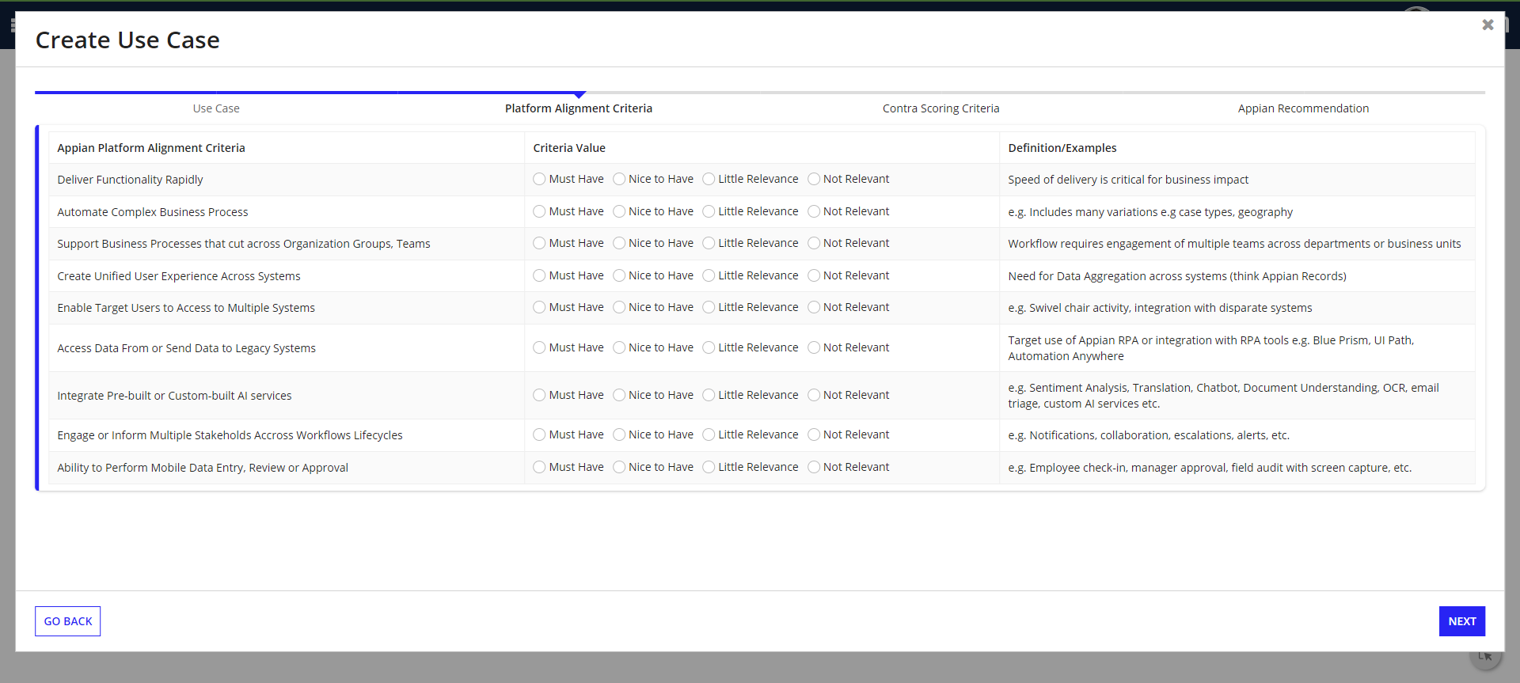

The above 9 criteria represent platform alignment criteria. Upon selecting values and clicking the “Next” button, users will be able to select more criteria values which represent contra scoring criteria:

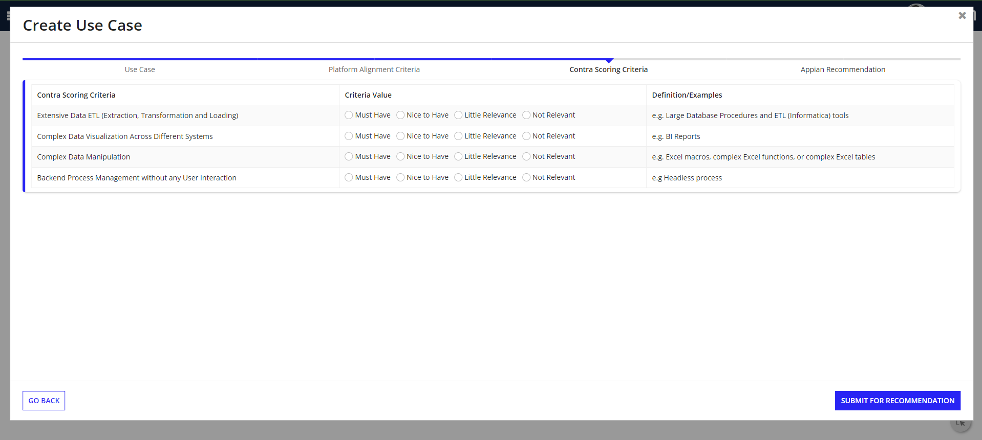

The above 4 criteria represent contra scoring criteria. Upon selecting values and clicking the “Submit for Recommendation” button, Appian will provide the user with a recommendation based on the criteria values selected. In this example, the recommendation provided is a *Good Fit* as show below:

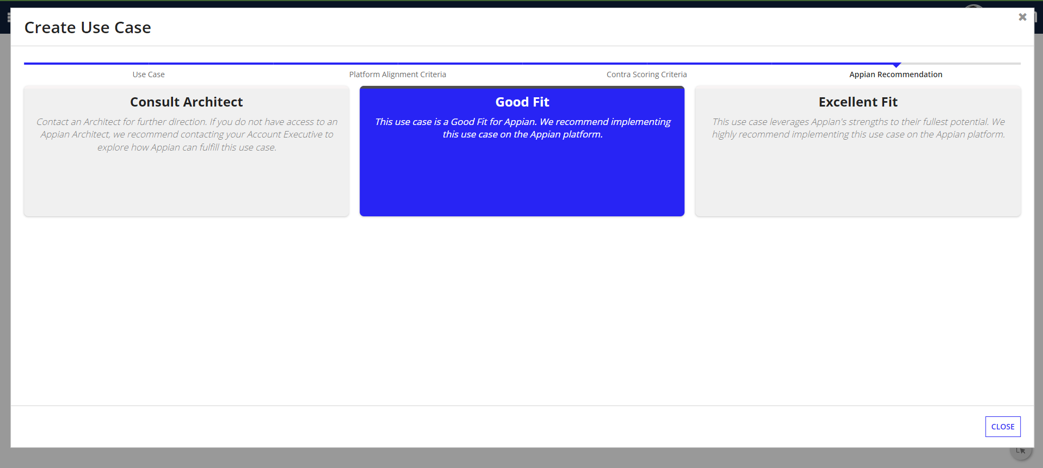

Once a user closes the above window, they will be taken back to the grid of use cases.

## **Update Use Case**

Once a client creates a use case, requirements and resources can change which can alter how well Appian aligns with the use case. In the Fit Assessment app, users can update a use case by clicking on the name of any use case within the grid (in the *Use Case* column). As a reminder, users can only update use cases that they created unless they are Administrators which gives them the ability to update any use case. If users have the correct permissions to update a use case, clicking on the use case will take them to this page:

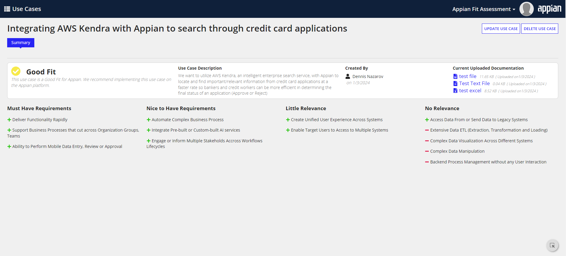

As you can see above, this is an example use case.

* The card layout displays the Appian recommendation, a description of the use case, who created it (and when), and supporting documentation the client uploaded
* Below the card will show the values selected for the 13 criteria
  + The green plus’s next to the criteria represent the 9 platform alignment criteria
  + The red dashes’ next to the criteria represent the 4 contra scoring criteria

Upon pressing the *Update Use Case* action, users will be taken to this page:

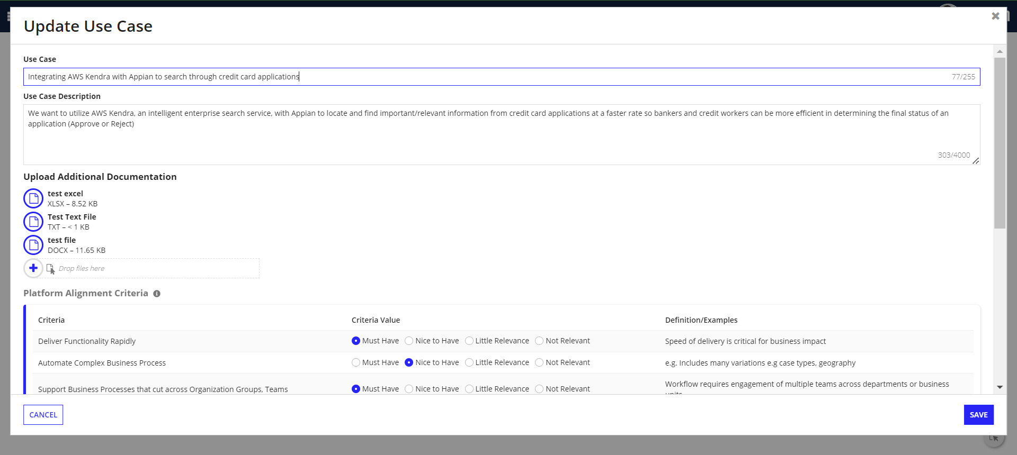

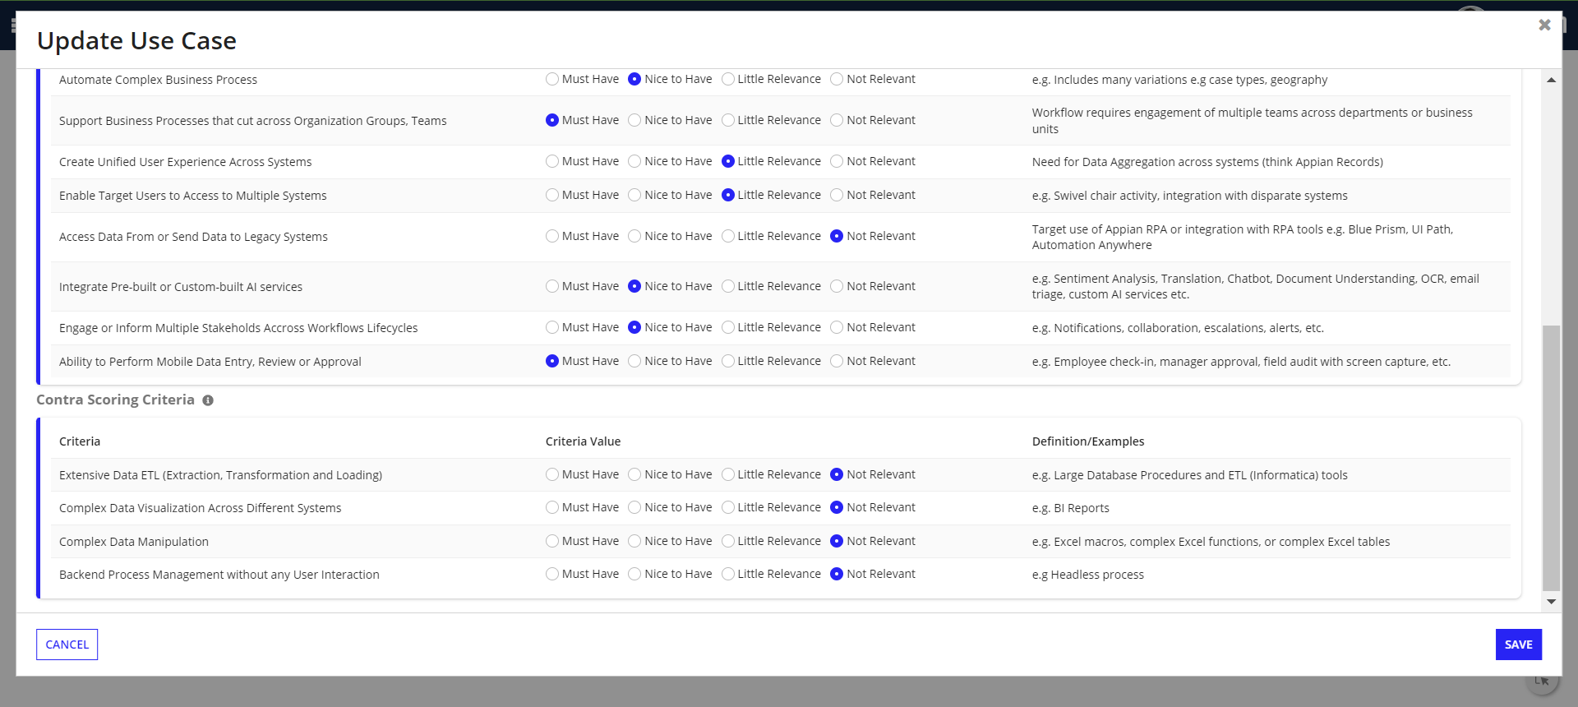

Users can update their use case here and the changes will reflect upon saving. In this example below, I updated the use case by removing one of the supporting documents and updating the criteria. Upon saving, this is what the updated use case looks like:

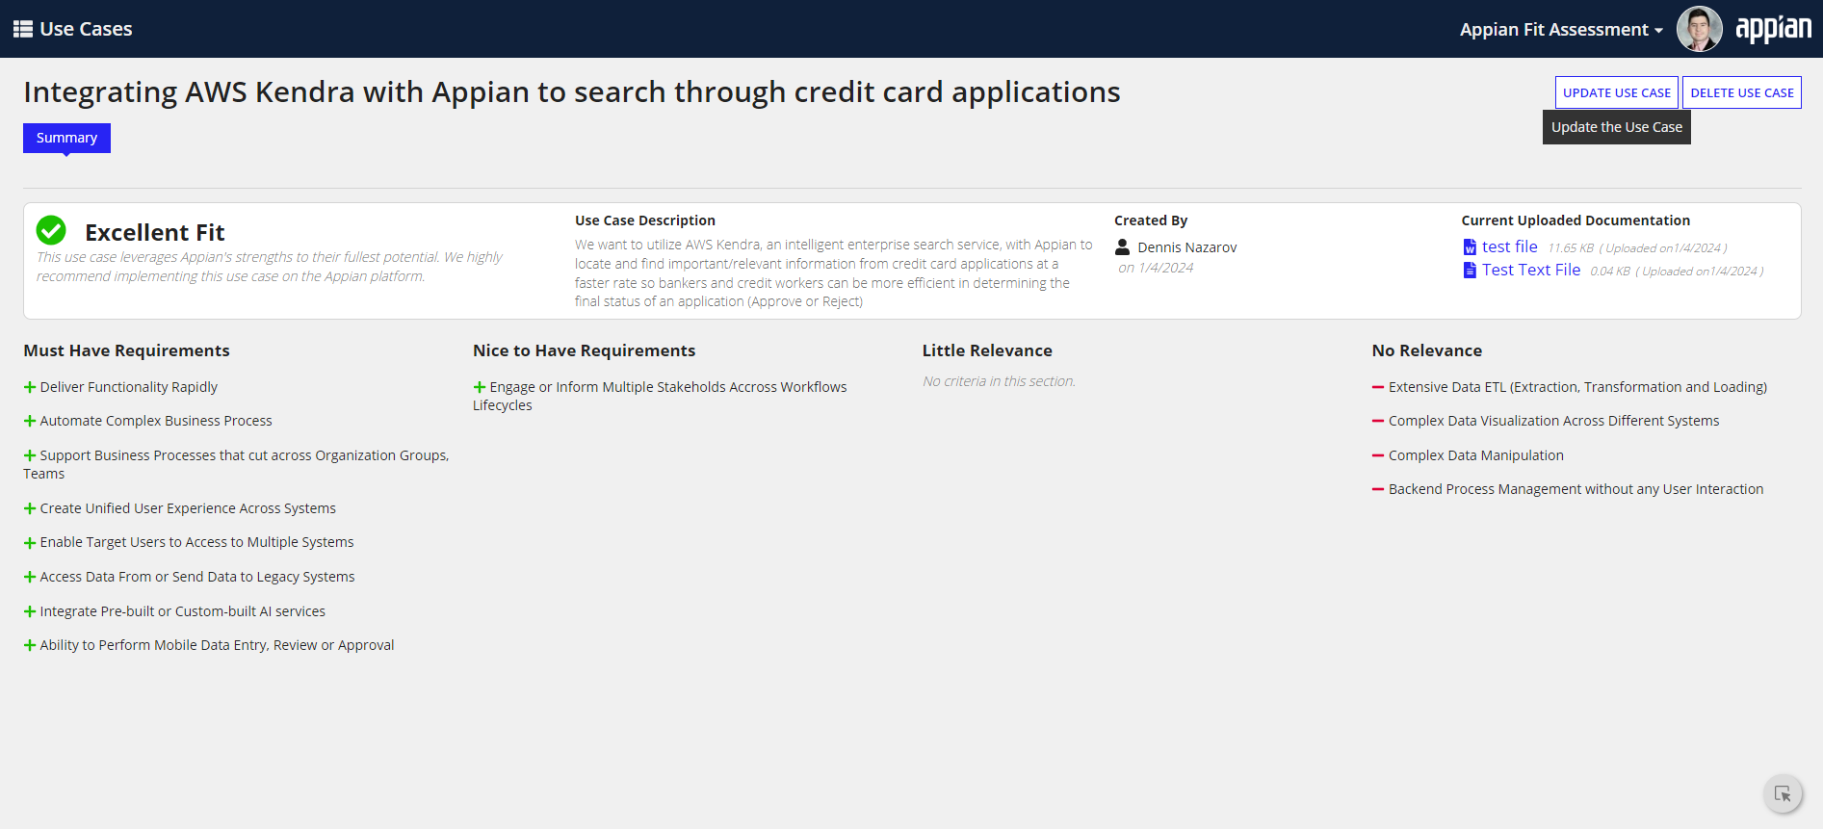

## 

## **Delete Use Case**

A client may have an outdated use case that doesn’t apply to their business anymore. The Fit Assessment application allows users to delete a use case completely in this case. Deleting a use case has the same permission levels as updating a use case. Upon pressing the “Delete Use Case” action, the following pop-up will appear:

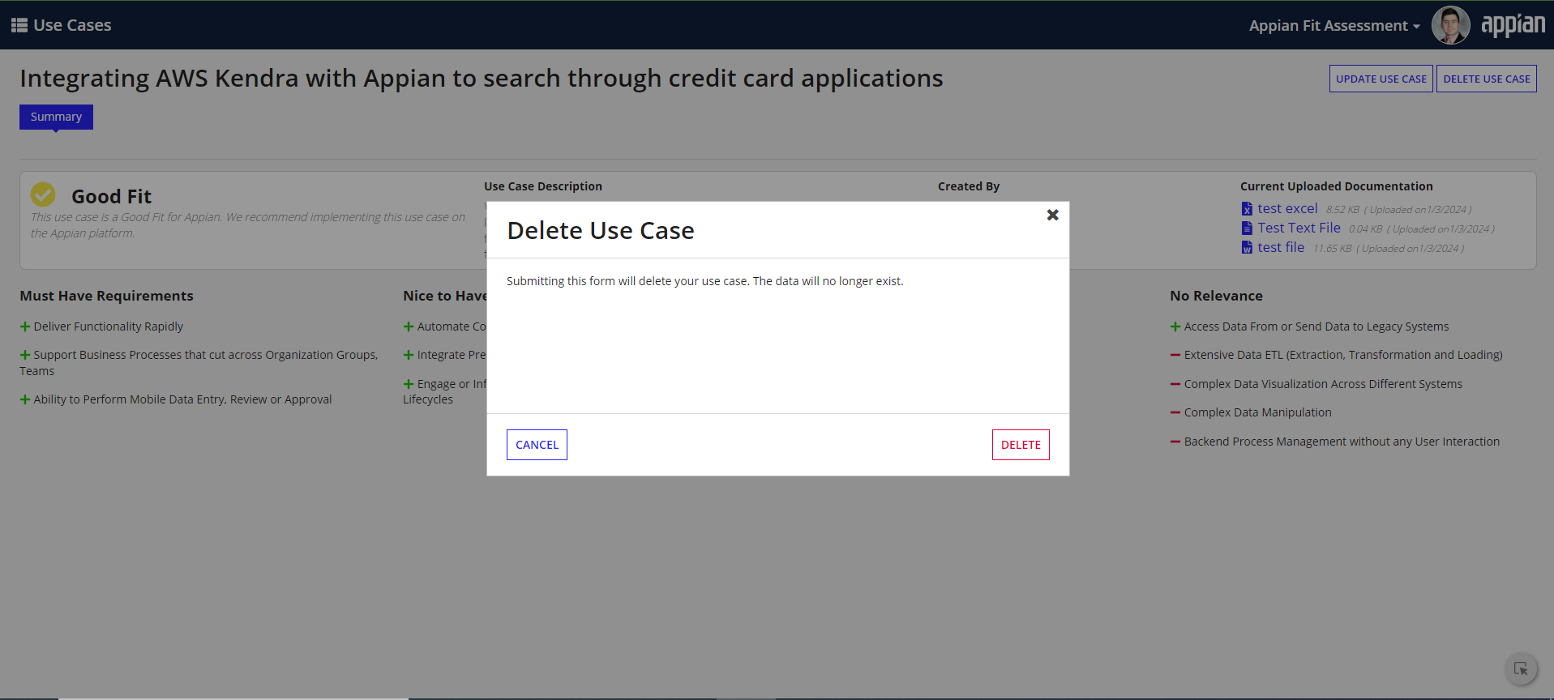

Upon pressing the *Delete* button, the following pop-up will appear to allow the user to navigate back to the grid of use cases:

