README
Notary Seal Tools Smart Service Plug-in

A Notary Seal used for digitally signing a document involves a digital representation of an official notary seal or stamp, applied electronically to authenticate the document's authenticity and validate its content. This digital seal serves a similar purpose to a physical notary seal by confirming the integrity and origin of the document in a digital format, ensuring its legal validity and providing assurance of its authenticity.

Input Parameters

Destination folder id | Id of the destination folder where the output signed file is saved.
Document to sign | Id of the document to sign.  Uploaded as a document into the Appian environment.
Keystore alias | Alias of Keystore certificate.
Keystore password | Password of Keystore certificate.
Keystore type | Type of Keystore(eg: PKCS12).
List of signature field names | List of field names where the signature is stamped (Eg. 15 Judge's Signature).
Signature Logo | Logo image that appears on the signature field.
Output file name | Filename of the signed output document without extension.
Location | Location that appears on the signature field.
Signer Name | Name that appears on the signature field.
Reason | Reason that appears on the signature field.
Character length to wrap | Character length to wrap

Output Parameters

Signed document Id | Id of the signed document(output file).
Success flag | Shows if the smart service is processed successfully.
ErrorMessage | Error Message in case of error

SSL certificate generation
- Follow the client specific process to get the CA Signed Certificate which includes .pem and .key file.

- Generate P12 certificate using OpenSSL
C:\OpenSSL-Win64\bin\openssl.exe pkcs12 -export -inkey [keyfilename].key -in
[pemfilename].pem -out [p12outputfilename].p12

Note: You can use any other supported tool to generate a P12 certificate. Plugin uses P12 certificate only.

- Import the P12 certificate into the Appian environment as a document in the application Knowledge Center.

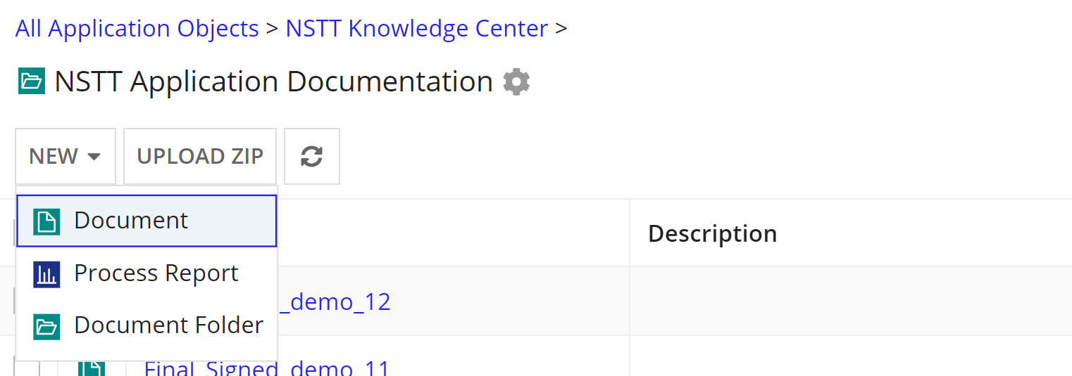

Notary seal tools smart service configuration example

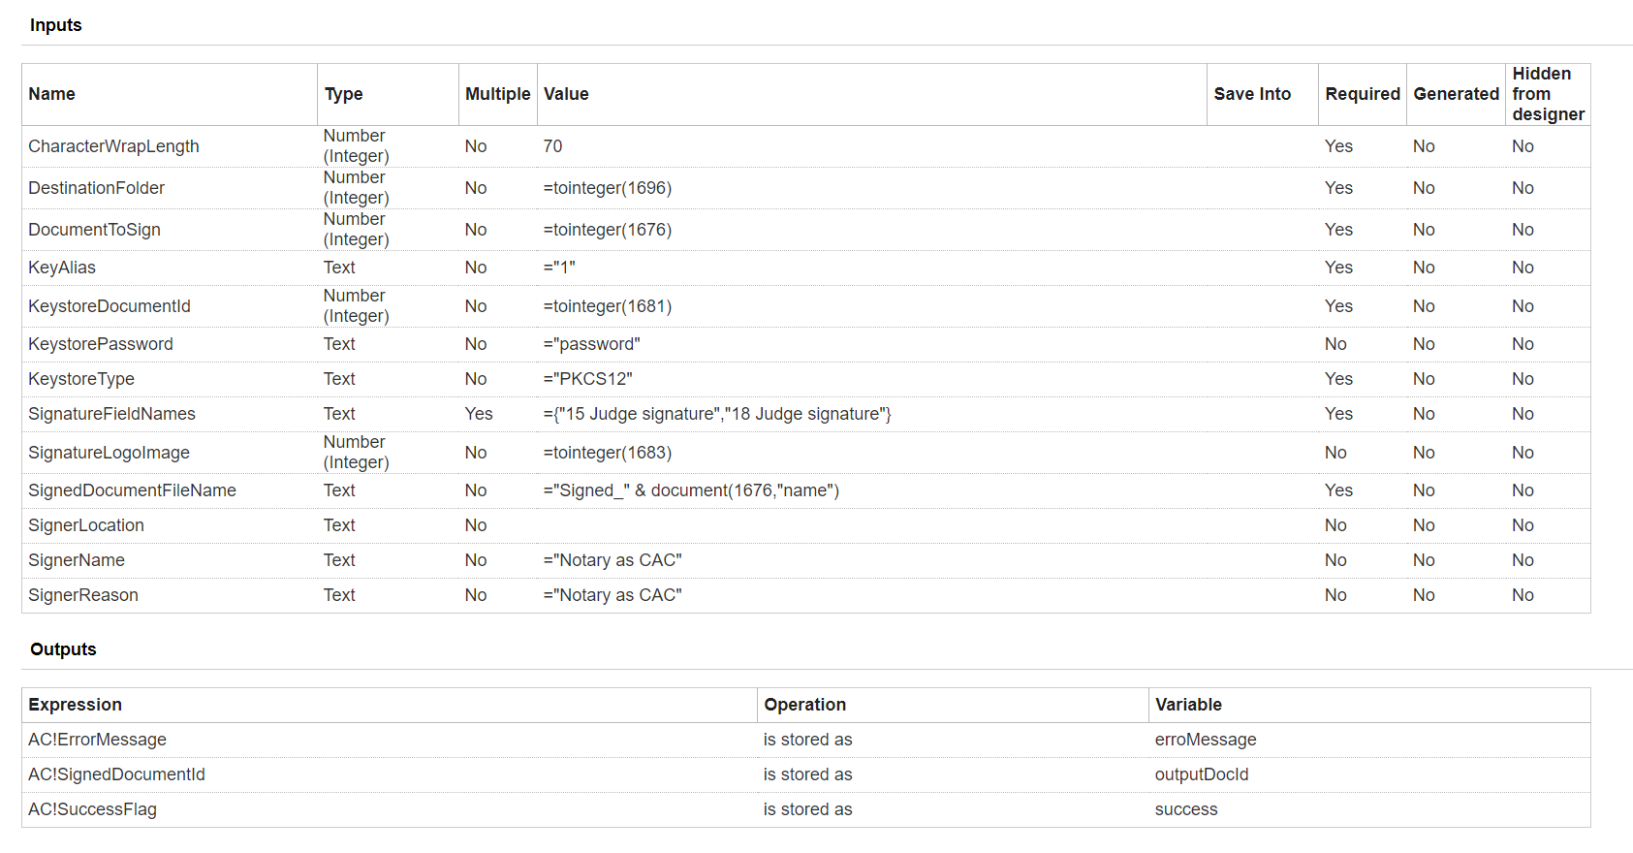

Sample output document

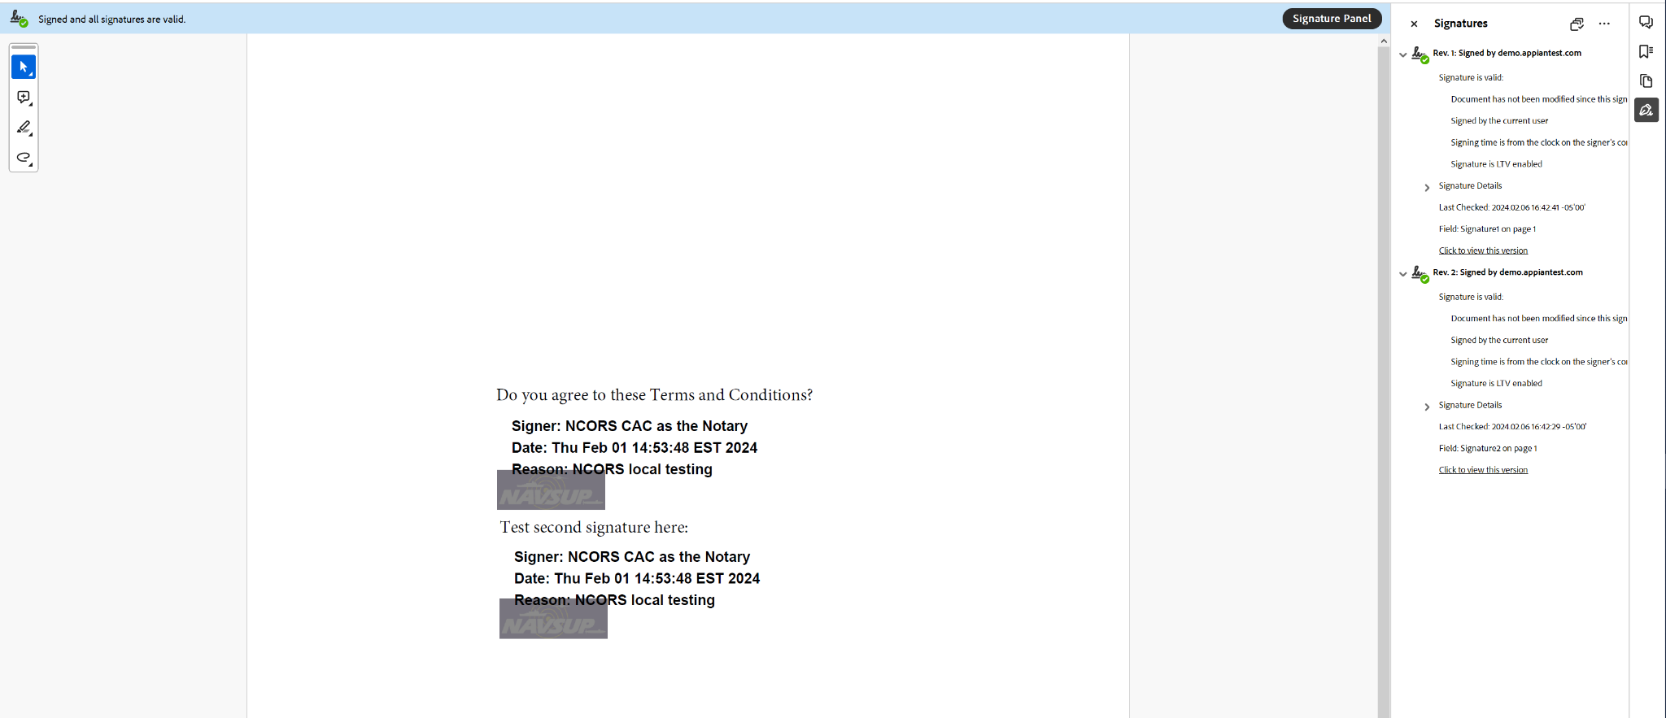

Sample Error Scenario

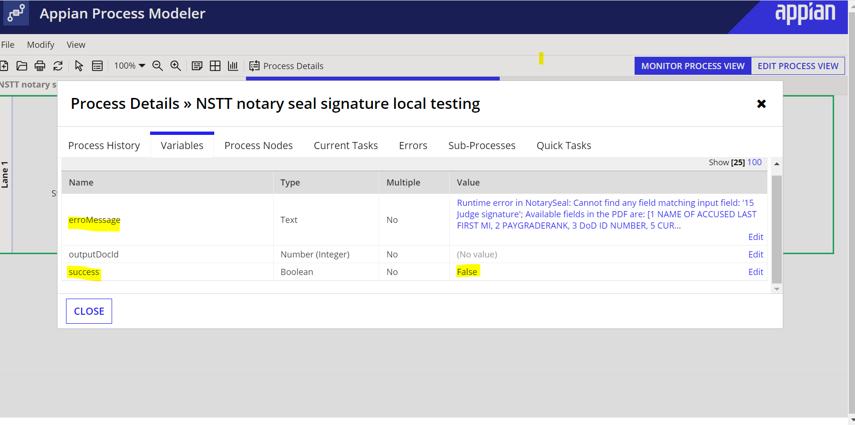

Enable LTV in Adobe

Add the certificate that was used to apply the digital signature into Adobe’s list of Trusted Identities, do the following:
1. Click the Signatures button in the left-pane.
2. Right-click the signature, and then click Show Signature Properties.
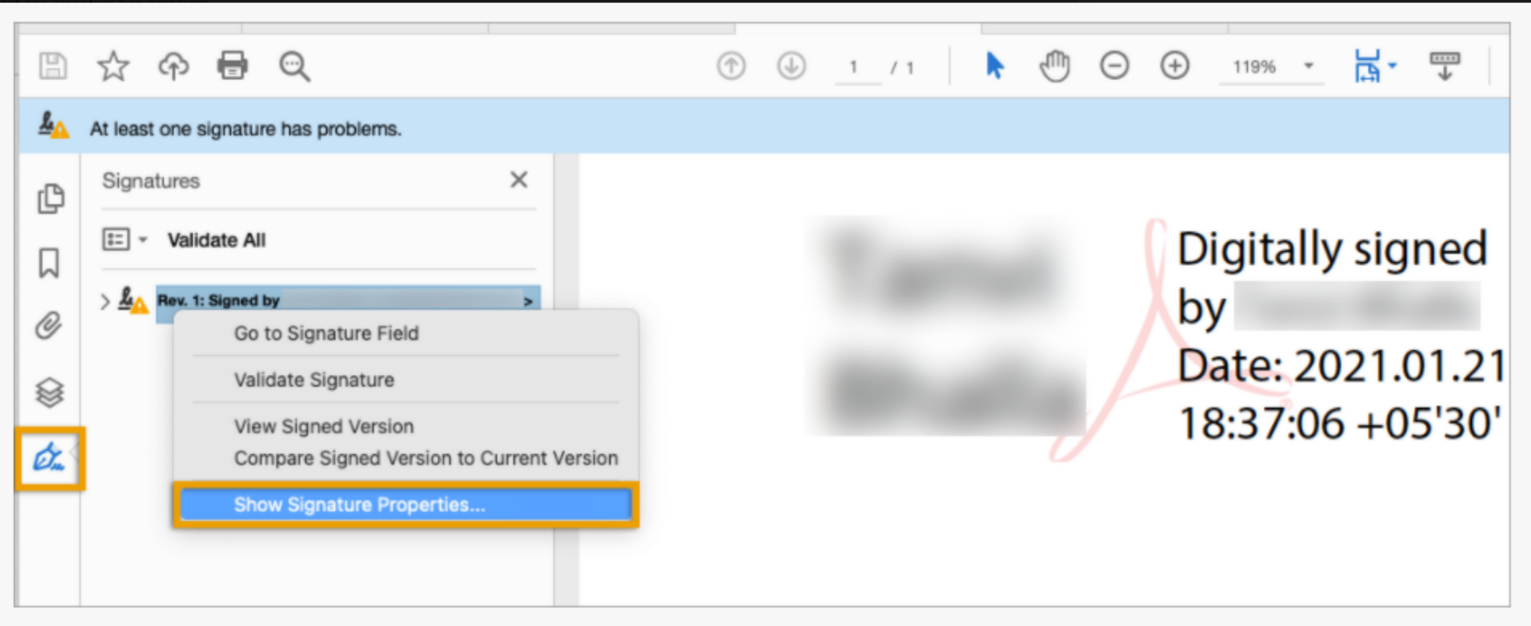
3. In the Signature Properties dialog box, click Show Signer's Certificate.
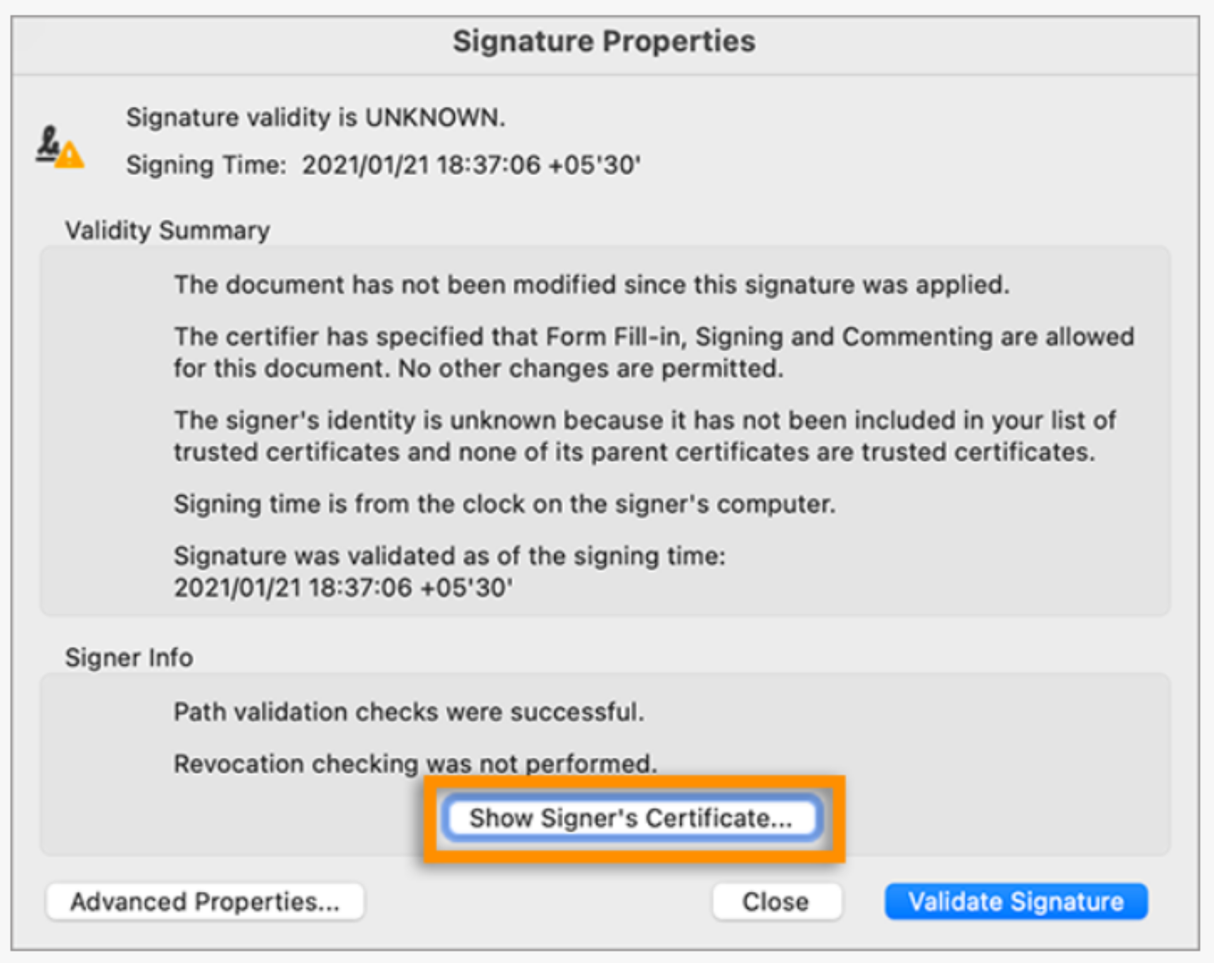
4. In the Certificate Viewer dialog box, click the Trust tab, and then click Add To Trusted Certificates.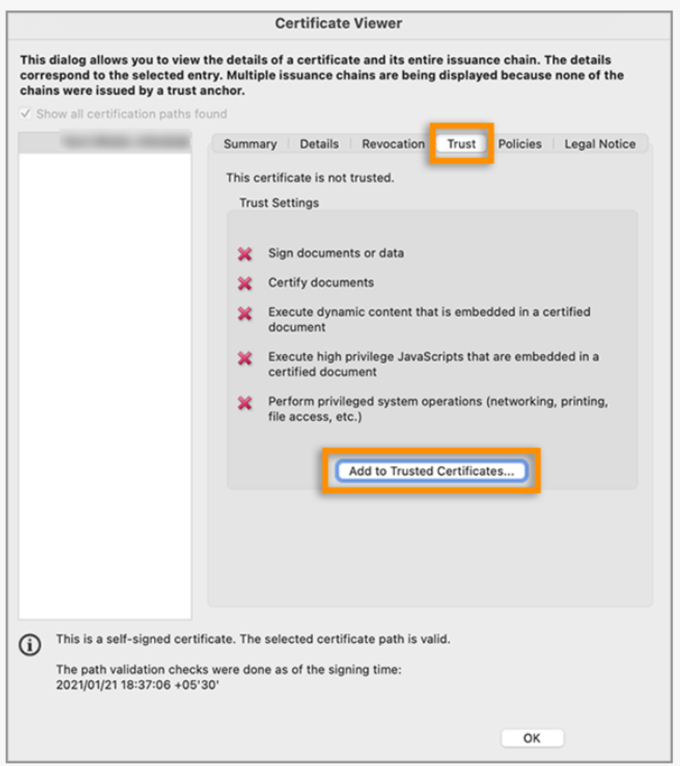

5. Click OK in the trust settings pop-up dialog, and then click OK.

Timestamp server Configuration

Follow the instructions given in this document to configure a custom time stamp server.

