AWS Lambda Connected System – V1.1.0

Overview
The AWS Lambda plugin provides the integrations to invoke and list the available functions in the AWS Lambda service in the AWS instance. To connect with the AWS instance, the connected system must be authenticated with the Access Key ID and the Secret Access Key.

Creating an Access Key in AWS Instance
- Login to your AWS Console.
- Click on your username and in the appearing pop up select Security Credentials.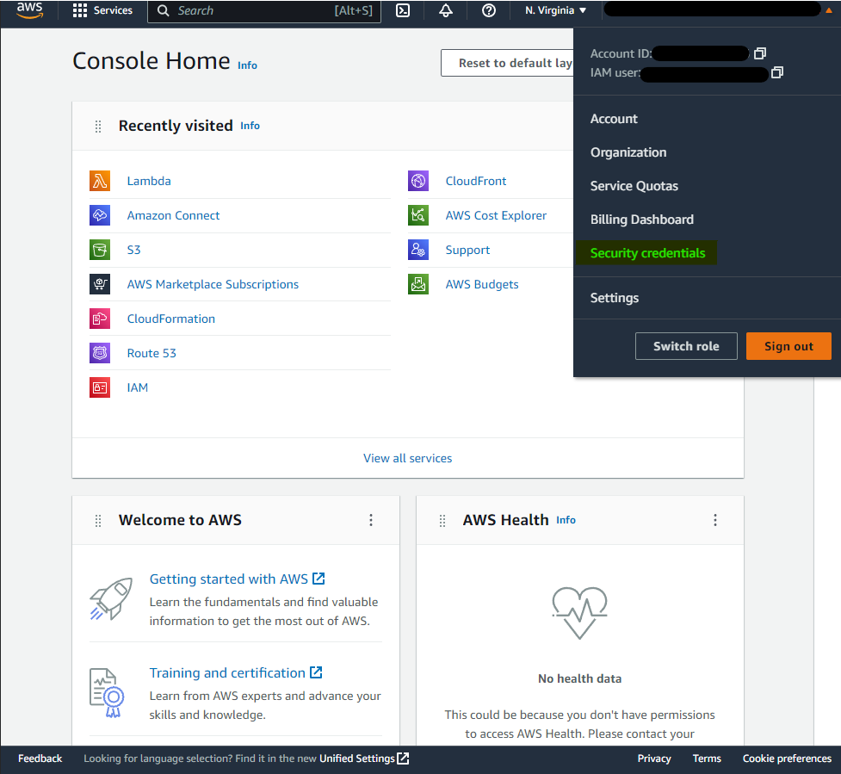
- In the Security credential window, scroll down to the Access keys section and click on the Create Access Key button to create a new one.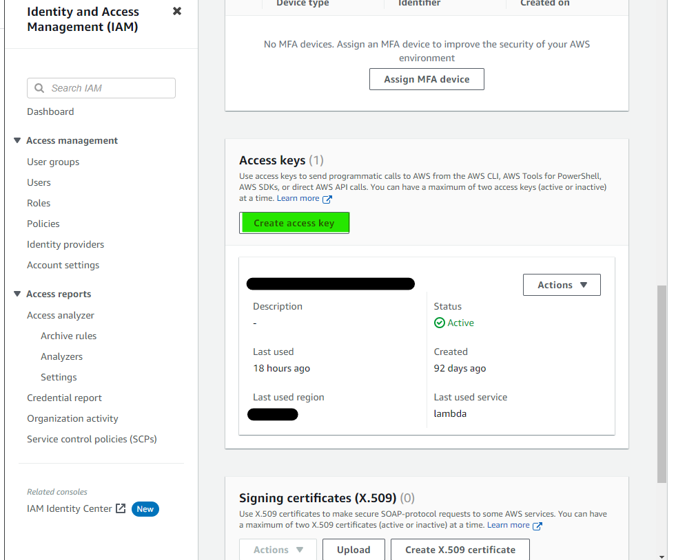
- In the appearing list of options, select Third-party service and click on Next.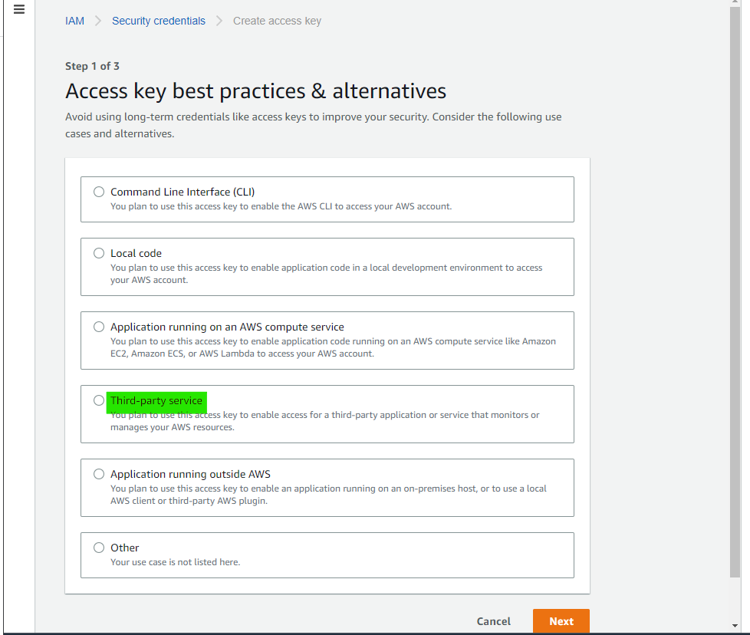
- In the next window, provide a description tag. This is an optional step. Click on Create Access key to proceed.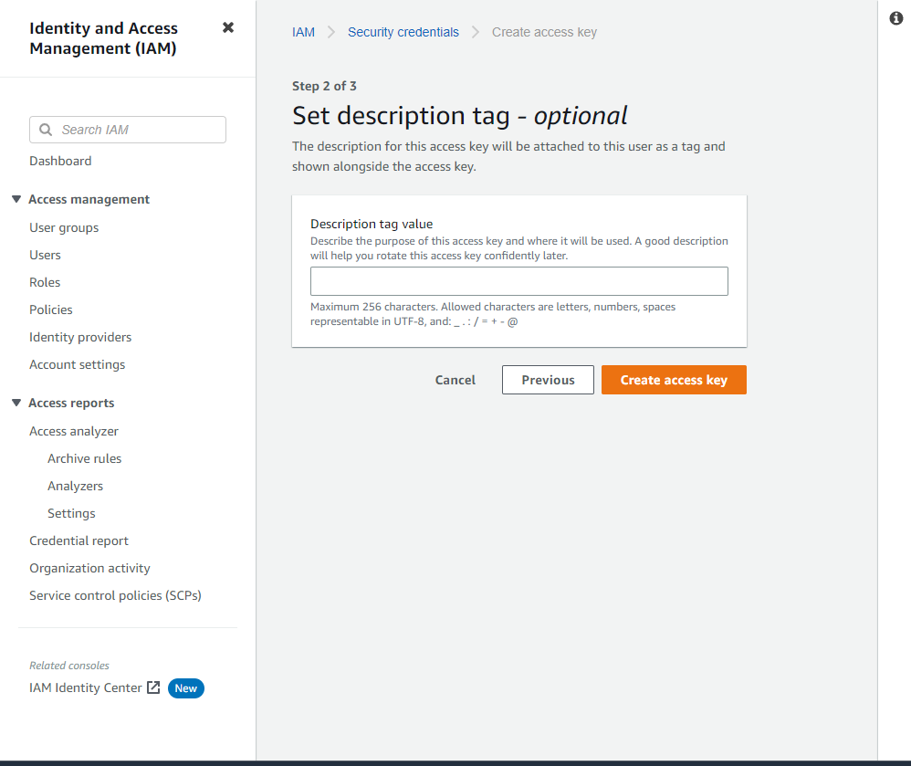
- The Access Key ID and the Secret access key will be displayed. The credentials can also be downloaded as a CSV file by clicking on the Download .csv file button. Please make sure that the credentials are noted which will not be visible again once the Done button is clicked.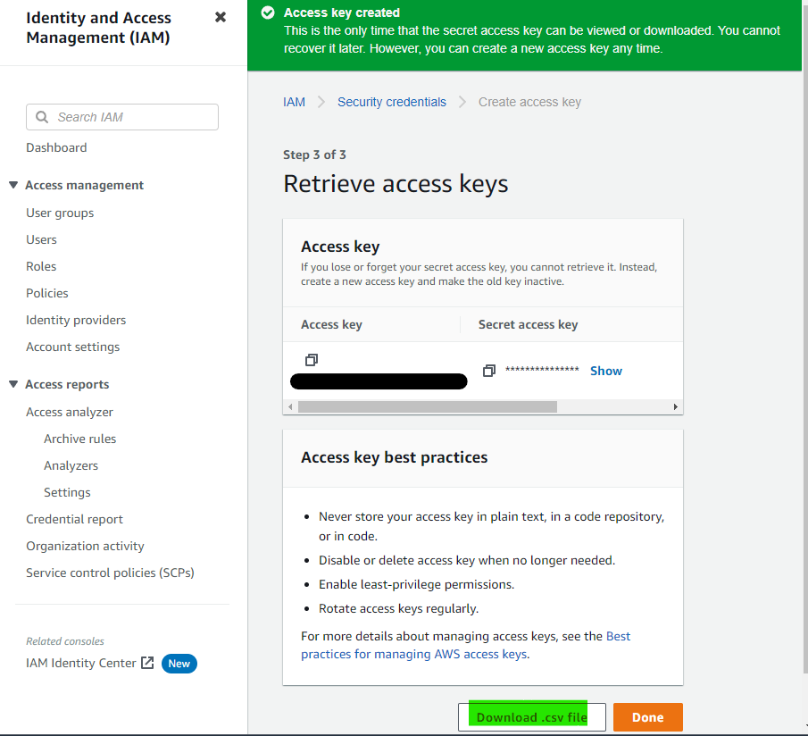
- Make sure that the Access key is active.

Connected System
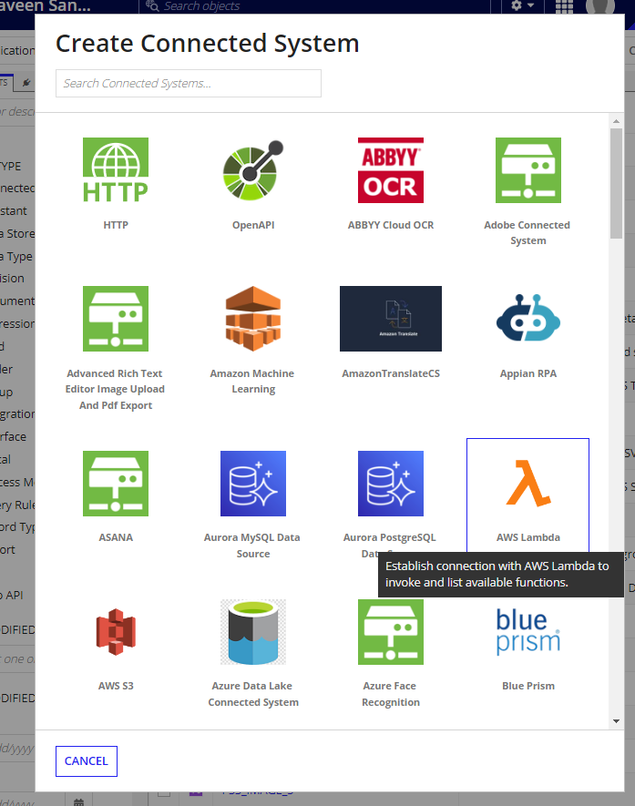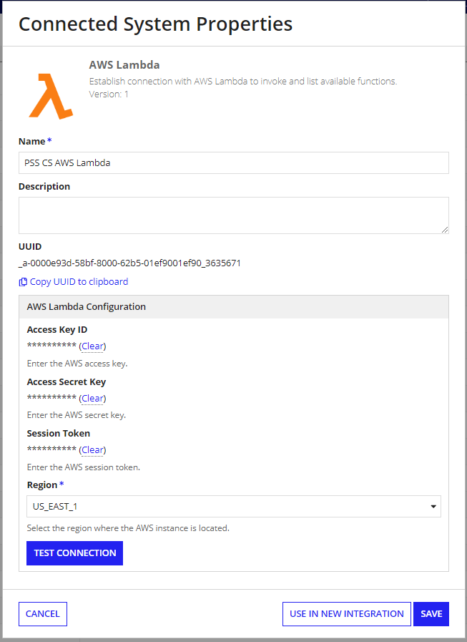
Provide the Access Key ID and the Secret Access key obtained from the AWS console. Select the AWS instance region and click on test connection to verify the credentials.

Please note that the Session Token property is optional and can be provided the Amazon Session token value if a session-based authentication mechanism is used.

Available Integrations

- List Available Function
- Invoke Function

List Available Function
This integration lists all the available functions for the provided credentials in the AWS Lambda service.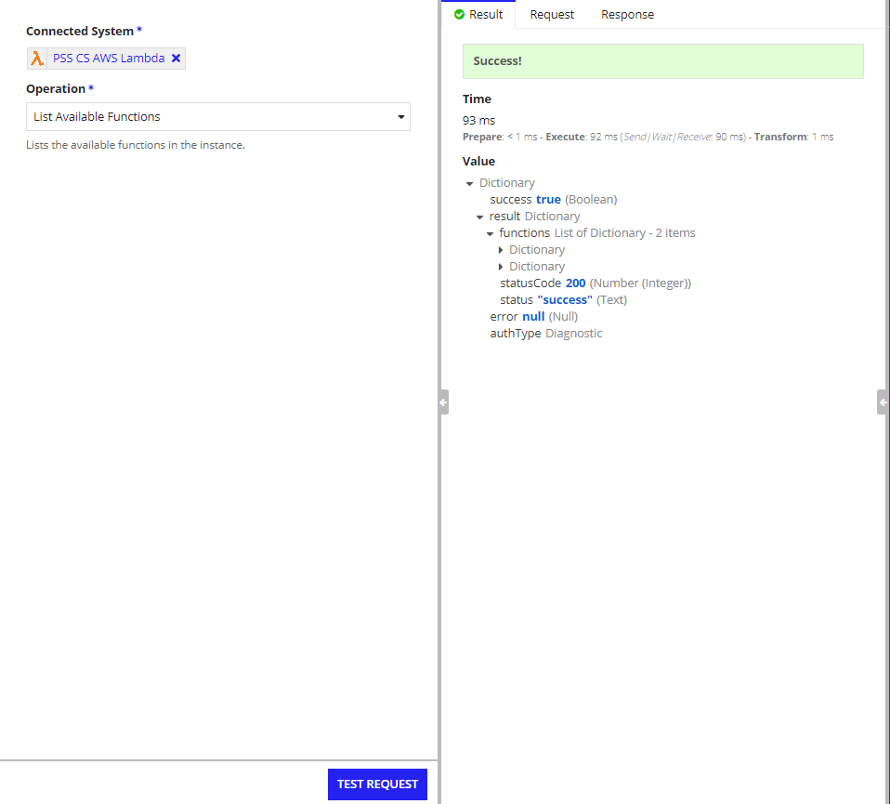

Invoke Function
The Invoke Function integration invokes the specified function and returns the output. It has two parameters:

- Function Name(required): the name of the AWS Lambda function to invoke.
- Inputs(optional): the inputs to the function. Must be provided as a JSON object. Use the Appian a!toJson method.
- Execution Timeout(optional): provide the execution timeout for the function. The integration will wait till the timeout expires. This can be used if the invoked function has a timeout configured. Must be within 1 and 900 seconds (about 15 minutes) inclusive.
Please note that the Execution timeout parameter controls how long the socket will be open for listening to the events from the invoked Lambda function. This does not modify the function timeout.

