Overview
The Org Chart component rule, orgChartDisplayField, is defined with the following inputs and outputs:
Input | Type | Default Value | Options
data | Dictionary / Input | none
chartTitle | String / Input - optional | 'Chart’
exportTitle | String / Input - optional | none
expandLevel | Number / Input - required | 1
options | Dictionary / Input - optional | See Options section | See Options section
selectedId | Text / Input - optional | MM/DD/YYYY

Output | Type
selectedId | Integer / Input

Data Structure
The data structure is a dictionary array that follows the format with these fields:
Field | Optional? | Description
id | No | Unique identifier of the node
employeeName | No | Name of employee (or other record) on the node. Picks up nameColor, if supplied
nameColor | Yes | Color of employeeName
bgColor | Yes | Override the background color of a node, provide a hex or HTML color
employeeName2 | Yes | Name of a second employee (or other record) on the node. Picks up nameColor2, if supplied
nameColor2 | Yes | Color of employeeName2
positionTitle | Yes | First subtitle under employeeName (or employeeName2, if provided)
parentId | No | Parent identifier if applicable. If no parent, provide “”
addlField1 | Yes | Additional field #1 under position title
addlField2 | Yes | Additional field #2 under position title
addlField3 | Yes | Additional field #3 under position title
addlField4 | Yes | Additional field #4 under position title
footerLeft | Yes | Left/bottom-aligned footer text
footerRight | Yes | Right/bottom-aligned footer text

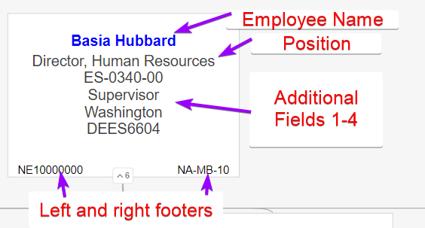

Sample Node
{employeeName: "Basia Hubbard", positionTitle: "Director, Human Resources", id: 1, parentId: "", positionColor: "blue", addlField1: "ES-0340-00", addlField2: "Supervisor", addlField3: "Washington", addlField4: "DEES6604", footerLeft: "NE10000000", footerRight: "NA-MB-10"},

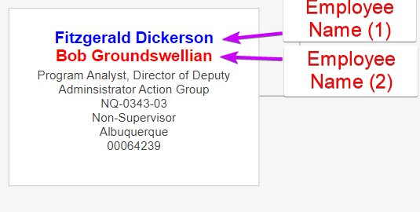

Sample Node 2
{employeeName: "Fitzgerald Dickerson", employeeName2:"Bob Groundswellian", nameColor2:"RED", positionTitle: "Program Analyst, Director of Deputy Adminsistrator Action Group", id: 58, parentId: 2, nameColor: "blue", addlField1: "NQ-0343-03", addlField2: "Non-Supervisor", addlField3: "Albuquerque", addlField4: "00064239"}

Options
The org chart component comes with several configuration areas to fine tune the look and feel of the chart.
Category/Field | Description | Default Value | Available Options
common
bgColor | Default background color of nodes | white | Any hex, rgba, or HTML color
font | Font family | Roboto | Fonts available to your browser
orientation | Flow of the org chart from the root node | top | top  left  right  bottom
selectionHighlight | What to highlight when selecting a node | FULL_PATH | FULL_PATH – highlight all nodes to root  SINGLE – single node
connectors
style | Connecting line style | SOLID | SOLID – solid  DASH – dashes  DOT – short dashes/dots
node
bodyTextSize | Size of node body text | 14px | Any pixel size
borderRadius | Border radius (rounding) of nodes | 2px | Any pixel size
height | Height of a node | 175px | Any pixel size
showShadow | Add shadow to node | true | T/F
vAlign | Align text vertically on node | false | T/F
width | Width of a node | 250px | Any pixel size
search
autoCollapse | Automatically collapse the hierarchy as you search, giving focus to matches | false | T/F
enabled | Enable the search option in the toolbar | true | T/F
name | If esarch is enabled, search on node attribute employeeName | true | T/F
title | If esarch is enabled, search on node attribute positionTitle | false | T/F
additionalFields | If esarch is enabled, search on node attributes addlField[1-4] | false | T/F
footer | If esarch is enabled, search on node attributes footerLeft and footerRight | false | T/F
download
types | File extensions to support for download | PNG | PNG – PNG of current view  PNG_ALL – PNG of entire graph  PDF - pdf

Examples
Default | 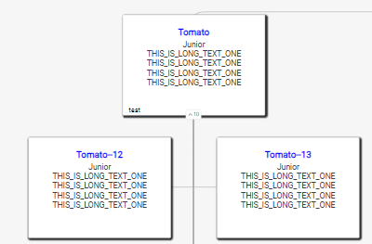
Rounded + Green + Center  [  common:[bgColor:#00ff6f,font:Roboto],  node:[vAlign:true,showShadow:true,height:175,width:250,borderRadius:375px],  connectors:[style:DASH],  download:[types:PNG]  ] | 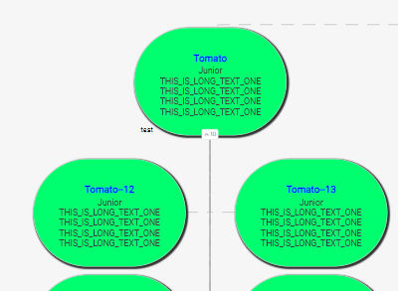
Left + Square + Not Center  [  common:[bgColor:#d6f3e3,font:Roboto],  node:[vAlign:false,showShadow:true,height:250,width:250,borderRadius:375px],  connectors:[style:DASH],download:[types:PNG]  ] | 