**Snowflake Connected System**

Snowflake is an analytic data warehouse that is fast, easy to use, and pliable. We have built the Snowflake Connected system to employ these benefits in Appian.

## You can use this connected system to create an integration object that can help perform SELECT, INSERT, UPDATE, DELETE, CALL FUNCTION or STORED PROCEDURE operations in the Snowflake Database tables or views. **Steps to Sign Up for Snowflake Account**

### **STEP-1: Fill the self-service form on Snowflake website:**

Navigate to Snowflake Website – [**https://signup.snowflake.com/**](https://signup.snowflake.com/)

Enter the details (First Name, Last Name, Valid Email Address and Company) in the Sign-Up form. If you are not working or do not wish to share the information of Company you are working, you can enter any random name or just mention ‘Student’.

Select your location and click **CONTINUE**.

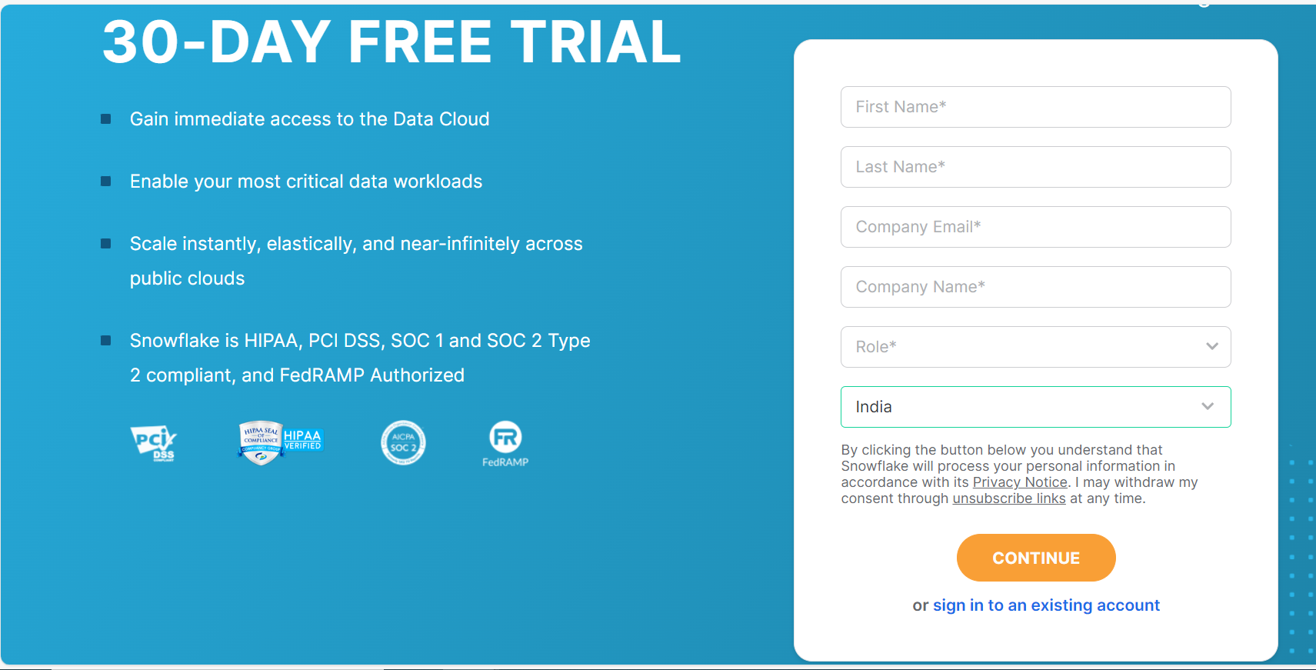

### **STEP-2: Select Snowflake Edition, Platform and Region**

After entering standard information on the first page of the form, you need to select the following which determines the features you can use during the trial and click **GET STARTED**.

* Snowflake Edition
* Cloud Platform
* Geographic Deployment Region

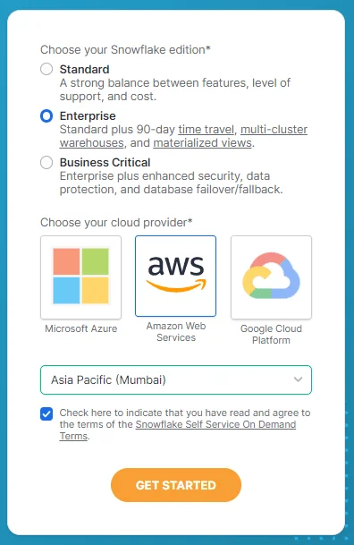

### **STEP-3: Activate your account.**

After completing the step-2, you will receive a message stating that an email has been sent to activate your account.

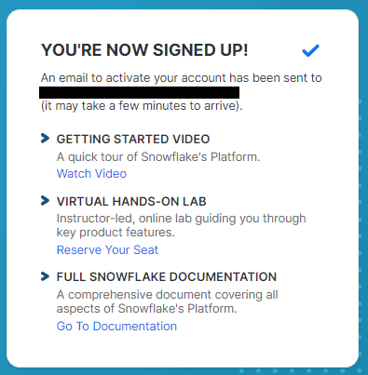

Navigate to your email and click on **CLICK TO ACTIVATE**. You will also find the URL to access your Snowflake account in the email.

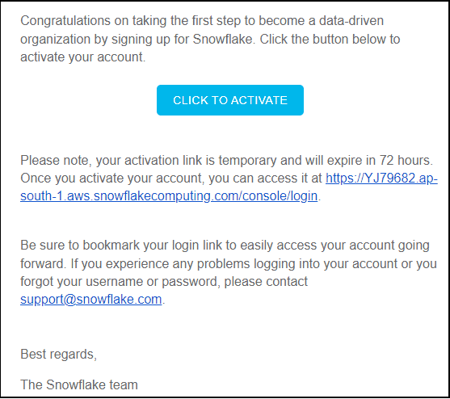

### **STEP-4: Create Username and Password**

Once you activate your account, you will be prompted to choose a Username and Password to get started. These credentials are required to login every time you need to access Snowflake.

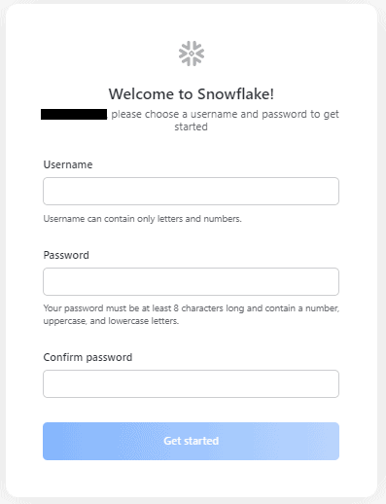

After successfully creating a Username and password, you will be asked to sign in. Sign in using the credentials created.

To establish the connection, while creating a connected system you will need -

* **Account Name:** Full name of your account (provided by Snowflake). Note that your full account name might include additional segments that identify the region and cloud platform where your account is hosted. ex: <account>.snowflakecomputing.com
* **Role:** Default access control role to use in the Snowflake session. The specified role should be an existing role already assigned to the specified user. If the specified role has not already been assigned to the user, the role is not used when the session. eg: ACCOUNTADMIN, SECURITYADMIN, SYSADMIN, PUBLIC. (Only provide single role)
* **User:** Login name of the user for the connection.
* **Password:** Password of the account

**Screenshots**

**Connected System:**

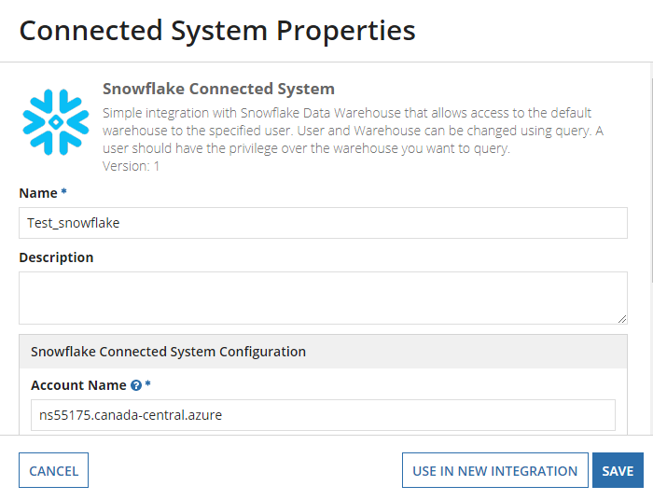

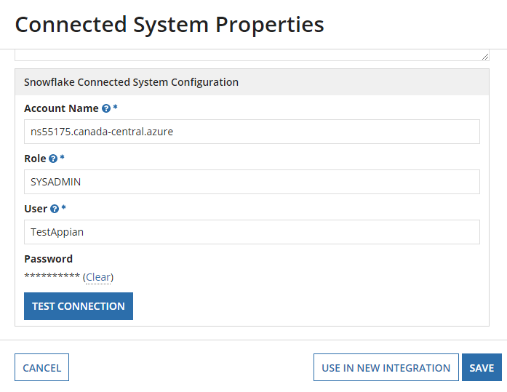

**Integrations:**

**Retrieving the data:**

This integration allows you to query the data from the warehouse for a specific user.

**Input Parameters**:

**Warehouse:** Optional parameter to specify the virtual warehouse for the connection.

**Database:** Optional parameter to specify the default database for the connection.

**Schema:** Optional parameter to specify the default schema to use for the specified database for the connection.

**Table or View:** The Table or View to be queried.

**Query Columns:** Provide list of column names to return specific columns.

**Condition:** Provide where conditions to filter. Eg: ID<=10

**Paging Info:** Page Info can be given as per Appian{ startindex: 0, batchsize:10}

**Sort Info:** It can be provided by selecting the bulletin Ascending.

**Query Timeout:** Optional parameter to specify the query timeout. Default value is 30 sec.

**Output Parameters**:

**Data**: Returns the data from the Executed Query.

**Column Metadata**: The Columns returned from the Executed Query.

**Received Count**: The number of rows returned within the given batch size.

**Total Count**: The number of rows returned from the database after executing the query.

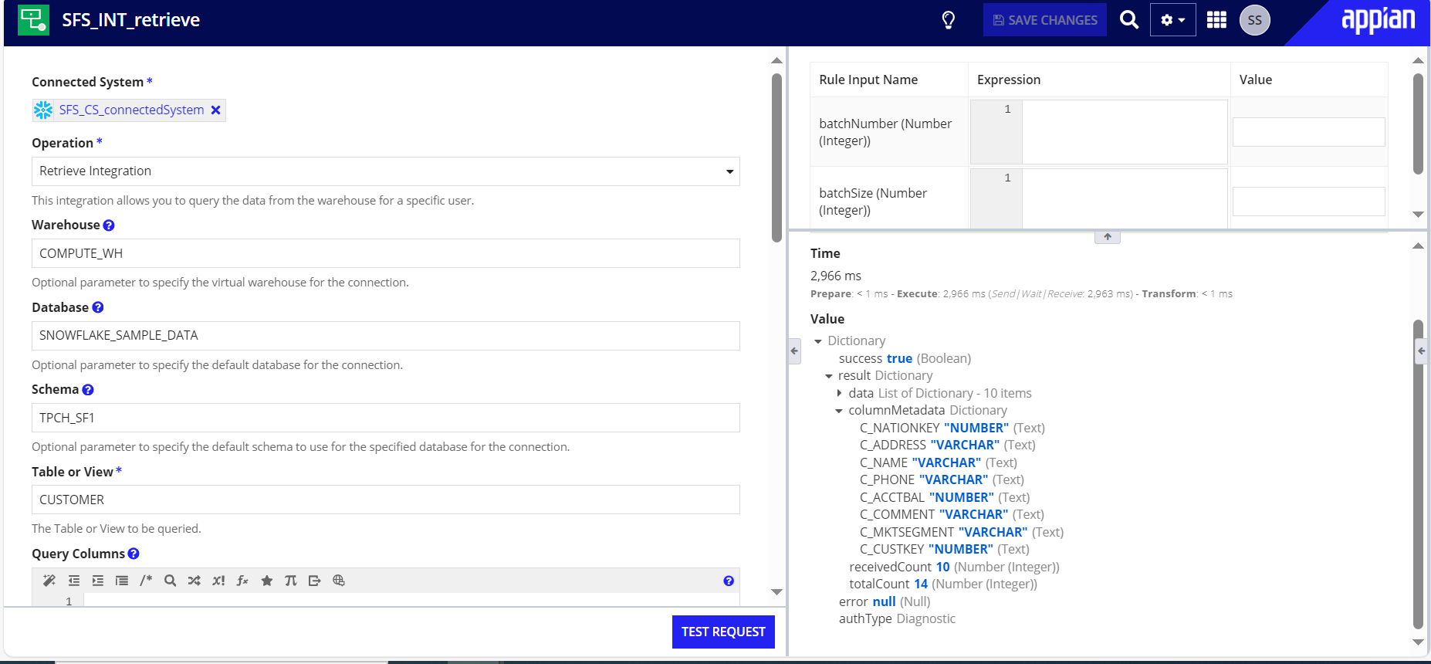

**Inserting the data:**

This integration allows you to insert the data from the warehouse for a specific user.

**Input Parameters**:

**Warehouse:** Optional parameter to specify the virtual warehouse for the connection.

**Database:** Optional parameter to specify the default database for the connection.

**Schema:** Optional parameter to specify the default schema to use for the specified database for the connection.

**Table :** The Table or View to which it should be inserted.

**Columns:** Provide list of columns.

**Values:** Provide list of values.

**Query Timeout:** Optional parameter to specify the query timeout. Default value is 30 sec.

**Output Parameters**:

**Data**: Returns the data from the Executed Query.

**Column Metadata**: The Columns returned from the Executed Query.

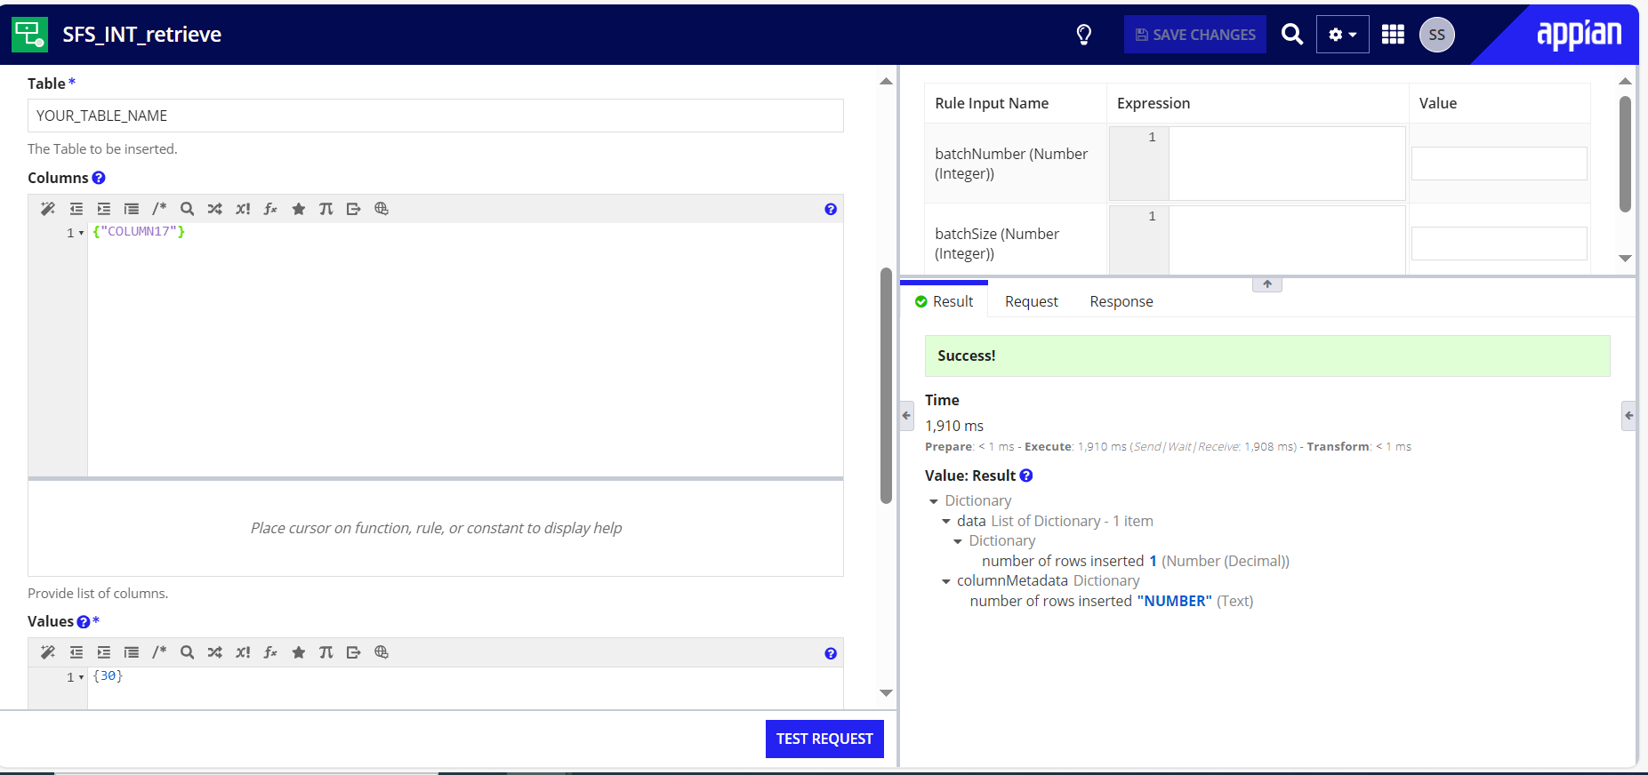**Updating the data:**

This integration allows you to update the data from the warehouse for a specific user.

**Input Parameters**:

**Warehouse:** Optional parameter to specify the virtual warehouse for the connection.

**Database:** Optional parameter to specify the default database for the connection.

**Schema:** Optional parameter to specify the default schema to use for the specified database for the connection.

**Table or View:** The Table or View to which it should be updated.

**Update:** Provide list of column & value pair.

**Condition:** Provide conditions to filter. Eg: ID<=10

**Query Timeout:** Optional parameter to specify the query timeout. Default value is 30 sec.

**Output Parameters**:

**Data**: Returns the data from the Executed Query.

**Column Metadata**: The Columns returned from the Executed Query.

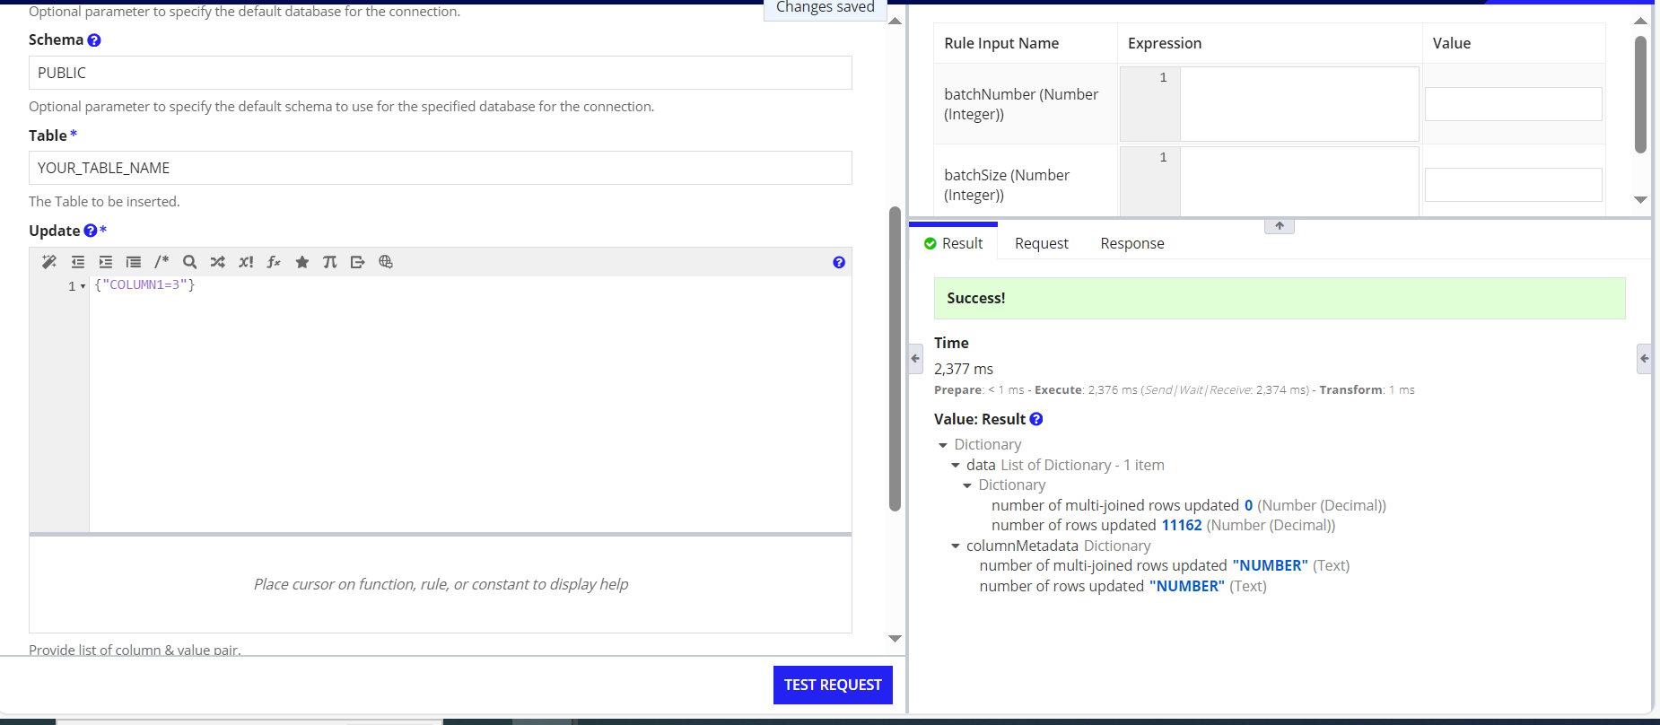

**Deleting the data:**

This integration allows you to delete the data from the warehouse for a specific user.

**Input Parameters**:

**Warehouse:** Optional parameter to specify the virtual warehouse for the connection.

**Database:** Optional parameter to specify the default database for the connection.

**Schema:** Optional parameter to specify the default schema to use for the specified database for the connection.

**Table or View:** The Table or View to which it should be inserted.

**Query Columns:** Provide list of column names to return specific columns.

**Condition:** Provide where conditions to filter. Eg: ID<=10

**Query Timeout:** Optional parameter to specify the query timeout. Default value is 30 sec.

**Output Parameters**:

**Data**: Returns the data from the Executed Query.

**Column Metadata**: The Columns returned from the Executed Query.

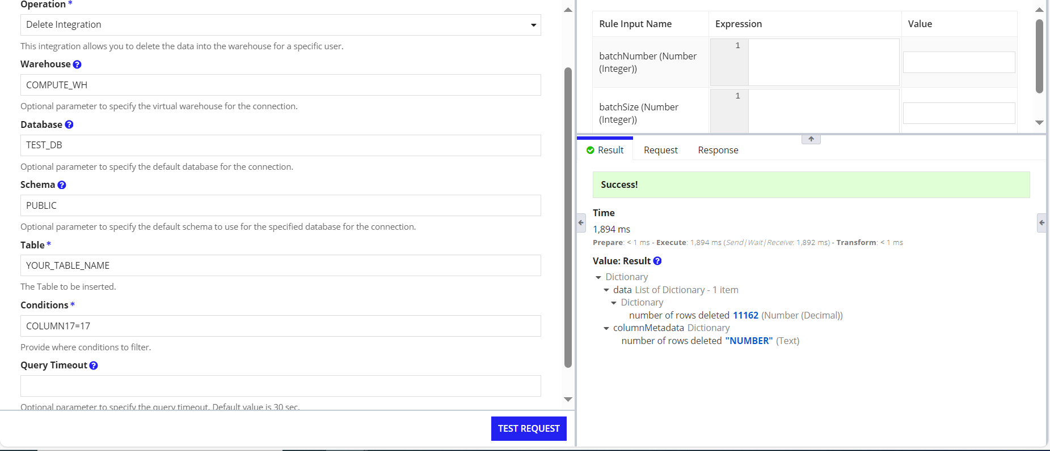

**Calling function or stored procedure:**

This integration allows you to call a procedure from the warehouse for a specific user.

**Input Parameters**:

**Warehouse:** Optional parameter to specify the virtual warehouse for the connection.

**Database:** Optional parameter to specify the default database for the connection.

**Schema:** Optional parameter to specify the default schema to use for the specified database for the connection.

**Procedure or Function:** Provide the Procedure or Function should be called.

**Arguments:** Provide all the arguments with comma(,) as delimiter.

**Query Timeout:** Optional parameter to specify the query timeout. Default value is 30 sec.

**Output Parameters**:

**Data**: Returns the data from the Executed Query.

**Column Metadata**: The Columns returned from the Executed Query.

