**File Transfer Protocols**

File Transfer Protocols are sets of rules and conventions that govern the efficient and secure exchange of files between computer systems. These protocols establish the standards for communication between devices, ensuring that data can be transferred reliably and accurately.

# **SFTP Utilities**

## **Send File Over SFTP**

**Parameters**

### **Inputs:**

1. Scs Key (Text) - The third-party credentials key for connecting to external systems that contains username, password, passphrase. (passphrase should be configured only if Private Key File is protected with Passphrase).
2. Use Per User Credentials (Boolean) - Set to true to enable users to use personal credential field values on the Third-Party Credentials settings page. Default is false.
3. Host Name (Text) - Hostname of the remote server for connection.
4. Port (Number) - Port number of the remote server. Default is 22.
5. Private Key File (Document) - Configure the document containing Private Key.
6. Known Host (Document) - Configure the document containing a list of known hosts.
7. Source Document (Document) - Configure the File to be transferred to the remote server.
8. Remote File Name (Text) - Name of the file saved on the remote server.
9. Remote File Path (Text) - Path on the remote server where the file needs to be transferred.

### **Outputs:**

1. Error Message (Text) - Sets the error message if any.
2. Error Occurred (Boolean) - Set to true on the occurrence of error

### **Screenshot:**

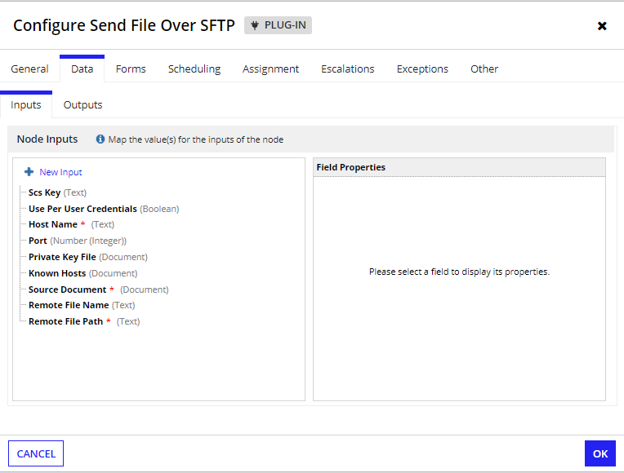

## **Create Directory Over SFTP**

**Parameters**

### **Inputs:**

1. Scs Key (Text) - The third-party credentials key for connecting to external systems that contains username, password, passphrase. (passphrase should be configured only if Private Key File is protected with Passphrase)
2. Use Per User Credentials (Boolean) - Set to true to enable users to use personal credential field values on the Third-Party Credentials settings page. Default is false.
3. Host Name (Text) - Hostname of the remote server for connection.
4. Port (Number) - Port number of the remote server. Default is 22.
5. Private Key File (Document) - Configure the document containing Private Key.
6. Known Host (Document) - Configure the document containing a list of known hosts.
7. New Directory Name (Text) - Name of the new directory to be created on the remote server.
8. Remote Directory Path (Text) - Path on the remote server where the new directory needs to be created.

### **Outputs:**

1. Error Message (Text) - Sets the error message if any.
2. Error Occurred (Boolean) - Set to true on the occurrence of error

### **Screenshot:**

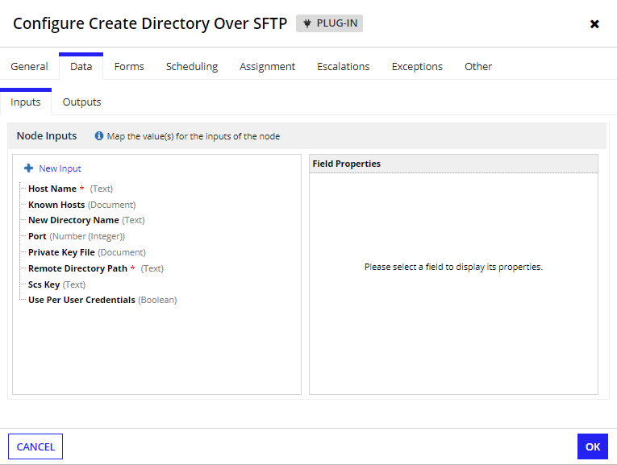

## **Receive File Over SFTP**

**Parameters**

### **Inputs:**

1. Scs Key (Text) - The third-party credentials key for connecting to external systems that contains username, password, passphrase. (passphrase should be configured only if Private Key File is protected with Passphrase)
2. Use Per User Credentials (Boolean) - Set to true to enable users to use personal credential field values on the Third-Party Credentials settings page. Default is false.
3. Host Name (Text) - Hostname of the remote server for connection.
4. Port (Number) - Port number of the remote server. Default is 22.
5. Private Key File (Document) - Configure the document containing Private Key.
6. Known Host (Document) - Configure the document containing a list of known hosts.
7. Remote File Path (Text) - Path on the remote server from where the file needs to be retrieved.
8. Existing Document (Document) - Configure the existing document that needs to be updated with the received file.
9. New Document Name (Text) - Name of the file to be saved in the Appian.
10. New Document Description (Text) - Description of the document saved in the Appian.
11. Save In Folder (Folder) - Folder where the received file needs to be saved.

### **Outputs:**

1. Error Message (Text) - Sets the error message if any.
2. Error Occurred (Boolean) - Set to true on the occurrence of error.
3. Received Document (Document) - The document retrieved from the remote server.

### **Screenshot:**

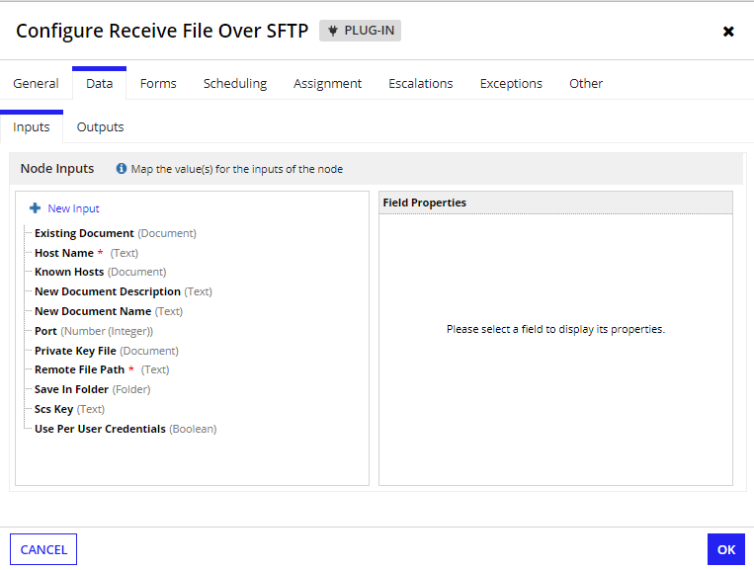

## **Receive Files in Folder Over SFTP**

**Parameters**

### **Inputs:**

1. Scs Key (Text) - The third-party credentials key for connecting to external systems that contains username, password, passphrase. (passphrase should be configured only if Private Key File is protected with Passphrase)
2. Use Per User Credentials (Boolean) - Set to true to enable users to use personal credential field values on the Third-Party Credentials settings page. Default is false.
3. Host Name (Text) - Hostname of the remote server for connection.
4. Port (Number) - Port number of the remote server. Default is 22.
5. Private Key File (Document) - Configure the document containing Private Key.
6. Known Host (Document) - Configure the document containing a list of known hosts.
7. Remote Folder Path (Text) - Path on the remote server from where the files needs to be retrieved.
8. Existing Document (Document) - Configure the existing document that needs to be updated with the received file.
9. New Document Name (Text) - Name of the file to be saved in the Appian.
10. New Document Description (Text) - Description of the document saved in the Appian.
11. Save In Folder (Folder) - Folder where the received file needs to be saved.

### **Outputs:**

1. Error Message (Text) - Sets the error message if any.
2. Error Occurred (Boolean) - Set to true on the occurrence of error.
3. Received Document (List of Documents) - The list of documents retrieved from the remote server.

### **Screenshot:**

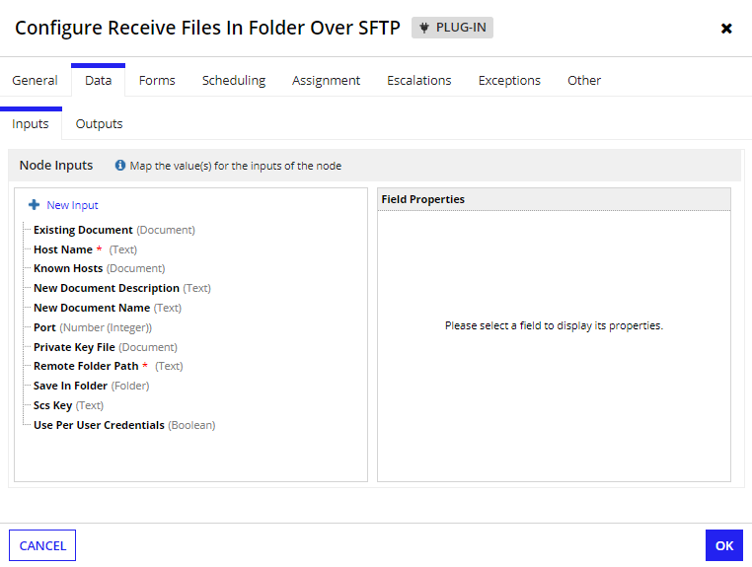

## **Rename File Over SFTP**

**Parameters**

### **Inputs:**

1. Scs Key (Text) - The third-party credentials key for connecting to external systems that contains username, password, passphrase. (passphrase should be configured only if Private Key File is protected with Passphrase)
2. Use Per User Credentials (Boolean) - Set to true to enable users to use personal credential field values on the Third-Party Credentials settings page. Default is false.
3. Host Name (Text) - Hostname of the remote server for connection.
4. Port (Number) - Port number of the remote server. Default is 22.
5. Private Key File (Document) - Configure the document containing Private Key.
6. Known Host (Document) - Configure the document containing a list of known hosts.
7. New File Name (Text) - New name of the file to be changed on the remote server.
8. Remote File Path (Text) - Path on the remote server of the file to be renamed.

### **Outputs:**

1. Error Message (Text) - Sets the error message if any.
2. Error Occurred (Boolean) - Set to true on the occurrence of error

### **Screenshot:**

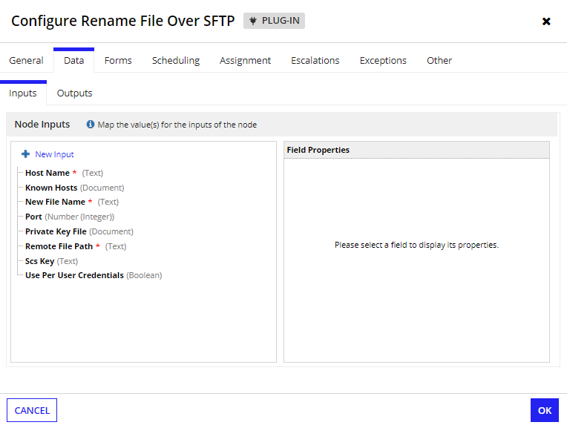

## **Remove File Over SFTP**

**Parameters**

### **Inputs:**

1. Scs Key (Text) - The third-party credentials key for connecting to external systems that contains username, password, passphrase. (passphrase should be configured only if Private Key File is protected with Passphrase)
2. Use Per User Credentials (Boolean) - Set to true to enable users to use personal credential field values on the Third-Party Credentials settings page. Default is false.
3. Host Name (Text) - Hostname of the remote server for connection.
4. Port (Number) - Port number of the remote server. Default is 22.
5. Private Key File (Document) - Configure the document containing Private Key.
6. Known Host (Document) - Configure the document containing a list of known hosts.
7. Remote File Path (Text) - Path on the remote server of the file to be removed.

### **Outputs:**

1. Error Message (Text) - Sets the error message if any.
2. Error Occurred (Boolean) - Set to true on the occurrence of error.

### **Screenshot:**

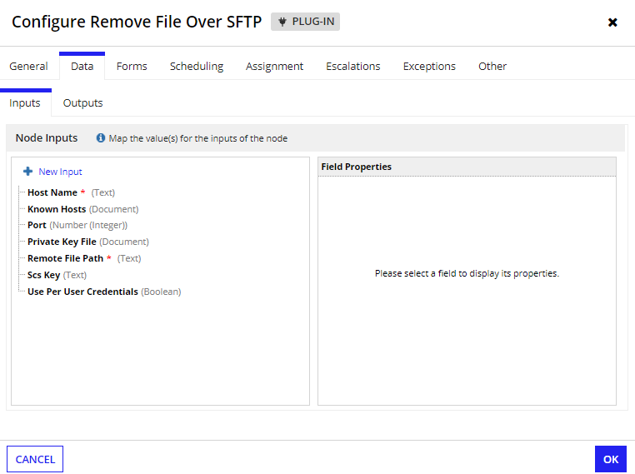

## **Remove Directory Over SFTP**

**Parameters**

### **Inputs:**

1. Scs Key (Text) - The third-party credentials key for connecting to external systems that contains username, password, passphrase. (passphrase should be configured only if Private Key File is protected with Passphrase)
2. Use Per User Credentials (Boolean) - Set to true to enable users to use personal credential field values on the Third-Party Credentials settings page. Default is false.
3. Host Name (Text) - Hostname of the remote server for connection.
4. Port (Number) - Port number of the remote server. Default is 22.
5. Private Key File (Document) - Configure the document containing Private Key.
6. Known Host (Document) - Configure the document containing a list of known hosts.
7. Remote Directory Path (Text) - Path on the remote server of the directory to be removed.

### **Outputs:**

1. Error Message (Text) - Sets the error message if any.
2. Error Occurred (Boolean) - Set to true on the occurrence of error

### **Screenshot:**

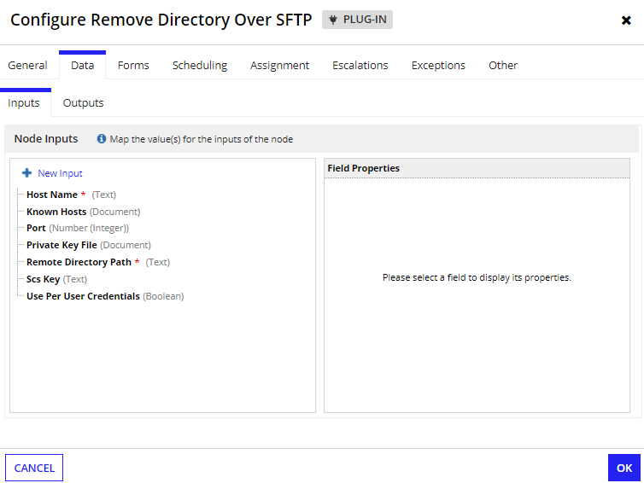

## **Get Remote Directory Contents Over SFTP**

**Parameters**

### **Inputs:**

1. Scs Key (Text) - The third-party credentials key for connecting to external systems that contains username, password, passphrase. (passphrase should be configured only if Private Key File is protected with Passphrase)
2. Use Per User Credentials (Boolean) - Set to true to enable users to use personal credential field values on the Third-Party Credentials settings page. Default is false.
3. Host Name (Text) - Hostname of the remote server for connection.
4. Port (Number) - Port number of the remote server. Default is 22.
5. Private Key File (Document) - Configure the document containing Private Key.
6. Known Host (Document) - Configure the document containing a list of known hosts.
7. Remote Directory Path (Text) - Path on the remote server of the directory from which the contents to be retrieved.

### **Outputs:**

1. Error Message (Text) - Sets the error message if any.
2. Error Occurred (Boolean) - Set to true on the occurrence of error.
3. Directories (List of Text) - List of Directories present in the defined folder.
4. Files (List of Text) - List of Files present in the defined folder

### **Screenshot:**

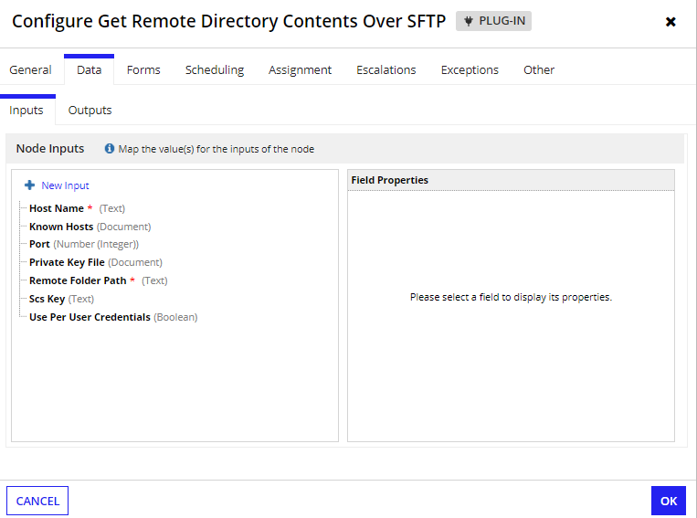

_________________________________________________________________________________

# **SCP Utilities**

## **Send File Over SCP**

**Parameters**

### **Inputs:**

1. Scs Key (Text) - The third-party credentials key for connecting to external systems that contains username, password, passphrase. (passphrase should be configured only if Private Key File is protected with Passphrase)
2. Use Per User Credentials (Boolean) - Set to true to enable users to use personal credential field values on the Third-Party Credentials settings page. Default is false.
3. Host Name (Text) - Hostname of the remote server for connection.
4. Port (Number) - Port number of the remote server. Default is 22.
5. Private Key File (Document) - Configure the document containing Private Key.
6. Known Host (Document) - Configure the document containing a list of known hosts.
7. Source Document (Document) - Configure the File to be transferred to the remote server.
8. Remote File Name (Text) - Name of the file saved on the remote server.
9. Remote File Path (Text) - Path on the remote server where the file needs to be transferred.

### **Outputs:**

1. Error Message (Text) - Sets the error message if any.
2. Error Occurred (Boolean) - Set to true on the occurrence of error

### **Screenshot:**

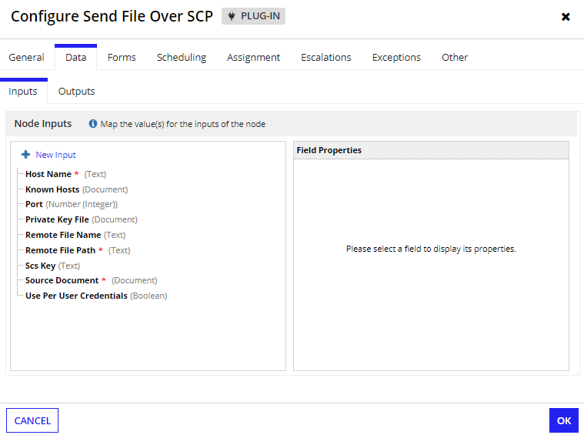

## **Receive File Over SCP**

**Parameters**

### **Inputs:**

1. Scs Key (Text) - The third-party credentials key for connecting to external systems that contains username, password, passphrase. (passphrase should be configured only if Private Key File is protected with Passphrase)
2. Use Per User Credentials (Boolean) - Set to true to enable users to use personal credential field values on the Third-Party Credentials settings page. Default is false.
3. Host Name (Text) - Hostname of the remote server for connection.
4. Port (Number) - Port number of the remote server. Default is 22.
5. Private Key File (Document) - Configure the document containing Private Key.
6. Known Host (Document) - Configure the document containing a list of known hosts.
7. Remote File Path (Text) - Path on the remote server from where the file needs to be retrieved.
8. Existing Document (Document) - Configure the existing document that needs to be updated with the received file.
9. New Document Name (Text) - Name of the file to be saved in the Appian.
10. New Document Description (Text) - Description of the document saved in the Appian.
11. Save In Folder (Folder) - Folder where the received file needs to be saved.

### **Outputs:**

1. Error Message (Text) - Sets the error message if any.
2. Error Occurred (Boolean) - Set to true on the occurrence of error.
3. Received Document (Document) - The document retrieved from the remote server.

### **Screenshot:**

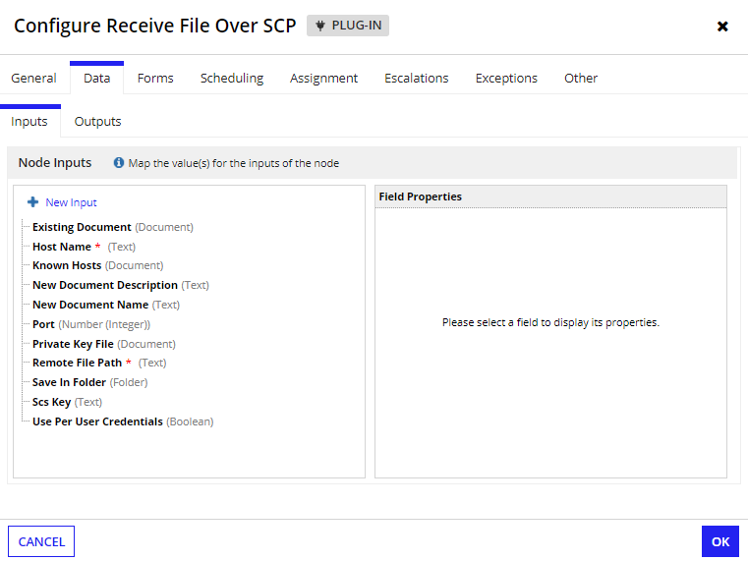

_____________________________________________________________________________________

# **FTPS Utilities**

## **Send File Over FTPS**

**Parameters**

### **Inputs:**

1. Scs Key (Text) - The third-party credentials key for connecting to external systems that contains username, password, passphrase. (passphrase should be configured only if Private Key File is protected with Passphrase).
2. Use Per User Credentials (Boolean) - Set to true to enable users to use personal credential field values on the Third-Party Credentials settings page. Default is false.
3. Host Name (Text) - Hostname of the remote server for connection.
4. Port (Number) - Port number of the remote server. Default is 21.
5. Private Key File (Document) - Configure the document containing Private Key.
6. Source Document (Document) - Configure the File to be transferred to the remote server.
7. Remote File Name (Text) - Name of the file saved on the remote server.
8. Remote File Path (Text) - Path on the remote server where the file needs to be transferred.

### **Outputs:**

1. Error Message (Text) - Sets the error message if any.
2. Error Occurred (Boolean) - Set to true on the occurrence of error

### **Screenshot:**

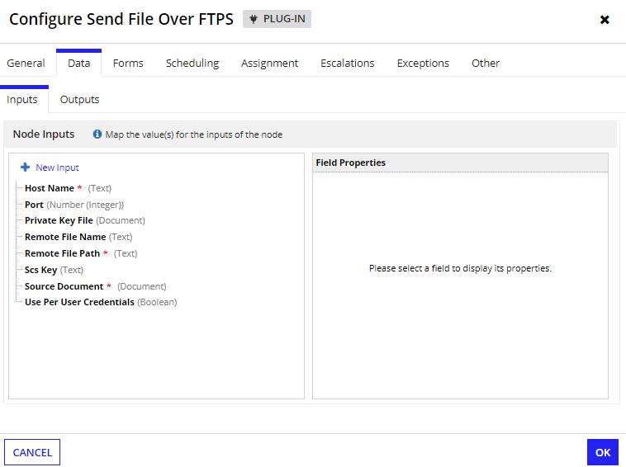

## **Create Directory Over FTPS**

**Parameters**

### **Inputs:**

1. Scs Key (Text) - The third-party credentials key for connecting to external systems that contains username, password, passphrase. (passphrase should be configured only if Private Key File is protected with Passphrase)
2. Use Per User Credentials (Boolean) - Set to true to enable users to use personal credential field values on the Third-Party Credentials settings page. Default is false.
3. Host Name (Text) - Hostname of the remote server for connection.
4. Port (Number) - Port number of the remote server. Default is 21.
5. Private Key File (Document) - Configure the document containing Private Key.
6. New Directory Name (Text) - Name of the new directory to be created on the remote server.
7. Remote Directory Path (Text) - Path on the remote server where the new directory needs to be created.

### **Outputs:**

1. Error Message (Text) - Sets the error message if any.
2. Error Occurred (Boolean) - Set to true on the occurrence of error

### **Screenshot:**

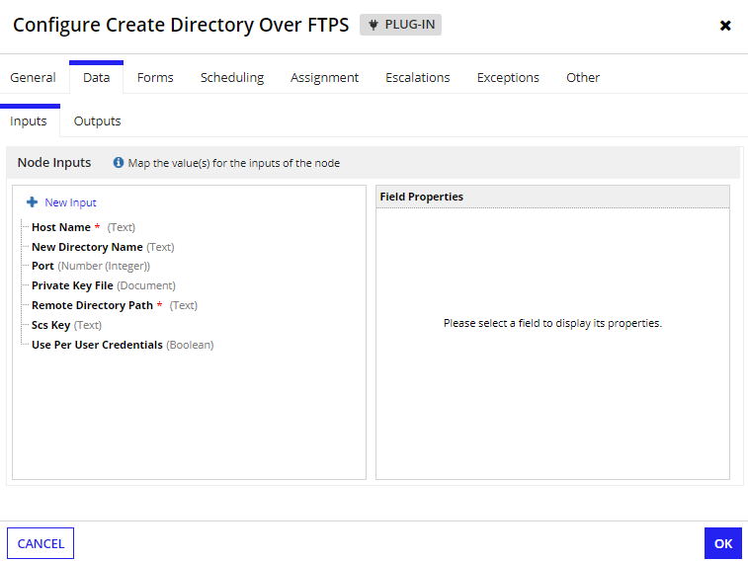

## **Receive File Over FTPS**

**Parameters**

### **Inputs:**

1. Scs Key (Text) - The third-party credentials key for connecting to external systems that contains username, password, passphrase. (passphrase should be configured only if Private Key File is protected with Passphrase)
2. Use Per User Credentials (Boolean) - Set to true to enable users to use personal credential field values on the Third-Party Credentials settings page. Default is false.
3. Host Name (Text) - Hostname of the remote server for connection.
4. Port (Number) - Port number of the remote server. Default is 21.
5. Private Key File (Document) - Configure the document containing Private Key.
6. Remote File Path (Text) - Path on the remote server from where the file needs to be retrieved.
7. Existing Document (Document) - Configure the existing document that needs to be updated with the received file.
8. New Document Name (Text) - Name of the file to be saved in the Appian.
9. New Document Description (Text) - Description of the document saved in the Appian.
10. Save In Folder (Folder) - Folder where the received file needs to be saved.

### **Outputs:**

1. Error Message (Text) - Sets the error message if any.
2. Error Occurred (Boolean) - Set to true on the occurrence of error.
3. Received Document (Document) - The document retrieved from the remote server.

### **Screenshot:**

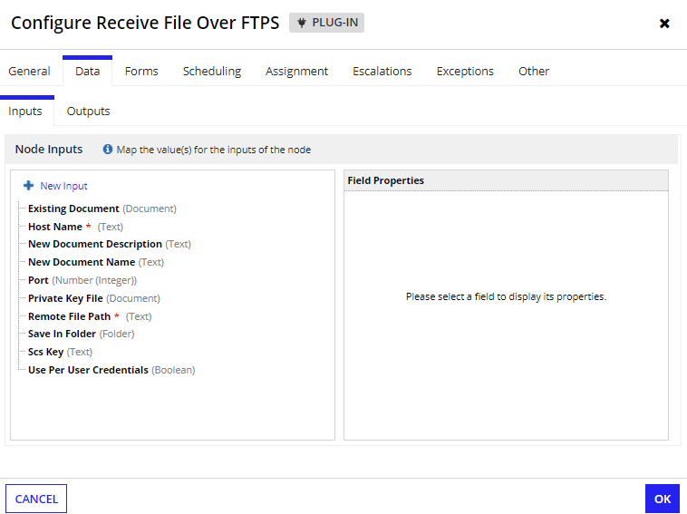

## **Receive Files in Folder Over FTPS**

**Parameters**

### **Inputs:**

1. Scs Key (Text) - The third-party credentials key for connecting to external systems that contains username, password, passphrase. (passphrase should be configured only if Private Key File is protected with Passphrase)
2. Use Per User Credentials (Boolean) - Set to true to enable users to use personal credential field values on the Third-Party Credentials settings page. Default is false.
3. Host Name (Text) - Hostname of the remote server for connection.
4. Port (Number) - Port number of the remote server. Default is 21.
5. Private Key File (Document) - Configure the document containing Private Key.
6. Remote Folder Path (Text) - Path on the remote server from where the files needs to be retrieved.
7. Existing Document (Document) - Configure the existing document that needs to be updated with the received file.
8. New Document Name (Text) - Name of the file to be saved in the Appian.
9. New Document Description (Text) - Description of the document saved in the Appian.
10. Save In Folder (Folder) - Folder where the received file needs to be saved.

### **Outputs:**

1. Error Message (Text) - Sets the error message if any.
2. Error Occurred (Boolean) - Set to true on the occurrence of error.
3. Received Document (List of Documents) - The list of documents retrieved from the remote server.

### **Screenshot:**

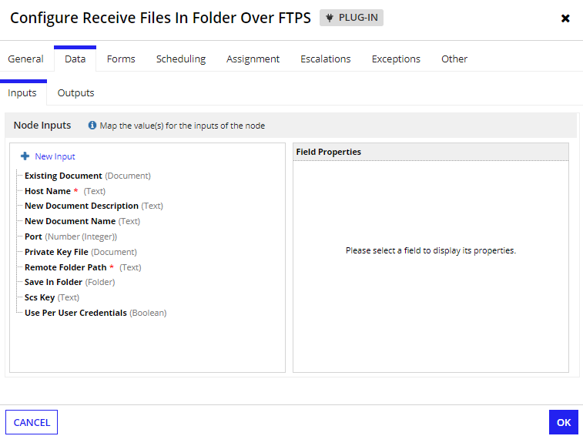

## **Rename File Over FTPS**

**Parameters**

### **Inputs:**

1. Scs Key (Text) - The third-party credentials key for connecting to external systems that contains username, password, passphrase. (passphrase should be configured only if Private Key File is protected with Passphrase)
2. Use Per User Credentials (Boolean) - Set to true to enable users to use personal credential field values on the Third-Party Credentials settings page. Default is false.
3. Host Name (Text) - Hostname of the remote server for connection.
4. Port (Number) - Port number of the remote server. Default is 21.
5. Private Key File (Document) - Configure the document containing Private Key.
6. New File Name (Text) - New name of the file to be changed on the remote server.
7. Remote File Path (Text) - Path on the remote server of the file to be renamed.

### **Outputs:**

1. Error Message (Text) - Sets the error message if any.
2. Error Occurred (Boolean) - Set to true on the occurrence of error

### **Screenshot:**

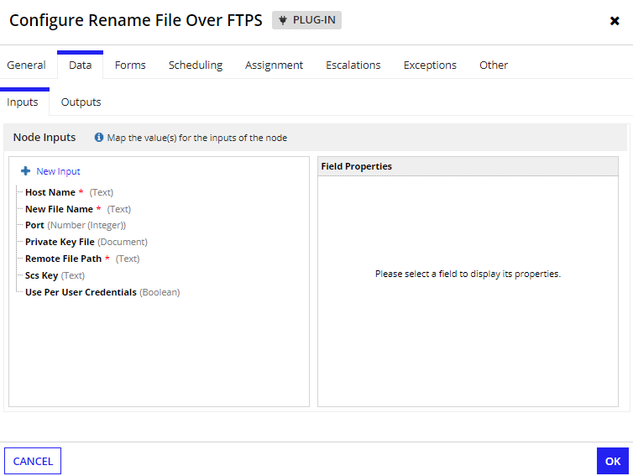

## **Remove File Over FTPS**

**Parameters**

### **Inputs:**

1. Scs Key (Text) - The third-party credentials key for connecting to external systems that contains username, password, passphrase. (passphrase should be configured only if Private Key File is protected with Passphrase)
2. Use Per User Credentials (Boolean) - Set to true to enable users to use personal credential field values on the Third-Party Credentials settings page. Default is false.
3. Host Name (Text) - Hostname of the remote server for connection.
4. Port (Number) - Port number of the remote server. Default is 21.
5. Private Key File (Document) - Configure the document containing Private Key.
6. Remote File Path (Text) - Path on the remote server of the file to be removed.

### **Outputs:**

1. Error Message (Text) - Sets the error message if any.
2. Error Occurred (Boolean) - Set to true on the occurrence of error.
3. Is File Removed (Boolean) - Set to true if the mentioned file is removed successfully in Remote Server.

### **Screenshot:**

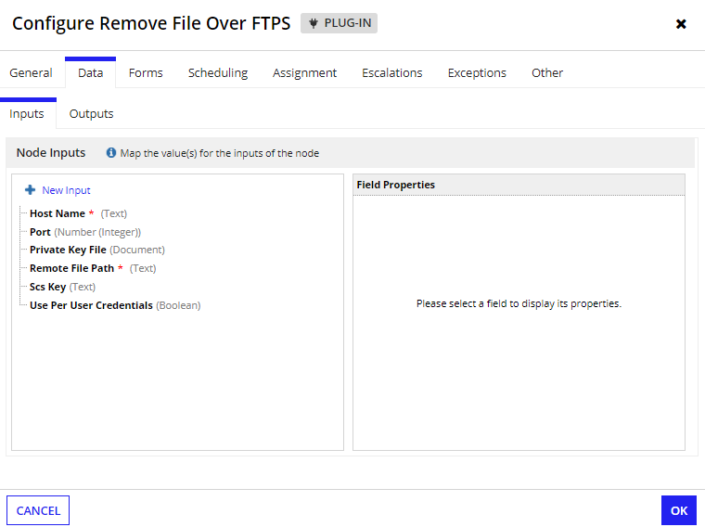

## **Remove Directory Over FTPS**

**Parameters**

### **Inputs:**

1. Scs Key (Text) - The third-party credentials key for connecting to external systems that contains username, password, passphrase. (passphrase should be configured only if Private Key File is protected with Passphrase)
2. Use Per User Credentials (Boolean) - Set to true to enable users to use personal credential field values on the Third-Party Credentials settings page. Default is false.
3. Host Name (Text) - Hostname of the remote server for connection.
4. Port (Number) - Port number of the remote server. Default is 21.
5. Private Key File (Document) - Configure the document containing Private Key.
6. Remote Folder Path (Text) - Path on the remote server of the directory to be removed.

### **Outputs:**

1. Error Message (Text) - Sets the error message if any.
2. Error Occurred (Boolean) - Set to true on the occurrence of error.
3. Is Directory Removed (Boolean) - Set to true if the mentioned Directory is removed successfully in Remote Server.

### **Screenshot:**

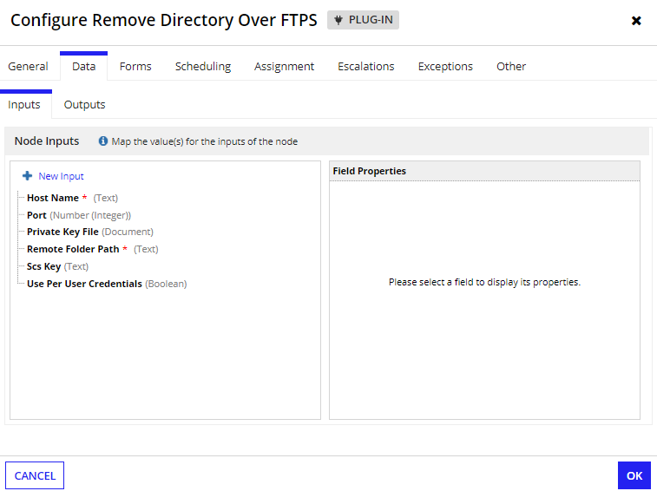

## **Get Remote Directory Contents Over SFTP**

**Parameters**

### **Inputs:**

1. Scs Key (Text) - The third-party credentials key for connecting to external systems that contains username, password, passphrase. (passphrase should be configured only if Private Key File is protected with Passphrase)
2. Use Per User Credentials (Boolean) - Set to true to enable users to use personal credential field values on the Third-Party Credentials settings page. Default is false.
3. Host Name (Text) - Hostname of the remote server for connection.
4. Port (Number) - Port number of the remote server. Default is 21.
5. Private Key File (Document) - Configure the document containing Private Key.
6. Remote Folder Path (Text) - Path on the remote server of the directory from which the contents to be retrieved.

### **Outputs:**

1. Error Message (Text) - Sets the error message if any.
2. Error Occurred (Boolean) - Set to true on the occurrence of error.
3. Directories (List of Text) - List of Directories present in the defined folder.
4. Files (List of Text) - List of Files present in the defined folder

### **Screenshot:**

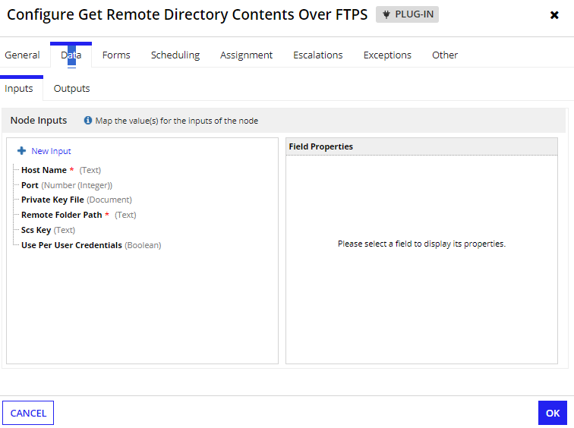

_____________________________________________________________________________________

# **FTP Utilities**

## **Send File Over FTP**

**Parameters**

### **Inputs:**

1. Scs Key (Text) - The third-party credentials key for connecting to external systems that contains username, password, passphrase. (passphrase should be configured only if Private Key File is protected with Passphrase).
2. Use Per User Credentials (Boolean) - Set to true to enable users to use personal credential field values on the Third-Party Credentials settings page. Default is false.
3. Host Name (Text) - Hostname of the remote server for connection.
4. Port (Number) - Port number of the remote server. Default is 21.
5. Enter Local Active Mode (Boolean) - Set to true to enable Local Active Mode or false to enable Local Passive Mode. Default is false.
6. Source Document (Document) - Configure the File to be transferred to the remote server.
7. Remote File Name (Text) - Name of the file saved on the remote server.
8. Remote File Path (Text) - Path on the remote server where the file needs to be transferred.

### **Outputs:**

1. Error Message (Text) - Sets the error message if any.
2. Error Occurred (Boolean) - Set to true on the occurrence of error

### **Screenshot:**

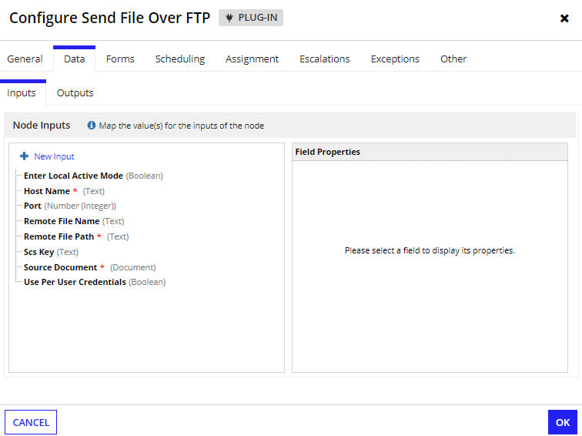

## **Create Directory Over FTPS**

**Parameters**

### **Inputs:**

1. Scs Key (Text) - The third-party credentials key for connecting to external systems that contains username, password, passphrase. (passphrase should be configured only if Private Key File is protected with Passphrase)
2. Use Per User Credentials (Boolean) - Set to true to enable users to use personal credential field values on the Third-Party Credentials settings page. Default is false.
3. Host Name (Text) - Hostname of the remote server for connection.
4. Port (Number) - Port number of the remote server. Default is 21.
5. Enter Local Active Mode (Boolean) - Set to true to enable Local Active Mode or false to enable Local Passive Mode. Default is false.
6. New Directory Name (Text) - Name of the new directory to be created on the remote server.
7. Remote Directory Path (Text) - Path on the remote server where the new directory needs to be created.

### **Outputs:**

1. Error Message (Text) - Sets the error message if any.
2. Error Occurred (Boolean) - Set to true on the occurrence of error

### **Screenshot:**

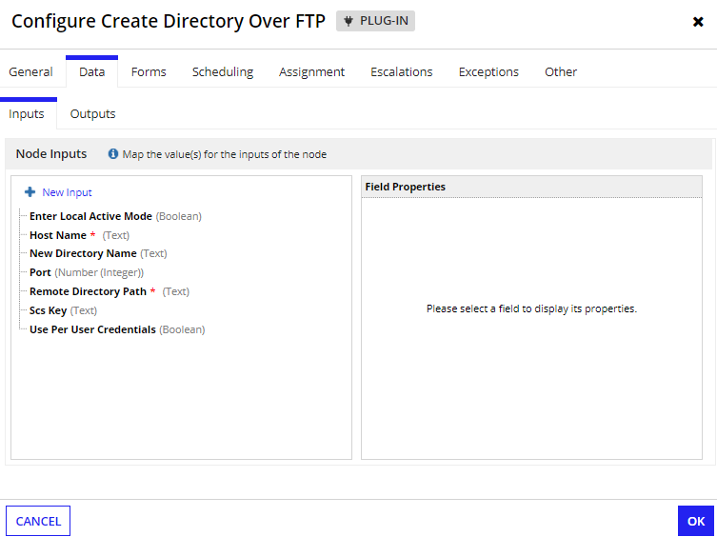

## **Receive File Over FTPS**

**Parameters**

### **Inputs:**

1. Scs Key (Text) - The third-party credentials key for connecting to external systems that contains username, password, passphrase. (passphrase should be configured only if Private Key File is protected with Passphrase)
2. Use Per User Credentials (Boolean) - Set to true to enable users to use personal credential field values on the Third-Party Credentials settings page. Default is false.
3. Host Name (Text) - Hostname of the remote server for connection.
4. Port (Number) - Port number of the remote server. Default is 21.
5. Enter Local Active Mode (Boolean) - Set to true to enable Local Active Mode or false to enable Local Passive Mode. Default is false.
6. Remote File Path (Text) - Path on the remote server from where the file needs to be retrieved.
7. Existing Document (Document) - Configure the existing document that needs to be updated with the received file.
8. New Document Name (Text) - Name of the file to be saved in the Appian.
9. New Document Description (Text) - Description of the document saved in the Appian.
10. Save In Folder (Folder) - Appian Folder where the received file needs to be saved.

### **Outputs:**

1. Error Message (Text) - Sets the error message if any.
2. Error Occurred (Boolean) - Set to true on the occurrence of error.
3. Received Document (Document) - The document retrieved from the remote server.

### **Screenshot:**

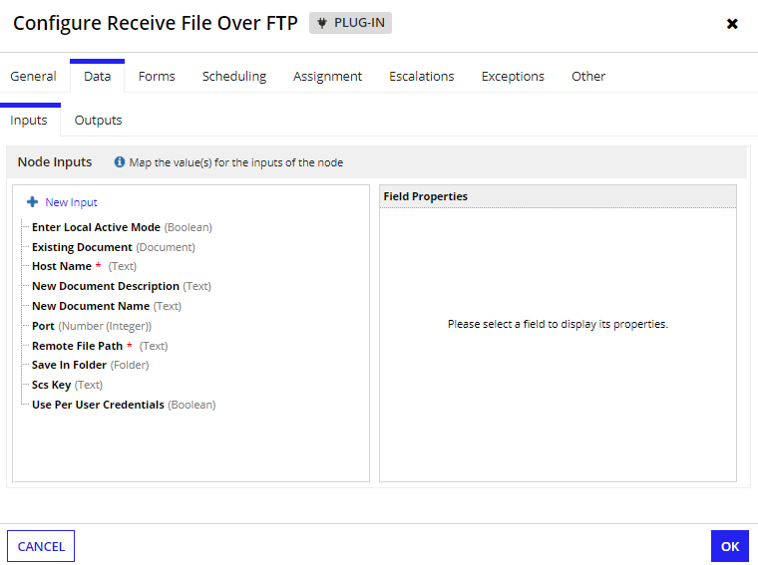

## **Receive Files in Folder Over FTPS**

**Parameters**

### **Inputs:**

1. Scs Key (Text) - The third-party credentials key for connecting to external systems that contains username, password, passphrase. (passphrase should be configured only if Private Key File is protected with Passphrase)
2. Use Per User Credentials (Boolean) - Set to true to enable users to use personal credential field values on the Third-Party Credentials settings page. Default is false.
3. Host Name (Text) - Hostname of the remote server for connection.
4. Port (Number) - Port number of the remote server. Default is 21.
5. Enter Local Active Mode (Boolean) - Set to true to enable Local Active Mode or false to enable Local Passive Mode. Default is false.
6. Remote Folder Path (Text) - Path on the remote server from where the files needs to be retrieved.
7. Existing Document (Document) - Configure the existing document that needs to be updated with the received file.
8. New Document Name (Text) - Name of the file to be saved in the Appian.
9. New Document Description (Text) - Description of the document saved in the Appian.
10. Save In Folder (Folder) - Appian Folder where the received file needs to be saved.

### **Outputs:**

1. Error Message (Text) - Sets the error message if any.
2. Error Occurred (Boolean) - Set to true on the occurrence of error.
3. Received Document (List of Documents) - The list of documents retrieved from the remote server.

### **Screenshot:**

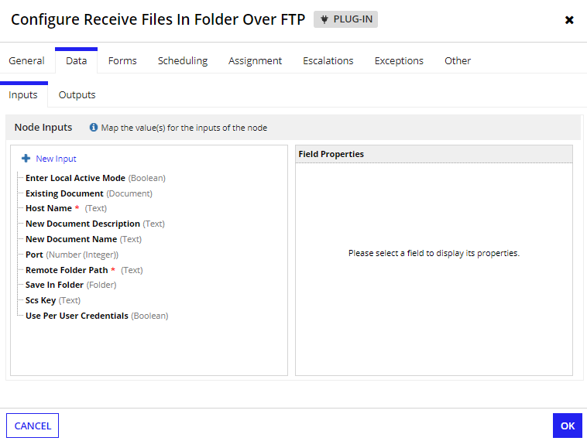

## **Rename File Over FTPS**

**Parameters**

### **Inputs:**

1. Scs Key (Text) - The third-party credentials key for connecting to external systems that contains username, password, passphrase. (passphrase should be configured only if Private Key File is protected with Passphrase)
2. Use Per User Credentials (Boolean) - Set to true to enable users to use personal credential field values on the Third-Party Credentials settings page. Default is false.
3. Host Name (Text) - Hostname of the remote server for connection.
4. Port (Number) - Port number of the remote server. Default is 21.
5. Enter Local Active Mode (Boolean) - Set to true to enable Local Active Mode or false to enable Local Passive Mode. Default is false.
6. New File Name (Text) - New name of the file to be changed on the remote server.
7. Remote File Path (Text) - Path on the remote server of the file to be renamed.

### **Outputs:**

1. Error Message (Text) - Sets the error message if any.
2. Error Occurred (Boolean) - Set to true on the occurrence of error

### **Screenshot:**

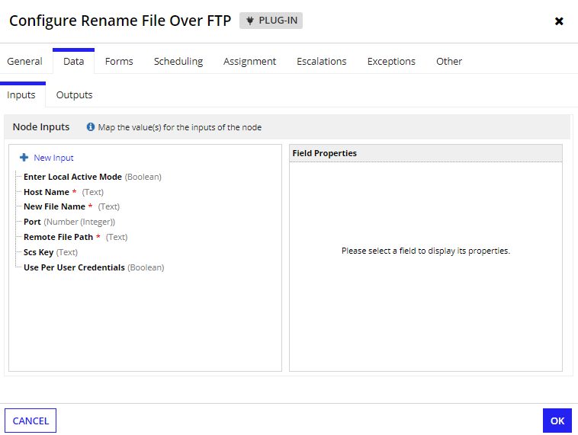

## **Remove File Over FTPS**

**Parameters**

### **Inputs:**

1. Scs Key (Text) - The third-party credentials key for connecting to external systems that contains username, password, passphrase. (passphrase should be configured only if Private Key File is protected with Passphrase)
2. Use Per User Credentials (Boolean) - Set to true to enable users to use personal credential field values on the Third-Party Credentials settings page. Default is false.
3. Host Name (Text) - Hostname of the remote server for connection.
4. Port (Number) - Port number of the remote server. Default is 21.
5. Enter Local Active Mode (Boolean) - Set to true to enable Local Active Mode or false to enable Local Passive Mode. Default is false.
6. Remote File Path (Text) - Path on the remote server of the file to be removed.

### **Outputs:**

1. Error Message (Text) - Sets the error message if any.
2. Error Occurred (Boolean) - Set to true on the occurrence of error.
3. Is File Removed (Boolean) - Set to true if the mentioned file is removed successfully in Remote Server.

### **Screenshot:**

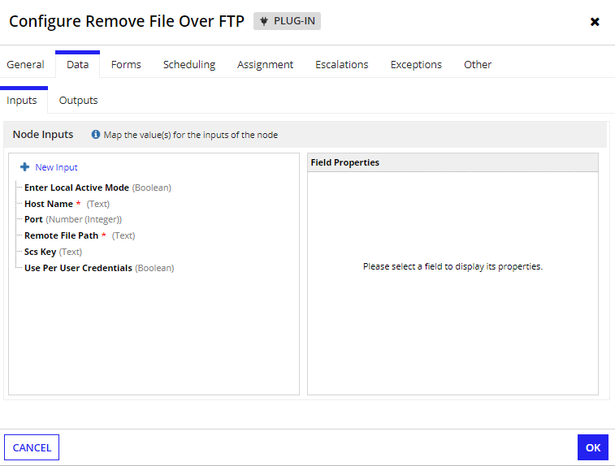

## **Remove Directory Over FTPS**

**Parameters**

### **Inputs:**

1. Scs Key (Text) - The third-party credentials key for connecting to external systems that contains username, password, passphrase. (passphrase should be configured only if Private Key File is protected with Passphrase)
2. Use Per User Credentials (Boolean) - Set to true to enable users to use personal credential field values on the Third-Party Credentials settings page. Default is false.
3. Host Name (Text) - Hostname of the remote server for connection.
4. Port (Number) - Port number of the remote server. Default is 21.
5. Enter Local Active Mode (Boolean) - Set to true to enable Local Active Mode or false to enable Local Passive Mode. Default is false.
6. Remote Folder Path (Text) - Path on the remote server of the directory to be removed.

### **Outputs:**

1. Error Message (Text) - Sets the error message if any.
2. Error Occurred (Boolean) - Set to true on the occurrence of error.
3. Is Directory Removed (Boolean) - Set to true if the mentioned Directory is removed successfully in Remote Server.

### **Screenshot:**

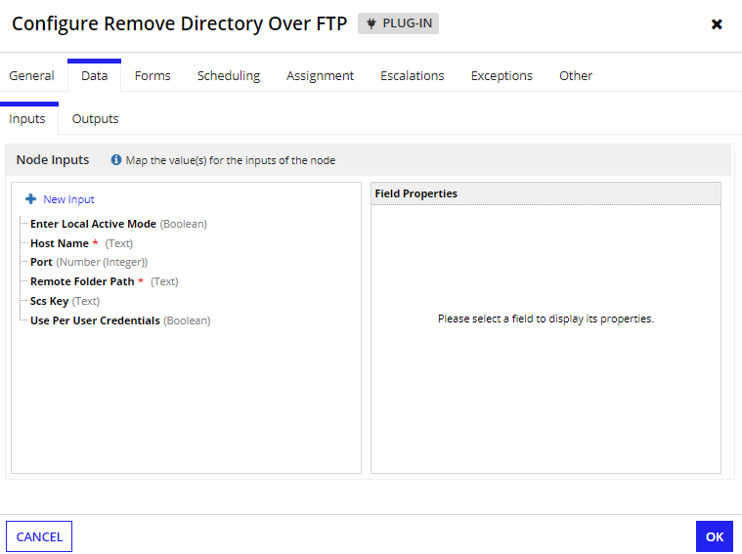

## **Get Remote Directory Contents Over SFTP**

**Parameters**

### **Inputs:**

1. Scs Key (Text) - The third-party credentials key for connecting to external systems that contains username, password, passphrase. (passphrase should be configured only if Private Key File is protected with Passphrase)
2. Use Per User Credentials (Boolean) - Set to true to enable users to use personal credential field values on the Third-Party Credentials settings page. Default is false.
3. Host Name (Text) - Hostname of the remote server for connection.
4. Port (Number) - Port number of the remote server. Default is 21.
5. Enter Local Active Mode (Boolean) - Set to true to enable Local Active Mode or false to enable Local Passive Mode. Default is false.
6. Remote Folder Path (Text) - Path on the remote server of the directory from which the contents to be retrieved.

### **Outputs:**

1. Error Message (Text) - Sets the error message if any.
2. Error Occurred (Boolean) - Set to true on the occurrence of error.
3. Directories (List of Text) - List of Directories present in the defined folder.
4. Files (List of Text) - List of Files present in the defined folder

### **Screenshot:**

