Document Page Counter

About
A plugin to get the number of pages, slides and sheets used in the office documents. The custom function can be used anywhere in the Appian expression editor by providing the Document Id of the document.
getnumberofpages:
Function : getnumberofpages()
Returns the number of pages in the given pdf document.

Parameters
Functions Details
Input type | Output type
Document | Integer

Notes:

- Supported Documents-
- .pdf documents.
- Supported Language - English (United States).

Screenshot:

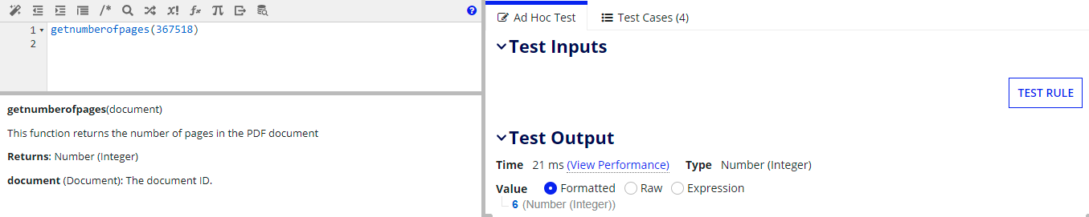

getnumberofsheets:
Function : getnumberofsheets()
Returns the number of sheets in the given document.

Parameters
Functions Details
Input type | Output type
Document | Integer

Notes:

- Supported Documents-
- .xlsx,.xls for documents generated from MS office and WPS.
- Documents from google sheets
- Supported Language - English (United States)

Screenshot:

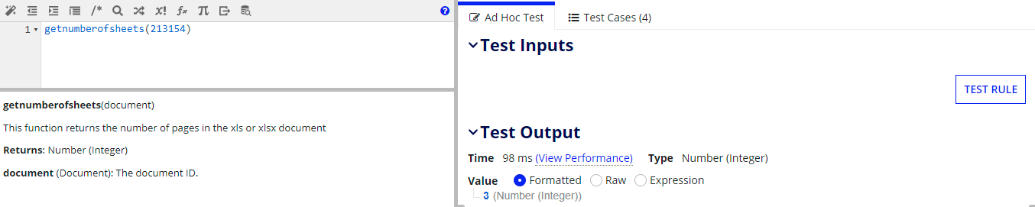

getnumberofslides:
Function : getnumberofslides()
Returns the number of slides in the given document.

Parameters
Functions Details
Input type | Output type
Document | Integer

Notes:

- Supported Documents-
- .pptx,.ppt for documents generated from MS office and WPS.
- Documents from google slides
- Supported Language - English (United States)

Screenshot:

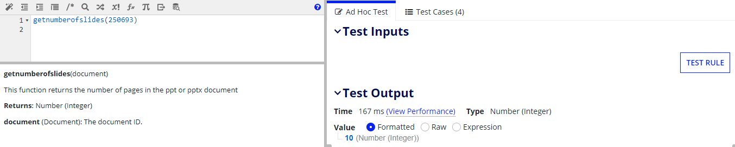

getnumberofpagesindocument:
Function : getnumberofpagesindocument()
Returns the number of pages in the given doc or docx document. Return the page Count only when the document metadata contains the page count or else returns 0.
Note: Works only for documents created using Microsoft Word.
Parameters
Functions Details
Input type | Output type
Document | Dictionary

Notes:

- Supported Documents-
  - .doc,.docx documents.
- Supported Language - English (United States).

Screenshot:

