Appian Document Understanding with Textract, Textract ID, Textract Query, Transcribe, Rekognition, and Comprehend

What is it for?

This solution helps to understand the contents of any documents (text, PDF, image, audio, video).

Textract (key-value, line text, ID, query)

The Textract Key-value demo showcases using textract to extract Key-Value pair for the fields you specify. Textract Line Extraction demo extracts the text line block out of it, and send it to comprehend to detect any key phrases. And the Textract ID demo shows how to query a piece of field information right inside the PDF file.

Textract Identification extraction calls a lambda function “analyzeID” to call a textract.analyze_id api to extract fields from official ID documents, such as passport, driver license, etc.

Textract Query calls a lambda function “textractQuery” to invoke the textract.analyze_document api to extract the response based on the query input.

Transcribe
For audio (mp3) and video (mp4) media files, the solution will use transcribe to generate a text transcription from the media file.

Rekognition
For image file, the solution will use AWS rekognition service to detect key entities from the image, the use case is if a gun get detected from the image, do something.

Comprehend
For various comprehend integrations, appian integrate with related AWS comprehend APIs to detect entities, detect key phrases, detect language, detect PII data, and detect sentiment.

Plug-in Requirements

Textract Plug-in Version 1.2.3
AWS Lambda Plug-in Version 1.0.3
Audio Player Plug-in Version 1.0.0
Installation
- Make necessary change to the “Document Understanding 1.1.0.txt” file for AWS service credentials.
- Deploy attached Lambda functions to your AWS account.
- Deploy required 3 Plugins
- Deploy the app package

Lambda Functions
- textractQuery
- analyzeID

Architecture Diagram – Textract Line Extraction
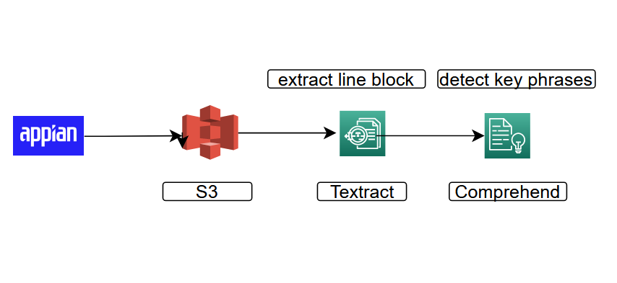
Textract ID Extraction

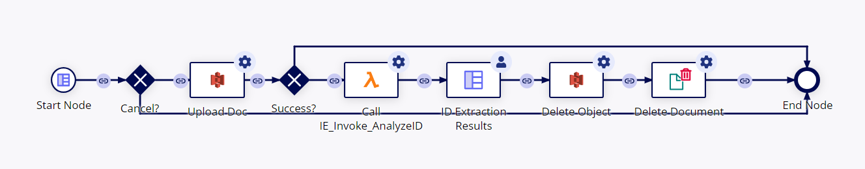

Textract Query

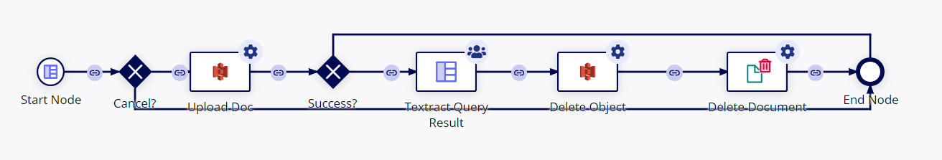

Architecture Diagram – Media Transcribe

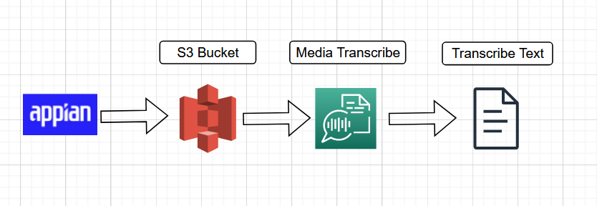

Architecture Diagram – Image Rekognition

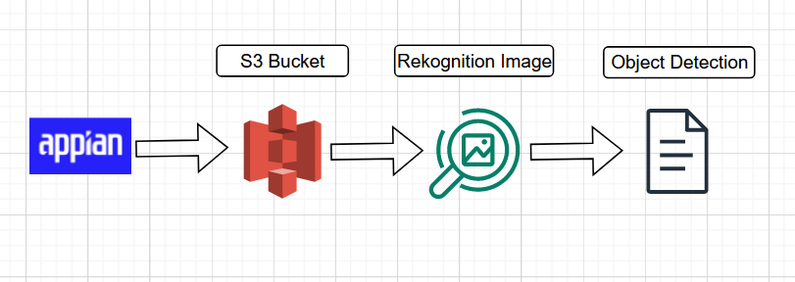

Demo flow
https://youtu.be/b9wu742W0QI

