README
S3 UI Upload Component Plug-in

Configure AWS
Below are example instructions on how to configure your AWS account to use Cognito for authentication and access to S3 buckets. Please note this is strictly an example and not officially recommended for a production environment.
- Grant Amazon Cognito access to your AWS account
- Configure Cognito
  - Create an identity pool. Example: cle-s3-identity-pool
  - Create an IAM role that will allow users to upload objects to S3. The role is where you specify maximum session duration. Example: cle-s3-anonymous-guest-user
  - Attach the IAM role to the Cognito identity pool
- Attach appropriate S3 policy to role. Example: attach policy cle-s3-cognito-access to role cle-s3-anonymous-guest-user
- Configure S3
  - Update or create an S3 bucket. Example: christina000bucket
  - Update bucket policy to allow IAM role access. Example: allow the role cle-s3-anonymous-guest-user to access the bucket christina000bucket
Figure 1. Example S3 Bucket Policy
{
"Version": "2012-10-17",
"Statement": [
{
"Sid": "PublicReadGetObject",
"Effect": "Allow",
"Principal": "*",
"Action": "s3:GetObject",
"Resource": "arn:aws:s3:::christina000bucket/*"
},
{
"Sid": "AnonymousGuestUpload",
"Effect": "Allow",
"Principal": {
"AWS": "arn:aws:iam::<ACCOUNT_NUMBER>:role/service-role/cle-s3-anonymous-guest-user"
},
"Action": "s3:*",
"Resource": "arn:aws:s3:::christina000bucket/*"
}
]
}

  - Update the CORS policy on the S3 bucket to allow the Appian site urls (both the main url and the dynamic url). This allows the component plug-in to work with AWS
Figure 2. Example CORS Policy
[
{
"AllowedHeaders": [
"*"
],
"AllowedMethods": [
"HEAD",
"PUT",
"POST",
"DELETE",
"GET"
],
"AllowedOrigins": [
"https://<YOUR_APPIAN_SITE>.appiancloud.com",
"https://<YOUR_APPIAN_SITE>.appiancloud-dynamic.com"
],
"ExposeHeaders": [
"ETag"
]
}
]


Screenshots
- Figure 3. Select File
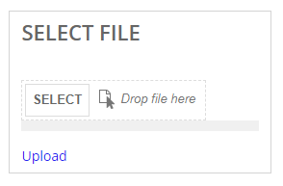
- Figure 4. Loading Bar
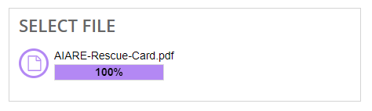
- Figure 5. Example SAIL code
