MS Outlook

MS Outlook can send emails on behalf of users or organizations, without requiring direct access to user credentials. By using the Oauth 2.0 protocol, developers can obtain an access token that allows them to securely authenticate and authorize their applications to access and send emails through the Graph API. This approach provides a more secure and user-friendly way to interact with the email system, while also providing a rich set of features for customization and automation of email sending workflows. This can be particularly useful for organizations that need to send large volumes of email, or for developers who want to create custom email applications or integrations.

Steps to be followed in Azure account :
- Login to your Azure account in the Azure portal.
- In the portal menu, click on ‘Azure Active Directory’.
- Click on the ‘App Registration’ and create a new app by using ‘New Registration’.
- You will find the Client ID within the app.
- Click on the ‘Certificates and Secrets’ option to generate a new client secret.
- In the ‘API permissions’ option, click on ‘Add permission’ and select the Microsoft Graph API.
- Select the necessary permissions needed by referring to the documentation.
- To use the On Behalf of operation the recipient of the email has an indication in their email client that the message was sent by the user of your application on behalf of another user. To know about the necessary permissions kindly refer the documentation.
- Administrators can update the from user's mailbox to always save a copy of messages sent from a delegate to their Sent Items.

- By setting the saveToSentItems property to false in a send mail request, you can prevent the item from being saved to the Sent Items folder. However, if an administrator has configured the "always save a copy" setting, the message will still be saved to the from user's Sent Items.

Functionality Provided :

Send Email
  - Sending simple emails with To, on Behalf Of(From),Cc and Bcc .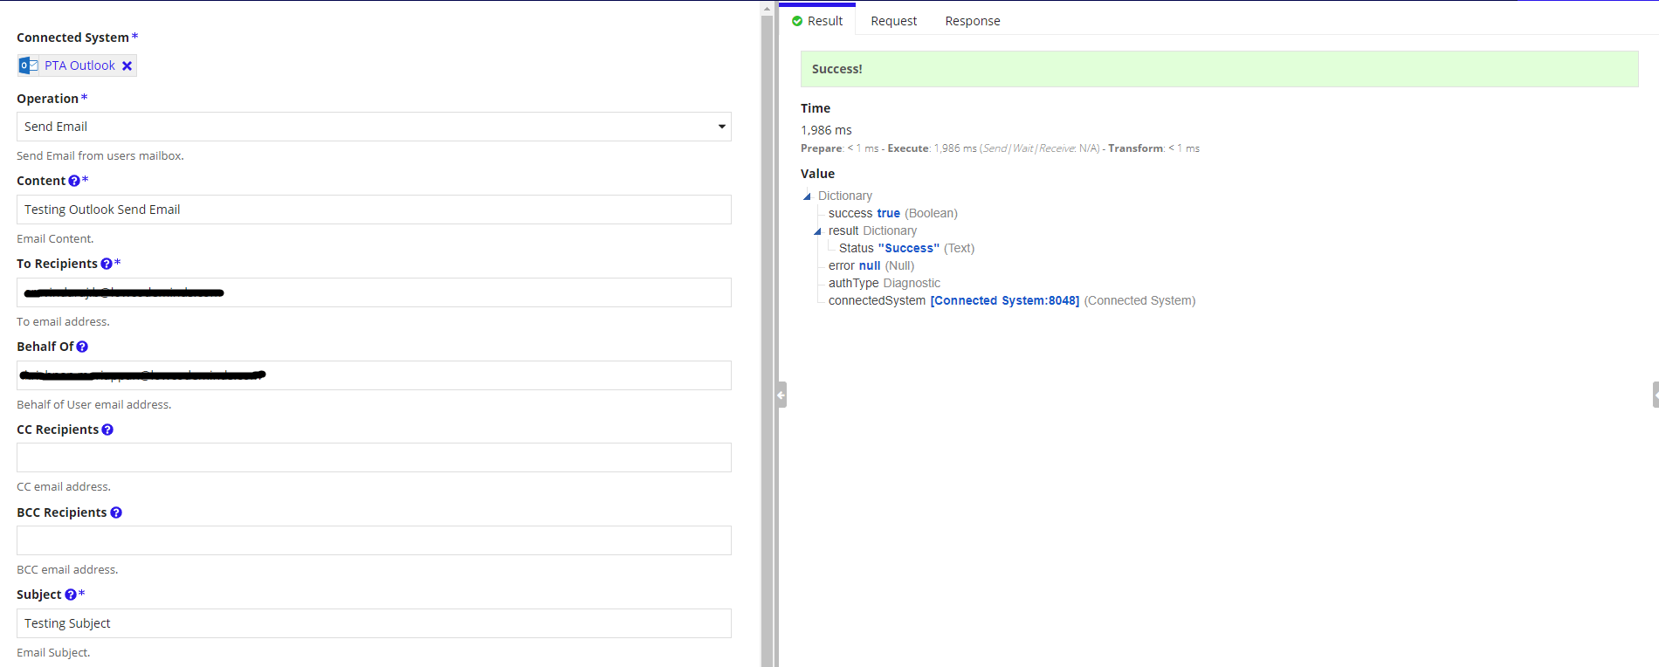

Send Email With Attachment
  - Sending emails along with attachments with all other provisions as in ‘Send Email’.
  - 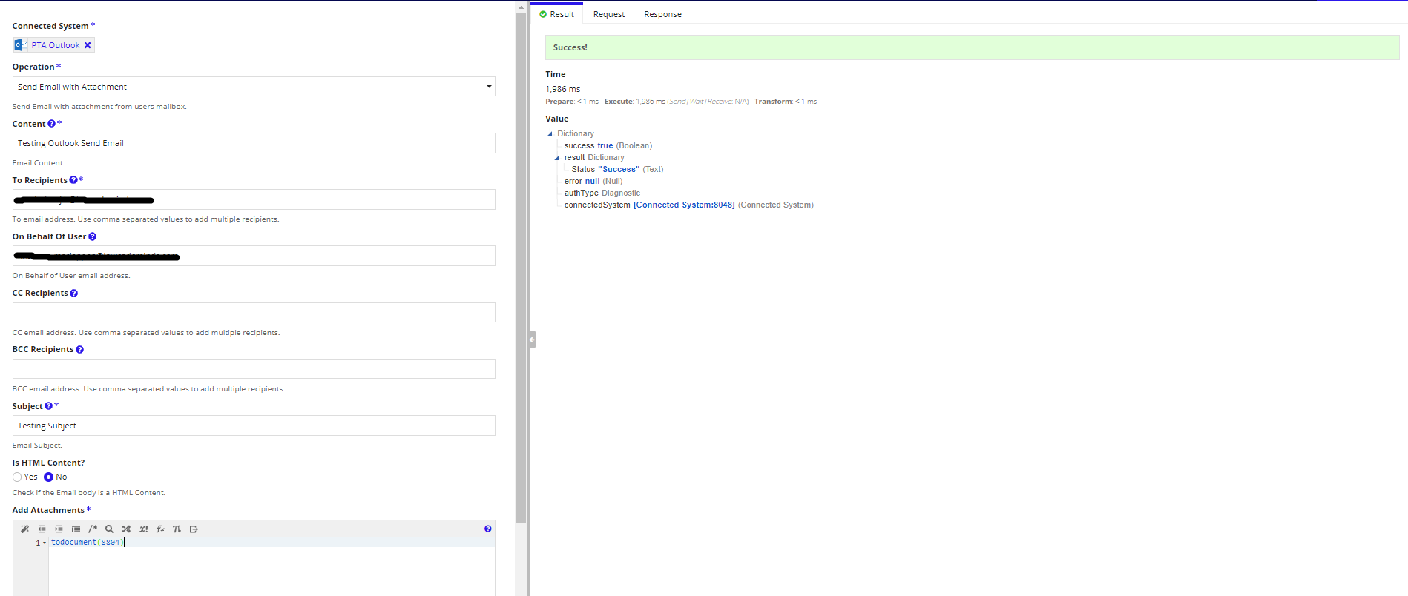

Limitations:
Sending email with attachments supports multiple files with total size not exceeding 25MB.

