Gantt Chart Component Plugin
Overview
The Gantt Chart Component can be used on Appian interfaces where you want to show a visual representation of a project schedule that allows you to visualize tasks and activities over time, whether it's by date, month, or year. It displays tasks or activities along a horizontal timeline, with each task represented by a bar. The length of the bar represents the duration of the task, while its position indicates its start and end dates.
With this component you can add projects, tasks, dependencies, customize styles etc.
Key Features& Functionality
- Time Format Options: Allow users to choose between hourly, daily, weekly, monthly, or yearly views for task display.
- Toggle Task List: Provide a toggle to show/hide the task list for more focused viewing.
- Custom Colours: Enable users to select custom colours for task bars and highlights.
- Task Types: Support different task types (project, milestone, task) with distinct visual representations.
- Progress Display: Show task progress visually within task bars, using progress bars or shading.
- Dependencies: Display visual lines connecting dependent tasks on the Gantt chart.
- More details and examples available in attached resources and sample application.

Parameters:
Parameter | Keyword | Type | Description
Label | label | Text | Text to display as the field label.
Label Position | labelPosition | Text | Determines where the label appears. Valid values:  "ABOVE" (default) Displays the label above the component.  "ADJACENT" Displays the label to the left of the component.  "COLLAPSED" Hides the label. The label will still be read by screen readers; see accessibility considerations for more information.  "JUSTIFIED" Aligns the label alongside the component starting at the edge of the page
Instructions | instructions | Text | Supplemental text about this field.
Help Tooltip | helpTooltip | Text | Displays a help icon with the specified text as a tooltip. The tooltip displays a maximum of 500 characters
Required | required | Boolean | Determines if a value is required to submit the form. Default: false.
Disabled | disabled | Boolean | Determines if the field should display as potentially editable but grayed out. Default: false.
validations | validations | List of Text String | Validation errors to display below the field when the value is not null.
Height | height | Text | Determines the layout height. Valid values: "SHORT", "MEDIUM", "TALL", "AUTO" (default).
Show When | showWhen | Boolean | Determines whether the component is displayed on the interface. When set to false, the component is hidden and is not evaluated. Default: true.
Tasks Value | tasksValue | List of Dictionary | Object (Please refer the task value structure section)
Tasks SaveInto | tasksSaveInto | List of Save | One or more variables that are updated with the tasks value when the user changes it. Use a!save() to save a modified or alternative value to a variable.

Tasks Structure
The task value dictionary has the following support elements.

Parameter | Required | Type | Description
id | yes | Text | Unique text value
name | yes | Text | Name in Text
start | yes | Date | Start Date (YYYY-MM-DD)
end | Depend | Date | End Date (YYYY-MM-DD
type | yes | Text | Valid values are project, task, milestone
progress | no | Text | Completion % of Task
dependencies | no | List of Text | Dependent tasks ids. Should be given as array (eg:- {‘id1,”id2”}
styles | no | Object | Should be valid hexa decimal value and accepted format is  “styles” : {  “backgroundColor”: “#eb4034”,  “backgroundSelectedColor”:  “#eb4034”,  “progressColor”:  “#eb4034”,  “progressSelectedColor”: “#eb4034”  }  Or can include the required styles from the SAIL interface.  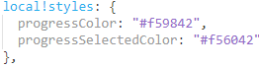
project | Depend | Text | Task project name
isDisabled | no | bool | Disables all action for current task.

Demo Application Provided for the Testing Purpose

In the Project section select the below options
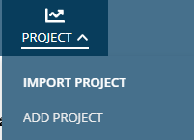
1. Import project (You can go to the project->import project in the demo application to explore).
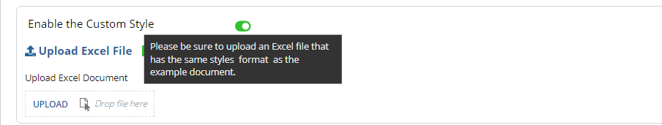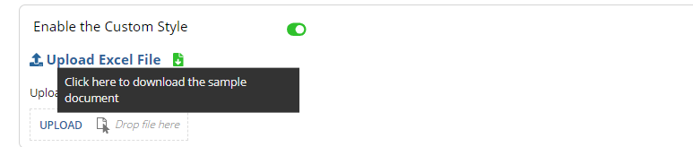
2. Add project (You can go to the project -> add project in the demo application to explore)
Fill out the details in the project details section and add a few tasks to see the Gantt chart display. Here the dependencies are added choose completed tasks before the current task.

Note: -
following plugins are used in the demo application com.appiancorp.ps.solutions
Appian Solutions Plugin
1.36.1
Slider Component
1.1.3
Ex1:-
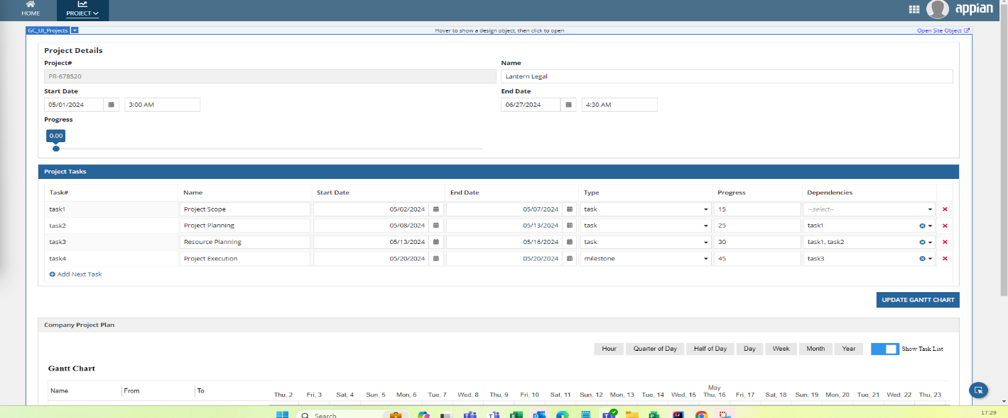
Ex2:-
