Advanced Rich Text Editor Connected System:

Allows users of the rich text editor component plug-in to upload images and have them be stored in the Appian document management system to export the content as Pdf and store them in Appian and return the corresponding document Id.

Companion Connected System plug-in which enables image uploads and pdf exports within the Rich Text Editor component plug-in exp(https://community.appian.com/b/appmarket/posts/rich-text-editor-vuram).

Note: This plugin does not support the conversion of characters to PDF that are not in English.

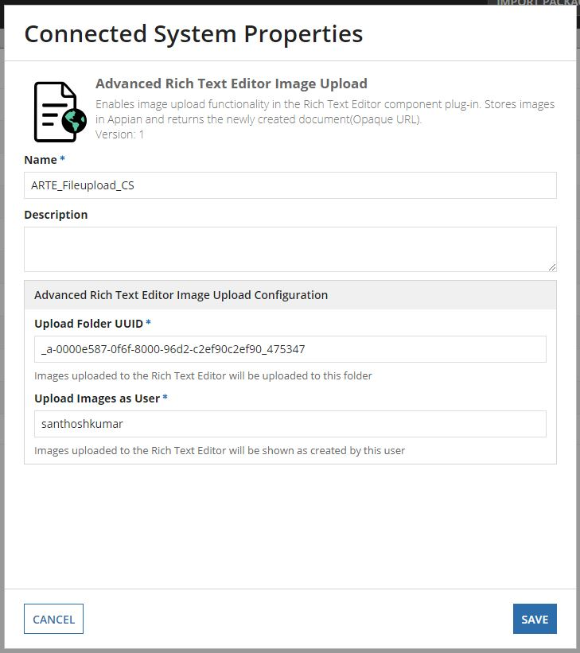

Upload Folder UUID - The folder uuid to which the exported pdf to be saved.

Upload Images as User - The username of the user.

