Linkedin Connected System

Connected System to post contents to LinkedIn.
Authentication type : OAuth 2.0 Authorization code.

Required fields : ClientID and ClientSecret.
(Configure your application in the Developer Portal to obtain Client ID and Client Secret.)

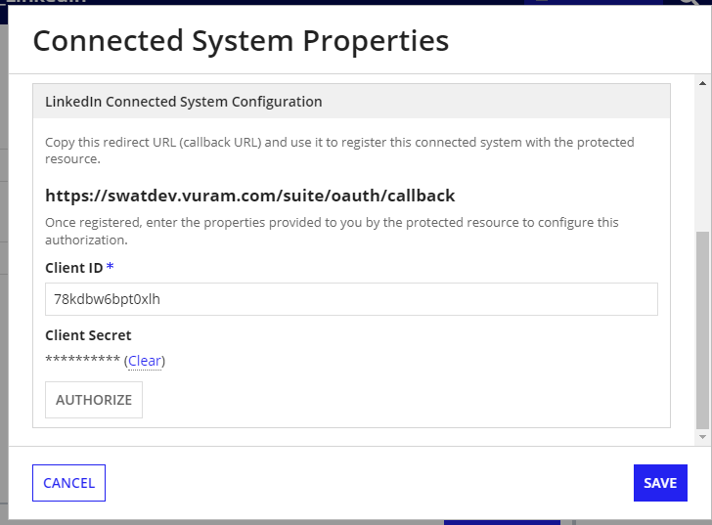

How to get ClientID and ClientSecret -

Login into Linked developer portal and create new app using this URL - https://www.linkedin.com/developers/apps/new

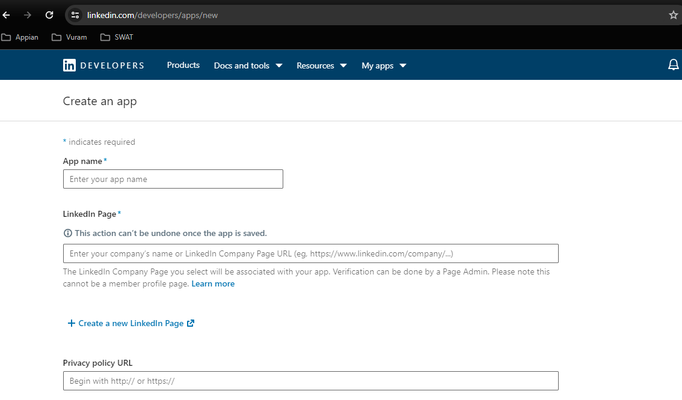

Enter the necessary details and create Application.

In the My Apps section select the latest created Application:

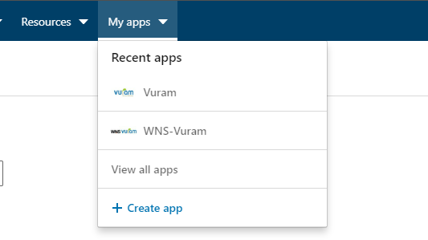

In the newly created application select the Auth section:

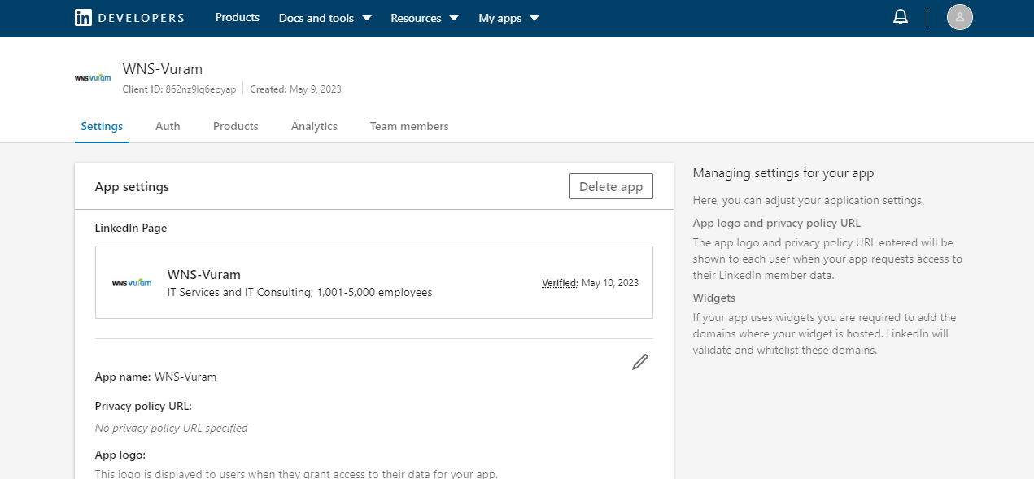

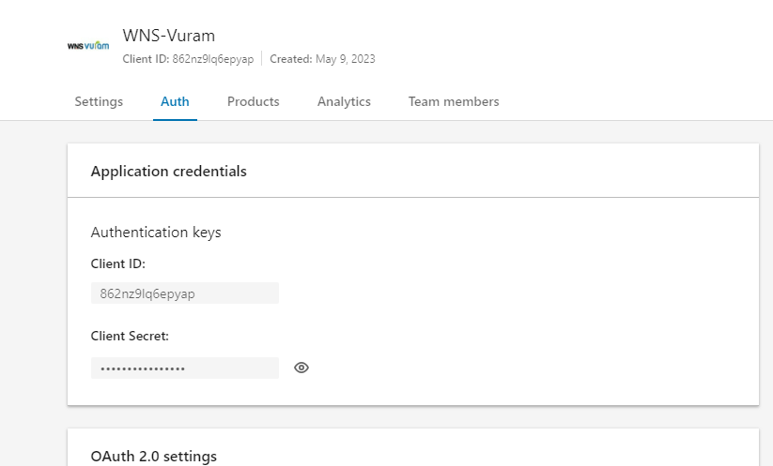

In the Auth sections you can see the Client ID and Client Secret for authentication.

How to Get LinkedIn API Version:

https://learn.microsoft.com/en-us/linkedin/marketing/integrations/community-management/shares/videos-api?view=li-lms-2023-11&tabs=http

Latest API version can be given as ex: “202301”(January 2023) - “YYYYMM”.

API versions will be deprecated. So it must be updated. Please check the above link for latest API version.

Integrations Available:

- Get User Details -

Gets the User information from Linkedin:

Field Name | Description | Format
ID | The member's unique identifier | Person URN
firstName | Member's first name | Text
lastName | Member's last name | Text
profilePicture | Member's profile picture URL | Text

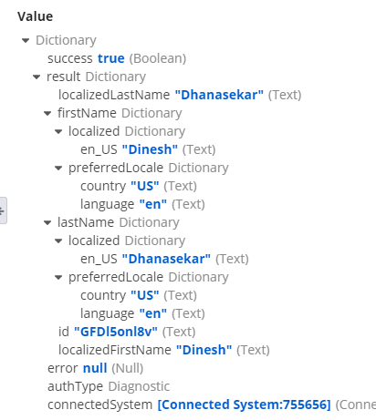

- Create Text Post

Create text post on linkedin page.
Require fields: Text( post content).

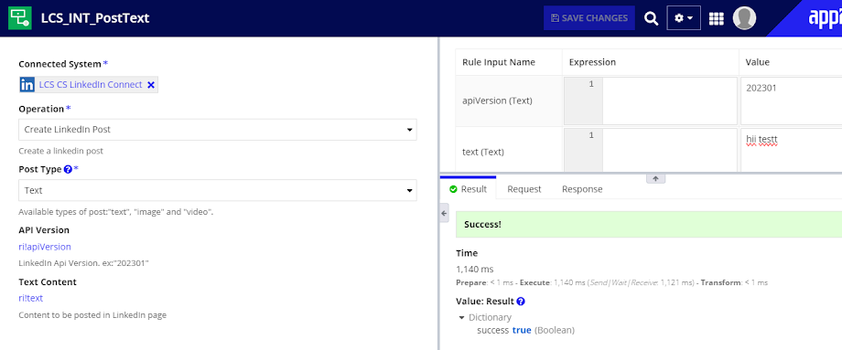

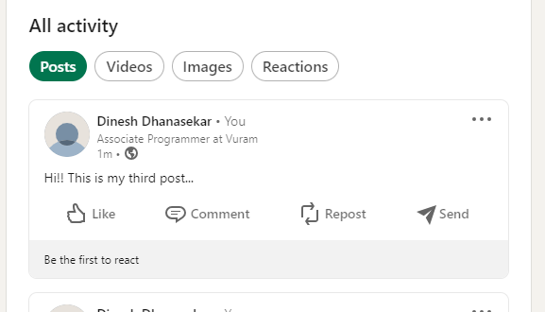

- Create Image Post

Create image post on linkedin page.
Require fields:
File- Image to post
Title - heading for the post

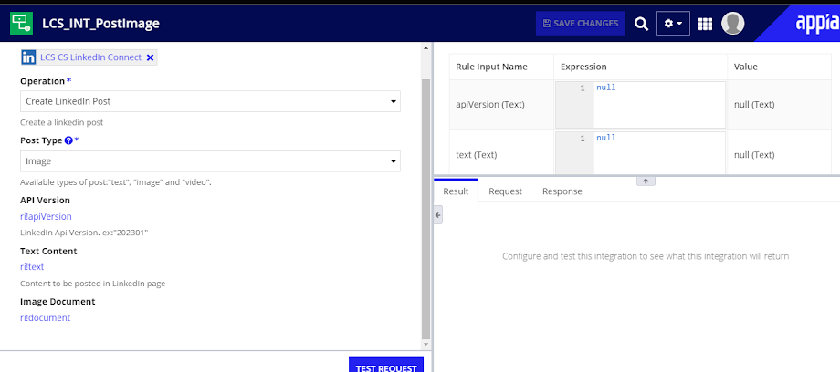
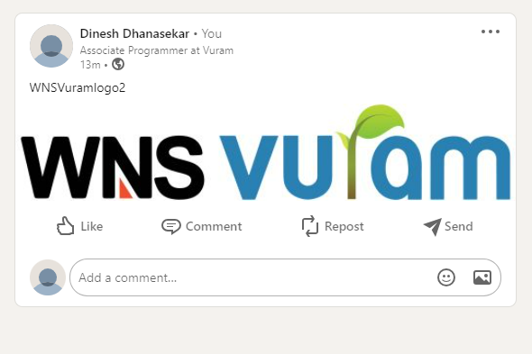

- Create Video POST:

Create Video post on LinkedIn page:

Required Fields:
Title: Title of the content
Video: Video document(.mp4 file within 50 mb)

