 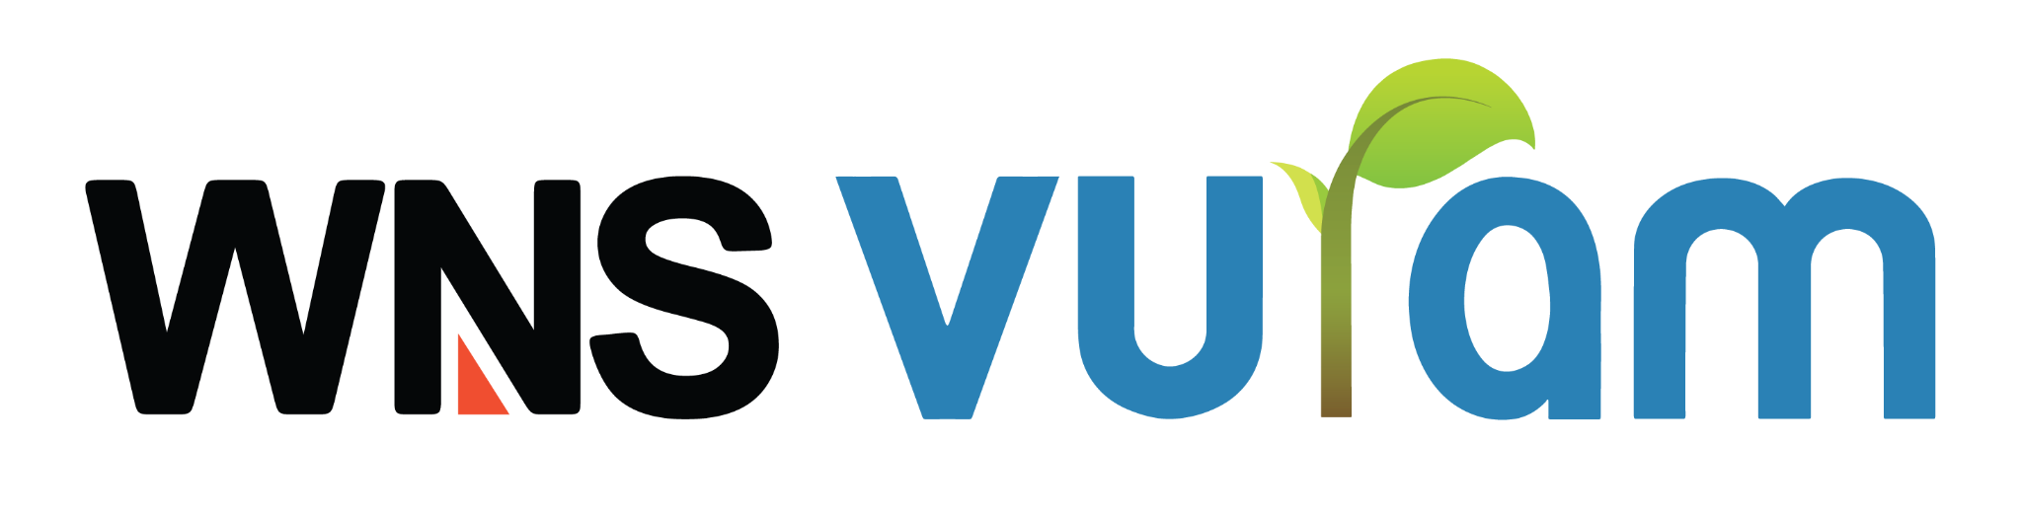

**E-mail Classification**

The RPA Bot accepts the username, App password, folder names, and keywords as inputs provided by the user. If both the username and password inputs are valid, the bot connects to Gmail through the properties for connecting to an IMAP email server using JavaMail. Then it reads the inbox messages of the Email and checks the keywords that are provided by the user and creates a folder by corresponding folder name given by the user. The bot also manages all negative scenarios and ensures a safe failure, guaranteeing exception-free automation.

**Methods:**

**1. Email Authentication:**

This method is used to get the username and password as input from the user. The entered username and password are validated through properties for connecting to an IMAP email server. If they are correct, the method accesses the respective Gmail account. In the event that the user provides incorrect credentials, a validation message of "Not Connected" is displayed. Negative scenarios related to the response body are also managed appropriately.

**2. Classify Emails:**

This method will get the folder name and keywords as inputs from the user. Then the method searches the email subject to determine whether the keyword is present in the subject or not. If the email subject includes the keyword, the process proceeds to move the email to the designated folder.

**Workflow :**

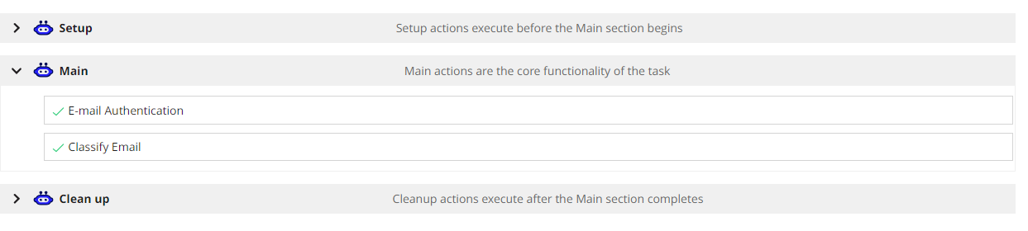

**Inputs :**

All the inputs are required for the bot to start. These inputs and how it has been given are described below.

1. **host –** The domain of the mail which we are conencting (Gmail)
2. **credentialName** - The credential name in the Appian RPA console, where the email id and its respective app password are stored.
3. **keywords** - If you wish to create multiple folders using multiple keywords, input them in a comma-separated format.
4. **folderName** - Similarly, provide the folder names in a comma-separated format, matching the order of the keywords. The bot will use this information to move corresponding emails to the appropriate folders.

**The sample Input screen is given below:**

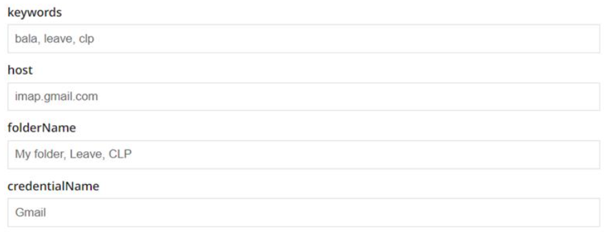

**Example output :**

The email messages have been moved into their respective keyword categories.

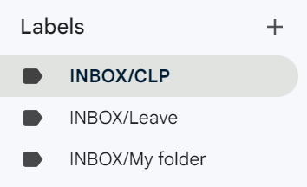

**PreRequisites :**

As already mentioned, the bot will take the App password of the email id to connect with the API. The App password is not the same as the Email Password. If the email password is given as an input , then the bot shows an error message as not connected . The password must be the App password of the respective email account.

The steps to create the app password for your account are as follows :

1. **Create App password for Google Account :**
2. Login and go to “ <https://myaccount.google.com/security> ”.
3. Check whether your account has 2-step verification enabled. If not, enable 2-step verification for your account.
4. After enabling it, use the search box to find "App Passwords" .

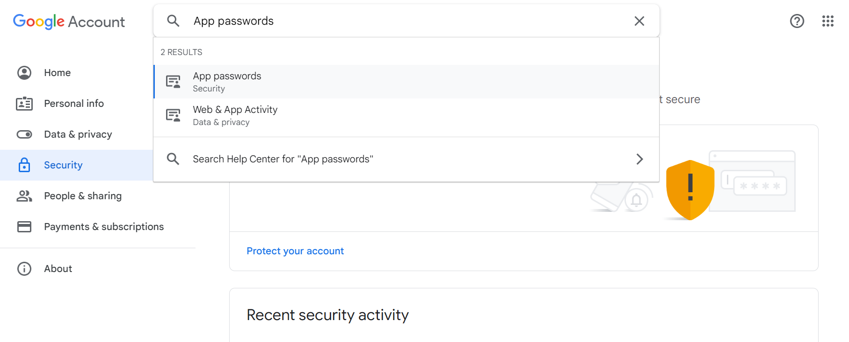

1. Provide your account password to verify your identity.
2. Select the app and device for which you want to generate an App password and click Generate.

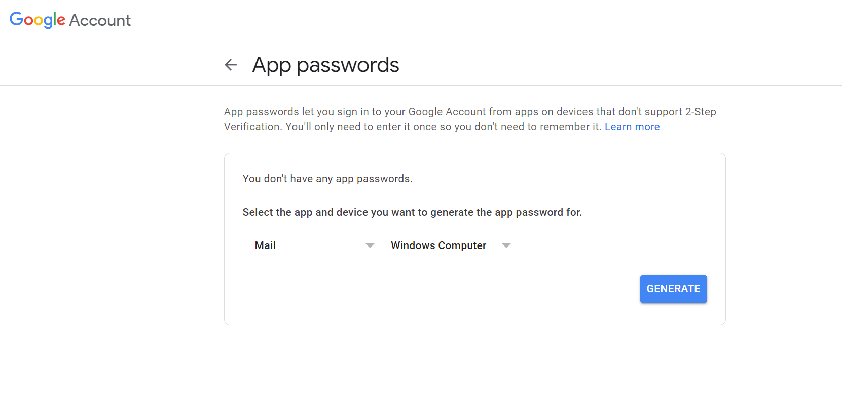

1. Your app password will be created and it shows a dialog box with your app password.

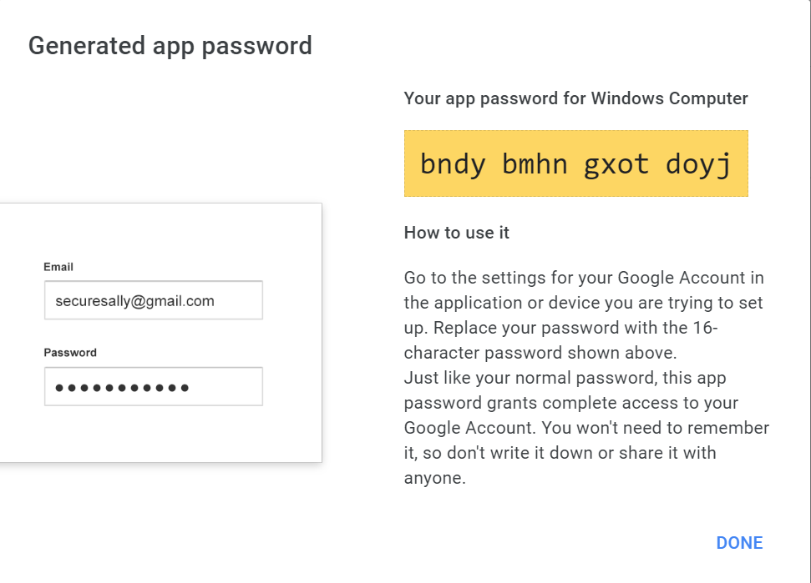

1. Copy and paste the app password in the input(password) of the Bot.

**2. Create App password for Outlook Account :**

1. Login to the Outlook mail, click on your profile and go to my profile settings

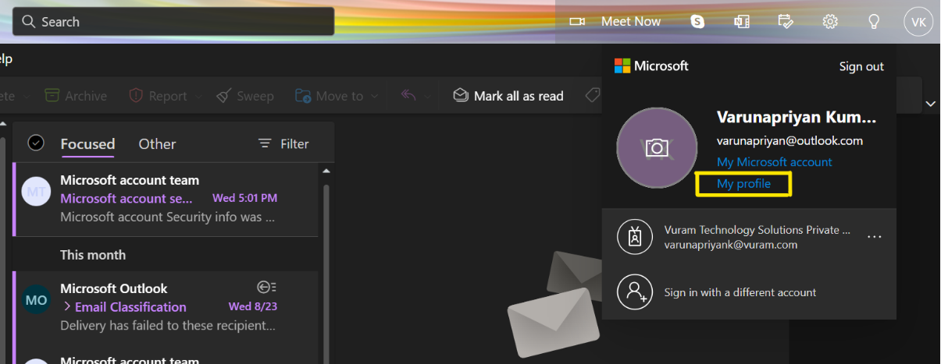

1. Click on the security tab on top

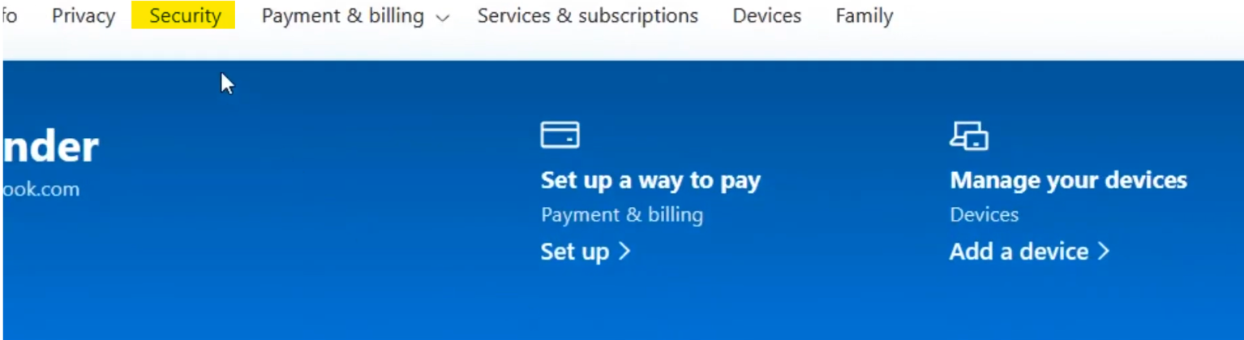

1. Setup the two factor authentication
2. After setting up the two factor authentication, Go to the security tab and scroll down to the App password section and click on “Create new app password”

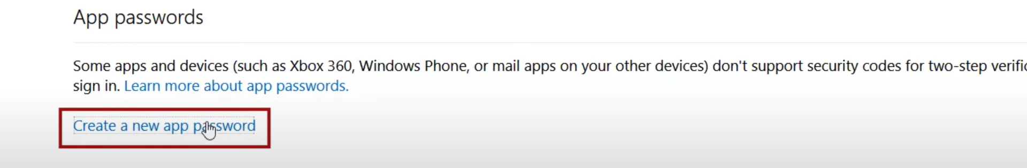

1. The app password will be created and will be displayed in the tab

