Draw BPMN Diagram Component

The bpmn.js is a JavaScript library that allows you to embed BPMN (Business Process Model and Notation) diagrams in web applications. BPMN is a standard for representing business processes graphically, providing a visual notation that is easily understandable by both business and technical users.

The bpmn.js is built on top of the BPMN 2.0 specification and provides a set of tools and utilities for working with BPMN diagrams. With bpmn.js, you can create, view, and edit BPMN diagrams in a web environment. It supports rendering BPMN diagrams in various shapes and styles, and it provides an interactive interface for users to manipulate and interact with the diagrams.
Function : bpmnDiagramField()
By using this component the user can draw a BPMN diagram in the given work area and by clicking on the save button the diagram will be saved as bpmn or svg in the Appian Folder specified in the Document Management Connected System and the Document Id will be saved in the Diagram Id saveInto parameter.If you have to prepopulate the diagram use the default diagram parameter use bpmn format not svg.

NOTE:
- Use the Document Management Connected system to store and retrieve diagram from Appian Folder.

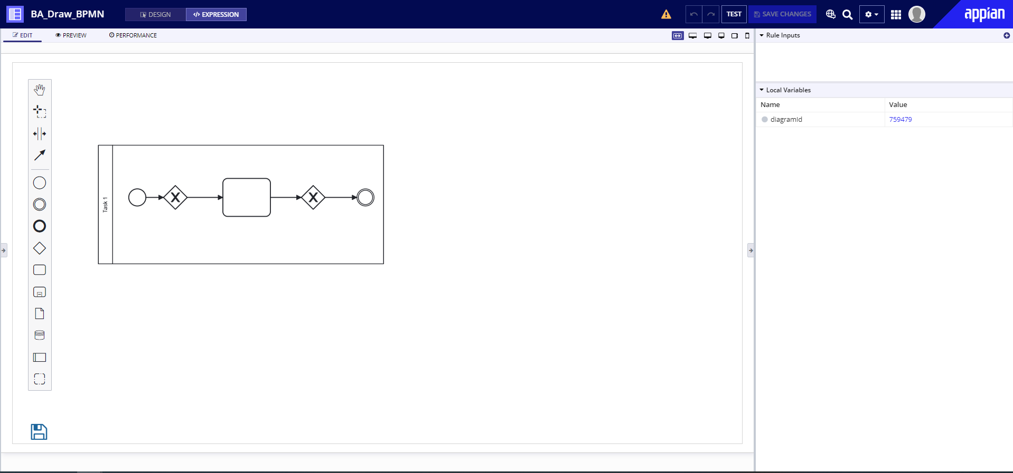

Parameters

Name | Keyword | Type | Description
Label | label | Text | Text to display as the field label.
Label Position | labelPosition | Text | Determines where the label appears. Valid values: “ABOVE” (default), “ADJACENT”, “JUSTIFIED”, “COLLAPSED”.
Height | height | Text | Determines the layout height. Valid values: “SHORT”, “MEDIUM”, “TALL”, “AUTO”.
Default Diagram | defaultDiagram | Number | Provide the documentId of the diagram that should be populated on the component load.(should be in bpmn format)
Image Storage Connected System | imageStorageConnectedSystem | Connected System | Connected system constant for diagram storage and retrieve in Appian. Deploy the following connected system.  Document Management Connected system
Diagram Id | diagramId | List of Save | Returns the documentId of the diagram stored in the Appian.
Save As | saveAs | Text | The diagram should save as bpmn or svg format.Valid inputs are "BPMN" and "SVG".
Diagram Name | diagramName | Text | The name of the diagram to be saved in the Appian folder.

Notes:

- Supported Browsers - Google Chrome, Edge.
- Supported Language - English (United States).
- Update the connected system parameters in the Demo application.

Example
Copy and paste the example into the INTERFACE DEFINITION in EXPRESSION MODE to see how it is displayed.

bpmnDiagramField(
label: "BPMN Diagram Field",
labelPosition: "ABOVE",
validations: {},
height: ri!height,
defaultDiagram: ri!defaultDiagram,
imageStorageConnectedSystem: cons!BA_BPMN_CS,
diagramId: local!diagramId,
saveAs: ri!saveAs,
diagramName: ri!diagramName
)

