Timer Component:
Function : stopWatchField()
The Timer component can be used on Appian screens for applications where Appian actions are time bound. For example, tasks with a deadline can monitor time taken in completing the form or action in Appian applications.
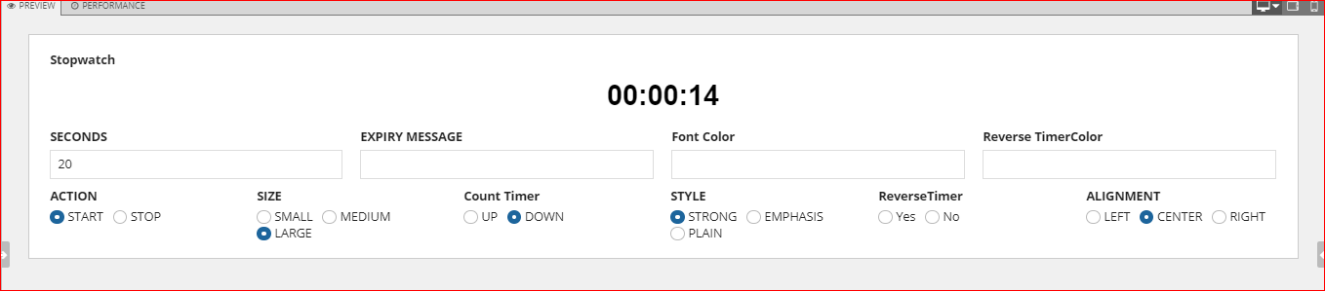

Parameters

Name | Keyword | Type | Description
Label | label | Text | Text to display as the field label.
Label Position | labelPosition | Text | Determines where the label appears. Valid values: “ABOVE” (default), “ADJACENT”, “JUSTIFIED”, “COLLAPSED”.
Height | height | Text | Determines the layout height. Valid values: “SHORT”, “MEDIUM”, “TALL”, “AUTO” (default).
Action | action | Text | Determines the action of the component. Valid values: START, RESET,STOP.
Size | size | Text | Determines the size of the component. Valid values: STANDARD (Default), SMALL, MEDIUM, LARGE.
Align | align | Text | Determines the alignment of the component. Valid values: LEFT(Default), RIGHT,CENTER.
Expired Message | expiredMessage | Text | Determines the expiry message of the component.
Color | color | Text | Determines the timer color of the component. Valid values: Any valid hex color or “STANDARD” (Default), “ACCENT”, “POSITIVE”, “NEGATIVE”, “SECONDARY”.
Style | style | Text | Determines the style of the component. Valid values: STRONG, EMPHASIS.
Timer Direction | timerDirection | Text | Determines the timer direction of the component. Valid values are "UP" and "DOWN", Default: DOWN.
Reverse Timer | enableReverseTimer | Boolean | Determines whether the timer needs to reverse after reaching Zero. When it is set to true, As soon as zero is reached, timer value starts to increment automatically. Default: false.
Reverse Timer Color | reverseTimerColor | Text | Determines the timer color when the timer reversed. Valid values: Any valid hex color or “STANDARD” (Default), “ACCENT”, “POSITIVE”, “NEGATIVE”, “SECONDARY”.
Seconds | seconds | Number (Integer) | Determines seconds of the component value. The maximum second range is 86400.

Notes:

- Supported Browsers - Google Chrome, Mozilla Firefox, Internet Explorer11, Edge, Safari.
- Supported Language - English (United States).

Example
Copy and paste the example into the INTERFACE DEFINITION in EXPRESSION MODE to see how it is displayed.

stopWatchField(
label: "Stopwatch",
labelPosition: "ABOVE",
height: "AUTO",

action:"START",
size: "LARGE",
align: "CENTER",
expiredMessage: null,
color:"ACCENT",
style: null,
timerDirection:"DOWN",
enableReverseTimer: null,
reverseTimerColor: "POSITIVE",
secondsValue: "60",
secondsSaveInto:null

)

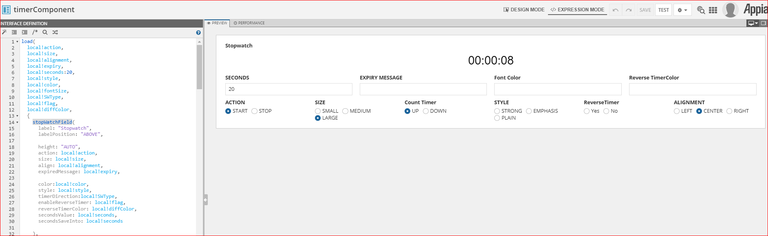

stopWatchField(
label: "Stopwatch",
labelPosition: "ABOVE",
height: "AUTO",
action: "START",
size: "MEDIUM",
align: "CENTER",
expiredMessage: null,
color: "POSITIVE",
style: null,
timerDirection: null,
enableReverseTimer: null,
reverseTimerColor: null,
secondsValue: 60,
secondsSaveInto: null

)

