PDF Annotation Document Access Connected System

Allows users of the PDF Annotation component plug-in to store and retrieve documents to/from the Appian document management system.

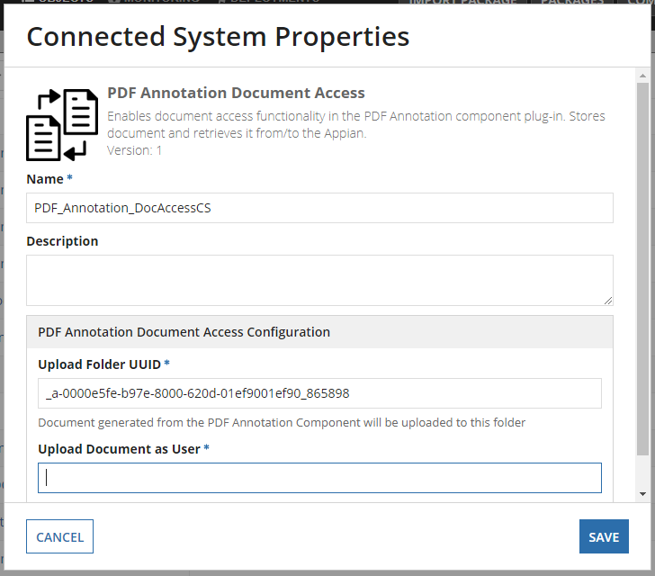

- Upload Folder UUID - Provide the UUID of the folder where the modified document is stored.
- Upload Images as User - Provide the username from Appian users to store and retrieve the document.

