Tableau Connected System

The Tableau Connected System plugin provides authentication to embed views created using Tableau within Appian interfaces. The Tableau Connected System plugin contains the Client APIs for generating the authentication token and querying the views and workbooks.

Note: This plugin requires the Tableau Component Plugin to embed the views from the Tableau environment.

Prerequisites: Requires a registered Tableau user account and requires Connected App to be created and enabled to get the client credentials.

Parameters
- Server URL - The pod URL where the site has been deployed.
- Site ID - The site name to authenticate to.
- Client ID - The client ID value from the Connected App.
- Secret ID - The secret ID value from the Connected App.
- Secret Value - The secret value from the Connected App.
- Username - The registered username in the Tableau Environment. Preferably the admin account.
- Password - The password for the admin account.
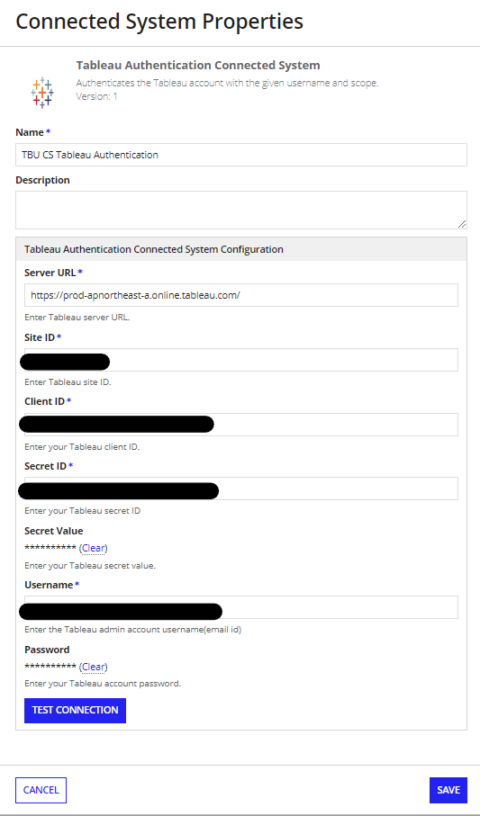

Steps to create Connected App in Tableau Environment
- Login to Tableau environment and navigate to Settings menu.
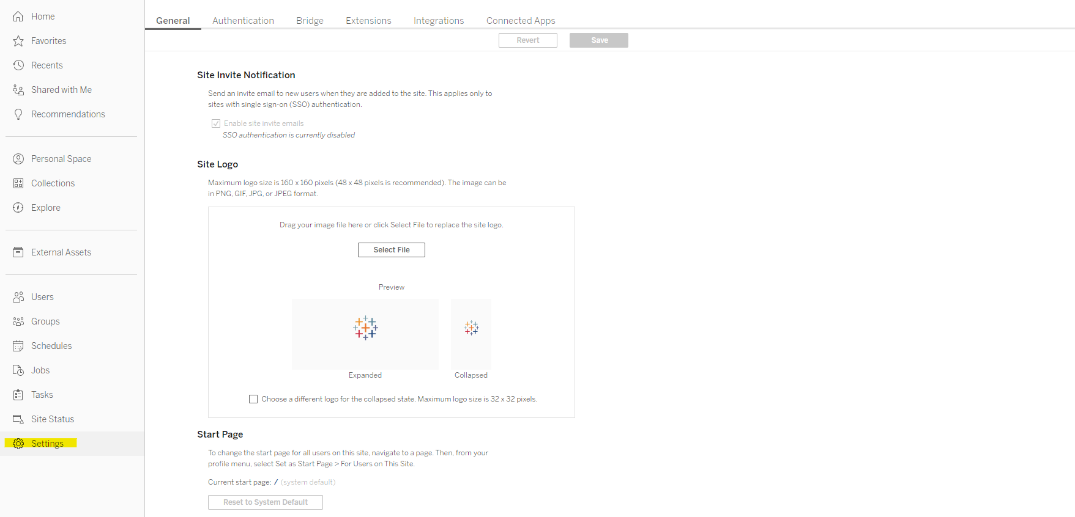
- Under the Settings page select the Connected Apps tab and select - New Connected App button.
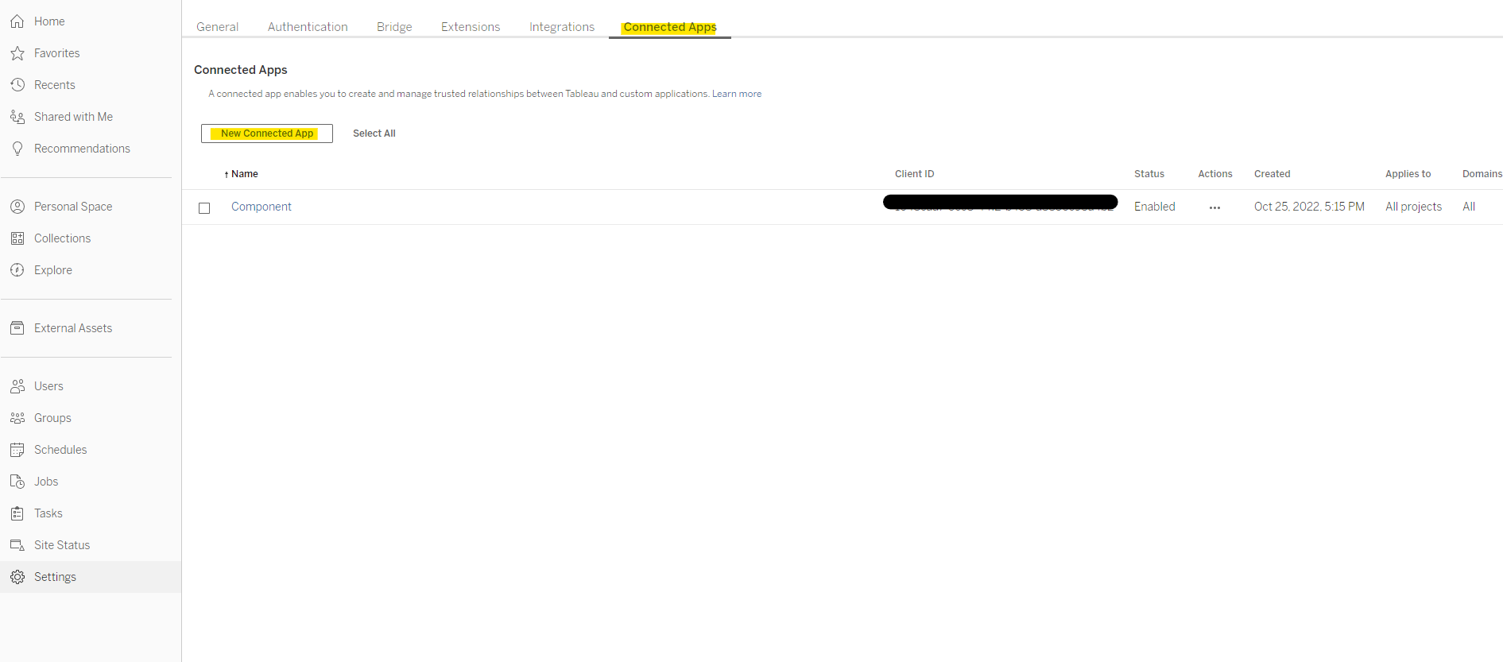
- In the Create Connected App pop-up, provide a name and click on create.
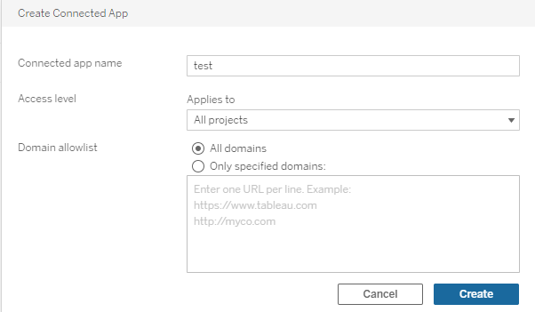
- In the Connected App window, click on Generate New Secret to generate the Secret ID and Secret Value. Copy the credentials (Client Id, Secret ID and Secret Value).
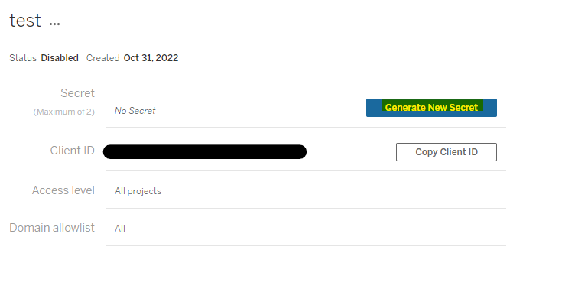

Get The Site ID and Server URL
The Site ID and Server URL can be found in the address bar of the web browser when you login to your site in the Tableau environment. Include https:// with the server URL.

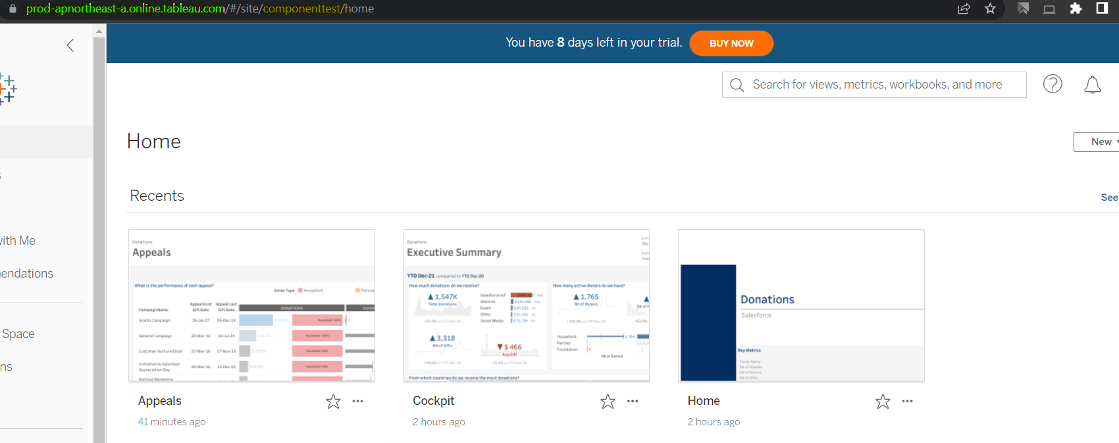

The green highlighted text is the server URL which is the pod name where the server has been deployed when creating the server and the yellow highlighted text is the site ID.

