Before Upload
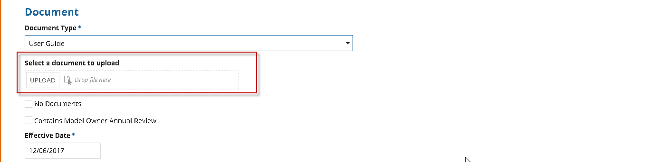
Upload a file Manually

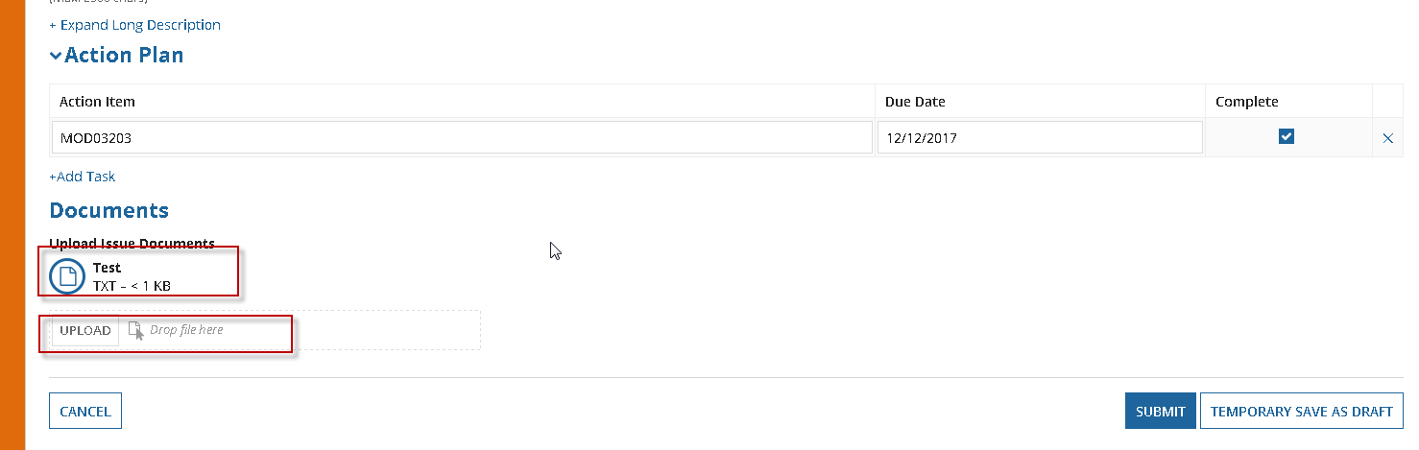
Upload a file through script using the below code
|populate |file_upload |field |Upload Issue Documents|with|${Document_UserGuide} |

