Bar chart displayed properly in Designer
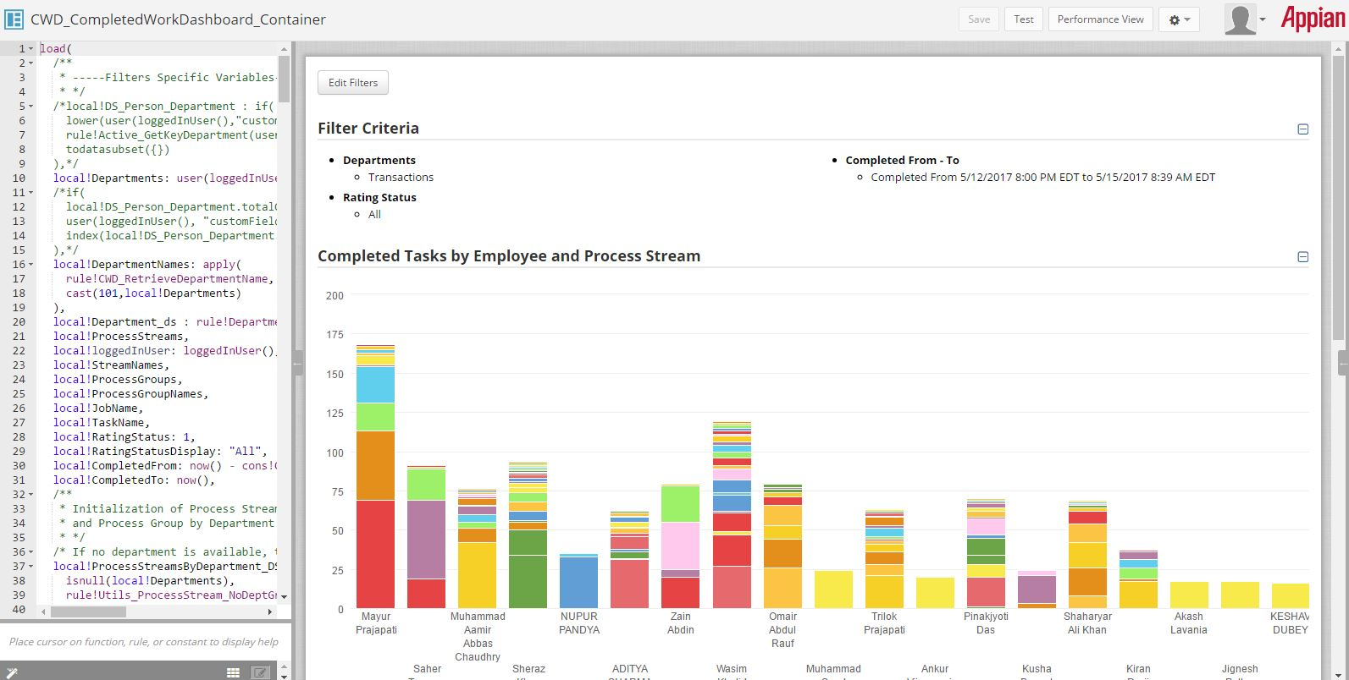

For same filters, the display is incredibly stretched in Tempo
