Task below which I am trying to click
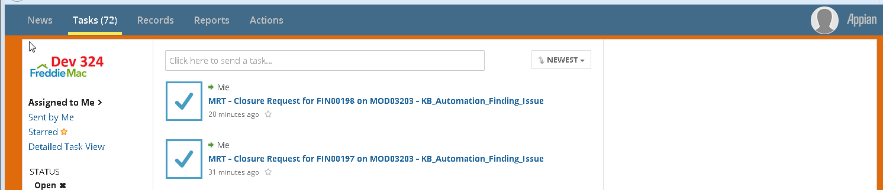

|click on task |MRT - Closure Request for FIN00198 on MOD03203 - KB_Automation_Finding_Issue |
Response from the above script
