Fitnesse

Installation of Fitnesse:
- Click on the below link and download the Fitnesse
https://forum.appian.com/suite/sites/shared-components/page/shared-components/record/lMBCLGOdlMUpdGVqW3dQaIKmclBmvvNEj8vu_cjb7T-5YiPr4Fu8ly5Yj1s09uenE4RYzA8zKyx7eiUh-mlLnOGtjH9N_m16m1I3ZvKT4QezhOWpQ/view/summary
- Extract the zip file into the one of the drives in the system
- Go the location in the unzipped folder FitNesseForAppian\configs
- Open the custom.properties file,
a) Configure the location of unzipped Fitnesse folder for “automated.testing.home”.
Ex: automated.testing.home=D:/FitNesseForAppian
b) Configure the appian version for the system in which you want run the fitnesse for “FITNESSE_FOR_APPIAN_VERSION”.
Ex: FITNESSE_FOR_APPIAN_VERSION=v17.2
- Open the user.properties file,
- Map the list of users and their credentials in the file, which are used for logging into the appian
Ex: testuser1=test1234
List of users for Application and their passwords which we need to configure in user.properties are,
Ex: Note1.Testuser@gmail.com=Test1234
- Click on start.bat which will be present in the FitnesseForAppian folder and you will be prompted with the command prompt as fitnesse started with the port details as below,
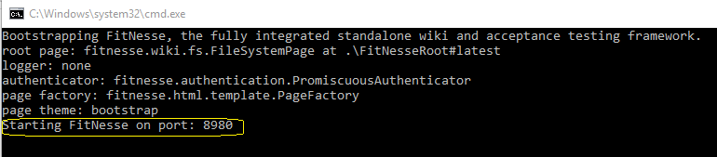
- Open the browser and type localhost:portnumber, for instance localhost:8980
- You will find the Cheat Sheet in which you will find the scripts for fields
- Under Examples you will find one TestExample and one can use it for checking the fitnesse connection
- On top of the page you will find Edit option. Click on “Edit” in order to edit the TestExample script
- You will be directed to the TestExample script page and under that you will find this Initialization part, which you need to configure as per your requisites.
- And later below to this initialization you need to start your script.

- After finishing you script save the script and click on “Test” which will be available on top the saved script

