Seeing below when we hit appian URL:
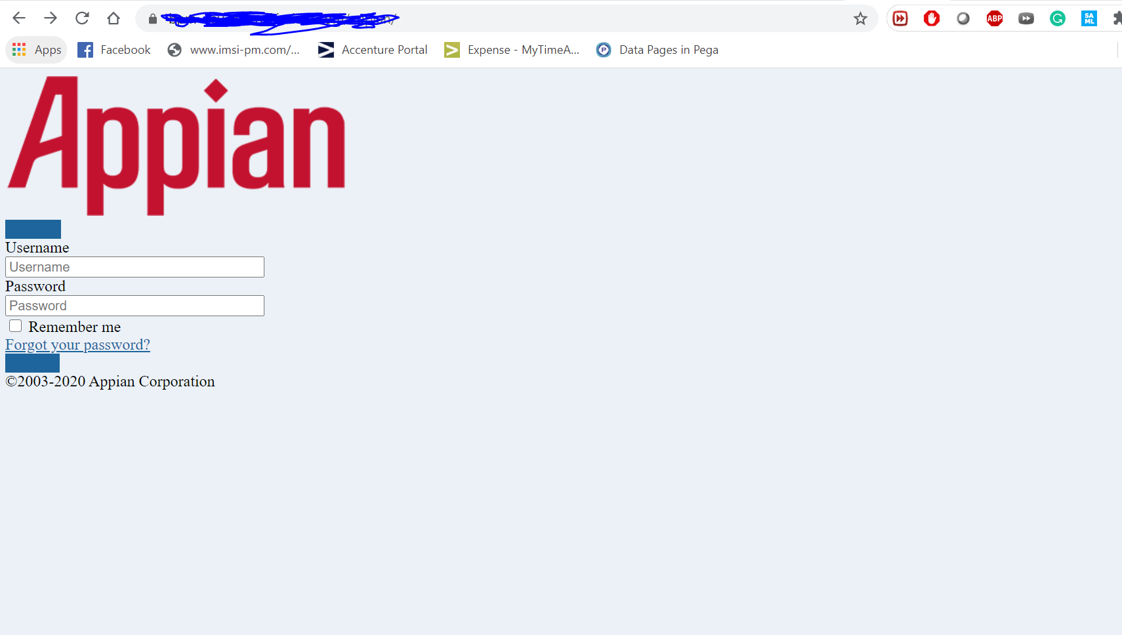
Seeing 404 errors for all the css pages in the Network tab:
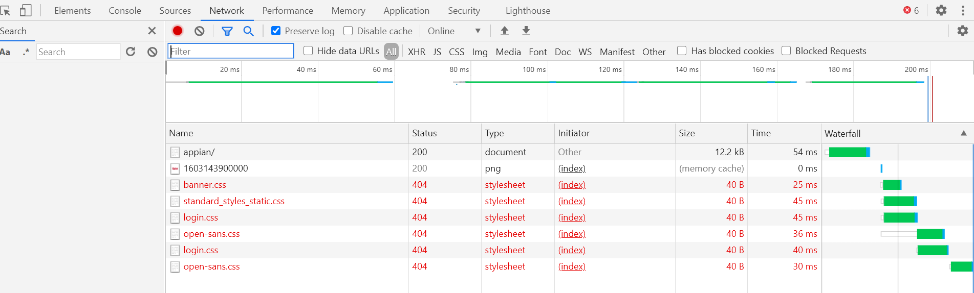

After login:
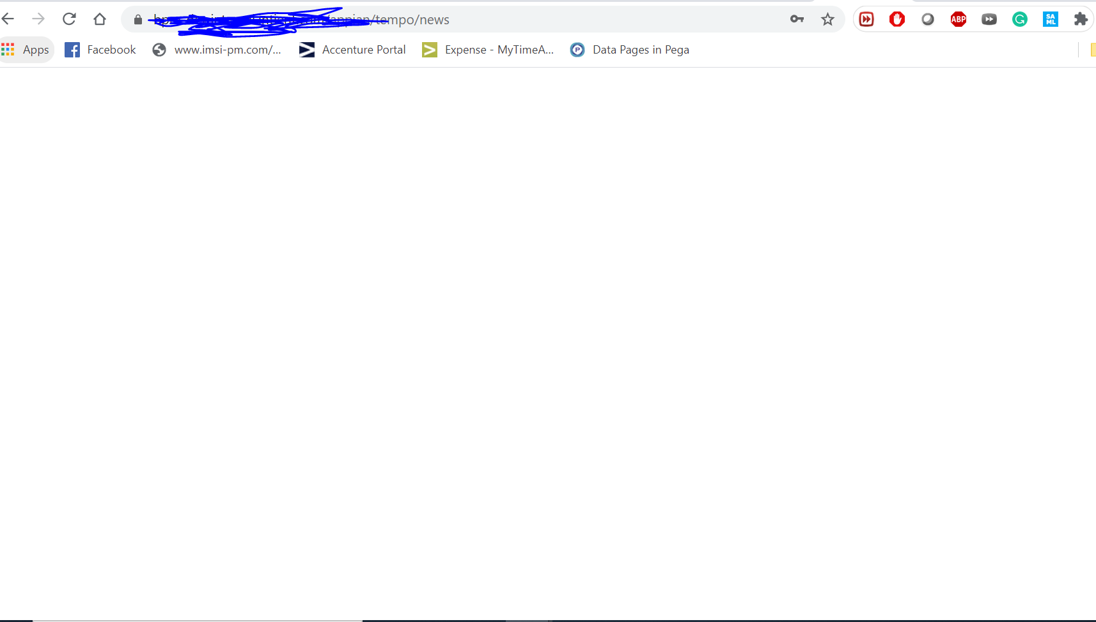
Seeing 404 errors for all the css pages in the Network tab:
