- Ensure that MySQL 5.7 service is running. From Start Menu, type Services, then click on Services.
- Scroll down until you see MySQL57 or MYSQL56(based on which version of MySQL you installed).

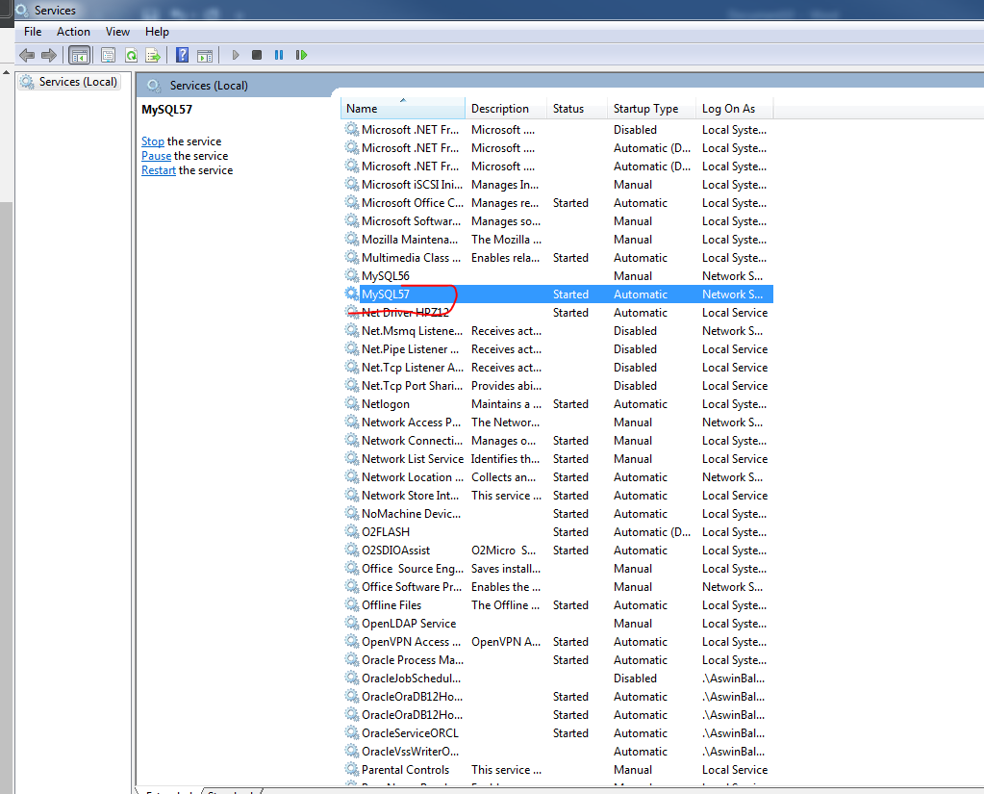

- Open up MySQL Workbench. Then go to Users and Privileges as shown below and then click root on the right side.
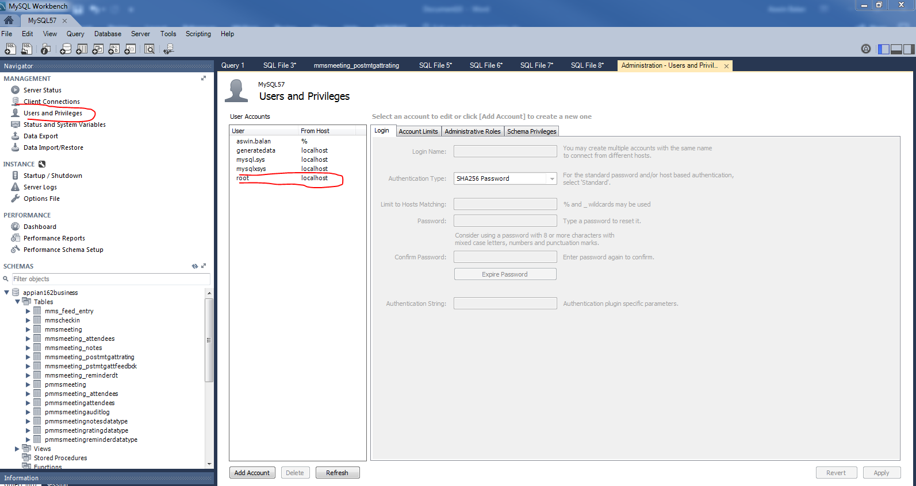

- Then click Schema Privileges and click “Add Entry”.
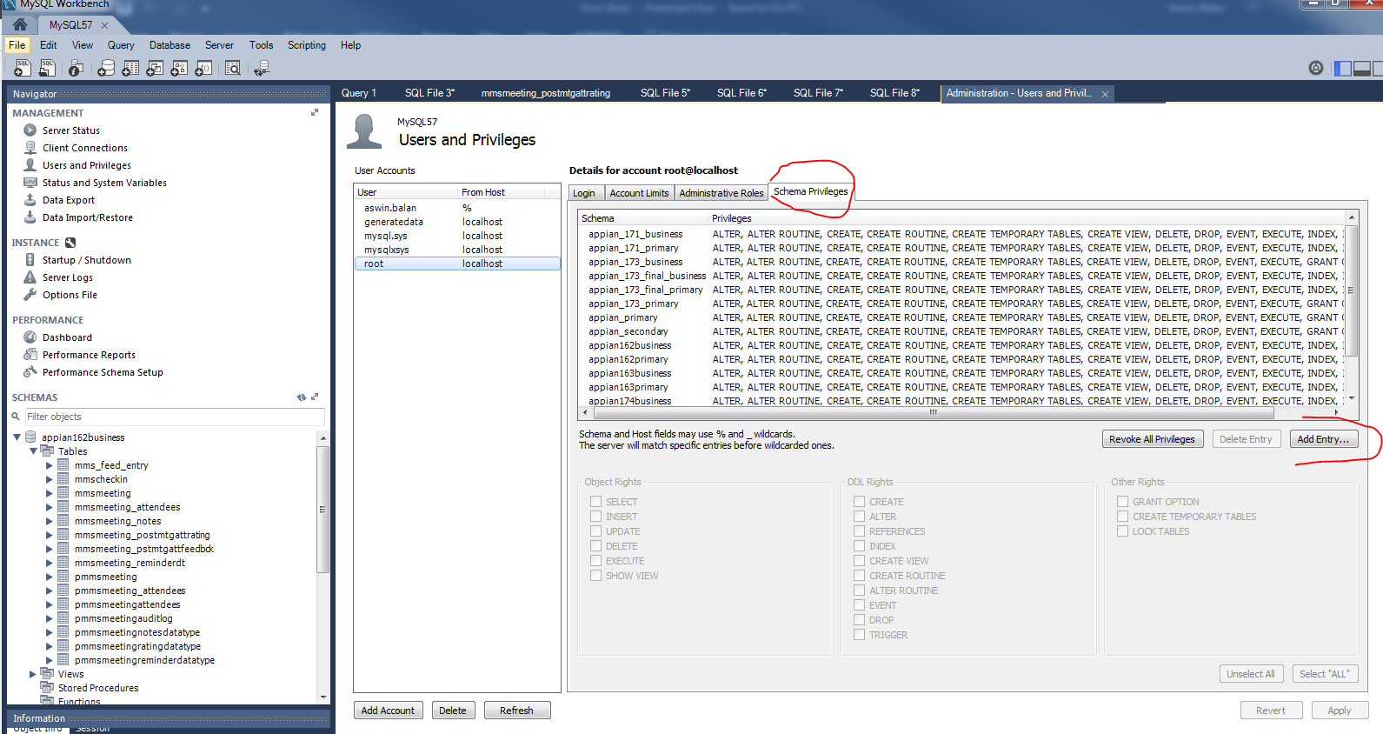

- Click “Selected Schema” and choose “APPIAN_SCHEMA” from the dropdown on the right side and click “Ok”.

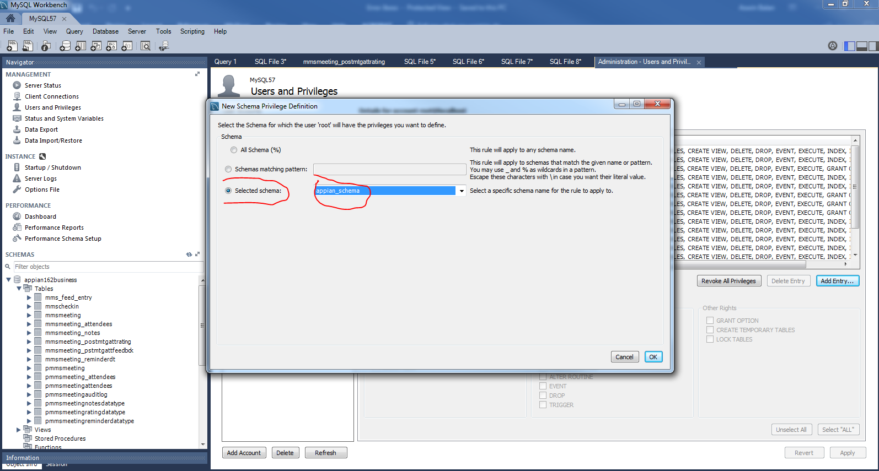

- Do the same thing mentioned in step 5 for BUSINESS_SCHEMA.

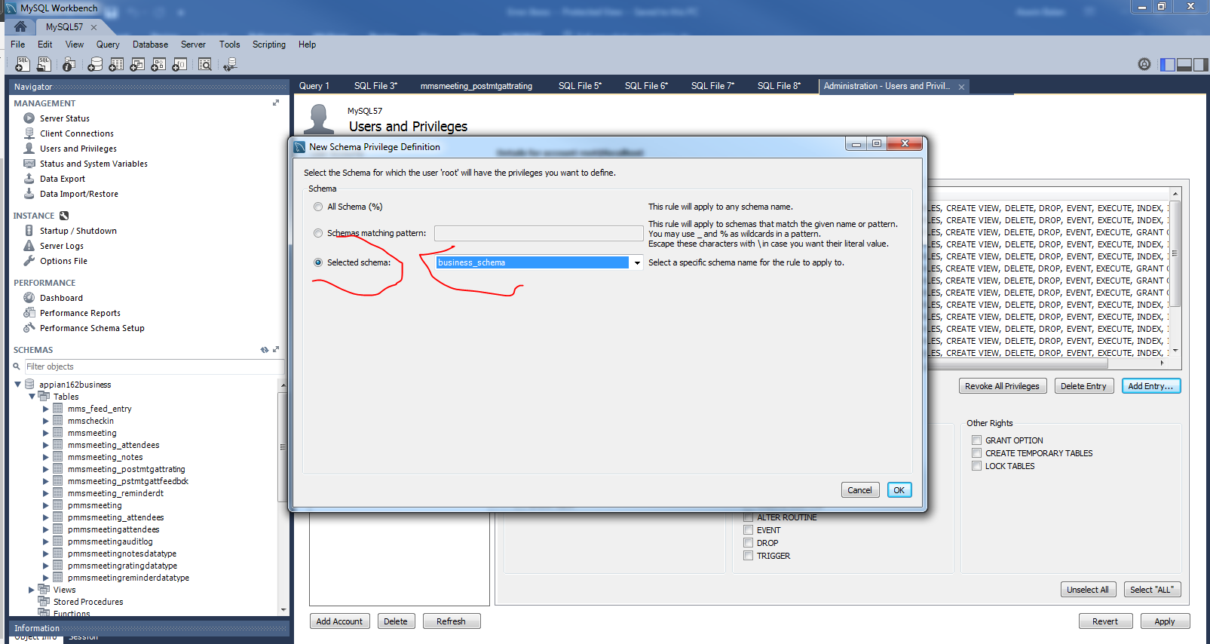

- From the grid, select APPIAN_SCHEMA and click “Select All” as shown below and then click Apply.

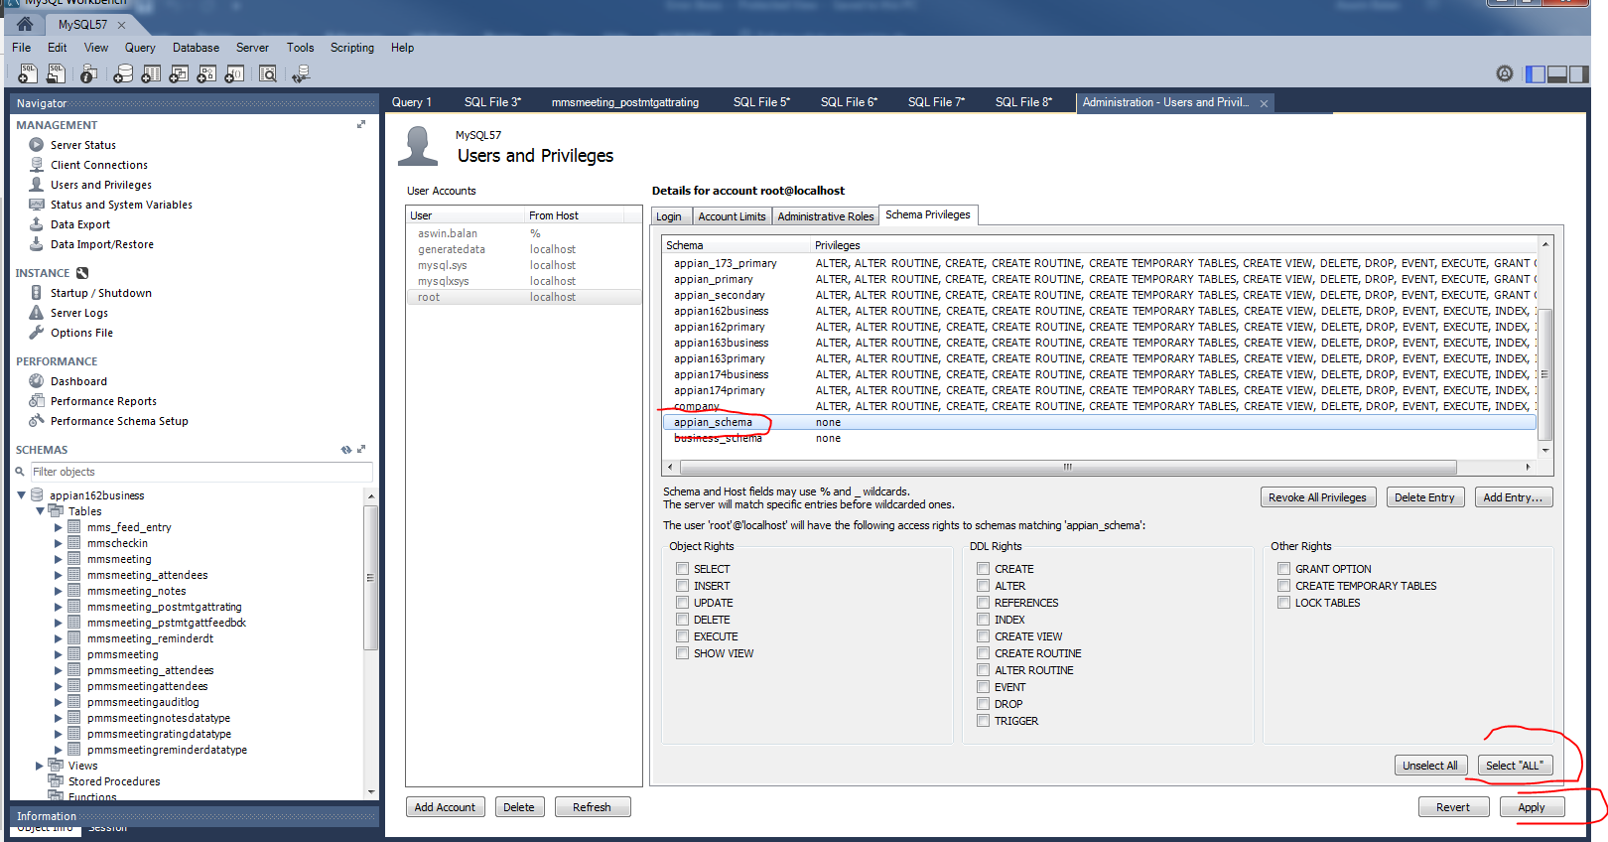

- Do the same thing mentioned in Step 7 for BUSINESS_SCHEMA.
