- In the main interface we have a toggle icon,we the default value for this is null. When user clicked on that we are setting a local variable value as true.
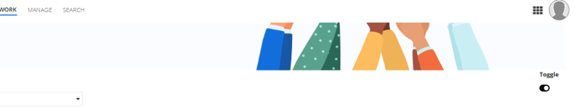
- Below this toggle icon we have a link, When user clicked on that link it will initiate a process model using a!startprocesslink smart service.
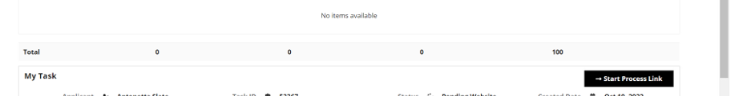
- That process model has interface rule in the startform, when user perform some action on that screen and submit the form he will again land on the main interface rule.
