Left hand side fields and right-hand side document:

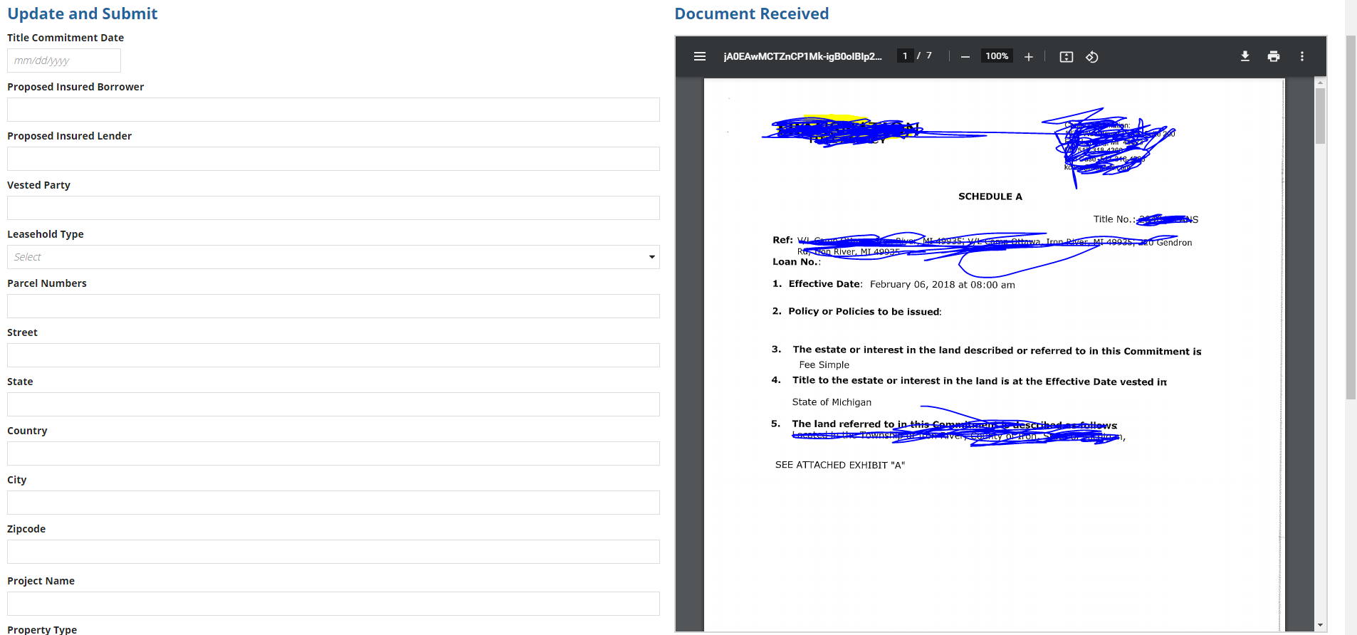
If user wan to check below fields, he should again scroll up and look for the specific field in the document.
Instead if we have both screens aligned with the fields user will have better experience. Is the a way to add scrollable option in the left side column layout?

