- Process Model View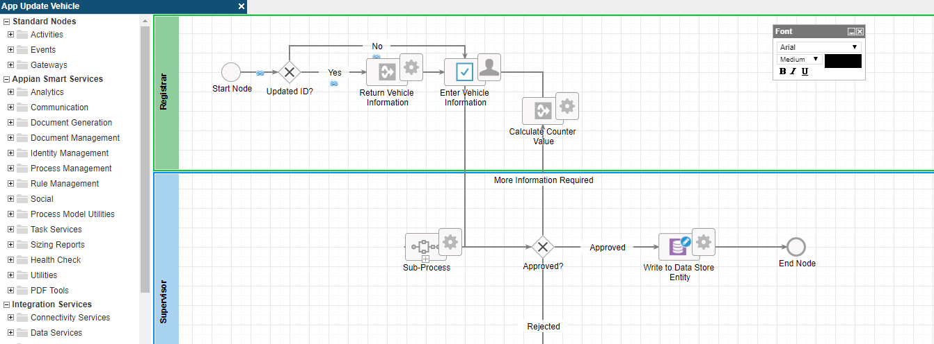

- ‘Updated ID?’ gateway properties
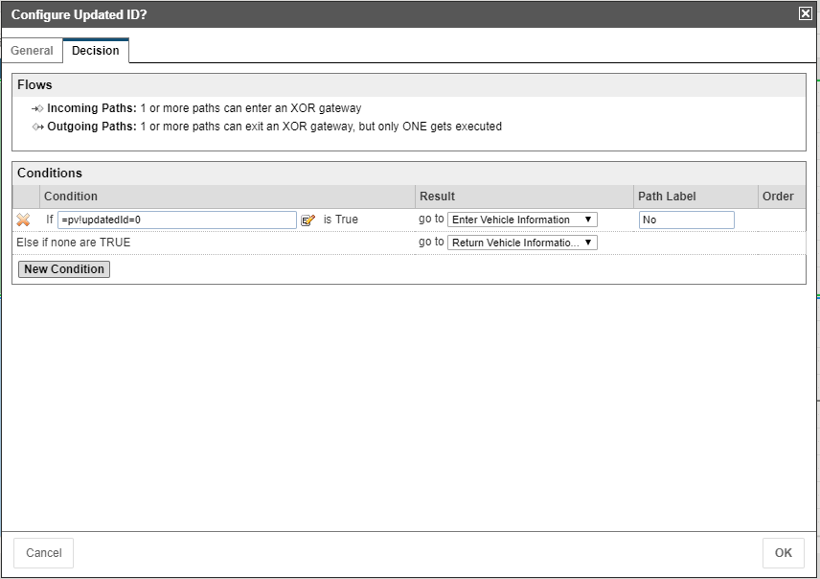

- ‘Return Vehicle Information’ Input data
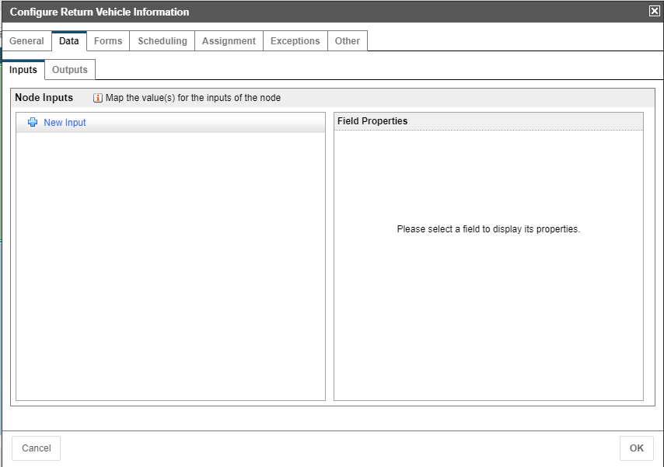

- ‘Return Vehicle Information’ Output data
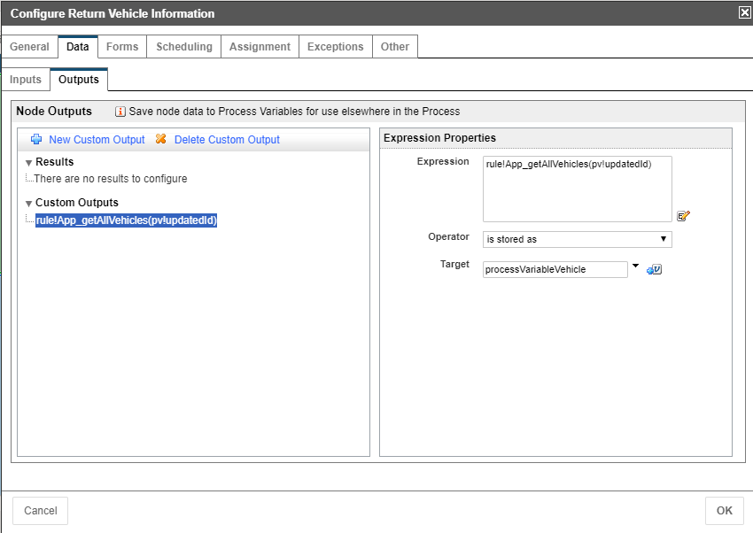

- ‘Enter Vehicle Information’ Input Data
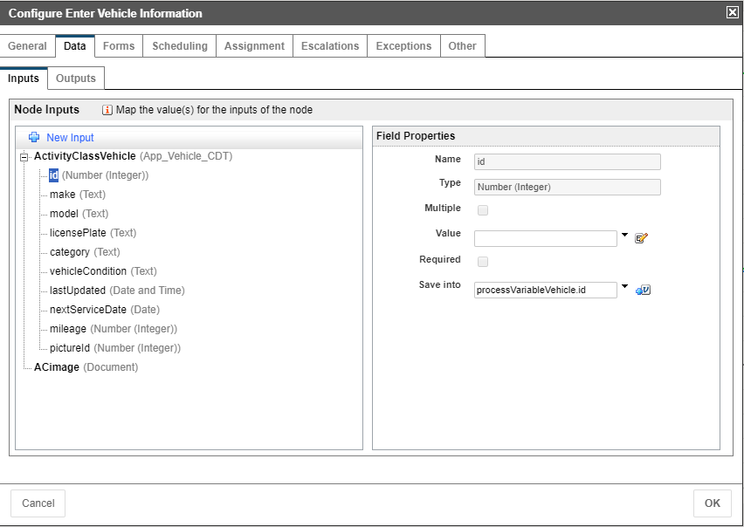

- ‘Enter Vehicle Information’ Output data
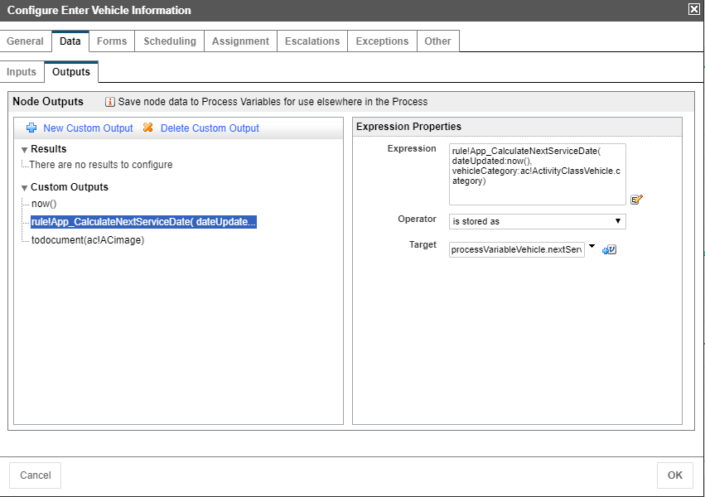

- ‘Enter Vehicle Information’ Forms data
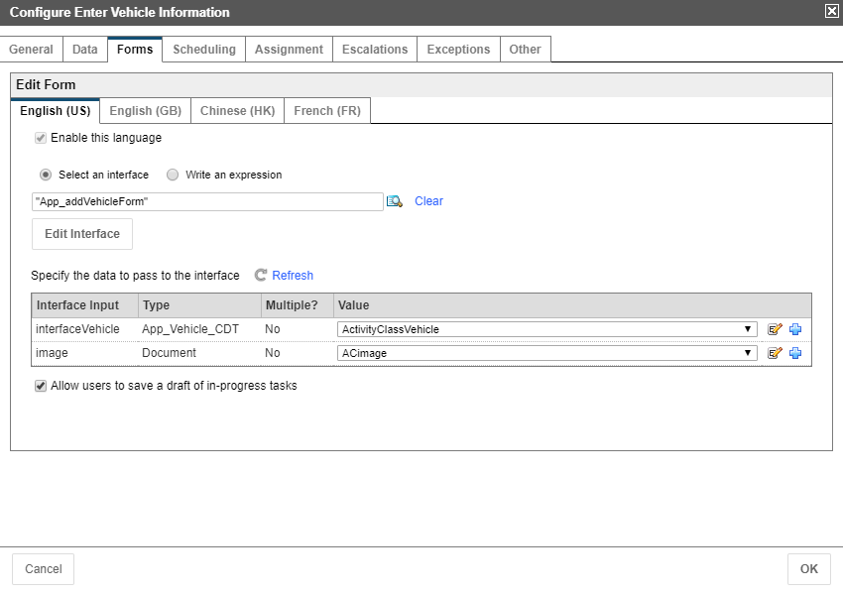

- Process Model Variables
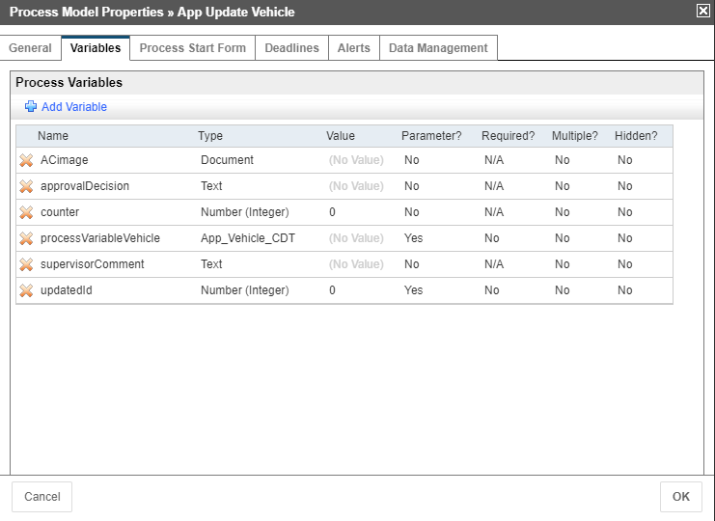

- Related Actions Page in Records tab
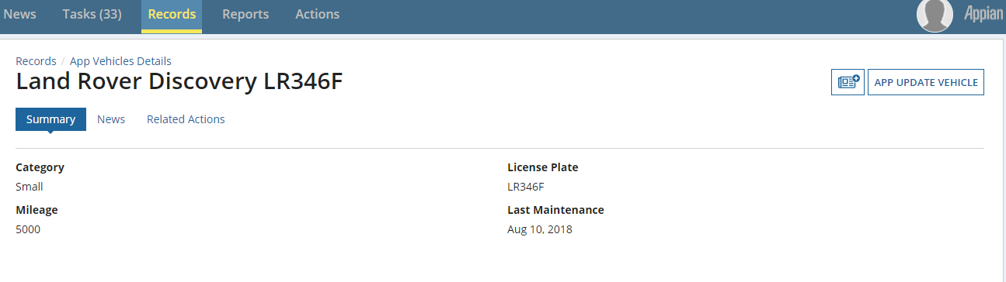
- Enter Vehicle Information page
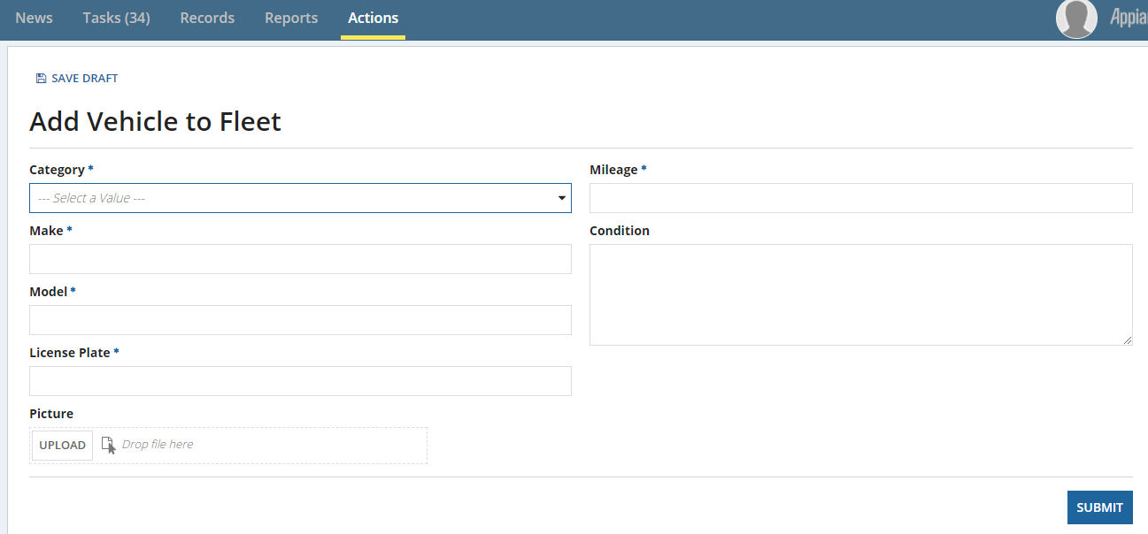

- Record Type screenshot
