Updated Screenshots and Supporting Information

Issue #1: ‘GO BACK’ button not working as intended.

Search Criteria:
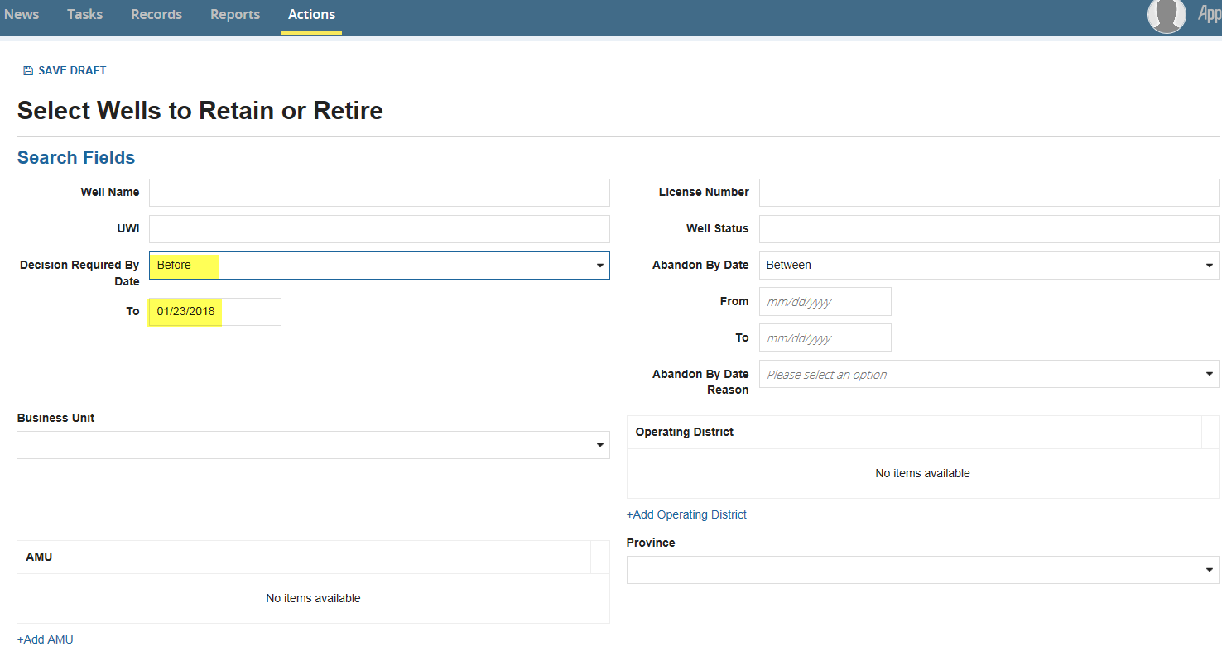

Made ‘Retain’ Decision on Well and Selected ‘Submit’
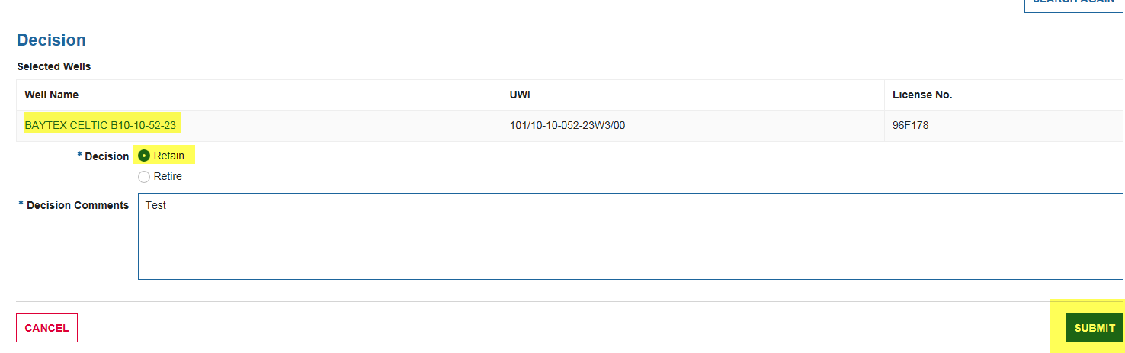

Next Screen
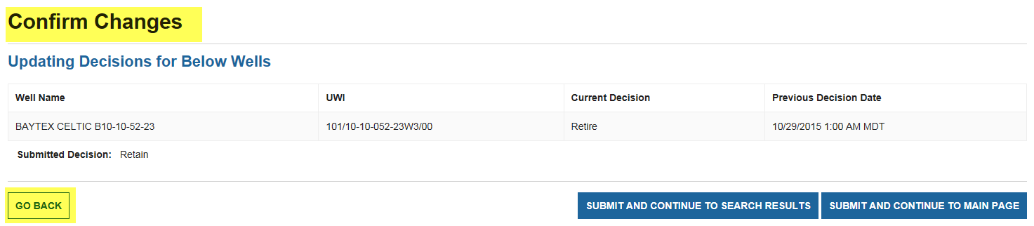

Following Screen After ‘GO BACK’ Button Selected
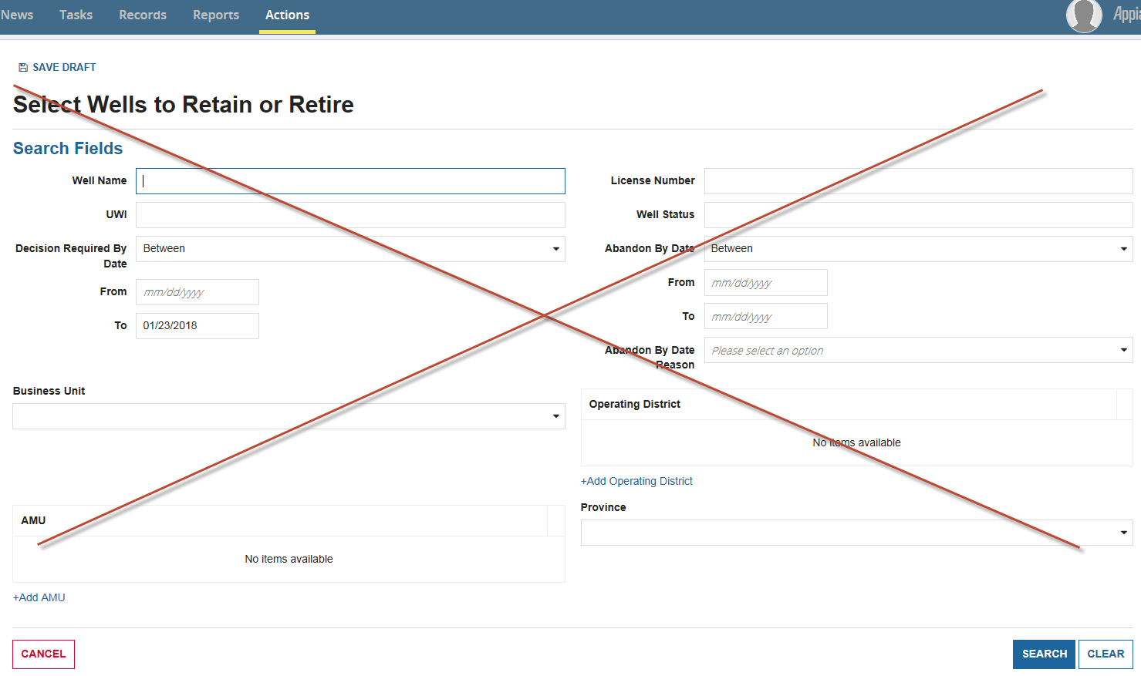

This is the incorrect screen that the ‘GO BACK’ button should lead to.

***System should go back one screen and keep the filters that were applied from the search page.

Expected Result: Select Wells to Retain or Retire screen with search filters applied (i.e. where the user made the decision before the confirmation screen as per the screenshot below) 