Our environment: Appian version 20.2 on premise.
Process documentation (system language is german)
First version of this process is created 16th of November 2017 and the last update was deployed at 26th of July 2018.

The core issue is correlated to this node:
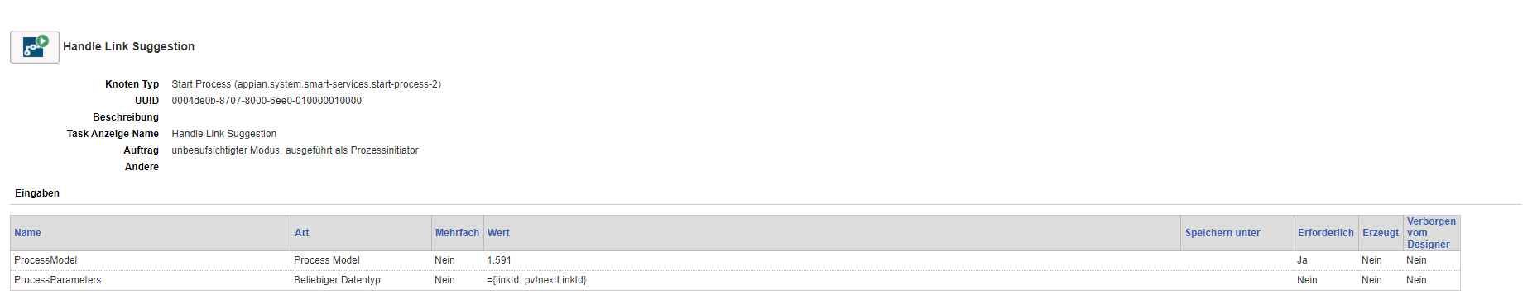
* Unattended mode, initiated as processinitiator, not multiple

We expect that this node is starting one other instance of the same process.
This is working fine for the first couple of hundred processes (this time 1062 instances). (green box) -> there is no fix number after which the process logic will create two processes.
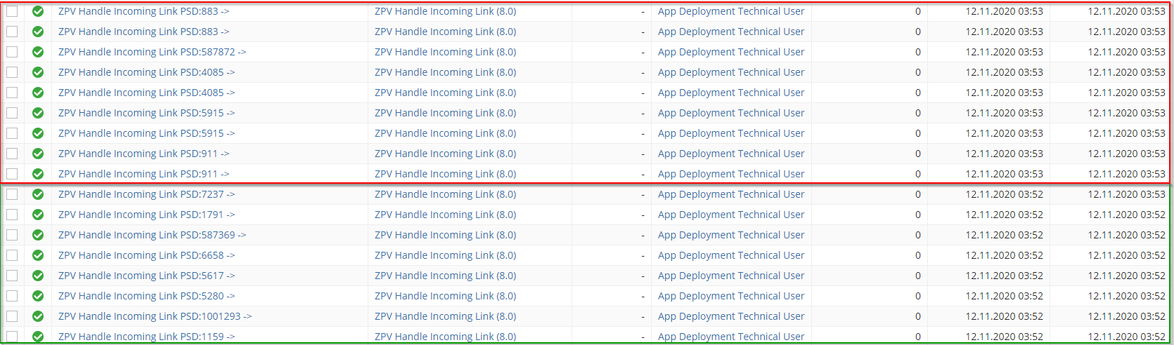
One time, we have two processes started and got two identical processes every time.
Identical means: exact same process variable, all parallel nodes and processes are executed and finished the exact same time.

On top, it happens another time, so one of these parallel processes is causing two other processes as well. That means we have 3 parallel processes then.
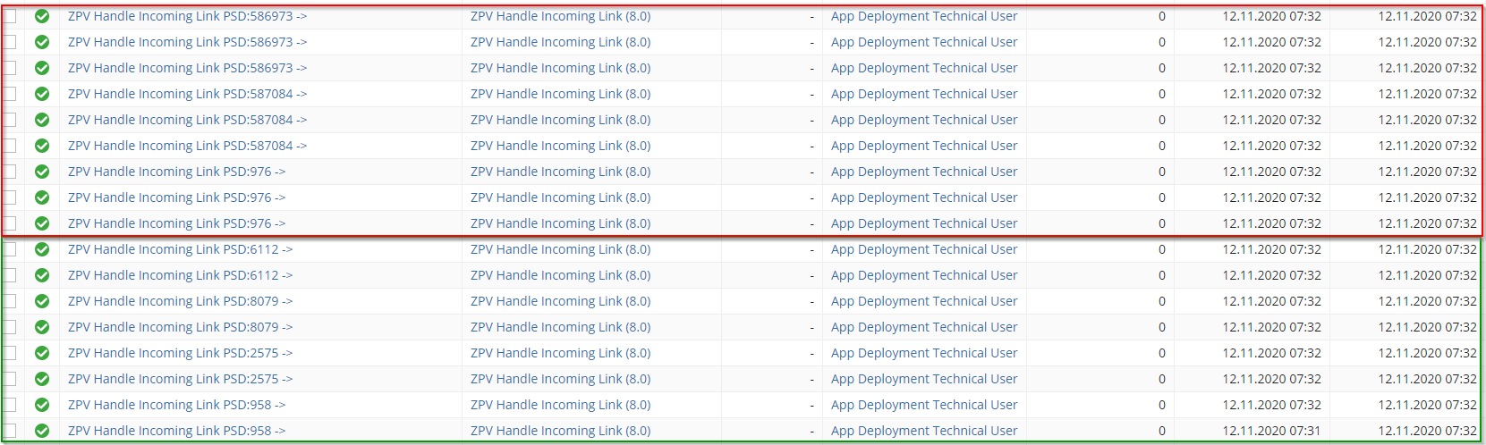
We are talking of 12.145 process of THIS process during the last 24 hours and around 37.000 processes in total during the last 24 hours. Not included directly deleted process instances.
Suggestion: the engine can’t handle that many processes and causes an issue here.
As the instances are deleted after 24 hours we suggest, this process goes wrong since deployment, but we cannot prove it.

