Write to Multiple Data store entity

Process Model:
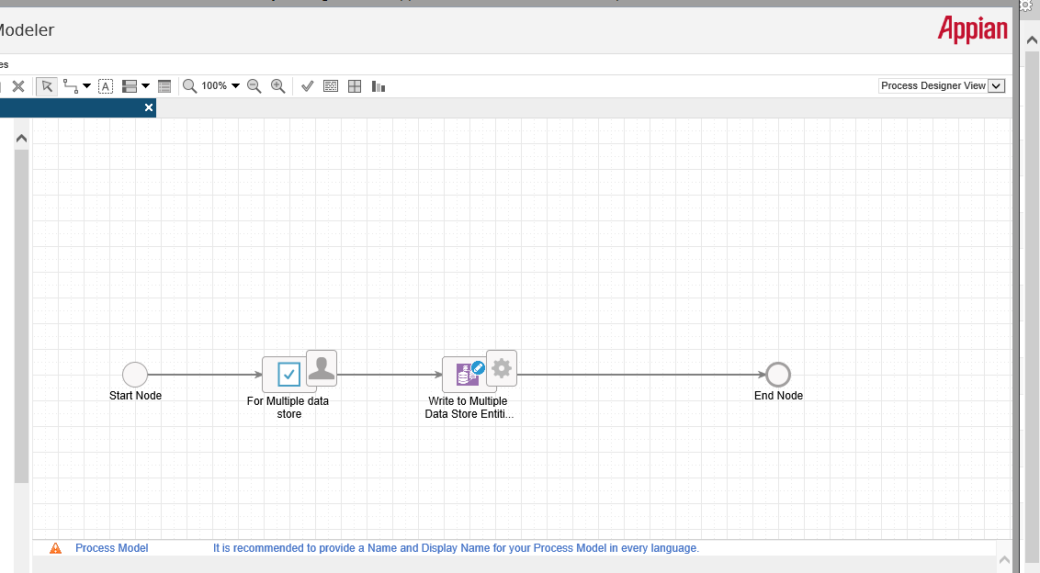
Variables:

CDT:
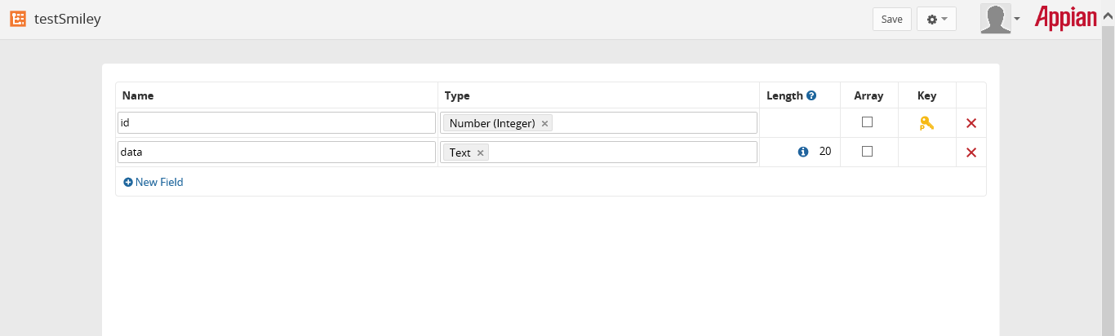

Case 1:
Data without smiley: Data gets stored in DB while inserting simple text data
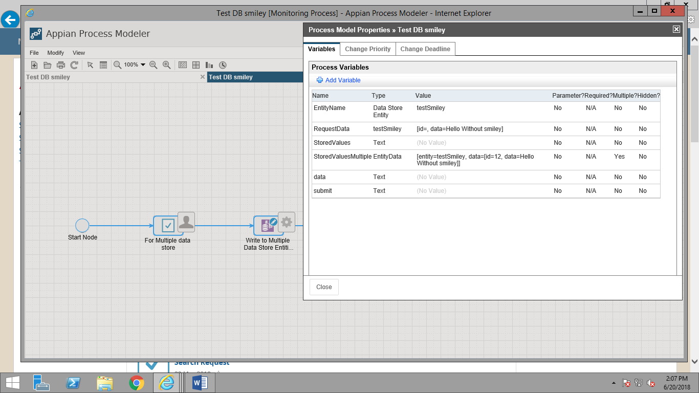

DB snapshot of inserted entry:

Case 2: Inserting data with smiley
Write to Multiple Data store entity broke due to smiley.
Alert message: There is a problem with task “Write to Multiple Data Store Entities” in the process “Test DB smiley”. XML handling failure trying to convert value EntityData [entity=DataStoreEntityRef[id=02377f7c-84c4-4948-9170-470ec382075e@22976, uuid=null], data=[TypedValue[it=3921,v={13,Hello Via multiple with smiley 😊}]]] to Appian type EntityData (id=2134)
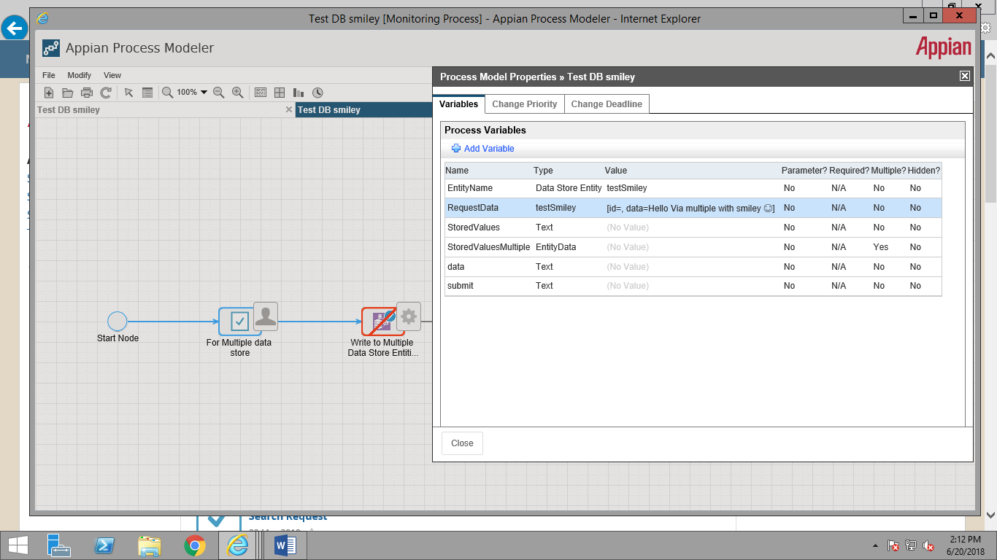

Write to Data store entity

Process Model:
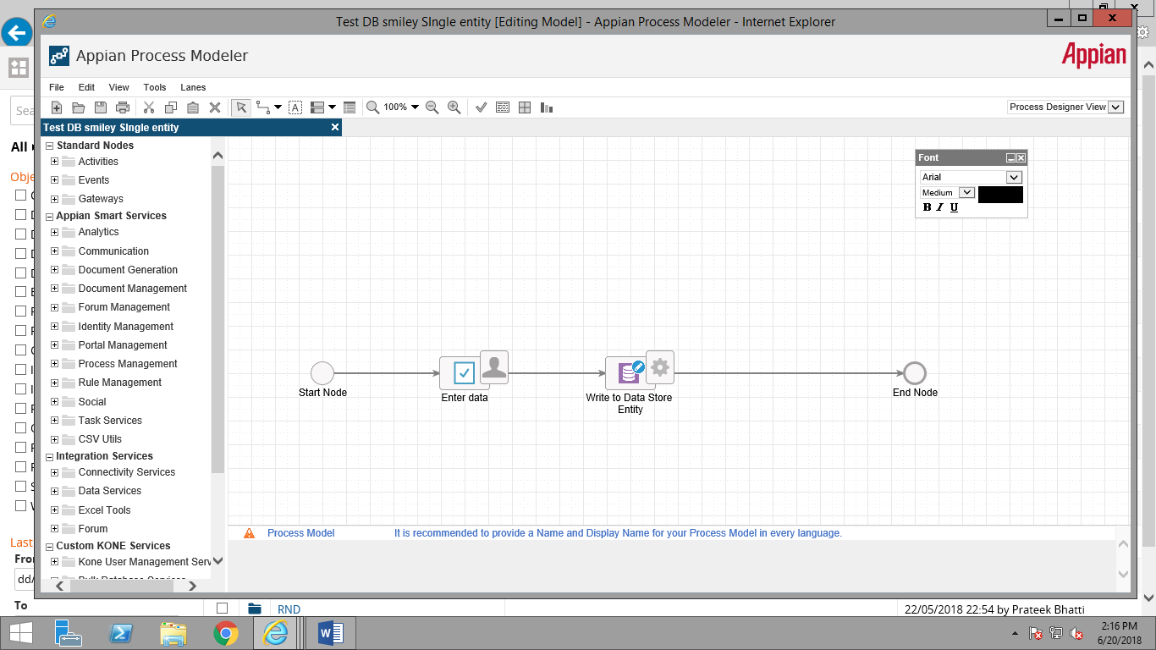
CDT is same for both Process models
Case: Inserting smiley with data
Outcome: The data get stored successfully in DB and Process didn’t break.
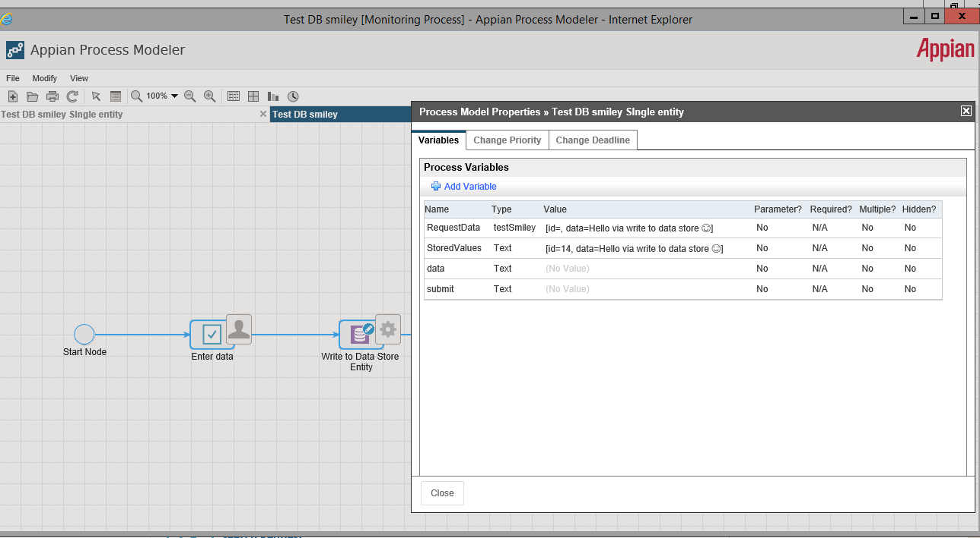
DB snapshot:

