App Registration on Azure Active Directory
- Log on to https://portal.azure.com/.

- Click on ‘Azure Active Directory’ > ‘App registrations’ > ‘New application registration’.

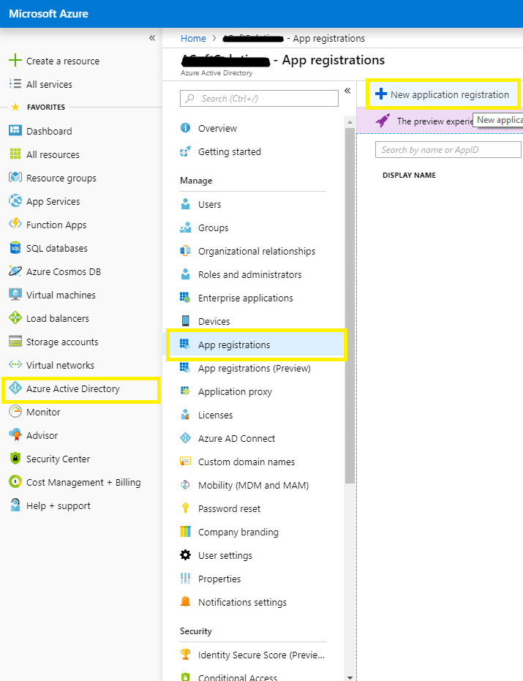

- Enter ‘Name’, Select ‘Application type’ as ‘Web App / API’ and ‘Sign-on URL’.
Name
Your application name.
Sign-on URL
https://<ABC>.appiancloud.com/suite/oauth/callback
(Call back URL present on the connected system configuration.)

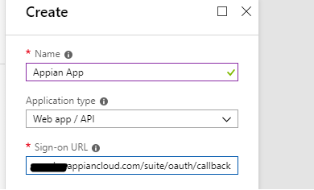

- Copy down the ‘Application ID’.
(This is what you need to input for ‘Client Id’ while configuring the Connected System in Appian.)

- Click on ‘Settings’ > ‘Keys’.
Enter DESCRIPTION, select EXPIRES and click Save. Then ‘VALUE’ will be populated. Copy down the value as it will be hidden after you exist.
(This is what is you need to input for ‘Client Secret’ while configuring Connected System in Appian.)

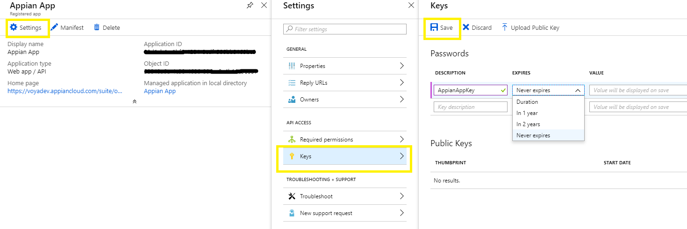

- Setup appropriate permissions for the app to access the SharePoint.

Click on ‘Required permissions’ > ‘Add’ > ‘Select an API’ > ‘Office 365 SharePoint Online’.

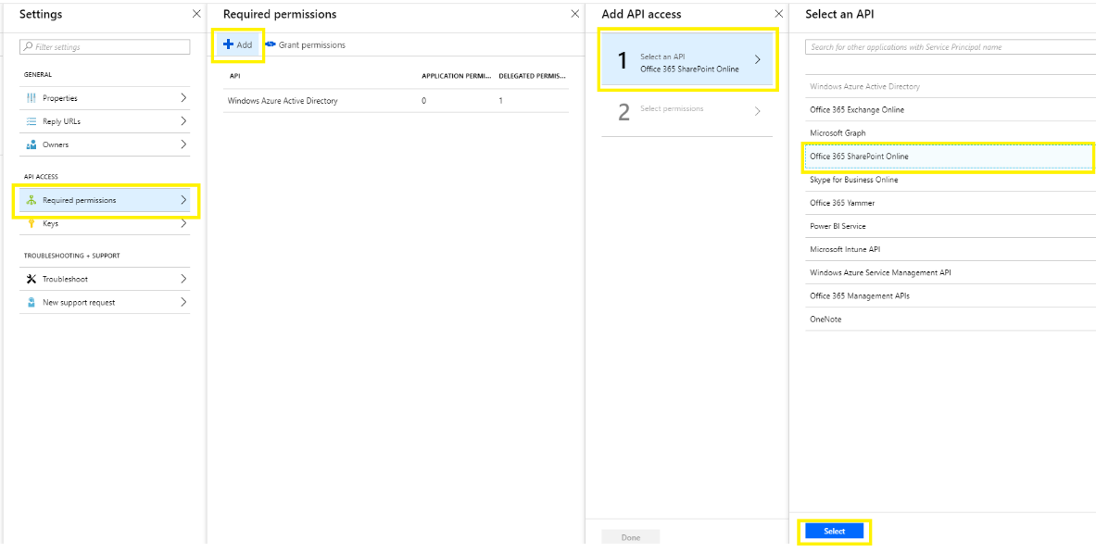
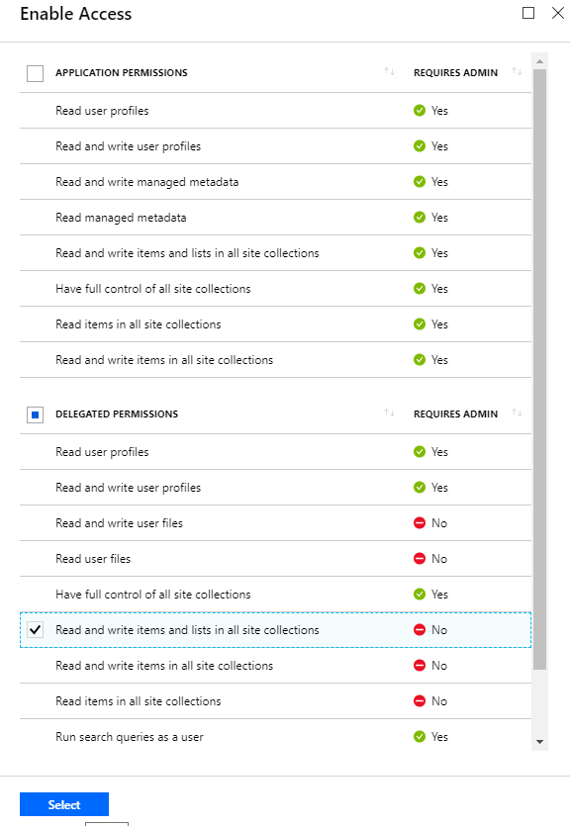

Click ‘Select’ and then ‘Done’.

Configuring Connected System in Appian
- Create a new Connected System. Choose HTTP and OAuth 2.0 in Authentication.

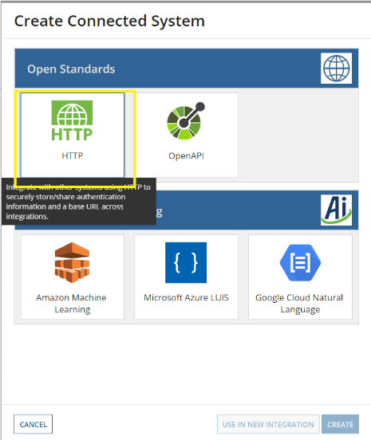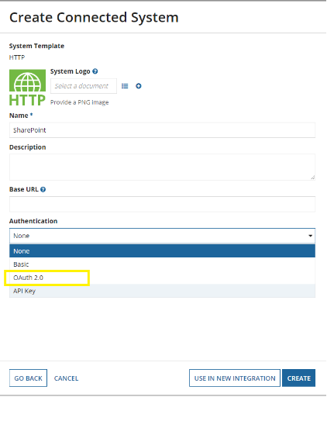

- Configure the Connected System.

Authorization Endpoint
https://login.microsoftonline.com/common/oauth2/authorize?resource=https://<ABC>.sharepoint.com

Client ID
Application ID copied in the previous steps.

Client Secret
Key copied in the previous steps.

Scope
Blank (optional)

Token Request Endpoint
https://login.microsoftonline.com/common/oauth2/token

Click on ‘Authorize’. It will open a new tab asking your consent (you may require to login to reach this step). You may or may not check on ‘Consent on behalf of your organization’ depending upon your scenario. Click on ‘Accept’.

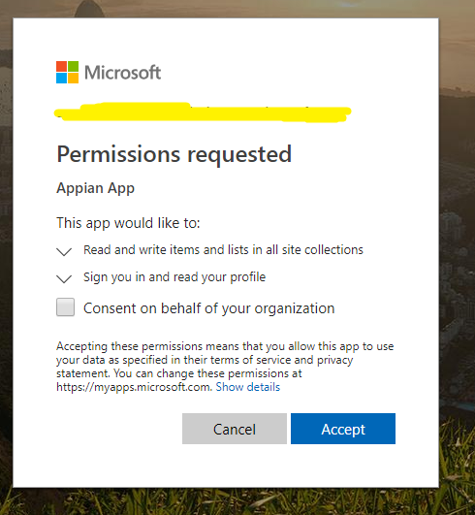

It should redirect back to the previous tab (Appian) where you can see a pop up window like below.

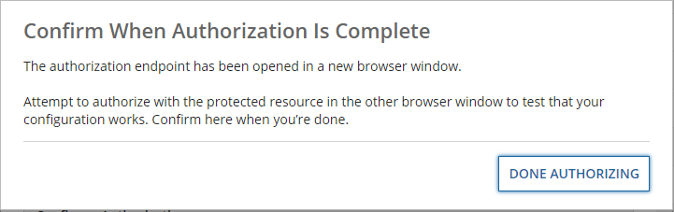

Click on ‘Done Authorizing’ and if everything was fine, you should see something like below.

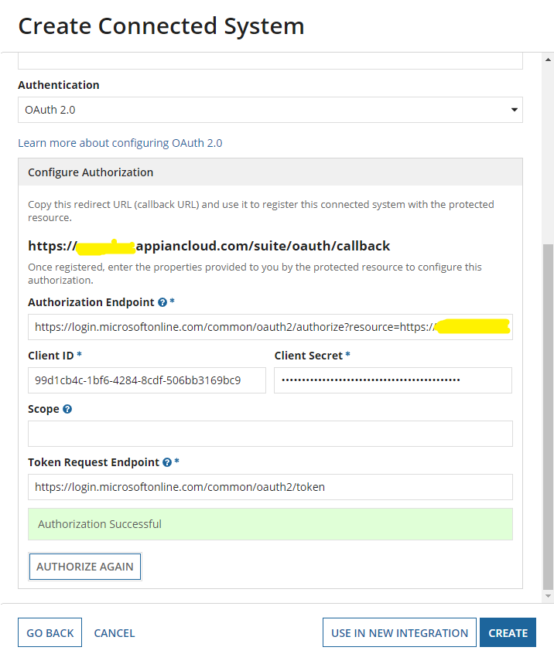

Click ‘Create’.

Configuring Integration object to upload document to SharePoint.
- Create new Integration object with the Connected System created in the previous step.

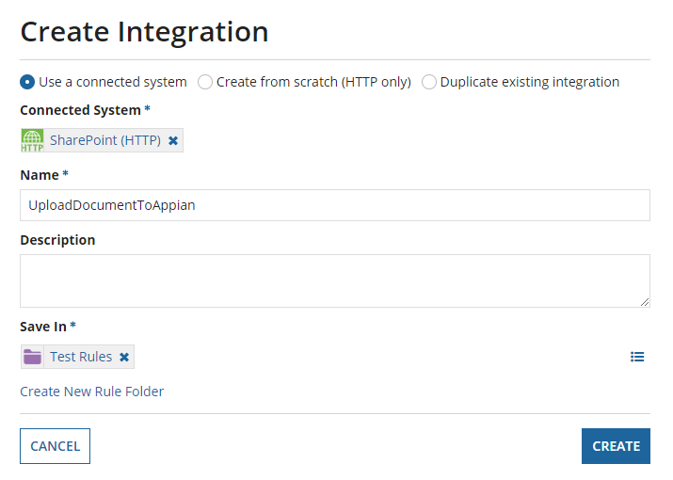

- URL would be.
https://asoftsolutions.sharepoint.com/_api/web/getfolderbyserverrelativeurl('Shared%20Documents')/files/add(url='" & ri!documentName & "',overwrite=true)

Your URL would be different depending upon the location you wish to upload in your SharePoint instance. For instance, I am trying to upload document in a folder name ‘Documents’.

- Method: POST, Usage: Modifies Data

- Create two rule inputs, document, document name of type ‘Document’ and ‘Text’ respectively.

- Set Content Type to Document (auto-detect) in ‘Body’ and map the document here using ri!document.

- Click ‘Test Request’.
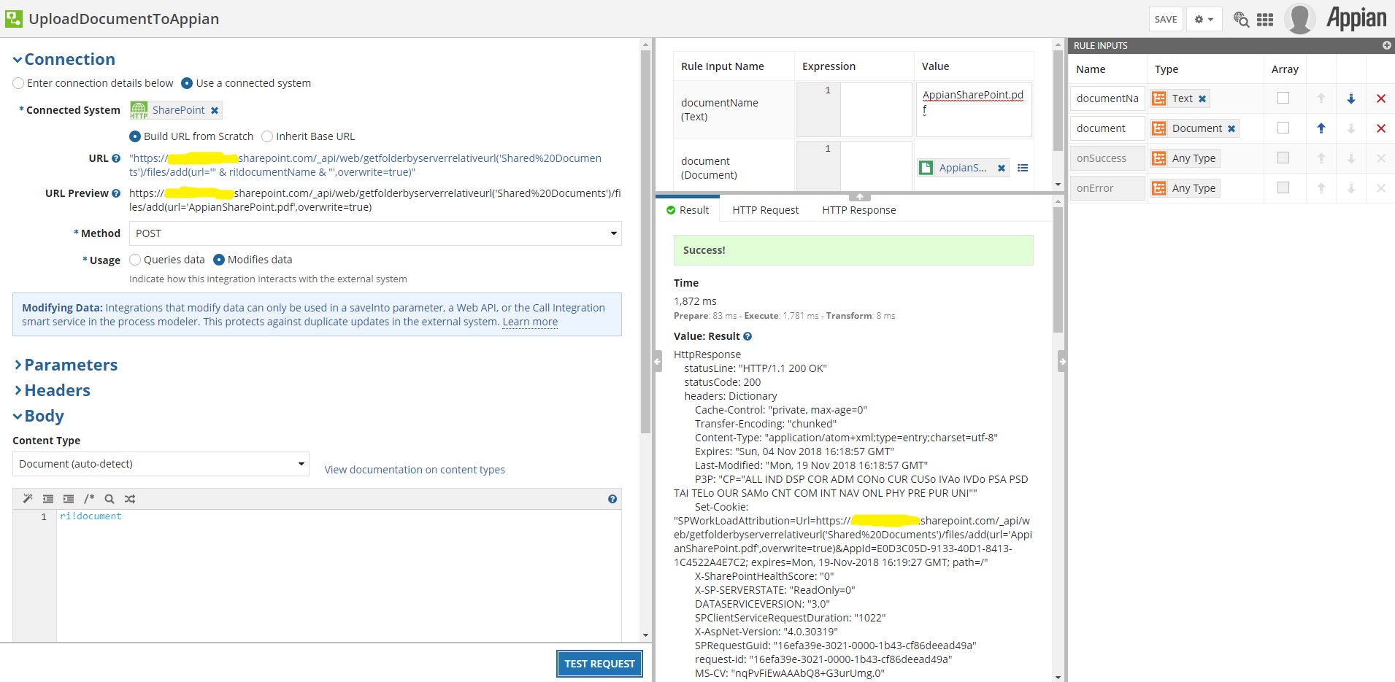
If everything went fine, you should see ‘Success!’ and off course the uploaded document in the location you specified in the URL!

