There are following steps which is converting from DOCX to PDF
- There is a textbox inside ###sample### is written and upload this file in document folder (as input).
###sample###
- Connection for DOCX to PDF in process model
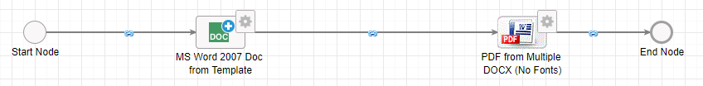

- Setup the configuration in MS Word 2007 doc node. Passing sample variable value 11.

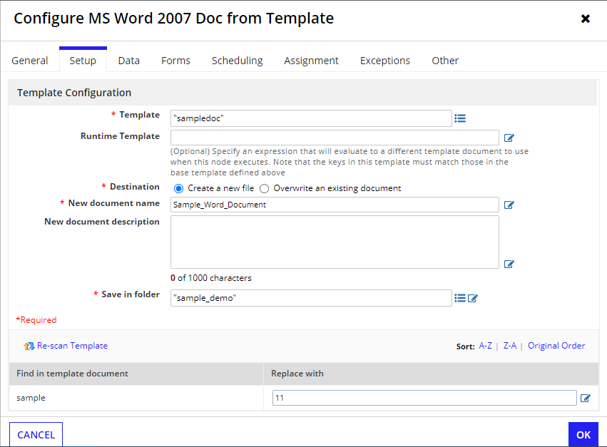

- For output, saving a document name as NewDocument
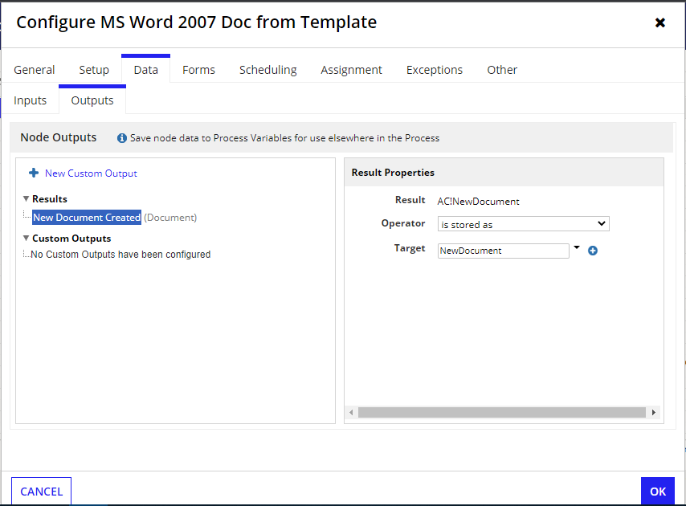

- Configure PDF from Multiple DOCX (No Fonts) node, passing the MS Word 2007 doc output in Source Documents parameter.
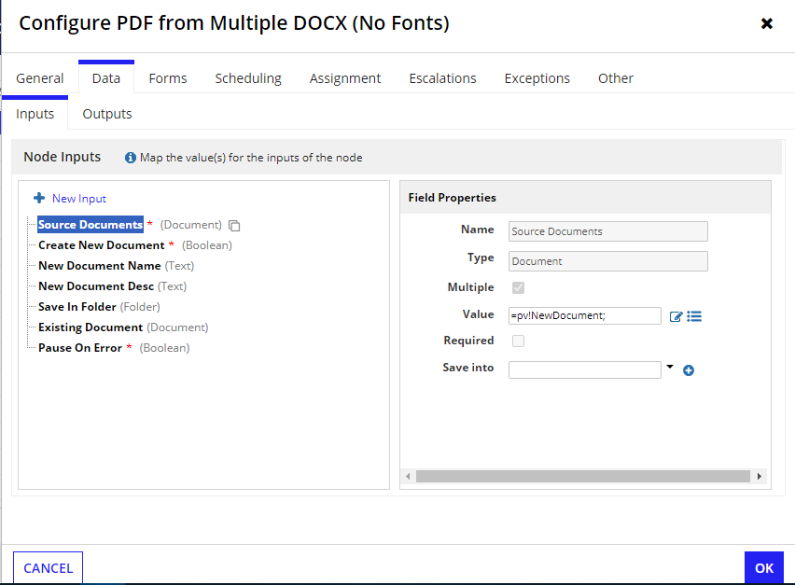
- In a DOCX file it showing as a output 11 which is configured in MS Word 2007 node
- In PDF it gives us a blank as output

