I am trying to create a process model that will capture the “login-audit.csv.yyyy-mm-dd” file each day and store it into a folder using the functions that come with the Log Reader (v1.1.2) [com.appiancorp.ps.logreader] plugin
I’ve created a constant (cons!ADM_LOG_PATH) that contains the relative path to the /logs directory which would change depending on the environment. My process model contains the following variables:
Variable | Value | Comments
logPath | cons!ADM_LOG_PATH | Data Type ‘Text’ – varies / environment so for our dev environment:  https://mydev.appiancloud.com/suite
filename | login-audit.csv.2018-04-17 (e.g.) | Data Type ‘Text’ – changes each day
logFiles |  | Data Type ‘LogContents’
logfile |  | Tried Data Type ‘Document’; also ‘CsvReport’ and also ‘LogFile’

I tried using several of the functions in order to ‘capture’ the log file I need, but haven’t been able to do so. For example, using the getloginfo() function and saving the result to pv!logFile (a pv I created with Data type ‘CsvReport’):
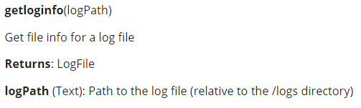
When I run the process, I get the following value for logFile:
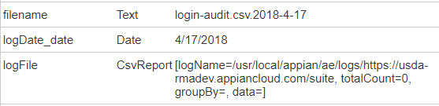 [logName=/usr/local/appian/ae/logs/https://mydev.appiancloud.com/suite, totalCount= 0, groupBy=, date=]
I don’t understand why the text highlighted in yellow displays. It should use the value stored in the constant and /logs. I was told this plugin is cloud approved but I’m thinking it is only for on-premise use????
I also tried using the readlog() function which returns ‘LogContents’. I get the same issue with the logPath – doesn’t seem to recognize the correct relative path either.
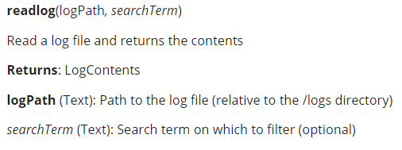
Based on what displays for this function, readlog(logPath, searchTerm), I used the following values:
readlog(cons!ADM_LOG_PATH, pv!filename) and save the results to ‘pv!logFiles’ (with data type ‘LogContents’) where:
cons!ADM_LOG_PATH = https://mydev.appiancloud.com/suite
pv!filename is derived based on the current date (e.g, “login-audit.csv.2018-04-17”)
When I run the process, I did not get an error, but the value of pv!logFiles is
logFiles LogContents [logName=/usr/local/appian/ae/logs/https://mydev. appiancloud.com/suite, totalCount=0, rows=]
How can I get the ONE log file that I need and store it to a folder in the Appian Document Management System?

