Documentation on Parse Excel Spreadsheet to CDT Smart Service

- This smart service allows us to read the data from excel and parse it to CDT.
- Firstly upload the excel file (.xlsx) format in Appian Document Management.
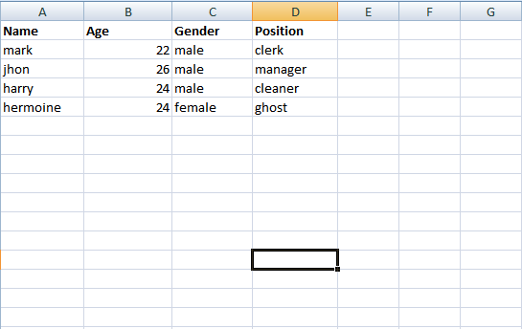

- Create a Custom data type with the same fields as per excel file.

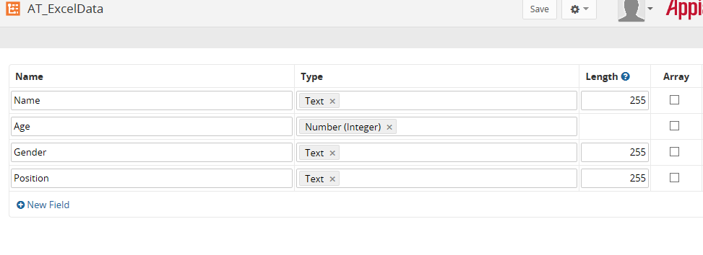
- Create a data store entity and publish it for creating the table in database.
- Create a process model to use this smart service and save it.
- Now go to palette Appian Smart services -> Document Management menu select the Parse Excel Spreadsheet to CDT component , drag it on to the canvas and place at desired location as below:
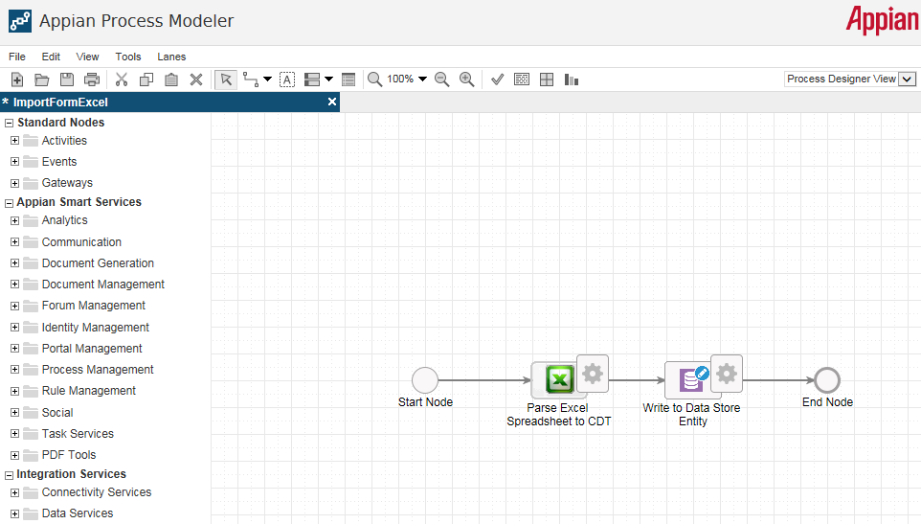
- Double click on the node to configure the activity.
- In General tab, we can provide the name and description of the node.
- In Data tab, provide the CDT value using expression editor to get the array list of items(CDT Array) as below:
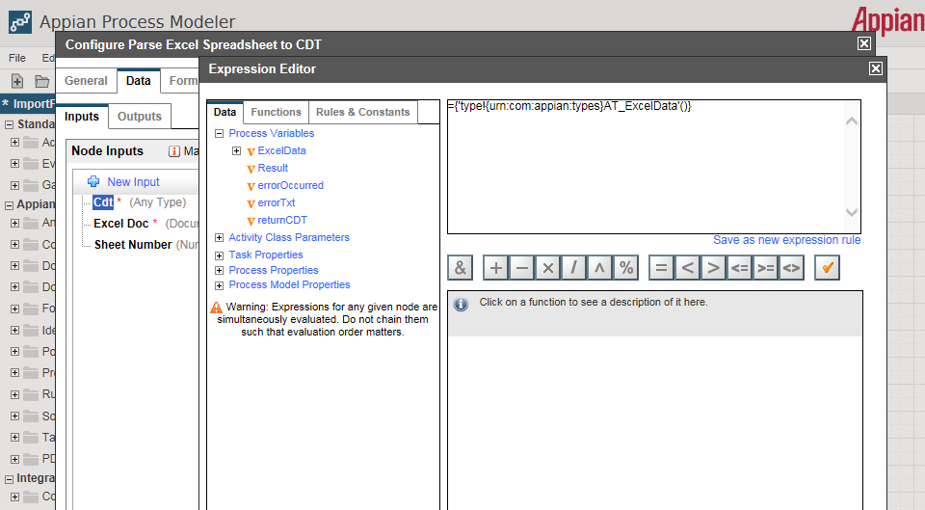

- Provide the excel document to be parse either using directory or using expression editor and sheet number as below:
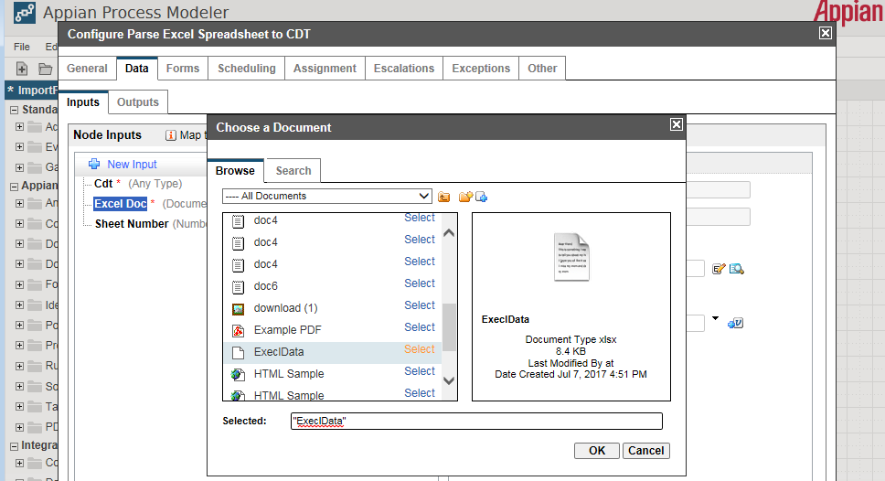

- In outputs tab, create a custom output to store the resulting CDT as below:

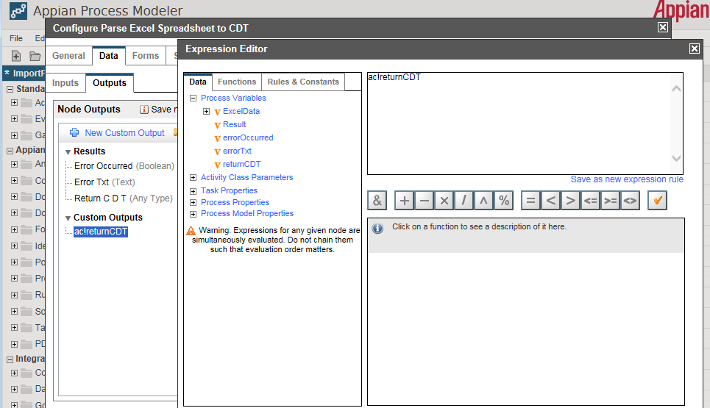
- Create a Write to data store entity smart service to store the data from excel into CDT and create a new input for accessing the CDT and create process variable for it as below:
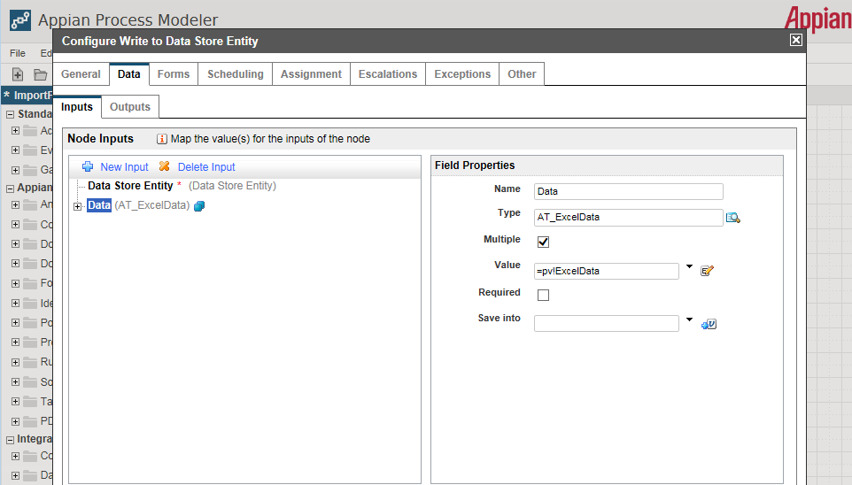

- Provide the Data store entity created to store the data using directory as below:

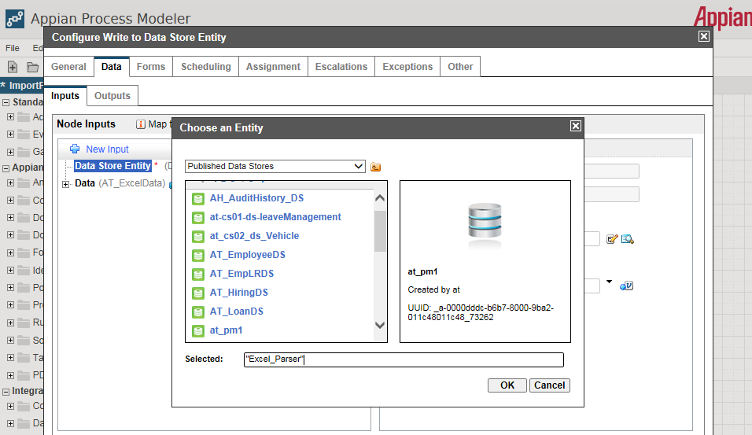
- Once all the changes are done, Click on OK button and save & validate the process model to check whether there exists any errors.
- For Debugging, directly use shortcut (CRTL + D) or go to file menu on toolbar and select the Start Process for debugging menu as below:
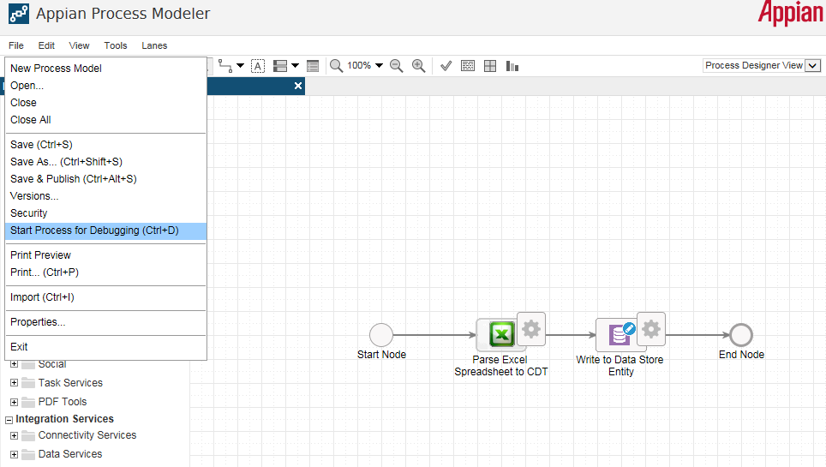

- After debugging, we can view the values in properties tab, the result is as below:

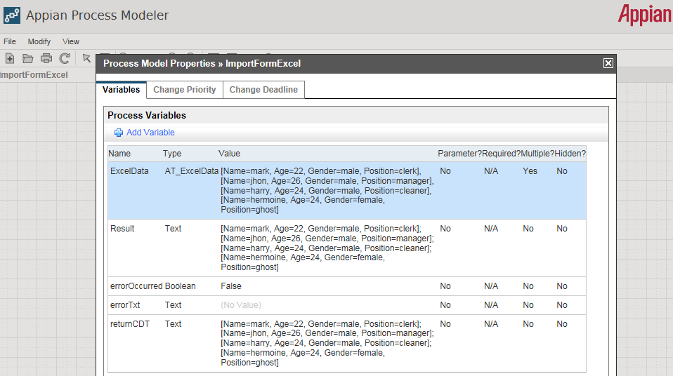

- Now access the database and check the data is parsed into CDT or not as below:

