This is what should occur as per the tutorial..
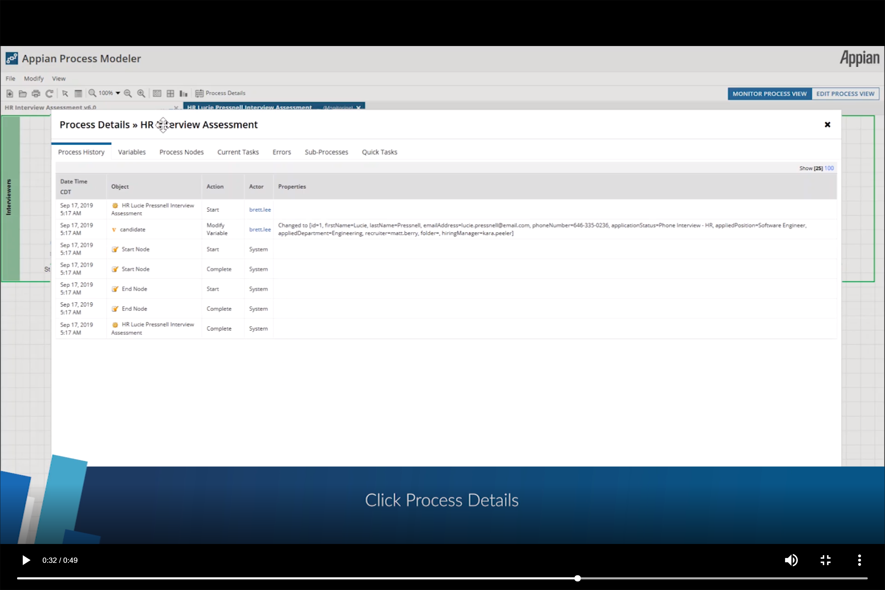

This is what comes up on mine….
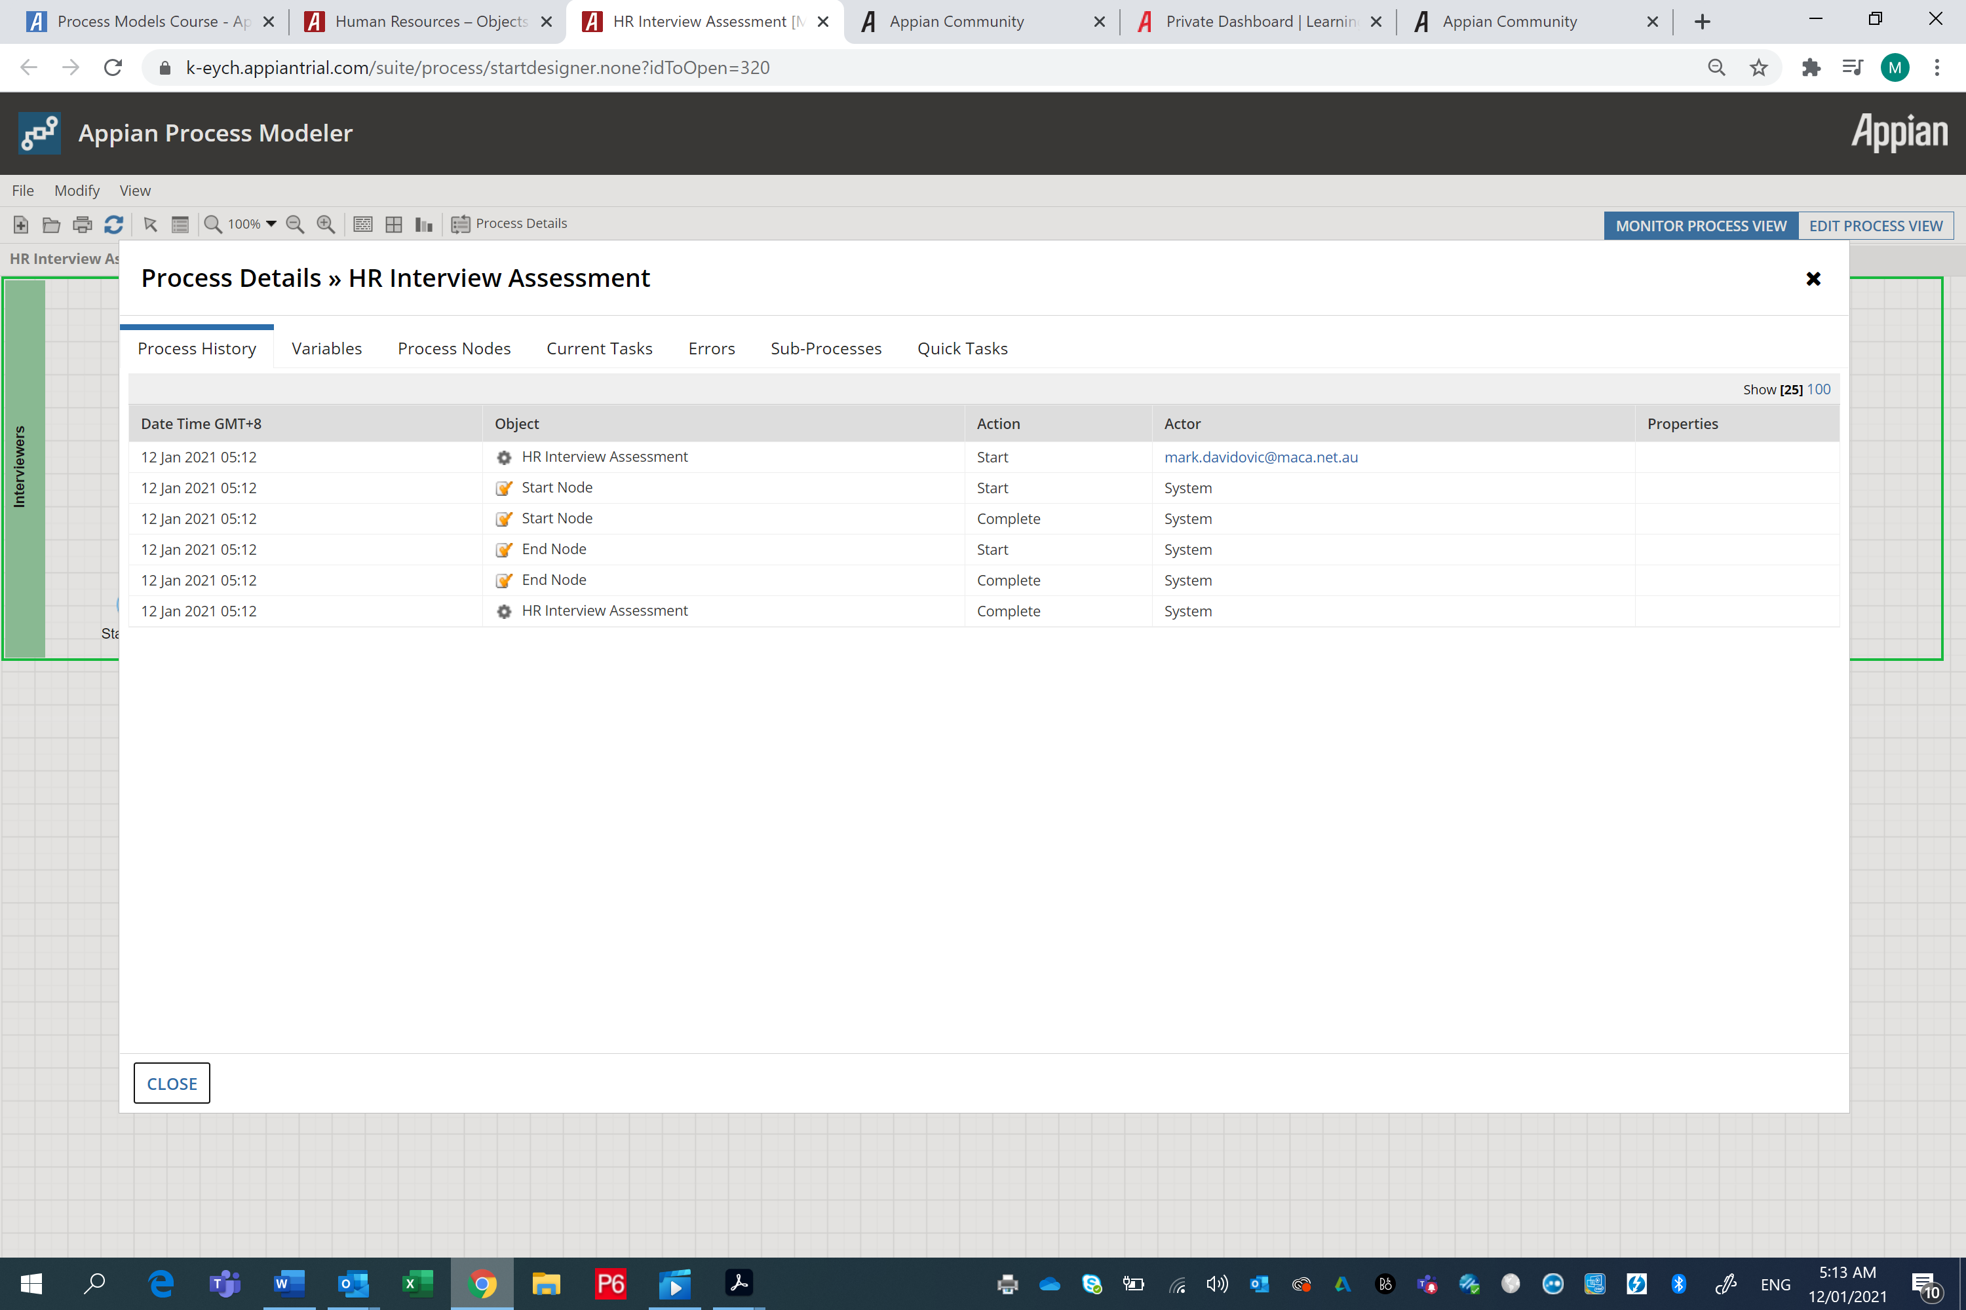
Ok, try to run the process in Tempo as per Pedro’s post…
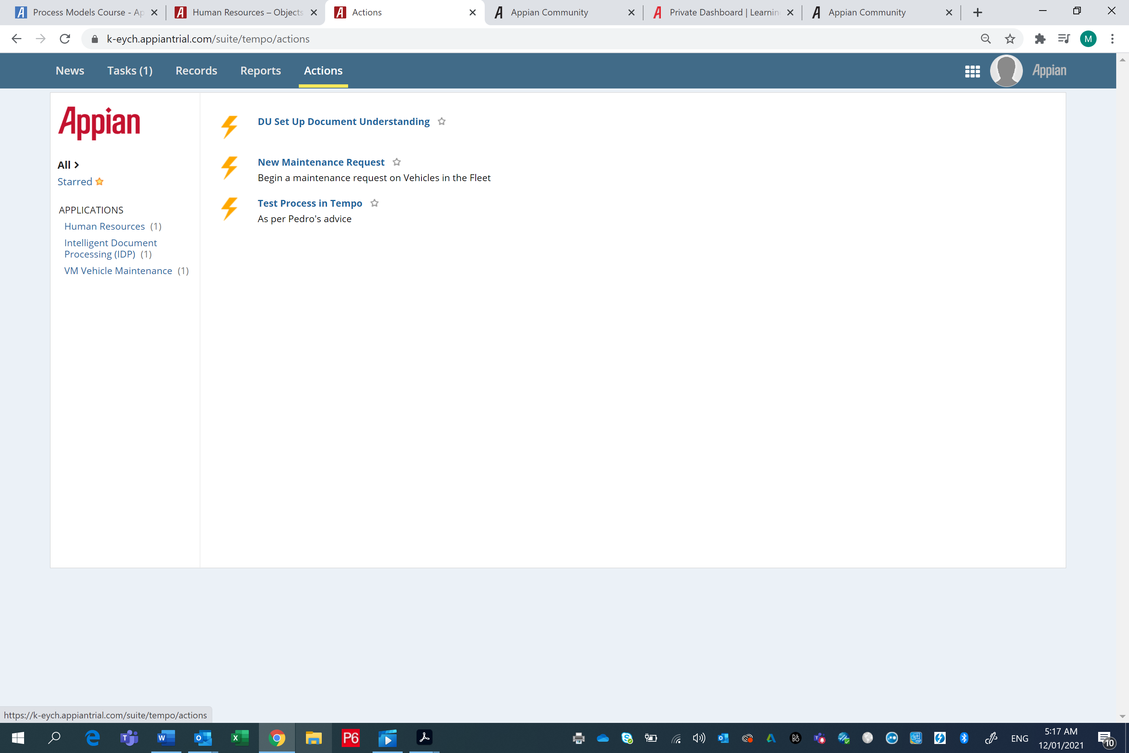

Yep, Start form invokes…..
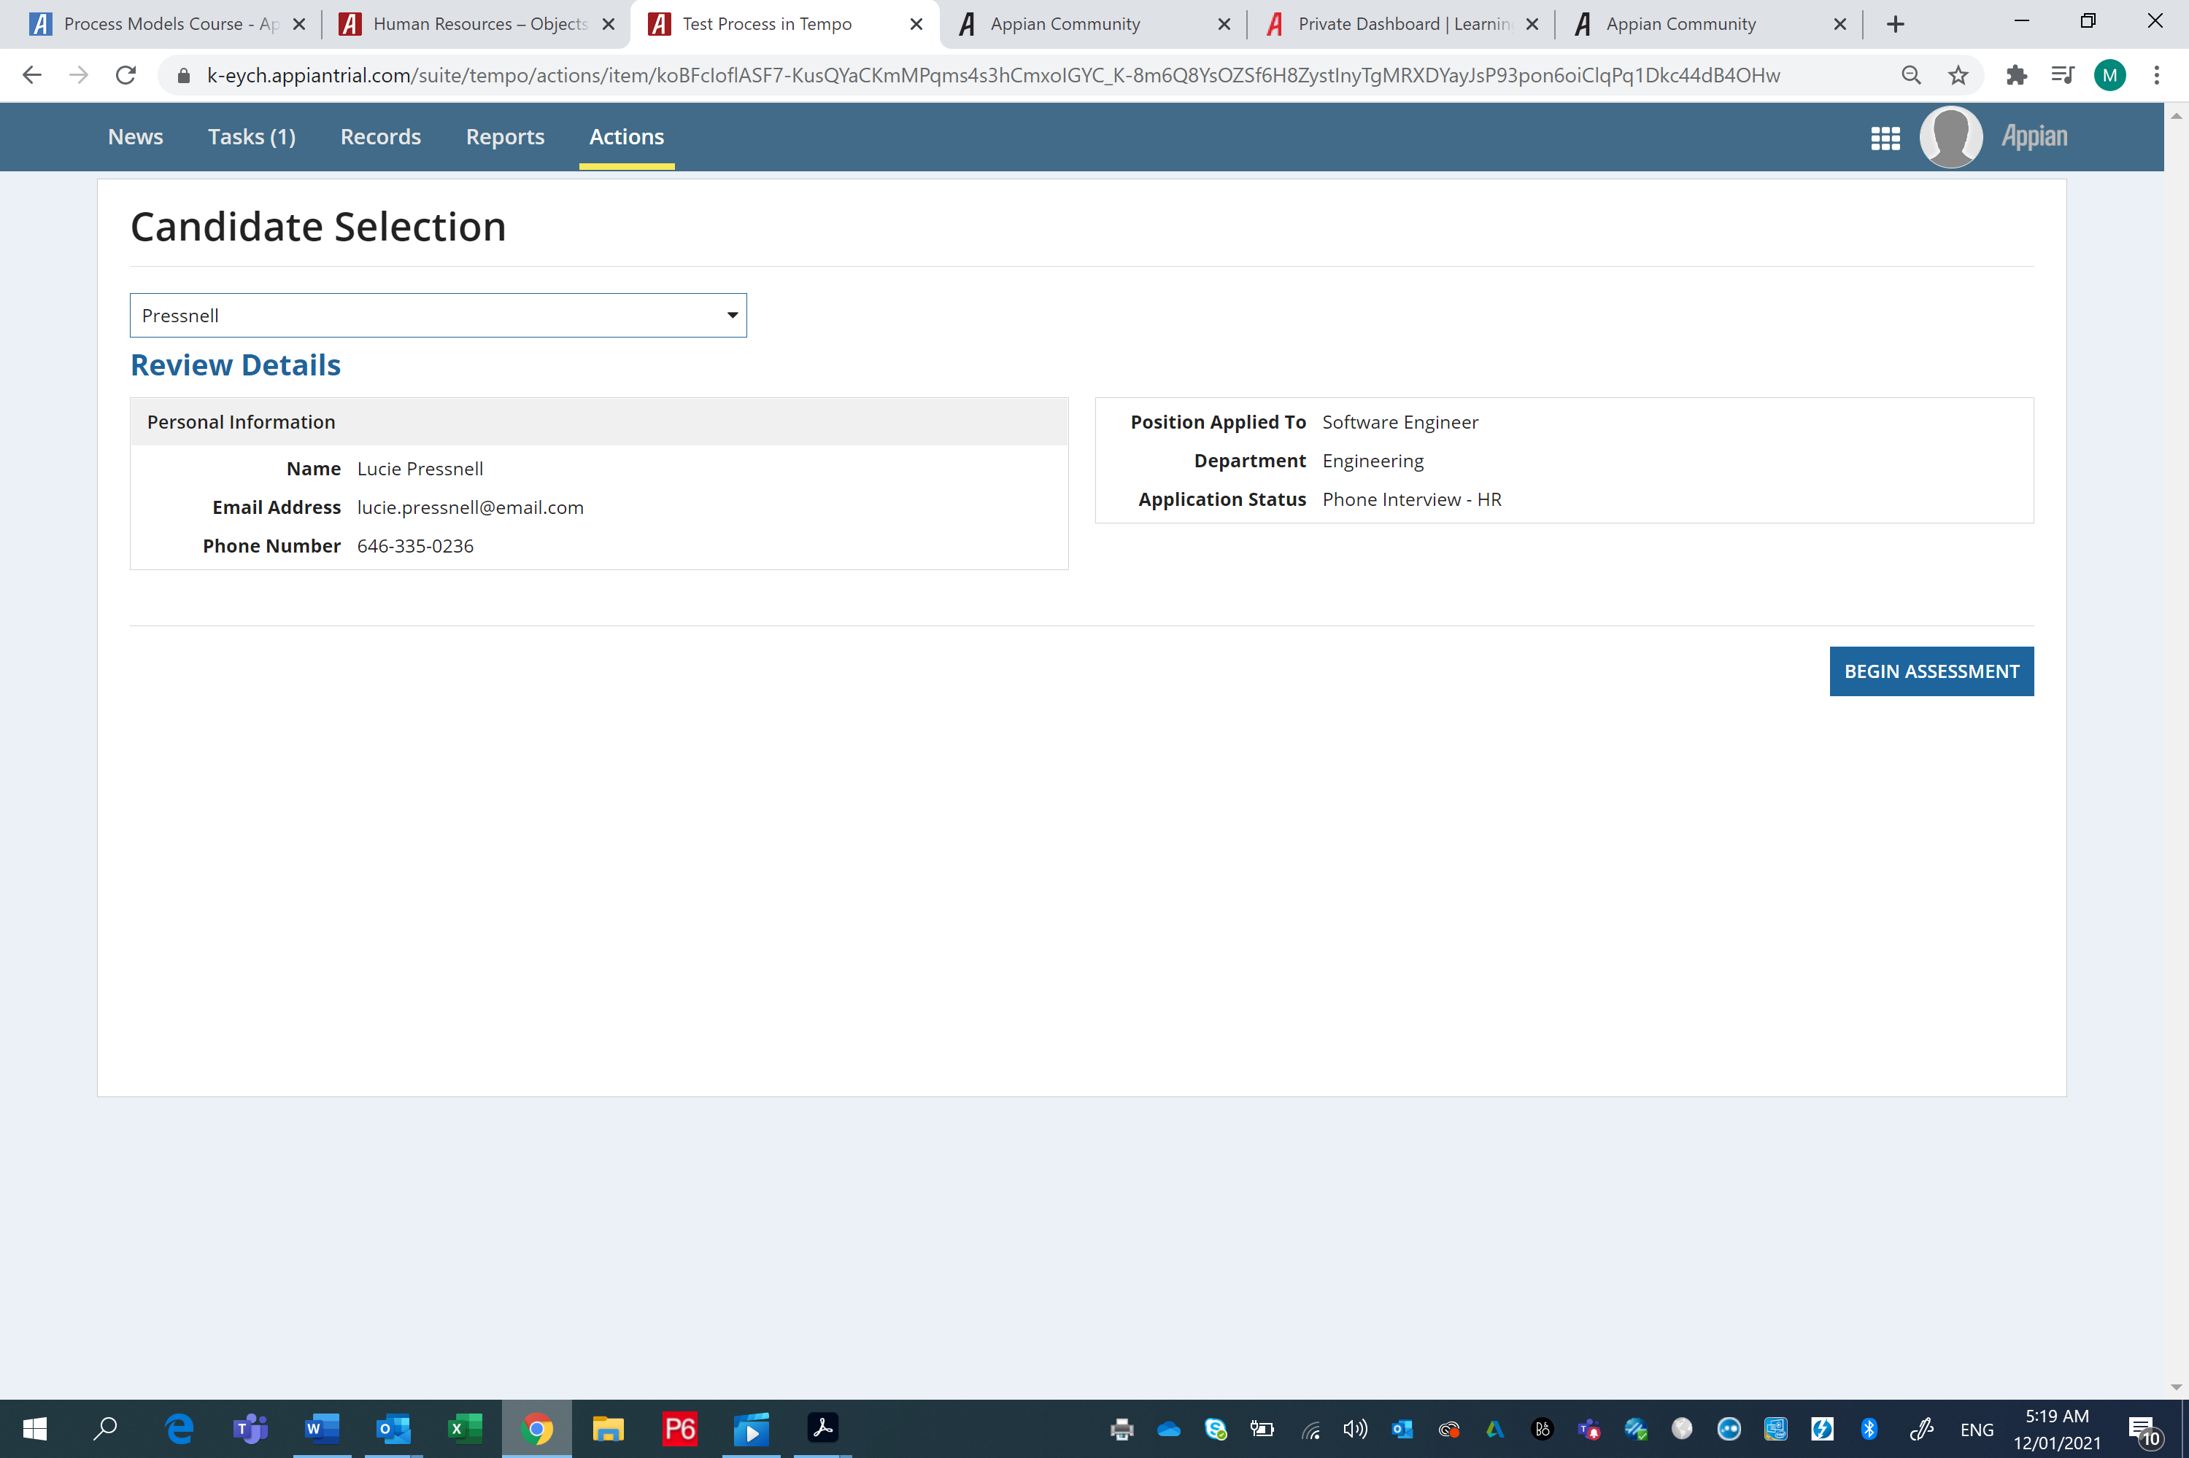

Tried the finished version of the HR Tutorial in Developer and ran in de-bug mode…
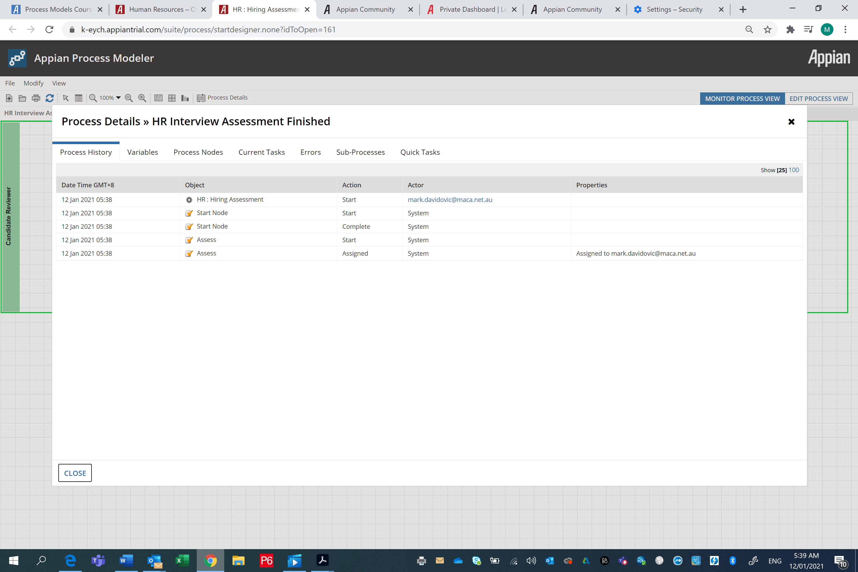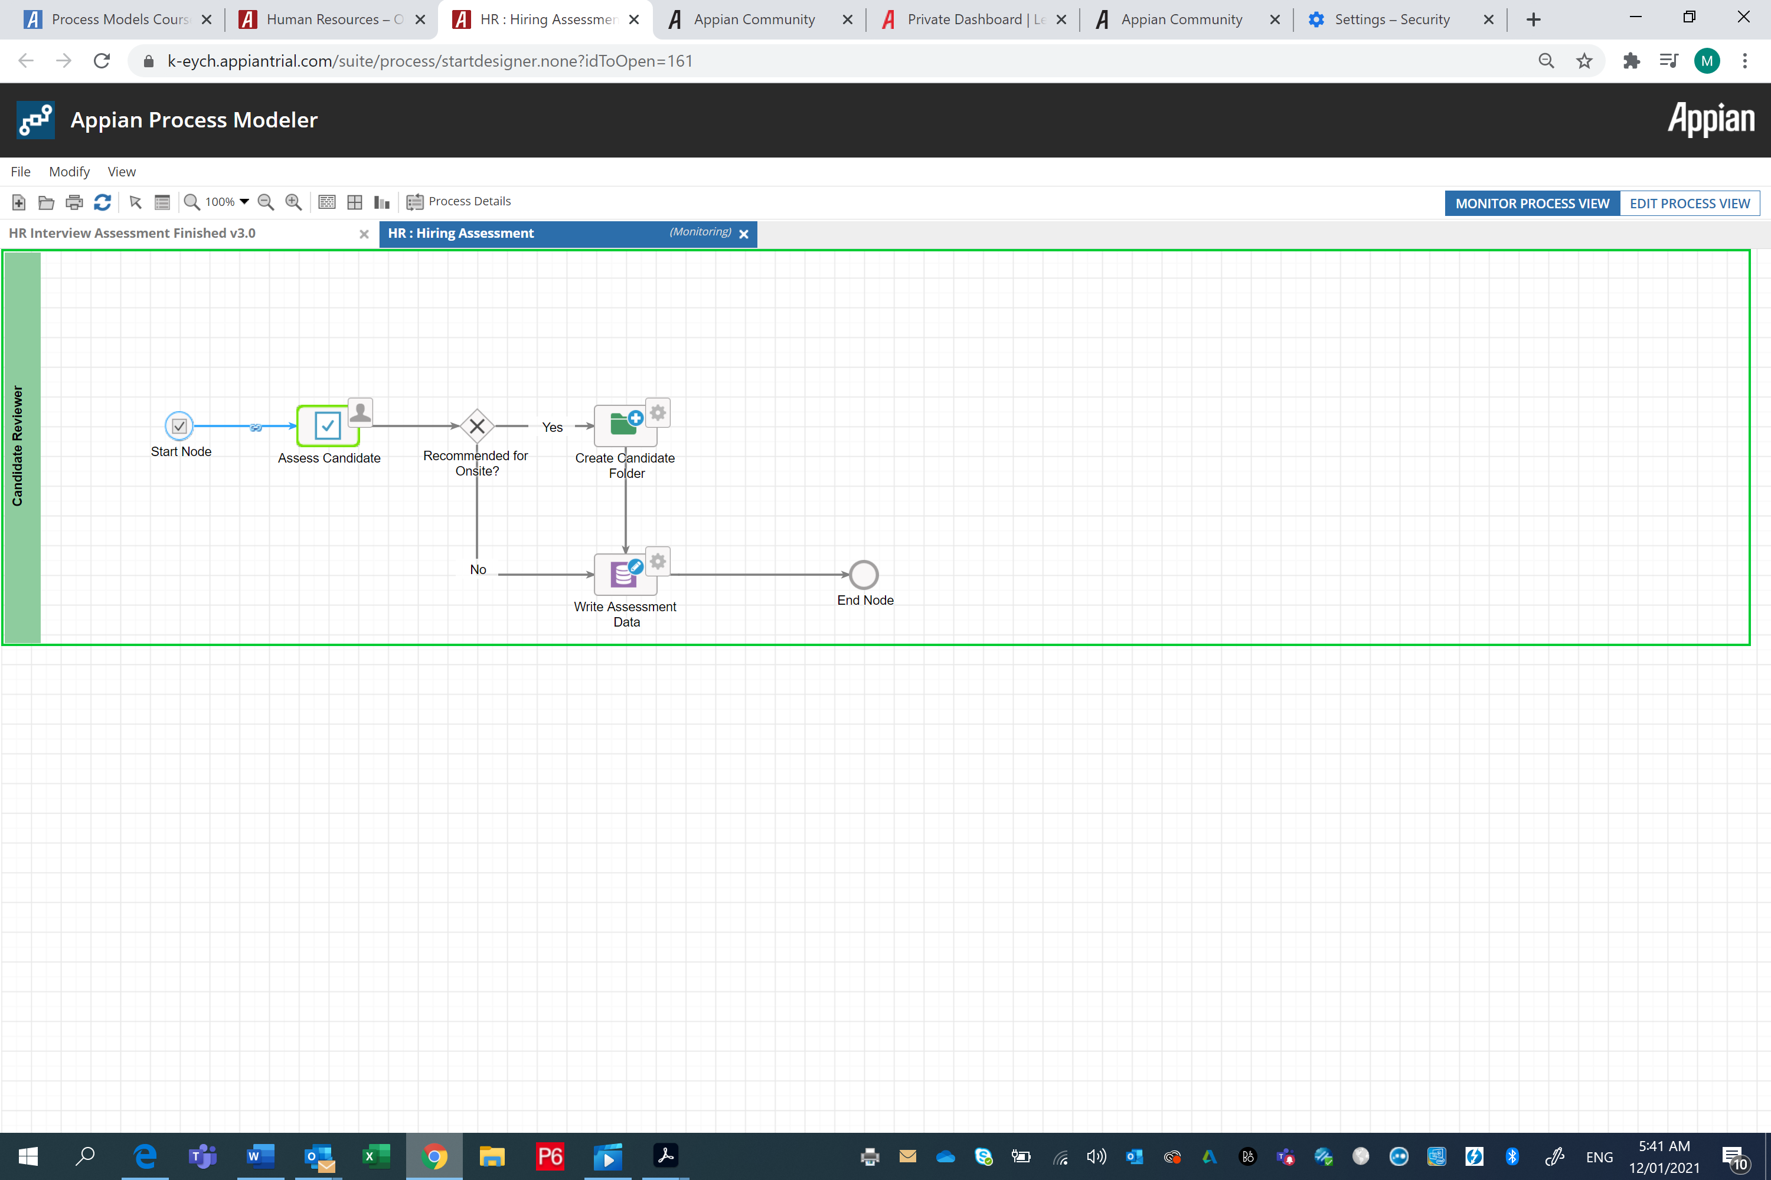
Bumped out, no Start Form. See how it only got to 1st Node
Tried in Tempo….
Worked ok & wrote to Database ok. No errors….(see 3 records written below…)
