XML File
<PersonName>
<first>Faisal</first>
<last>Faridi</last>
</PersonName>

CDT Structure:
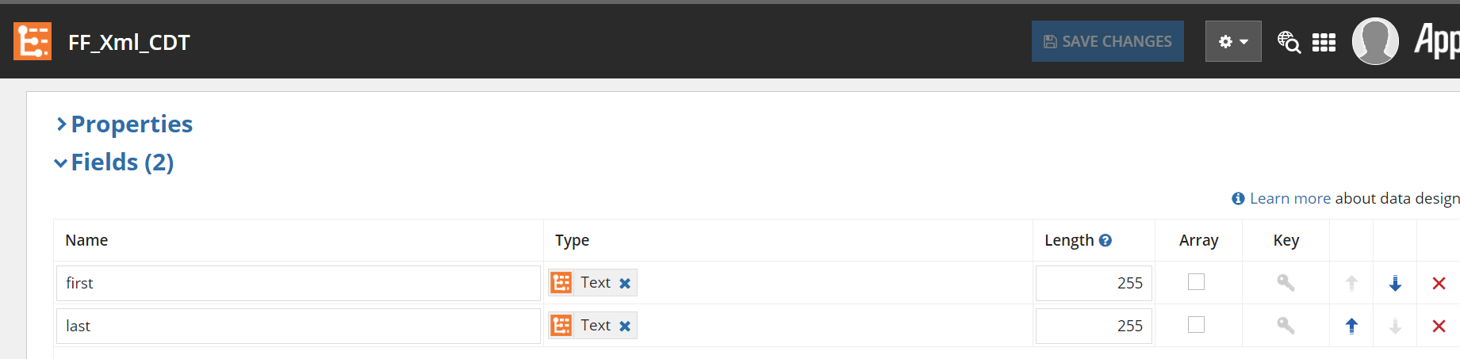

Process variables
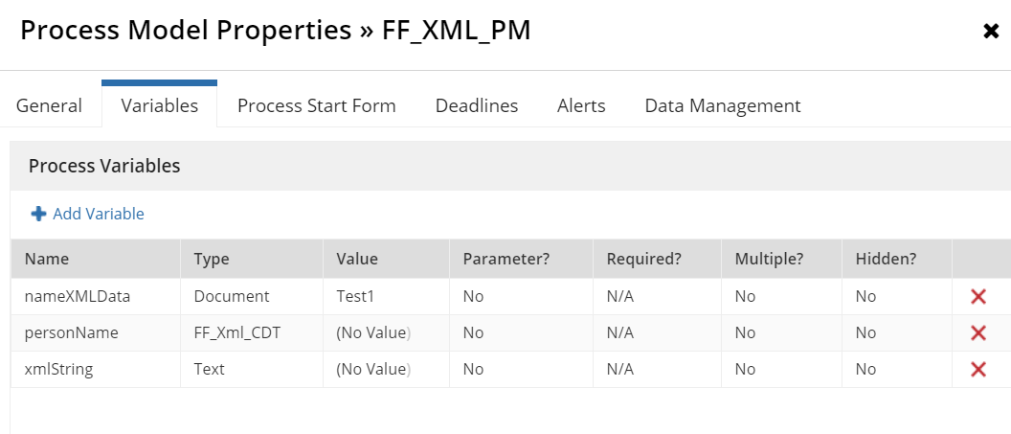

1st Script Task
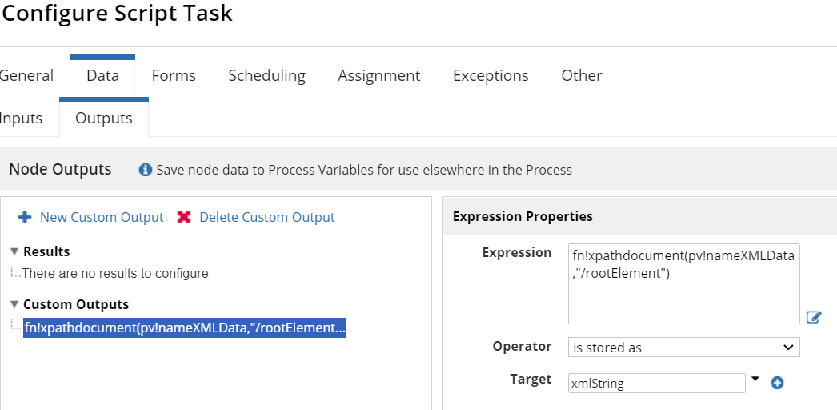

2nd Script Task

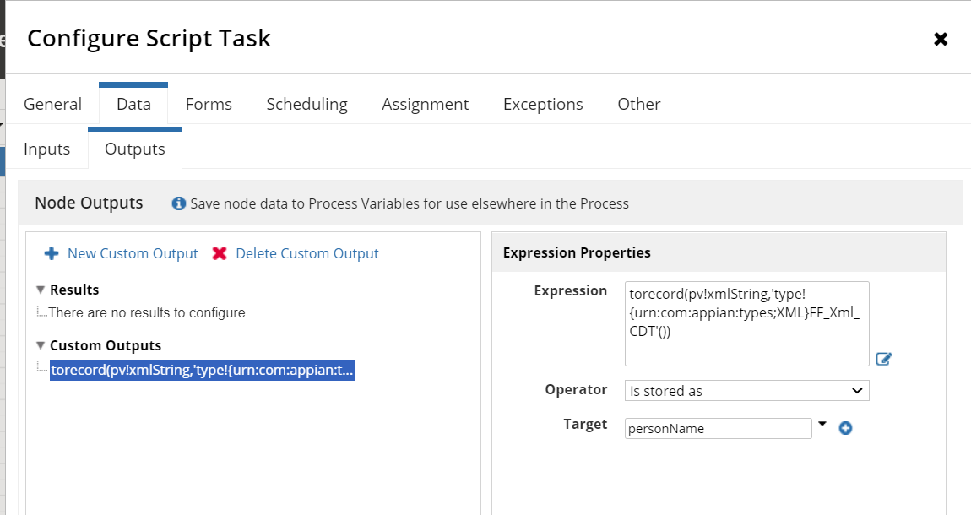

But the Process variable is not updated along with CDT which is showing null.

