I have cancelled the Start Form but the flow comes till User Input Task.
Doubt: Is this behaviour correct?

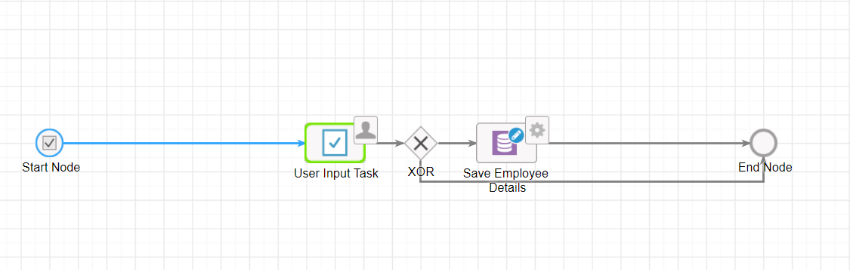

Now I submitted the start form and the flow comes at the same place as above but now I have cancelled the approver form but it took the end path without executing anything (See Below).

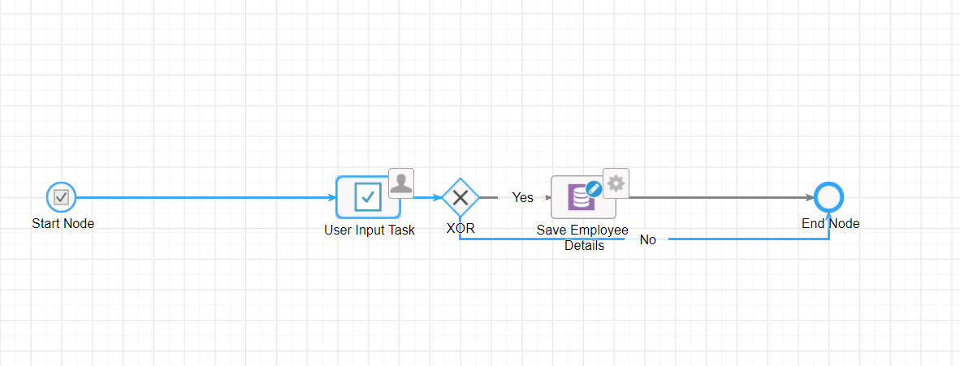
Doubt 2: My flow should not take the above path. What could be the possible solution?

XOR not configured based on cancel or Submit. It was rather based on radio buttons on the approval forms.
