This is what should occur as per the tutorial..
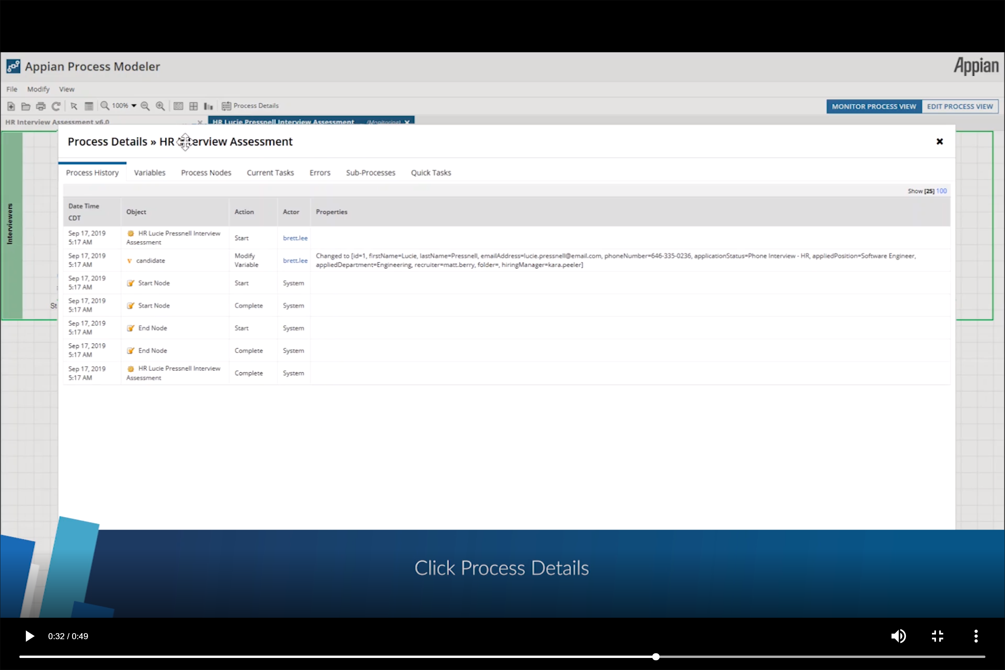

This is what comes up on mine….
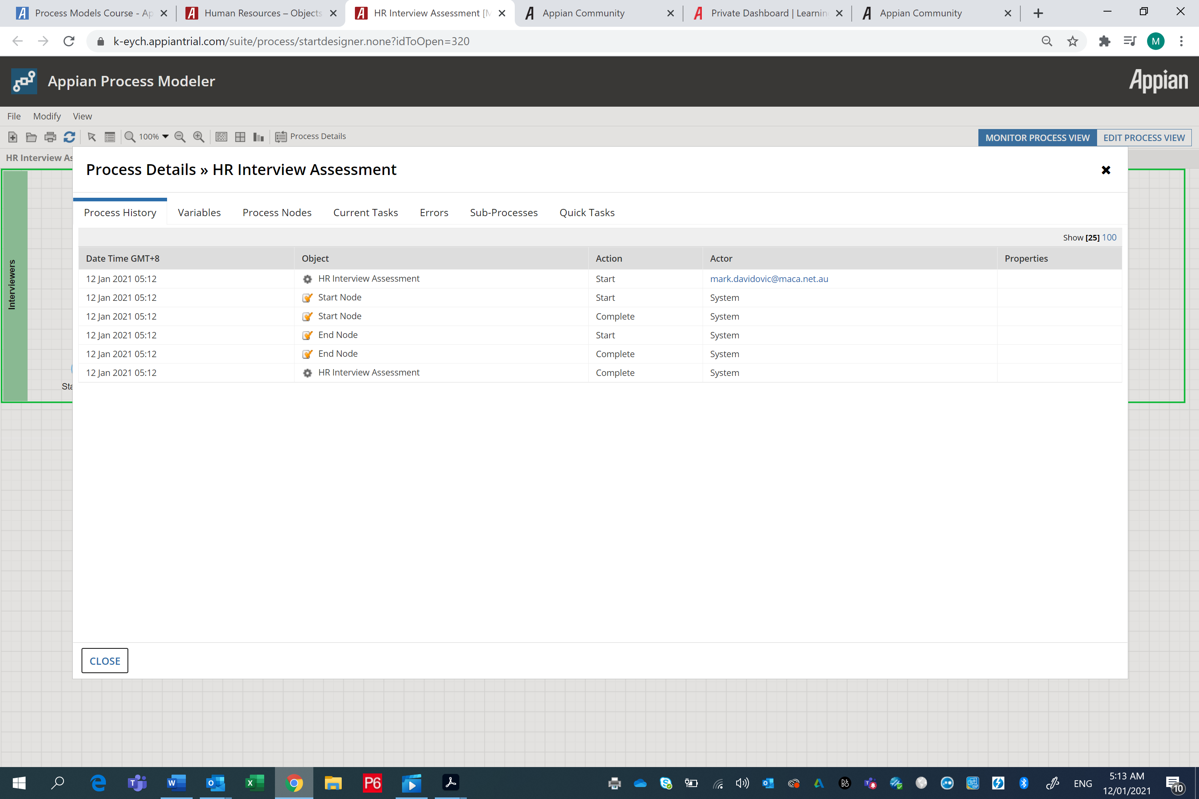
Ok, try to run the process in Tempo as per Pedro’s post…
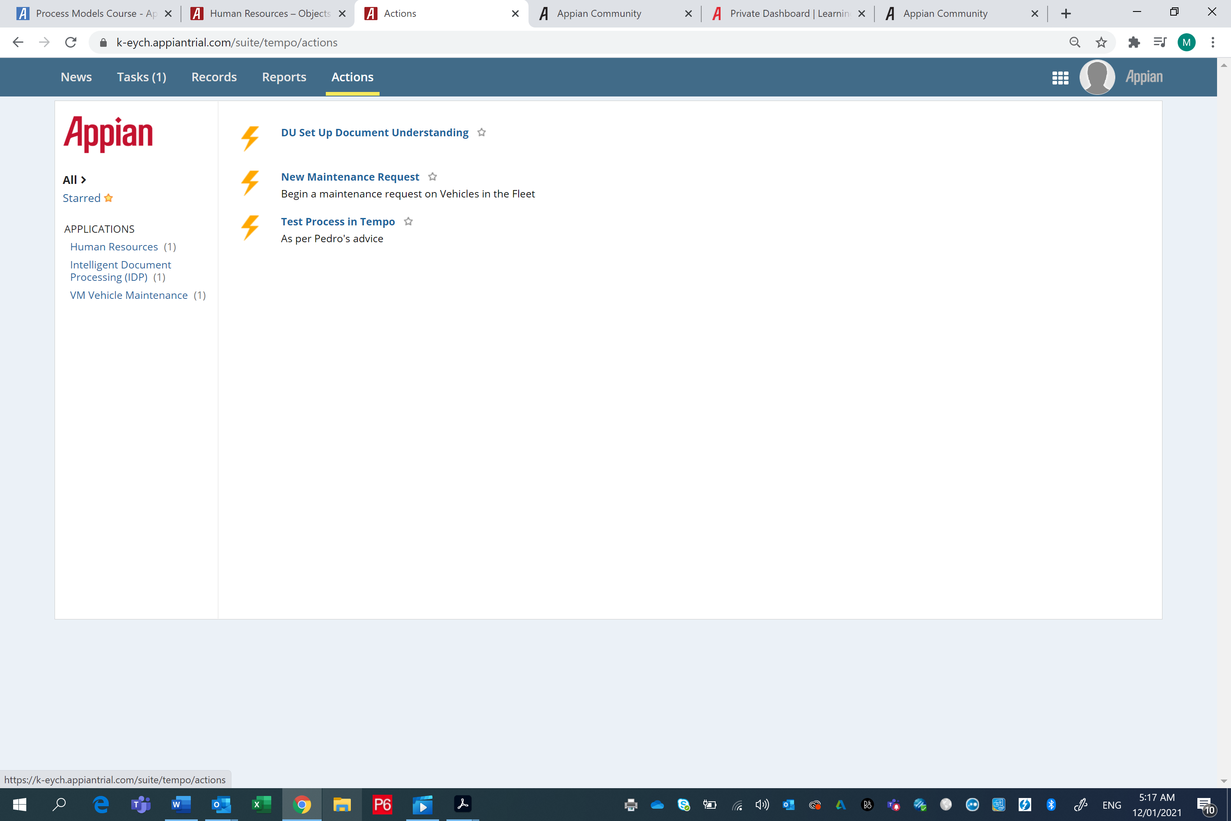

Yep, Start form invokes…..
