Below is my code:
a!localVariables(
local!accExec,
local!programInstance:
rule!GPO_getProgramInstanceDetails(
programInstanceID: ri!programInstanceID
),
local!a:rule!GPO_WEB_fetchPID(programInstanceID: 1267),
a!formLayout(
label: "Update AE/BE contact",
contents: {
a!columnsLayout(
columns: {
a!columnLayout(
contents: {
a!textField(
label: "Account Executive",
labelPosition: if(
ri!readOnly,
"ADJACENT",
"ABOVE"
),
value: local!accExec,
saveInto: {local!accExec},
readOnly: ri!readOnly,
validations: if(
len(
local!accExec
) > 255,
"Value may not be longer than 255 characters. You have entered " & len(
local!accExec
) & " characters.",
null
)
)
}
)
}
)
},
buttons: a!buttonLayout(
primaryButtons: {
a!buttonWidget(
label: "Submit",
value: local!accExec,
saveInto: {
local!a[1].accExecutive, a!save(ri!GPO_ProgramInstanceCountryMap, local!a[1]),
a!startProcess(
processModel: cons!GPO_AccountExecute_PM,
processParameters: {programInstanceCountryMap:ri!GPO_ProgramInstanceCountryMap}
)
},
submit: true,
style: "PRIMARY"
)
},
secondaryButtons: {
a!buttonWidget(
label: "Cancel",
value: true,
saveInto: ri!cancel,
submit: true,
style: "NORMAL",
validate: false
)
},
showWhen: or(
isnull(
ri!readOnly
),
not(
ri!readOnly
)
)
)
)
)

Expression Rule GPO_WEB_fetchPID:
a!queryEntity(
entity: cons!GPO_AE,
query: a!query(
logicalExpression: a!queryLogicalExpression(
operator:"OR",
filters: {
a!queryFilter(
field: "id",
operator: "=",
value: ri!id,
),
a!queryFilter(
field: "programInstanceID",
operator: "=",
value: ri!programInstanceID,
)
},
ignoreFiltersWithEmptyValues: true
),
pagingInfo: a!pagingInfo(
startIndex: 1,
batchSize: -1,
)
),
fetchTotalCount: false
).data

Process model: GPO_AccountExecute_PM

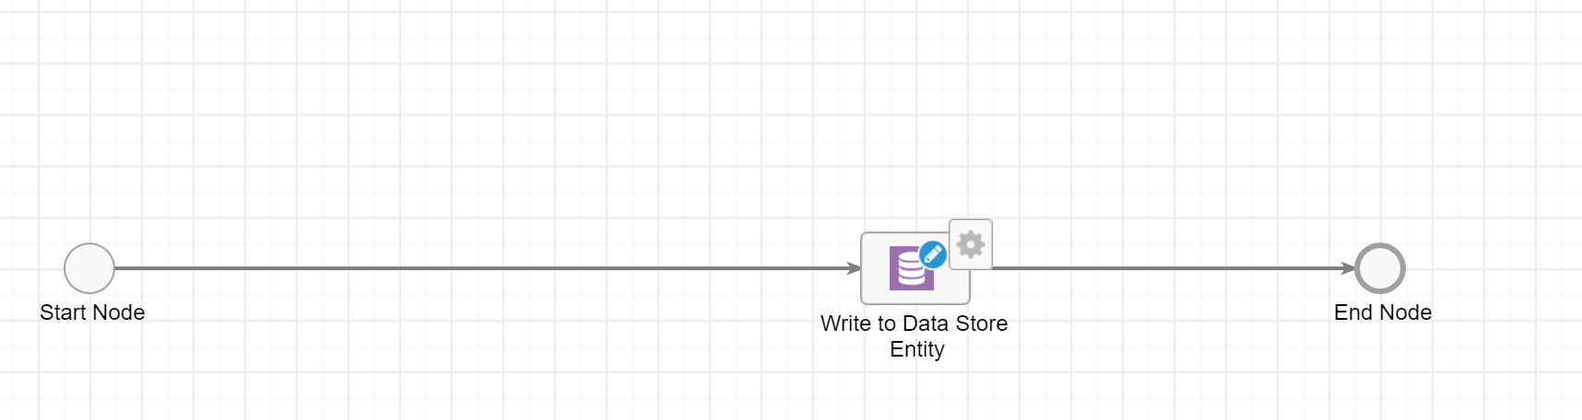
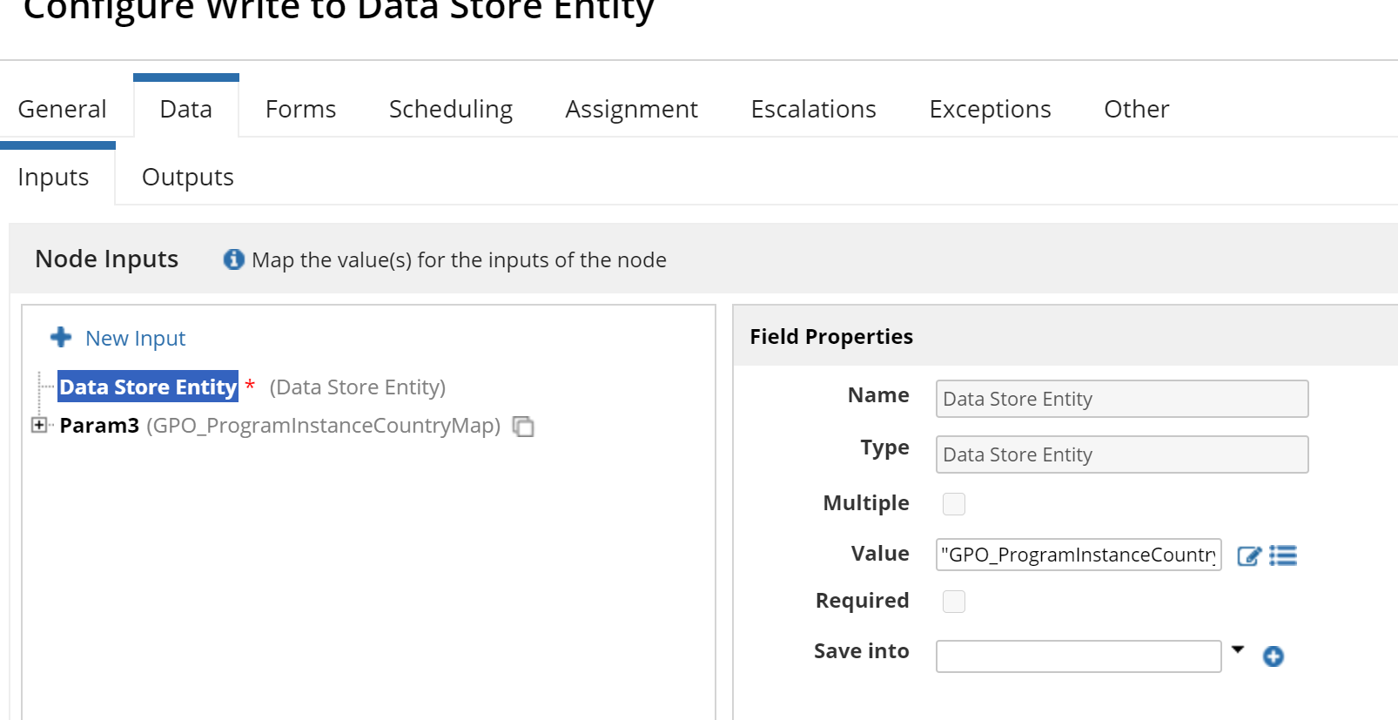

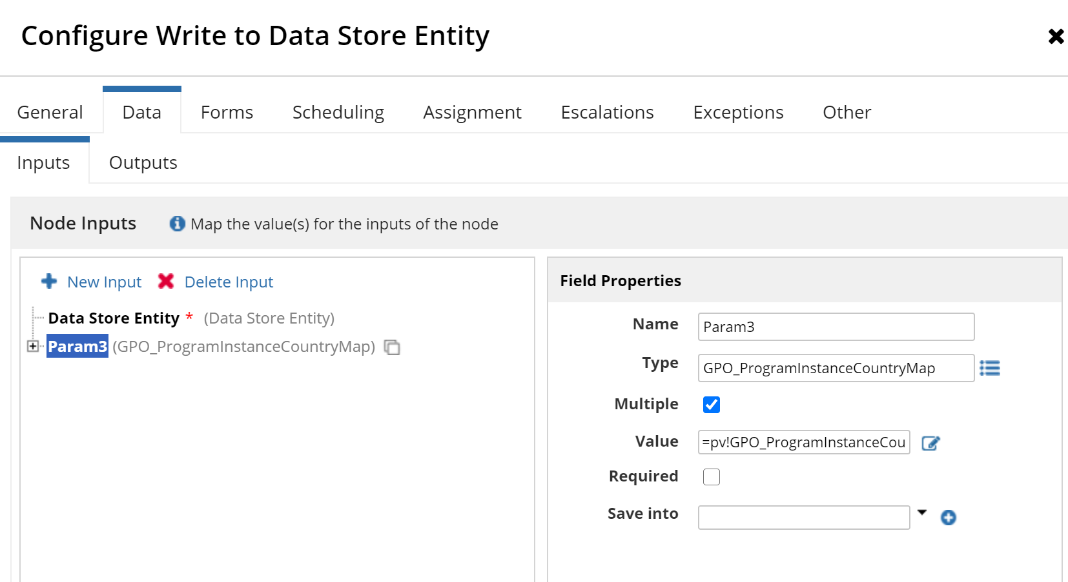

CDT Structure
