Defect in Process Model :-
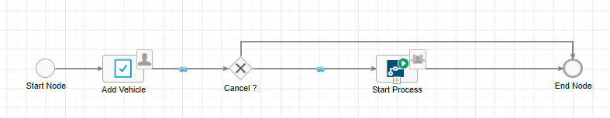
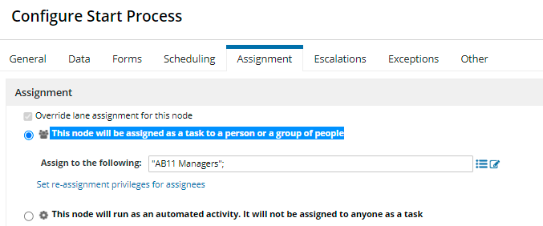

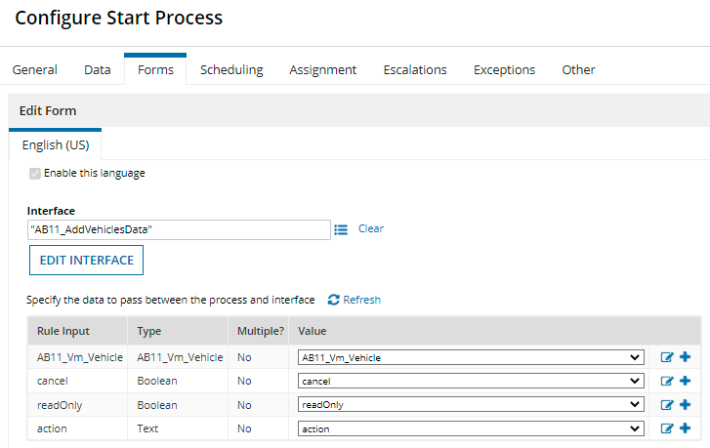

Ran Parent process.
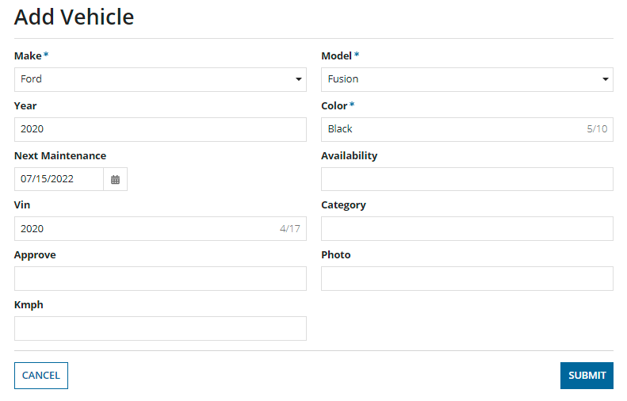
Now same data is available in start process smart service Form. Changed some values.

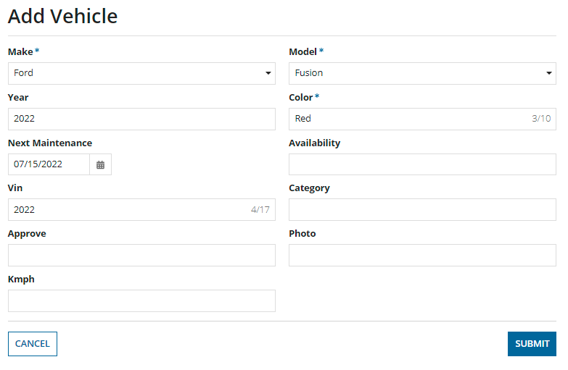

These changed values are not passed to subprocess. Then what is the user of this start process smart service Form ?
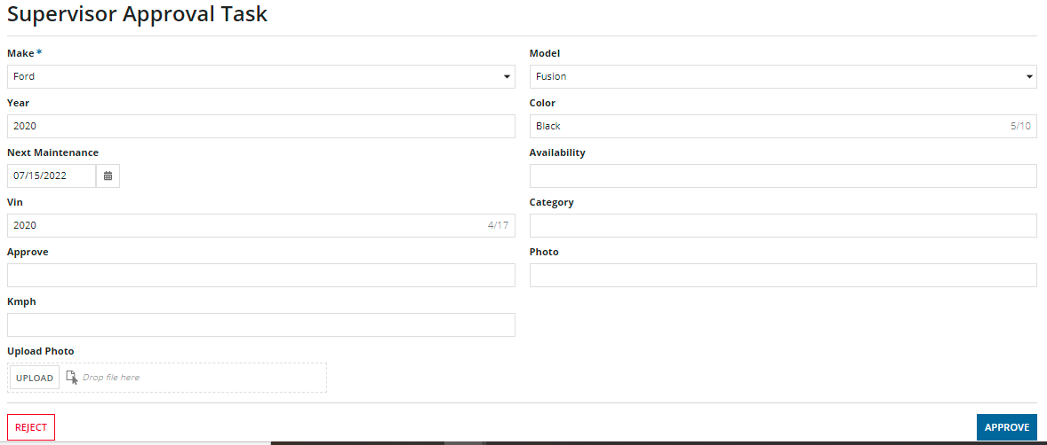

Parent process variables have updates values.

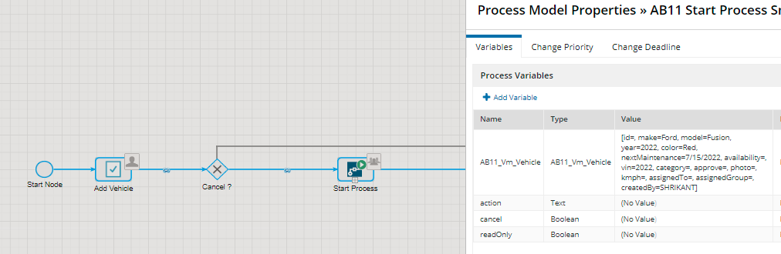

But child process has old values. (Not updated in this start process smart service Form )
