The What
Project or Product Name
Project Timeframe
?? Weeks
Product Pitch (one or two sentences)
We are building < Name> so that we can < >

The Why
Product Goals

Success Measures
These may or may not map one-to-one with Product Goals. These should be framed as measurements.
For example: Reduce < > 50% by < >
Tips: Start with Action Verbs: Achieve, Improve, Reduce, Complete, Increase
Use these 5 Categories to identify measures
Hard Dollars Saved or Incremental Revenue Achieved - identify a dollar amount saved or new revenue that will be achieved.
Process Improvements Metrics that Help Competitiveness - improvements realized that can be directly linked to your ability to compete and win new business. For example is shortening on-boarding time for new clients.
lag time?
Process Improvement Metrics that Reduce Risk - Achieving better compliance to regulations.
Process Improvement Metrics that Reduce Operating Expenses and Improve Service
General Process Improvement Metrics - For example, "99% reduction in manual steps

 | Reduce Risks | Improvement Management of | Increase Productivity
Measure
what we will measure
Source
source for measurement
Benchmark
what the situation is now
Minimum Target
the minimum acceptable value for the measurement
Desired Target
the desired target value for the measurement

The Who
Contributors and Relationships
Identify Name, skills, percent allocated to project, specific time windows they are available if necessary, and place them in the appropriate location on the venn diagram
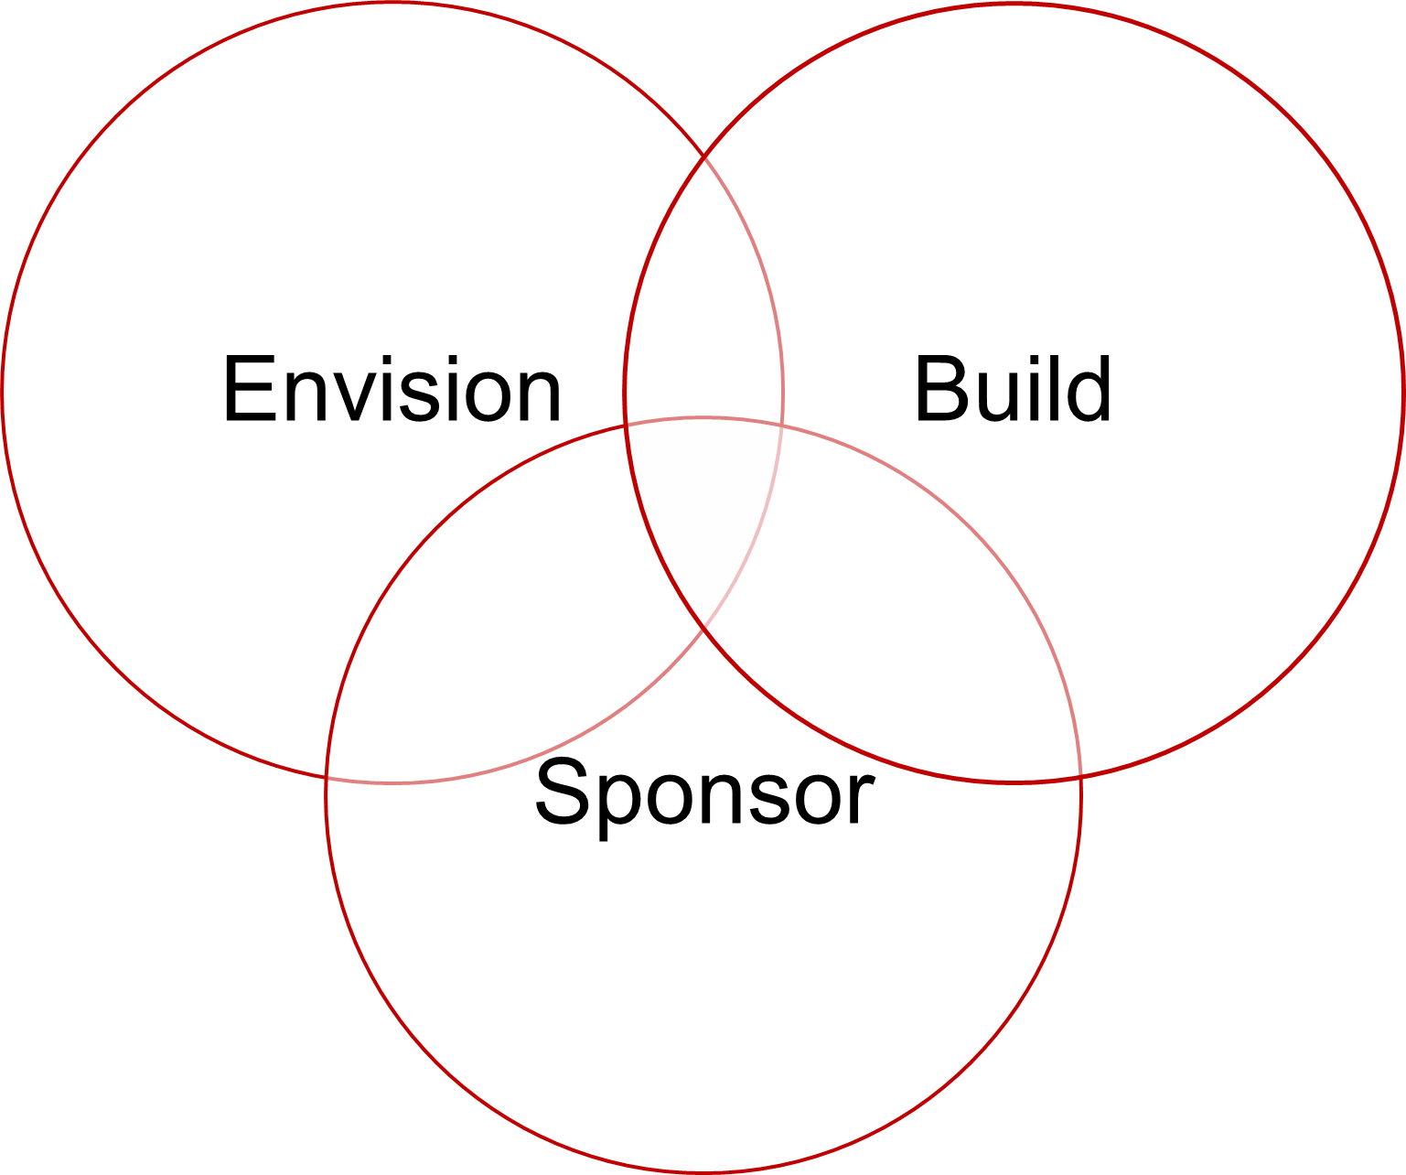

The When
Cadence
Time(s) for Sprint Retrospective/Sprint Planning, Daily Stand-Up, Sprint Demos, Prioritization Meeting, Estimation Meeting, and Backlog Grooming Sessions
Code Freeze for Demos
Sprint 3
Week of DD/MM/YY

Sprint 2
Week of DD/MM/YY
Sprint 1
Week of DD/MM/YY
User Story Workshop
10:00 – 12:00
Backlog Estimation
8:15 (after stand-up)
*Daily Stand-Ups, Daily at 9:45, webex
Holiday
Backlog Prioritization
10:00 (after stand-up)
Backlog Prioritization
10:00 (after stand-up)
Sprint Demo
10:00 – 11:00
Sprint Planning
1:00-3:00/5:00
Sprint Demo
10:00 – 11:00
Sprint Planning
1:00-3:00/5:00
Fri
Thurs
Wed
Tues
Mon
Sprint 4
Week of DD/MM/YY

Deploy
Finalize Release
End User Testing
Logistics
Time(s) for Sprint Retrospective/Sprint Planning, Daily Stand-Up, Sprint Demos, Prioritization Meeting, Estimation Meeting, and Backlog Grooming Sessions
Meeting | Required Attendees | Optional Attendees | Facilitator | Logistics | Notes
Daily Stand-Up
Backlog Prioritization
Sprint Demo
Sprint Planning

Constraints
 | Monday | Tuesday | Wednesday | Thursday | Friday | Notes  (PTO, etc.)
Product Owner Availability for Questions
Product Owner Available for Validation Review
Core Team, Core Hours

Misc.
- <insert Misc. questions specific to project context>

