Introduction
Appian led projects start with an intense two week period known as Sprint 0. During Sprint 0, the project team completes all the prep work required to quickly deliver a solution. Prep work often includes: requirements analysis, requirements decomposition, estimation and prioritization, solution design, release planning, prototype creation, design reviews, and, most likely, initial development. A list of deliverables typically produced in Sprint 0 is included in Exhibit A.

In order for Sprint 0 to be effective, a number of logistics need to be completed PRIOR to project kickoff. This document summarizes the pre-kickoff logistics as well as the schedule for Sprint 0.

Logistics
The following items must be completed prior to Day 1 of the Project:

Status | Item | Responsible Person
☐ | Provide Latest Requirement Artifacts
☐ | Create Draft Schedule for Sprint 0 (see examples below)
☐ | Reserve Conference Rooms and Desks for Project Meetings and Development Work (make sure conference rooms meet capacity requirements)
☐ | Schedule Meetings with Stakeholders (see Schedule section for details) for First Two Weeks
☐ | Complete install of at least 2 Appian environments (development and test)
☐ | Provide a list of environments and their purpose (e.g. test environment is used for integration testing)
☐ | Provide team members with Admin Accounts to Appian Development and Test Environment
☐ | Provide Appian with Expense Policy (if different from MSA)
☐ | Provide Appian with Permission to Book Travel

Additional logistics if initiating a new project with an Appian Expert Delivery team:

Status | Item | Responsible Person
☐ | Provide Appian Staff Building and After-Hours Access for First Two Weeks
☐ | Complete Background or Any Other Security Checks
☐ | Provide Appian Staff with Required Domain Accounts
☐ | Provide Appian with Guest Network Access for Onsite Meetings (e.g. guest wifi)
☐ | Provide Appian Staff with Required Network Accounts including VPN
☐ | Provide Appian Staff with Company Laptops (if required)

Sprint 0 Schedule

SAMPLE Sprint 0 Calendar
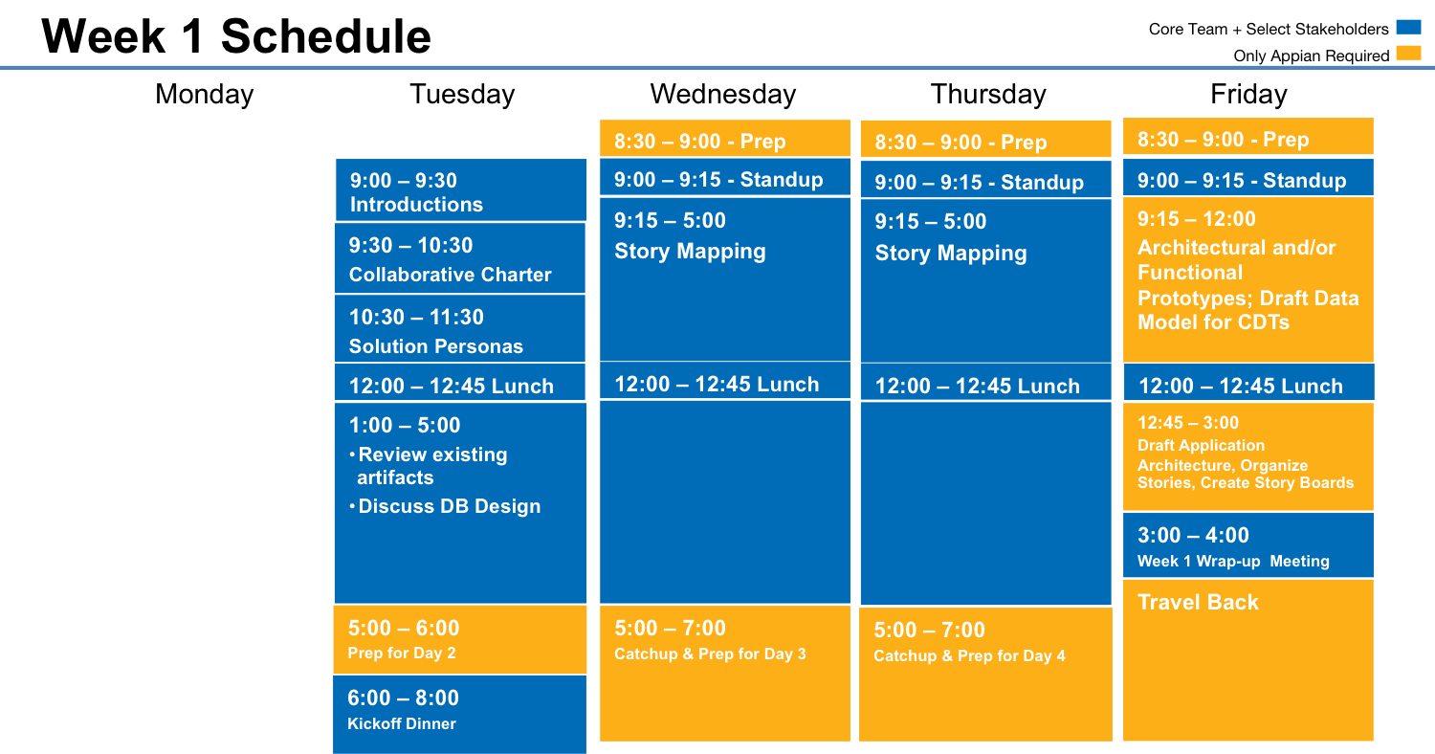

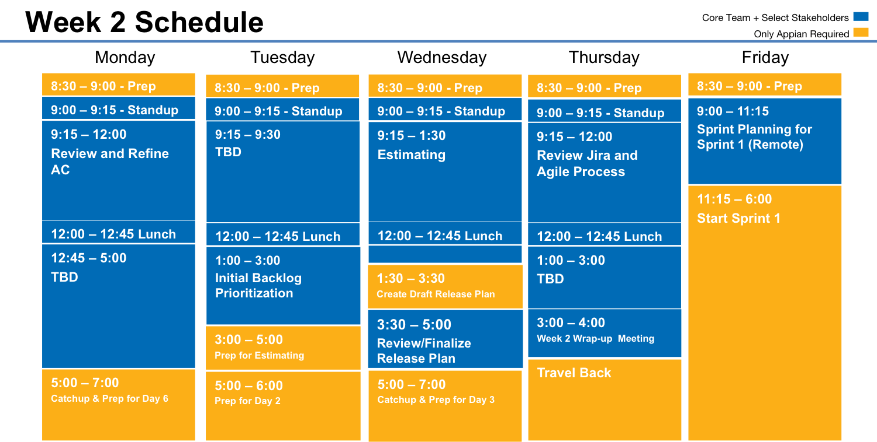

SAMPLE Schedule Details

Week 1 Draft Schedule (Note: this schedule will be updated on a daily basis)

Tuesday MM/DD/YYYY
Meeting | Time | Objectives | Attendees | Reach Back Support | Logistics
Project Kick Off | 9:00 – 9:30 | Introduce Team Members and Review Schedule | Company Core Team and Appian Core Team | n/a | Meeting Room with Projector, and Whiteboard or Easel
Collaborative Project Charter | 9:30 – 10:30 | Clarify project goals, team members roles and responsibilities, communications protocol, and other logistics | Company Core Team and Appian Core Team | n/a | Meeting Room with Projector, and Whiteboard or Easel
Solution Personas | 10:30 – 11:30 | Identify Users, Discuss their Current-Day Problems, Define Benefits they Want from the Solution, and Begin to Identify Groups | Company Core Team and Appian Core Team | n/a | Meeting Room with Projector, and Whiteboard or Easel
Review existing artifacts, database design and testing plans | 1:00 – 5:00 | Ensure shared understanding of future state design | Company Core Team and Appian Core Team | SMEs not on the Company Core Team | Meeting Room with Projector, Whiteboard or Easel, and Wall to Hang Post-Its
Kick-Off Dinner (Tentative) | 6:00 – 8:00 |  | Company Core Team and Appian Core Team | n/a | TBD
Wednesday MM/DD/YYYY
Meeting | Time | Objectives | Attendees | Reach Back Support | Logistics
Daily Standup | 9:00 – 9:15 | Review plan for the day and make sure everyone is aware of any updates | Company Core Team and Appian Core Team | n/a | Meeting Room
Story Map | 9:15 – 5:00 | Capture detailed functional requirements | Company Core Team and Appian Core Team | SMEs not on the Company Core Team | Meeting Room with Projector, Whiteboard or Easel, and Wall to Hang Post-Its
Thursday MM/DD/YYYY
Meeting | Time | Objectives | Attendees | Reach Back Support | Logistics
Daily Standup | 9:00 – 9:15 | Review plan for the day and make sure everyone is aware of any updates | Company Core Team and Appian Core Team | n/a | Meeting Room
Story Map | 9:15 – 5:00 | Capture detailed functional requirements | Company Core Team and Appian Core Team | SMEs not on the Company Core Team | Meeting Room with Projector, Whiteboard or Easel, and Wall to Hang Post-Its
Friday MM/DD/YYYY
Meeting | Time | Objectives | Attendees | Reach Back Support | Logistics
Daily Standup | 9:00 – 9:15 | Review plan for the day and make sure everyone is aware of any updates | Company Core Team and Appian Core Team | n/a | Meeting Room
Architectural and Functional Prototypes and Draft Data Model for CDTs | 9:15 – 12:00 | Refine Initial Design Plans | Select Members of Core Teams | SMEs not on data team | Meeting Room with Projector, Whiteboard or Easel, Story Map Hanging on Wall
Draft Application Architecture, Organize Stories, Create Story Boards | 12:45 – 3:00 | Document the initial design plans in the Application Architecture document and start creating story boards | Appian Core Team | TBD | Meeting Room with Projector, Whiteboard or Easel, Story Map Hanging on Wall
Week 1 wrap up meeting | 3:00 – 4:00 | Share with the group what we achieved in week 1. | Company Core Team and Appian Core Team | n/a | Meeting Room

Week 2 Draft Schedule (Note: this schedule will be updated on a daily basis)
Monday MM/DD/YYYY
Meeting | Time | Objectives | Attendees | Reach Back Support | Logistics
Daily Standup | 9:00 – 9:15 | Review plan for the day and make sure everyone is aware of any updates | Company Core Team and Appian Core Team | n/a | Meeting Room
TBD | 9:15 – 12:00 | TBD | Company Core Team and Appian Core Team | SMEs not on the Company Core Team | Meeting Room with Projector, Whiteboard or Easel, Story Map Hanging on Wall
Review and Refine AC | 12:45 – 5:00 | Refine AC that will be used for Stories and Promote shared understanding | Company Core Team and Appian Core Team | SMEs not on the Company Core Team | Meeting Room with Projector, Whiteboard or Easel, Story Map Hanging on Wall
Tuesday MM/DD/YYYY
Meeting | Time | Objectives | Attendees | Reach Back Support | Logistics
Daily Standup | 9:00 – 9:15 | Review plan for the day and make sure everyone is aware of any updates | Company Core Team and Appian Core Team | n/a | Meeting Room
TBD | 9:15- 12:00 | TBD | Company Core Team and Appian Core Team |  | Meeting Room
Backlog Prioritization | 1:00 – 3:00 | Prioritize Backlog | Appian Core Team, Company PO and/or PM | Company SMEs | Meeting Room with Projector, Whiteboard or Easel, Story Map Hanging on Wall
Prep for estimating | 3:00 - 5:00 | Internal discussions and preparation for story point estimating | Appian Core Team |  | Meeting Room with Projector, Whiteboard or Easel, Story Map Hanging on Wall
Wednesday MM/DD/YYYY
Meeting | Time | Objectives | Attendees | Reach Back Support | Logistics
Daily Standup | 9:00 – 9:15 | Review plan for the day and make sure everyone is aware of any updates | Company Core Team and Appian Core Team | n/a | Meeting Room
Estimating Session | 9:15- 1:30 | Complete Estimating backlog items | Appian Core Team, Company designers, Company PO and/or PM | Company SMEs | Meeting Room with Projector, Whiteboard or Easel, Story Map Hanging on Wall
Create Draft Release Plan | 1:00 – 3:00 | Create Draft Release Plan | Appian Core Team | n/a | Meeting Room with Projector, Whiteboard or Easel, Story Map Hanging on Wall
Review Draft Release Plan | 3:30 – 5:00 | Review Draft Release Plan | Appian Core Team, Company designers, Company PO and/or PM and core sponsor | Company SMEs | Meeting Room with Projector, Whiteboard or Easel, Story Map Hanging on Wall
Thursday MM/DD/YYYY
Meeting | Time | Objectives | Attendees | Reach Back Support | Logistics
Daily Standup | 9:00 – 9:15 | Review plan for the day and make sure everyone is aware of any updates | Company Core Team and Appian Core Team | n/a | Meeting Room
Review Jira | 9:15 - 12:00 | Familiarize Company with how to track and monitor the project | Appian TDM and Company PO and/or PM | n/a | Meeting Room with Projector, Whiteboard or Easel, Story Map Hanging on Wall
TBD | 1:00 – 3:00 | TBD |  |  | Meeting Room
Week 2 wrap up meeting | 3:00 – 4:00 | Share with the group what we achieved in week 2. | Company Core Team and Appian Core Team | n/a | Meeting Room
Friday MM/DD/YYYY
Meeting | Time | Objectives | Attendees | Reach Back Support | Logistics
Sprint Planning | 9:00 – 11:00 | Plan Sprint 1 | Appian Core Team and Company PO | n/a | n/a – Team will be remote. Meeting conducted via webex

Exhibit A – Typical Sprint 0 Deliverables

Sprint 0 produces some or all of the following deliverables:
- Project Kickoff Deck
- Sprint 0 Schedule
- Project Charter
- User Personas
- Product Backlog
a prioritized list of items (aka “backlog items”) that contain short descriptions of functionality desired in the application
- Definition of Ready (DoR) and Definition of Done (DoD)
i.e. criteria required for a backlog item to enter or exit a Iteration respectively
- Release Plan*
- Appian Architecture Document
- Data Model
- Data Dictionary
- Prototypes (aka POCs or Mockups)
- Story Board
- Story Map
- Implemented User stories (including technical stories such as CDT creation)

(*) indicates required deliverable

