Project Description Example
< Project 001 >

Table of Contents

Project Description 1
Project Overview 1
Process 3
Data 3
Integrations 5
PLugins 5
Reports and Content Management 5
Infrastructure & Security 6
Culture and SDLC 6
Project Organization 7
Quality Assurance 7
Potential Impediments and Risks 7

Project Description
Project Overview
One Sentence Summary
This solution will allow the creation of Contracts, including review process and integration with an External System to facilitate the creation of Contracts in the External System

Description of As-Is
The existing solution is partly supported in Salesforce (SFDC) and emails and The Company would like to move completely away from SFDC to Appian. Integrations between SFDC and External System are currently via emails and human intervention (swivel chair).

Description of To-Be
Sales team would log into Appian and initiate the creation of a new Contract. Certain contracts, depending on simple logic (based on contract amount), require a review step by Sales Management. The contracts that do not require a review step are “auto” approved.
Appian generates PDF versions for all approved contracts based on one of seven (7) templates. The PDF version of the contracts are associated with the Contracts and available to view/download and stored in Appian. PDF Contracts could be re-generated on request. Approved contracts also trigger the creation of contracts in the External System through an integration.
The Sales team can also initiate a Execute Item in External System from Appian through an action associated with a Contract.

Process
Key Processes

- Contract Creation and Approval
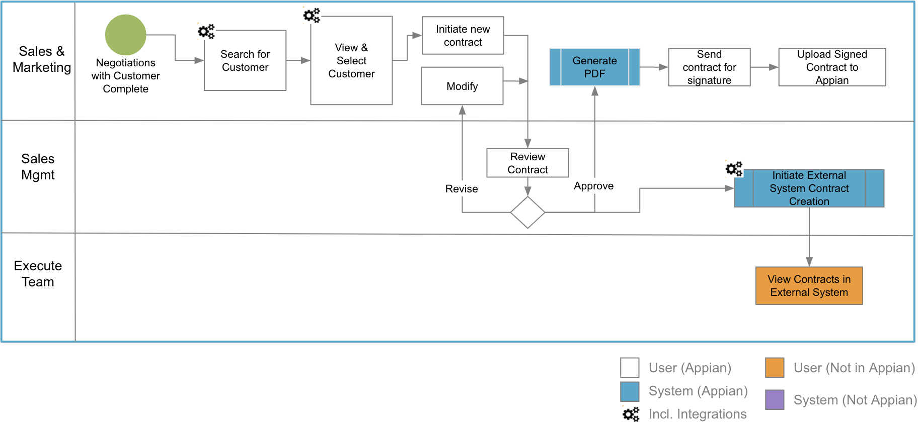

- Execute Item Request

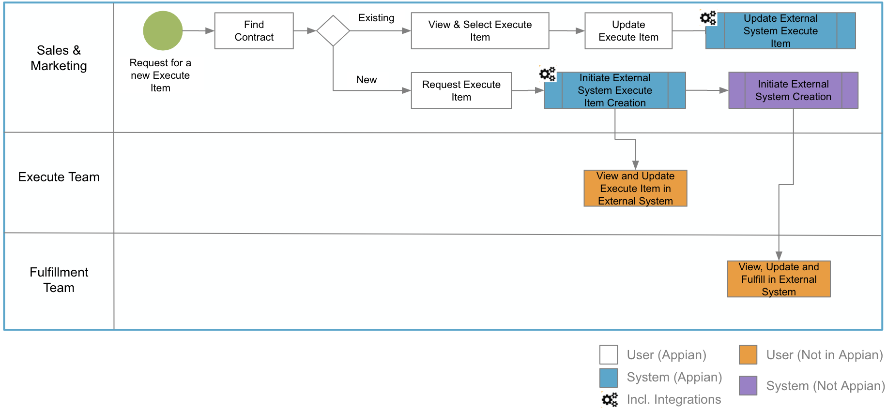

Actors
- Sales Team
- Marketing Team
- Sales Managers
- Marketing Managers
Notable Business Rules
- Logic to select certain Contracts for additional review/approval
  - Based on contract value and volume
- Choice of template (out of ~7) to use to create PDF versions of contracts
Data
Records
- Customer
  - Source: External System, lookup via integration
  - Details
    - ~ 50 data fields and simple validations/business rules
    - ~ Few (2-3) thousand customers
- Supplier
  - Source: External System, lookup via integration
  - Details
    - ~ 40 data fields and simple validations/business rules
    - ~ 1500 suppliers
- Contract
  - ~ 40 Fields and simple validations/business rules
  - ~ 2 documents per Contract
  - ~ 10k - 12k created per year
  - ~ 6 formats of contract templates
- Execute Item
  - ~ 10 Fields and simple validations/business rules
  - ~ 80k processed per year
Logical Data Model
n/a

Audit
Logging of the approval process including comments must be available. PDF Version of contracts, when generated, must also track which user triggered the manual generation.
Integrations
Types of Integrations
- All integrations will be through AcmeOne Integration Services
- ReSTful services

Number of Integrations
- Read/Lookup
  - Customers (External System)
  - Execute Items
- Writes/Updates
  - Contract in External System
  - Execute Item in External System
  - Update Execute Item in External System
Implementation Details
- All integrations services need to be built prior to project start
Miscellaneous Information
n/a

Plugins
Plugin Implications
no plugins required

Reports and Content Management
Reports
Two (2) medium sized report

Content Management

n/a

Infrastructure & Security
On-Premise and/or Cloud
Cloud install communicating with one on premise systems (External System) through AcmeOne Integration Services
Network
Assume VPN will be implemented
Authentication
n/a
Environments
Standard cloud setup
Security Considerations

- Contract information and documentation visibility must be limited to the Sales Team and Sales Management teams

Culture and SDLC
SDLC
n/a
Agile Maturity
Familiar but not widespread practitioners
Big Bang vs. Incremental
Multiple phases planned. Phase 1 must contain Contract management and Execute Item management
Deployment Governance
n/a
Overhead Requirements
n/a

Project Organization
Team Composition
n/a
Stakeholder Considerations
n/a
Product Owner
n/a

Quality Assurance
Testing Processes
Assume delivery team will test their work within the Sprints. Assume an external QA team will test functionality as they become available to test.
Assume Hardening for end to end testing and a UAT period

External QA Involvement
Unknown
Other QA Considerations
n/a
Potential Impediments and Risks

- All integration services yet to be built in AcmeOne Integration Services

Sizing Panel

Guidance
- Consider Sprint 0 and Hardening while estimating
- Consider standard <x> person delivery pod

Attendees
<5 attendees>

Baselines doc <link to a document containing baseline project sizes that attendees are familiar with>

Sizes
Instructions: Please send <coordinator> your individual estimate
 | Size (S, M, L, XL) | Notes

