Overview
The Calendar component rule, calendarDisplayField, is defined with the following inputs:

Param | Type | Default Value | Options
title | String / Input - optional | Month Year (e.g. January 2021)
showTitle | Boolean / Input - optional | true
viewType | String / Input - required | week view | DAY, WEEK, MONTH
dateContext | Text / Input - required | Today
detailDateFormat | Text / Input - optional | MM/DD/YYYY
visibleWeeks | Integer / Input - optional | All weeks for a month
weekendDisplay | String / Input - optional | Show weekends | FULL, NARROW, NONE
useDetailPopup | Boolean / Input - optional | True
readOnly | Boolean / Input - optional | False
events | Dictionary?list / Input - optional | n/a
selectedEvent | Text / Output - optional | n/a
theme | Dictionary - optional | Basic theme using site’s Accent color
timezone | Text - optional | Browser timezone | TZ timezone name or code (https://en.wikipedia.org/wiki/List_of_tz_database_time_zones)

Timezones
This component expects all times are provided as GMT since the component inherits the browser/system timezone. Your events may appear at incorrect times if you do not follow this guidance.

Provided Utilities
- Rule - GCG_RULE_Util_mergeChangedEvent
  - If working with an editable calendar, this rule helps with merging a changed event back into a local variable (typically your events input
- Rule - GCG_CAL_Util_convertDatetimetoUTC
  - Shows an example of taking a datetime string and transforming it to UTC format.
- Site - GCG Calendar Demo
  - Showcases a few working implementations of the calendar

Event Structure
The events dictionary has the following support elements. Note that ToastUI supports more elements but they are not officially supported by this component in the current release:

Param | Required | Type | Description
id | No | Integer | A unique integer value for an event, such as a database Primary Key. Not required, but strongly recommended.
calendarId | Yes | Integer | Must use 1 to inherit styling characteristic..
category | Yes | Text | Must be time at this time.
start | No | UTC formatted timestamp | Start datetime of an event. If left blank, the event time will be marked as the current time. Must be GMT to support browser timezone offset.
end | No | UTC formatted timestamp | End datetime of an event. If left blank, the event will end 30 minutes after the start time. Must be GMT to support browser timezone offset.
location | No | Text | Location of event.
attendees | No | Text | Text?list | Attendees of event. Can be a single string or a Dictionary array. Strings are presented as-is; Arrays are joined with a comma delimiter
body | No | Text | Body of event.
color | No | Text | Text color of title in event card. Supports HTML color, HEX code, or rgba() string.
bgColor | No | Text | Background color of event card. Supports HTML color, HEX code, or rgba() string.
borderColor | No | Text | Color of left bar of event card. Supports HTML color, HEX code, or rgba() string.

Example Events and Behaviors
The following example events showcase how an event may render based on different inputs:

Scenario | Definition | Reference Screenshot
Typical event | {  id: "5",  calendarId: "1",  title: "Swim Practice",  category: "time",  start: "2020-01-30T09:30:00.000Z",  end: "2020-01-30T10:30:00.000Z",  location: "Swimming pool",  attendees:"Mary, John, and Sue",  body: "Need to do 10 laps"  } | 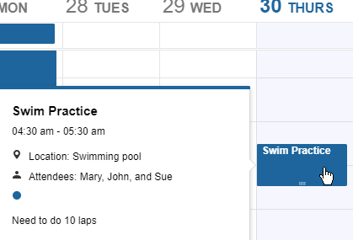
No or invalid calendar Id - Accent color is lost | {  id: "5",  title: "Swim Practice",  category: "time",  start: "2020-01-30T09:30:00.000Z",  end: "2020-01-30T10:30:00.000Z",  location: "Swimming pool",  attendees:"Mary, John, and Sue",  body: "Need to do 10 laps"  } | 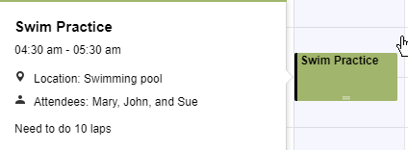
Title and Time only | {  id: "5",  calendarId: "1",  title: "Swim Practice",  category: "time",  start: "2020-01-30T09:30:00.000Z",  end: "2020-01-30T10:30:00.000Z"  }
Multi-day event - Appears in top section. Shows date based on date parameter (MM/DD/YYYY in example 1, YYYY-MM-DD in example 2) | {  id: "4",  calendarId: "1",  title: "Study Group",  category: "time",  start: "2020-01-27T01:00:00.000Z",  end: "2020-01-28T02:00:00.000Z",  location: "Jim's House",  body: "Cram session for the exam."  } | 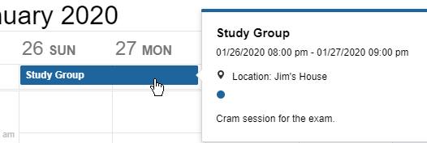  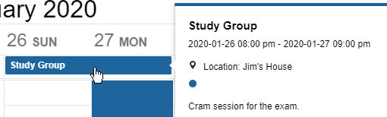
Missing Endtime - Event ends 30 minutes after Start | {  id: "5",  calendarId: "1",  title: "Swim Practice",  category: "time",  start: "2020-01-30T09:30:00.000Z  }
Missing Start and End - Event will load for a 30 minute window based on current time | {  id: "5",  calendarId: "1",  title: "Swim Practice",  category: "time"  }
Missing Start Only - Event will load with incorrect timing | {  id: "5",  calendarId: "1",  title: "Swim Practice",  category: "time",  end: "2020-01-30T10:30:00.000Z"  }
Missing Category | {  id: "4",  calendarId: "1",  title: "Study Group",  start: "2020-01-27T01:00:00.000Z",  end: "2020-01-28T02:00:00.000Z",  location: "Jim's House",  body: "Cram session for the exam."  } | Event will NOT appear.
Individual event colors | {  id:”2”,  calendarId:”1”,  title:”My Title”,  category:”time”,  location:”My Location”,  start:”2023-02-21T14:30:00.000Z”,  end:”2023-02-21T19:00:00.000Z,”  attendees:”My attendees”,  body:”My Body”,  bgColor:”GreenYellow”,  color:”#FF0000  } | 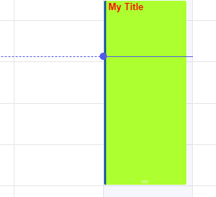

Styling
The calendar inherits the accent color of your Site or Tempo environment. Additional styling can be set using the theme parameter. Some examples are available in the sample interface GCG_CAL_CMPT_exampleFive, and the complete list of overridable attributes is available in the ToastUI documentation @ https://github.com/nhn/tui.calendar/blob/main/docs/en/apis/theme.md

To adjust styling, set the theme parameter to a dictionary containing a list of attributes and style values (typically either a color or a small css snippet). Colors can generally be set by a common html color (e.g. “red”, “blue”), a valid hex code, or an RGBa string.

Some styles only apply to specific calendar views – generally speaking, the first word will indicate if it’s a common, monthly, weekly, or other style. Styles related to unsupported calendar views are not supported.

NOTE: If you set the theme and want to change it, at this time you will need to re-render the entire calendar component to ensure all previously set styles are reset. As such, it is generally not recommended to allow user interactions to dynamically change styles.

Example Styling
The following example events showcase how an event may render based on different inputs to the theme input:

Scenario | Definition | Reference Screenshot
Color in Background | {  "common.backgroundColor":  “rgba(0, 255, 0, 0.5)”  } | 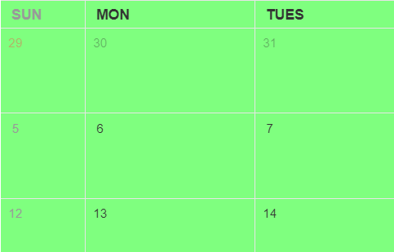
Thick Borders | {  "common.border":  "4px groove #e5e5e5",  "month.dayname.borderLeft":  "4px groove #e5e5e5",  "week.daygridLeft.borderRight":  "4px groove #e5e5e5"  } | 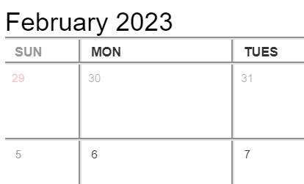
Darker Weekend and Out of Month Dates | {  "common.saturday.color":  "blue",  "common.holiday.color":  "green",  "month.holidayExceptThisMonth.color":  "#FF00AB",  "month.dayExceptThisMonth.color":  "rgba(10, 10, 10, 1)"  } | 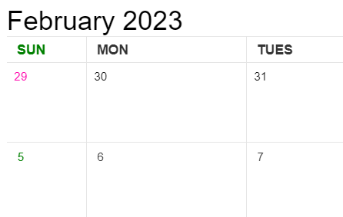
Altering the current time indicators(past, present, future) | {  "week.daygrid.backgroundColor":  "green",  "week.currentTimeLineToday.border":  "4px solid green",  "week.currentTimeLineFuture.border":  "1px solid red"  } | 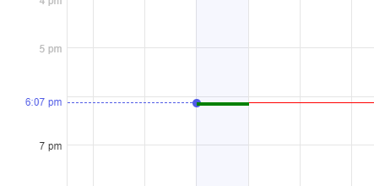
Background Colors | {  "month.dayname.backgroundColor":  "rgba(80, 80, 80, 0.8)",  "common.backgroundColor":  "rgba(100, 100, 100, 0.2)",  "common.dayname.color":  "#000",  "common.holiday.color":  "#000",  "common.saturday.color":  "#000",  "month.weekend.backgroundColor":  "rgba(80, 80, 80, 0.8)",  "month.weekday.backgroundColor":  "rgba(80, 80, 80, 0.8)",  "month.holidayExceptThisMonth.color":  "#000",  "month.dayExceptThisMonth.color":  "#000"  } | 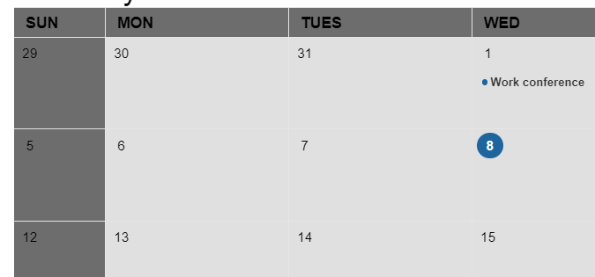

All theme options with default values below:

'common.border': '1px solid #e5e5e5',
'common.backgroundColor': 'white',
'common.holiday.color': '#ff4040',
'common.saturday.color': '#333',
'common.dayname.color': '#333',
'common.today.color': '#333',

// creation guide style
'common.creationGuide.backgroundColor': 'rgba(81, 92, 230, 0.05)',
'common.creationGuide.border': '1px solid #515ce6',

// month header 'dayname'
'month.dayname.height': '31px',
'month.dayname.borderLeft': 'none',
'month.dayname.paddingLeft': '10px',
'month.dayname.paddingRight': '0',
'month.dayname.backgroundColor': 'inherit',
'month.dayname.fontSize': '12px',
'month.dayname.fontWeight': 'normal',
'month.dayname.textAlign': 'left',

// month day grid cell 'day'
'month.holidayExceptThisMonth.color': 'rgba(255, 64, 64, 0.4)',
'month.dayExceptThisMonth.color': 'rgba(51, 51, 51, 0.4)',
'month.weekend.backgroundColor': 'inherit',
'month.day.fontSize': '14px',

// month schedule style
'month.schedule.borderRadius': '2px',
'month.schedule.height': '24px',
'month.schedule.marginTop': '2px',
'month.schedule.marginLeft': '8px',
'month.schedule.marginRight': '8px',

// month more view
'month.moreView.border': '1px solid #d5d5d5',
'month.moreView.boxShadow': '0 2px 6px 0 rgba(0, 0, 0, 0.1)',
'month.moreView.backgroundColor': 'white',
'month.moreView.paddingBottom': '17px',
'month.moreViewTitle.height': '44px',
'month.moreViewTitle.marginBottom': '12px',
'month.moreViewTitle.borderBottom': 'none',
'month.moreViewTitle.padding': '12px 17px 0 17px',
'month.moreViewList.padding': '0 17px',

// week header 'dayname'
'week.dayname.height': '42px',
'week.dayname.borderTop': '1px solid #e5e5e5',
'week.dayname.borderBottom': '1px solid #e5e5e5',
'week.dayname.borderLeft': 'none',
'week.dayname.paddingLeft': '0',
'week.dayname.backgroundColor': 'inherit',
'week.dayname.textAlign': 'left',
'week.today.color': 'inherit',
'week.pastDay.color': '#bbb',

// week vertical panel 'vpanel'
'week.vpanelSplitter.border': '1px solid #e5e5e5',
'week.vpanelSplitter.height': '3px',

// week daygrid 'daygrid'
'week.daygrid.borderRight': '1px solid #e5e5e5',
'week.daygrid.backgroundColor': 'inherit',

'week.daygridLeft.width': '72px',
'week.daygridLeft.backgroundColor': 'inherit',
'week.daygridLeft.paddingRight': '8px',
'week.daygridLeft.borderRight': '1px solid #e5e5e5',

'week.today.backgroundColor': 'rgba(81, 92, 230, 0.05)',
'week.weekend.backgroundColor': 'inherit',

// week timegrid 'timegrid'
'week.timegridLeft.width': '72px',
'week.timegridLeft.backgroundColor': 'inherit',
'week.timegridLeft.borderRight': '1px solid #e5e5e5',
'week.timegridLeft.fontSize': '11px',

'week.timegridOneHour.height': '52px',
'week.timegridHalfHour.height': '26px',
'week.timegridHalfHour.borderBottom': 'none',
'week.timegridHorizontalLine.borderBottom': '1px solid #e5e5e5',

'week.timegrid.paddingRight': '8px',
'week.timegrid.borderRight': '1px solid #e5e5e5',
'week.timegridSchedule.borderRadius': '2px',
'week.timegridSchedule.paddingLeft': '2px',

'week.currentTime.color': '#515ce6',
'week.currentTime.fontSize': '11px',
'week.currentTime.fontWeight': 'normal',

'week.currentTimeLinePast.border': '1px dashed #515ce6',
'week.currentTimeLineBullet.backgroundColor': '#515ce6',
'week.currentTimeLineToday.border': '1px solid #515ce6',
'week.currentTimeLineFuture.border': 'none',

// week creation guide style
'week.creationGuide.color': '#515ce6',
'week.creationGuide.fontSize': '11px',
'week.creationGuide.fontWeight': 'bold',

// week daygrid schedule style
'week.dayGridSchedule.borderRadius': '2px',
'week.dayGridSchedule.height': '24px',
'week.dayGridSchedule.marginTop': '2px',
'week.dayGridSchedule.marginLeft': '8px',
'week.dayGridSchedule.marginRight': '8px'

