Intelligent Decision making (Claim processing)

Deployment Steps: -
- Execute ICP.SQL script (DDL and Ref Data scripts).
- Import the package (Intelligent Decision (Claims) Processing.zip) along with Intelligent Decision (Claims) Processing.Properties customization file.

Application Usage steps: -
- Add user id to the “ICP Claim Initiators” Group for the Claim initiation.
- Once the user id is added into the above group, you would see the below screen on the Home tab of the application.
- a) Initiate Manual Claim Process is end to end manual process (It contains 3 Manual steps 1) Claim initiation 2) Claim Preauthorization 3) Claim Final Authorization).
b) “Initiate Intelligent Claim Process” also contains same steps. To showcase the capability the technology accelerator, the Claim Preauthorization step has been configured to leverage the ML capability to get step outcome without manual intervention.
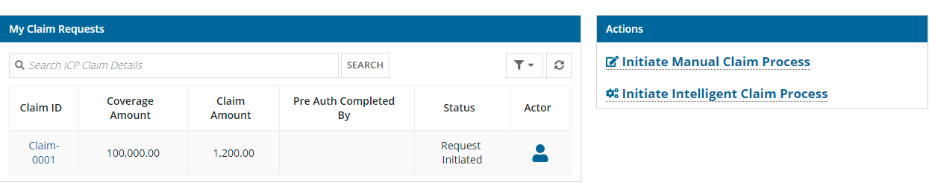
Note: - a)” Initiate Intelligent Claim process” capability can be
verified once Machine learning model is up and running
in the AWS Sage maker.
b) We have given “Initiate Manual Claim process” to show case
the difference between manual and intelligent decision process.
- Once you click on the “Initiate Manual process” the below screen will appear.
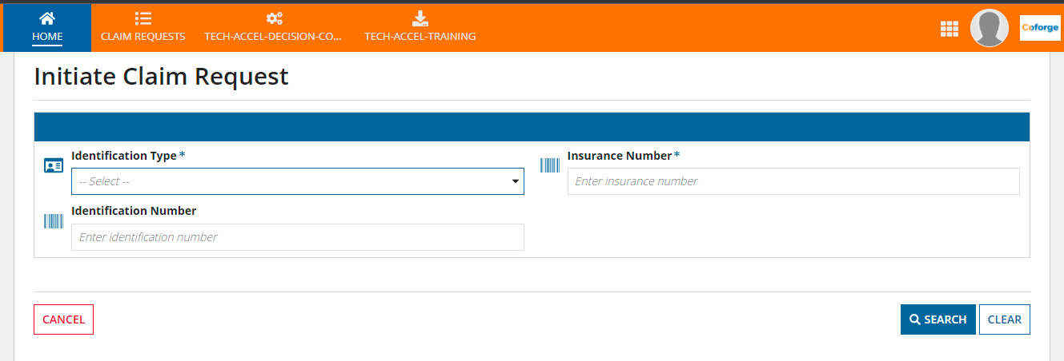

- For initiation use the following ref data
Identification Type – Driving Licence
Insurance Number – 1234
Identification Number – DL1234
- Click on Search button then below screen will appear
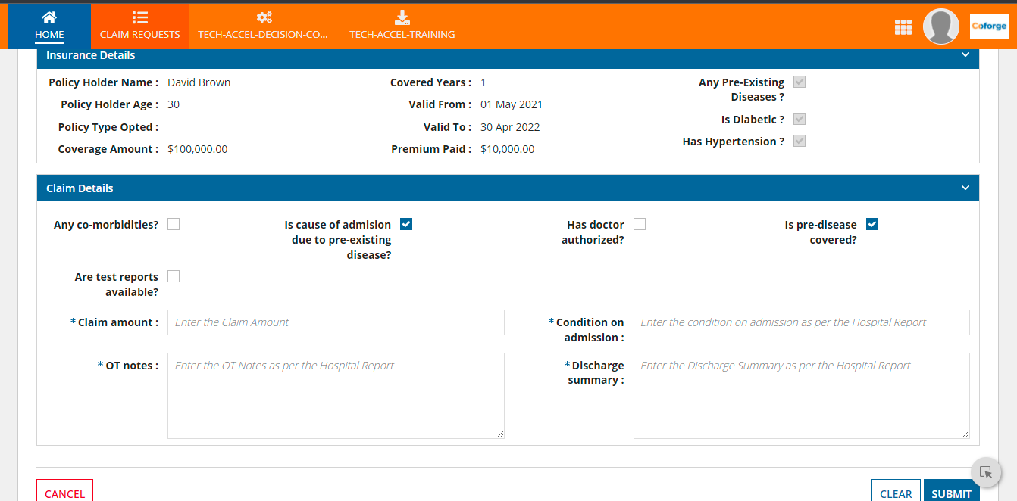
- Enter respective fields and click on Submit button.
- Once now you submit, the workflow in the Preauthorization step.
- Pre Auth-Approval process: -.
- Add your another user id in to the “ICP Pre Auth Assessors” Group.
- You could see below screen to approve the Preauthorization of the claim.
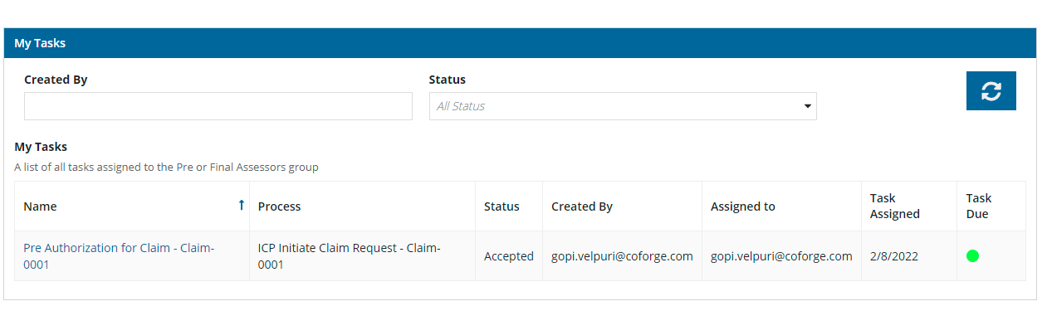
- Once the Task is approved it goes to the Final Authorization step
- Final Authorization process Approval: -
- Add another userid to the “ICP Final Auth Assessors” Group
- You could see below Task available in the Home tab
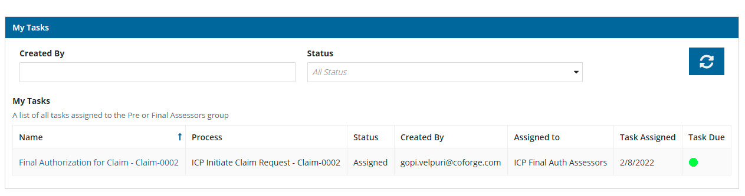
- The below screen will appear to approve the Final Authorization
