Microsoft Teams Connected System

Overview

Microsoft Teams Connected System consumes the Microsoft Graph API to access Microsoft Teams functionality. Microsoft Graph is the gateway to data and intelligence in Microsoft 365. This connected system allows developers to create teams and populate them with users and channels, by automating the creation and management of teams, channels. Using Microsoft Graph API we can also archive the teams you are no longer using. One can also send messages to Chat, Group and Channel.

Accessing Microsoft Graph API

To call Microsoft Graph, a connected system must be authenticated with the Microsoft identity platform. The access token contains information about your app and the permissions it has to access the resources and APIs available through Microsoft Graph. To get an access token, our app must be registered with the Microsoft identity platform(Azure Portal) and be authorized by either a user or an administrator to access the Microsoft Graph resources it needs.

Connected systems can either access Teams on behalf of User(Authorization code grant) and without a user(Client Credential grant).

Register a Azure App

- Register your App
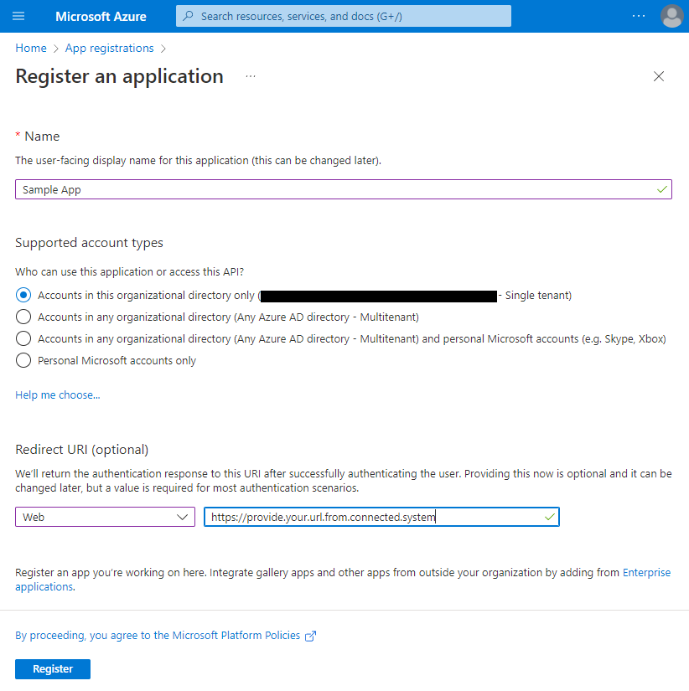
- Once registered, create Client Secret from App>Certificates & Secret>New Client Secret.

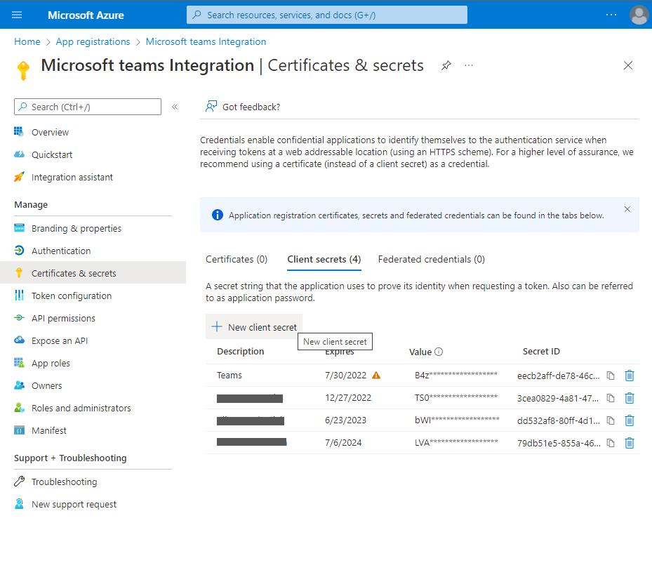
- After secret creation, keep it at a safe place as you can’t get it another time.
- Get the Client Id, Tenant Id and Secret Key from the application which will be used in this connected system.

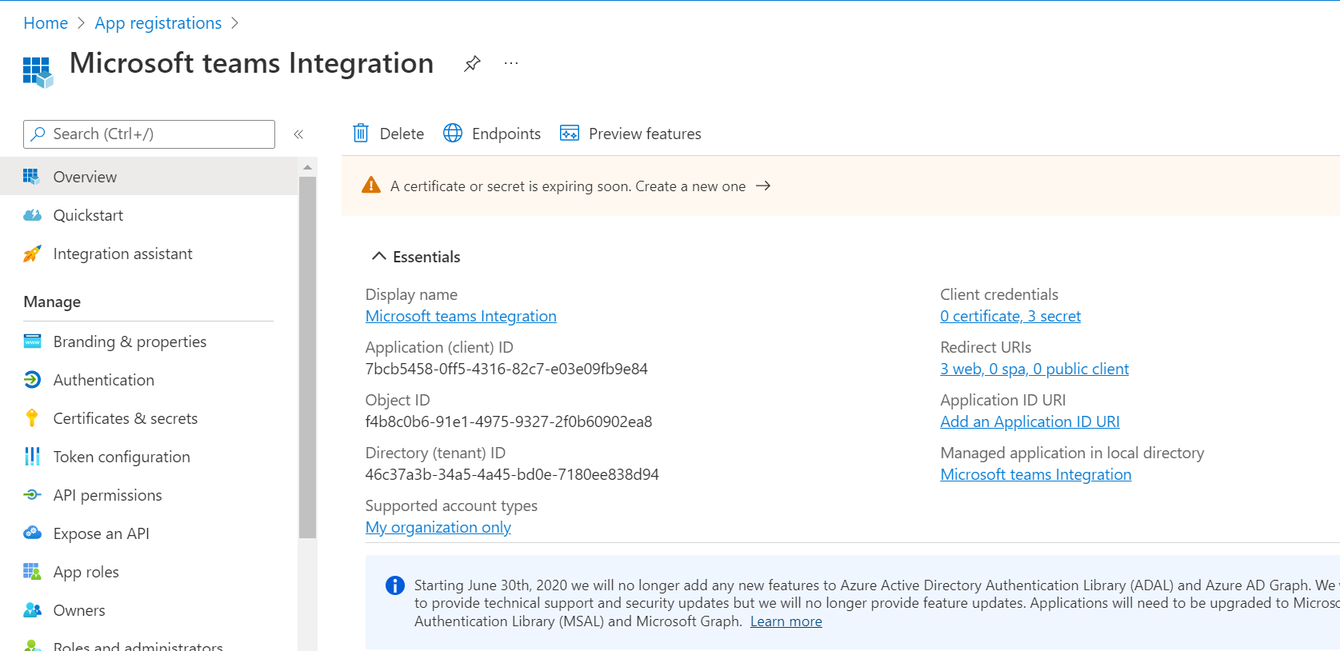

Requesting API permissions
After registering the application, we need to provide the application with API permissions. Each operation or API request needs special permission to access the graph api.
For example, Creation of Chat requires Chat.ReadWrite permission
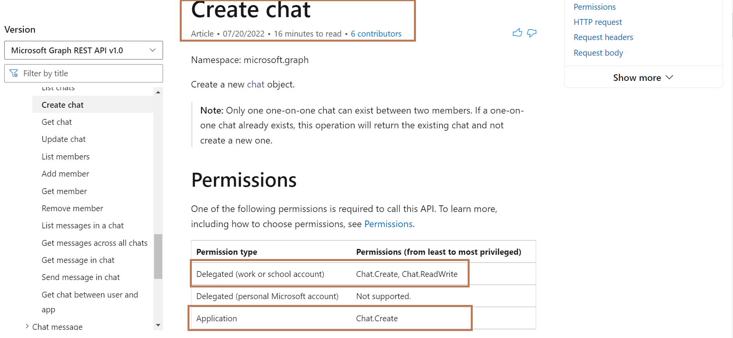

Delegated Permissions are needed for Authorization Code Grant
Application Permissions are needed for Client Credentials

Refer the API documentation to find the permissions required for different operations.

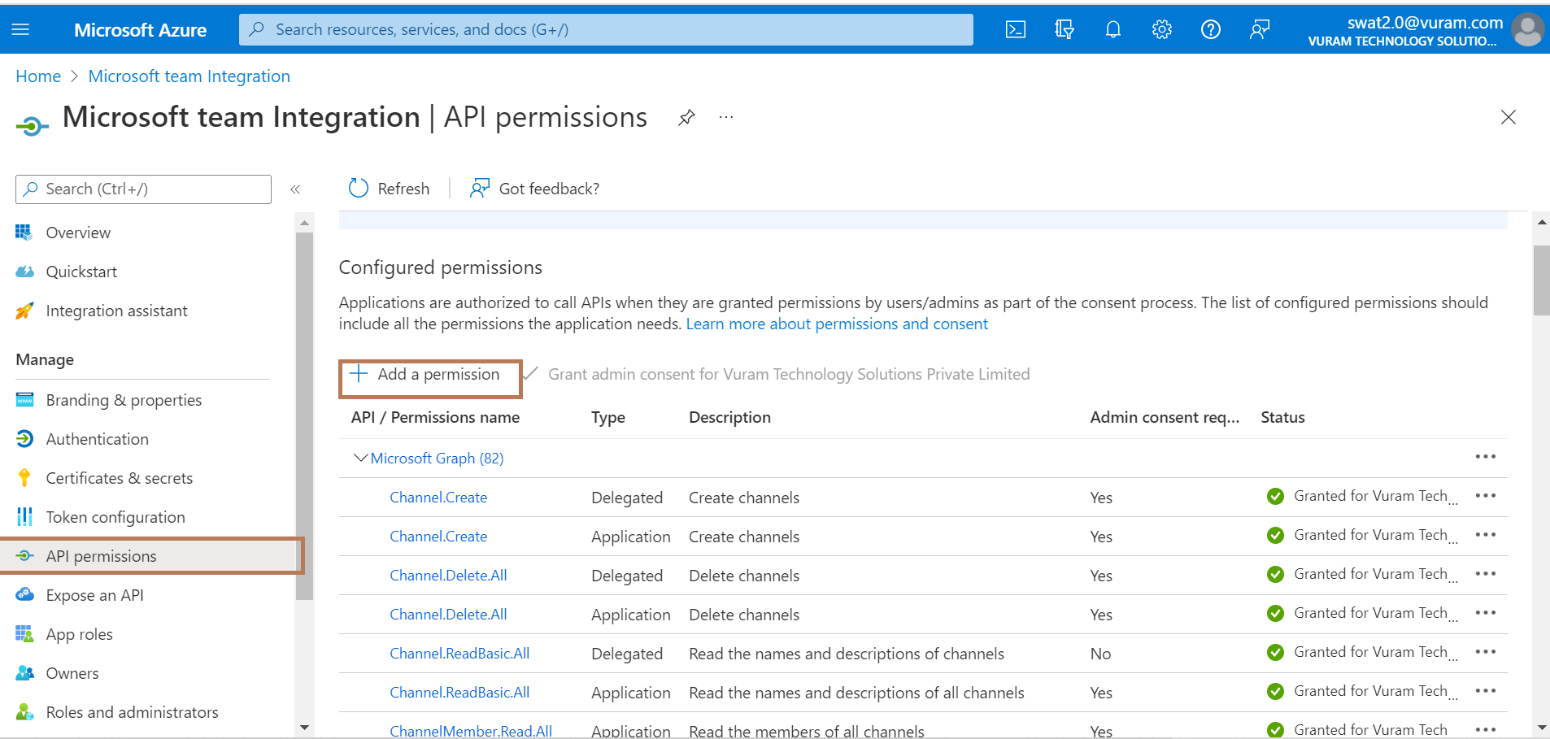
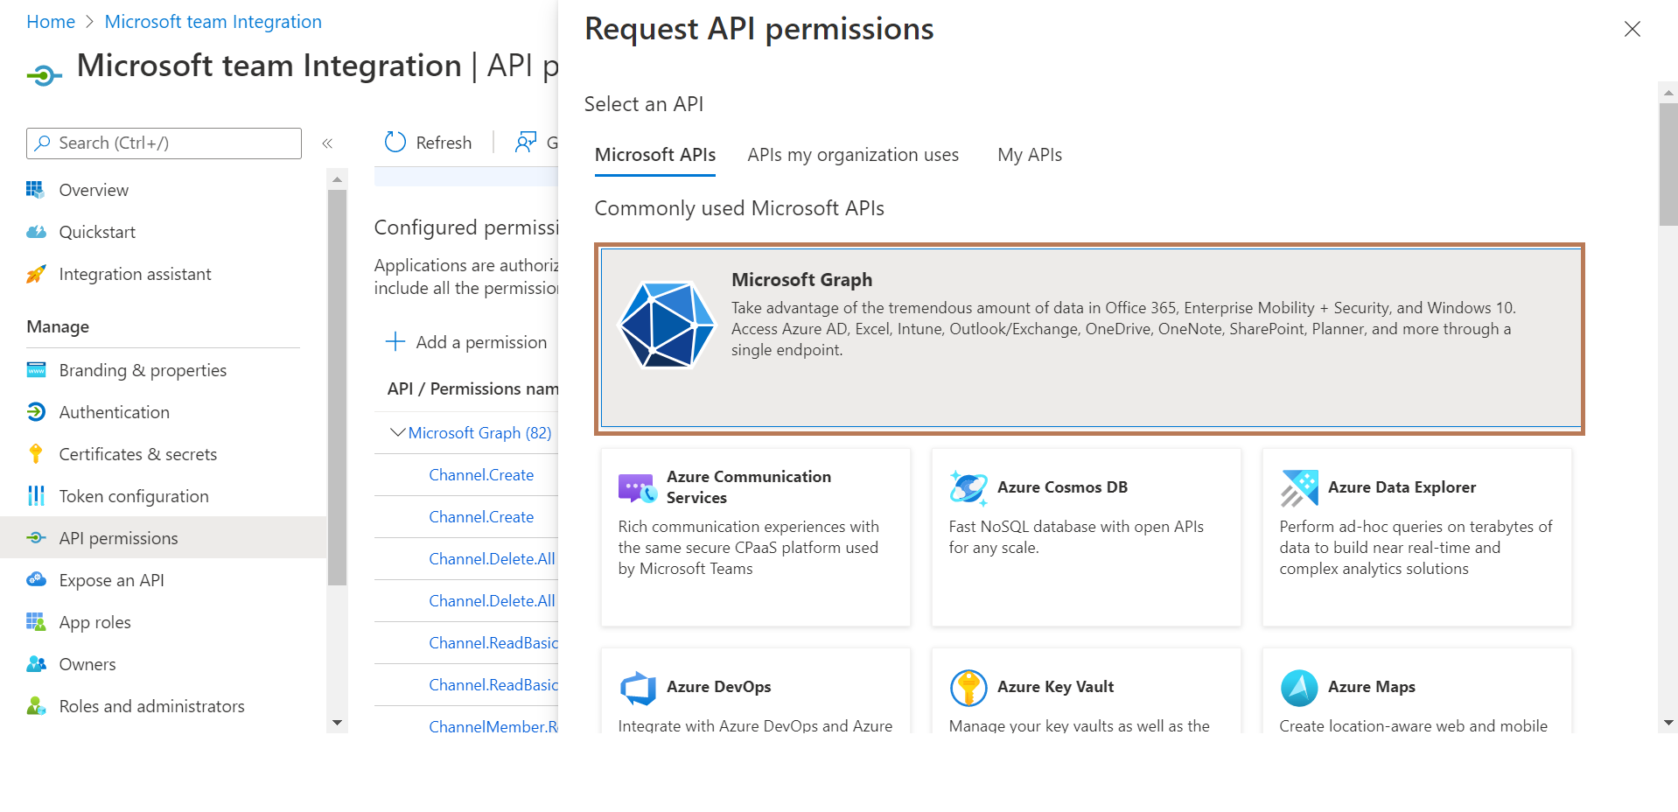
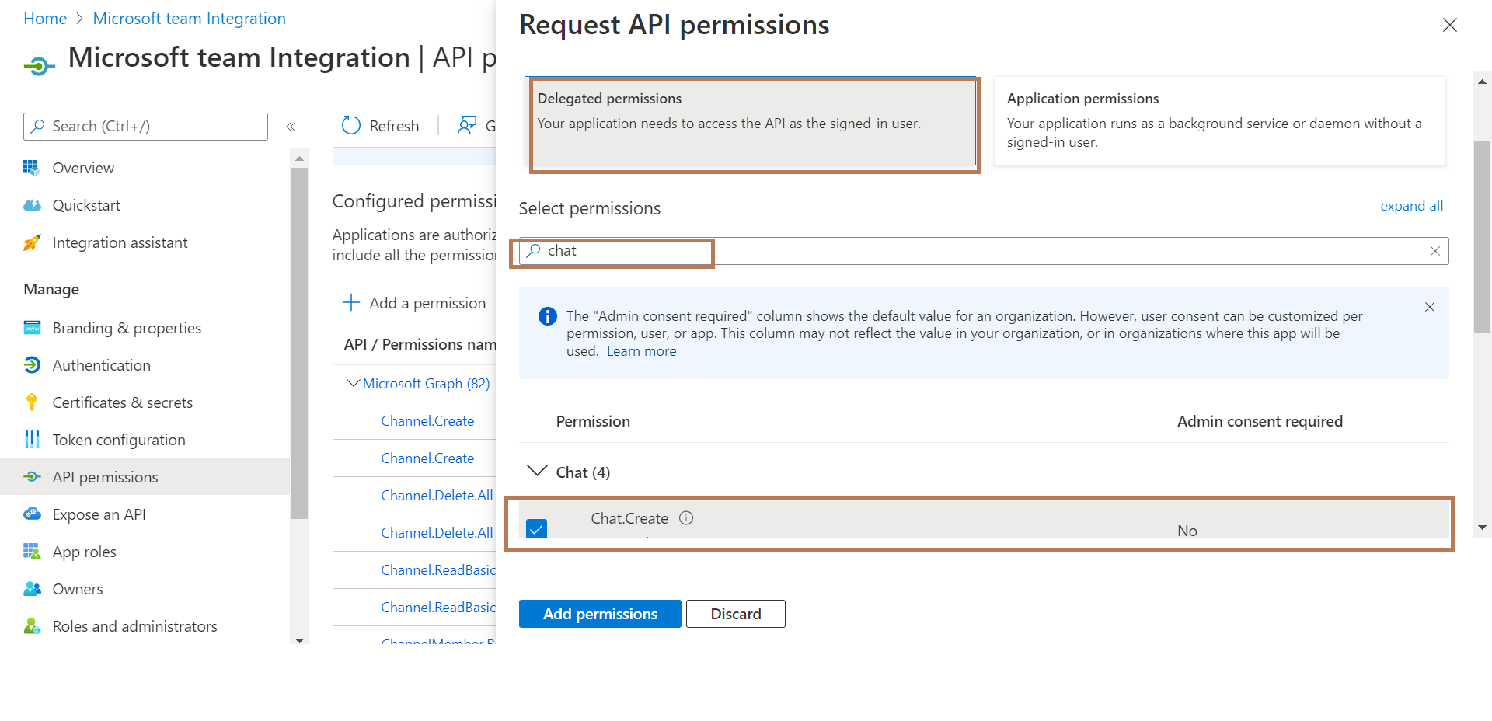
After adding the required permissions, we need to provide admin consent. This admin consent can be provided only by user who as admin access
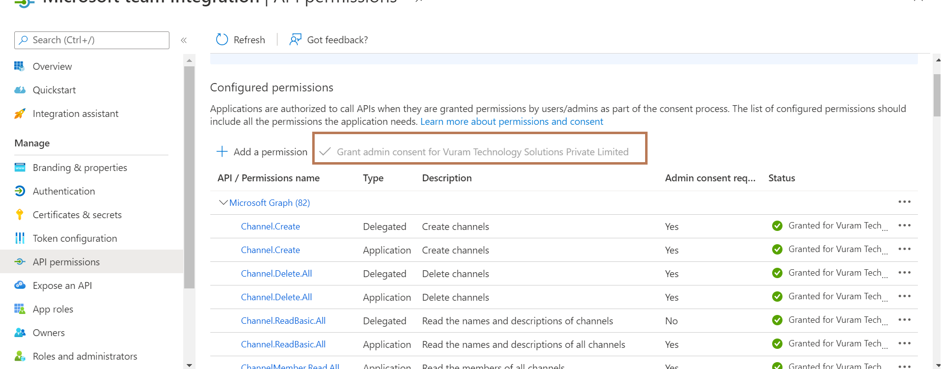
Available Integrations

Category | Integrations | Authorization Code Grant  (Delegated Permissions) | Client Credentials  (Application Permissions) | Permissions
Chat Integrations | Create New One on One Chat | Yes | Yes | Chat.Create, Chat.ReadWrite
 | Create New Group Chat | Yes | Yes | Chat.Create, Chat.ReadWrite
 | List the Chats of the Signed-In User | Yes | No | Chat.ReadWrite
 | List the Messages in the Chat | Yes | No | Chat.ReadWrite
 | Send Messages in Chat | Yes | No | Chat.ReadWrite, Sites.ReadWrite.All
Team Integrations | Create Team | Yes | Yes | Team.Create
 | List All the Teams | Yes | Yes | Group.ReadWrite.All
 | Get the details of a Team | Yes | Yes | TeamSettings.ReadWrite.All
 | List the Teams of the Signed-In User | Yes | No | TeamSettings.ReadWrite.All
 | Add Members in a Team | Yes | Yes | TeamMember.ReadWrite.All
 | List Members in a Team | Yes | Yes | TeamMember.ReadWrite.All
 | Remove Members from a Team | Yes | Yes | TeamMember.ReadWrite.All
 | Archive Team | Yes | Yes | TeamMember.ReadWrite.All
 | Unarchive Team | Yes | Yes | TeamMember.ReadWrite.All
 | Delete Team | Yes | Yes | Group.ReadWrite.All
Channel Integrations | Create Channel in a Team | Yes | Yes | Channel.Create
 | List the Channels in a Team | Yes | Yes | ChannelSettings.ReadWrite.All
 | Get the details of a Channel in Team | Yes | Yes | ChannelSettings.ReadWrite.All
 | List Messages / Replies in a Channel | Yes | No | ChannelMessage.Read.All
 | Delete Channel | Yes | Yes | Channel.Delete.All
 | Add Members in Private Channel | Yes | Yes | ChannelMember.ReadWrite.All
 | List Members in Private Channel | Yes | Yes | ChannelMember.ReadWrite.All
 | Get details of a Channel Member | Yes | Yes | ChannelMember.ReadWrite.All
 | Remove Private Channel Member | Yes | Yes | ChannelMember.ReadWrite.All
 | Send/Reply Message in Channel | Yes | No | ChannelMessage.Send, Sites.ReadWrite.Al
Miscellaneous Integration | Send Invitation | Yes | Yes | Directory.ReadWrite.All
 | Download Attachment | Yes | No | Sites.ReadWrite.All

Connected System - Authorization Code Grant
- Create the Microsoft Team Connected System (Authorization Code Grant) using the above credentials.
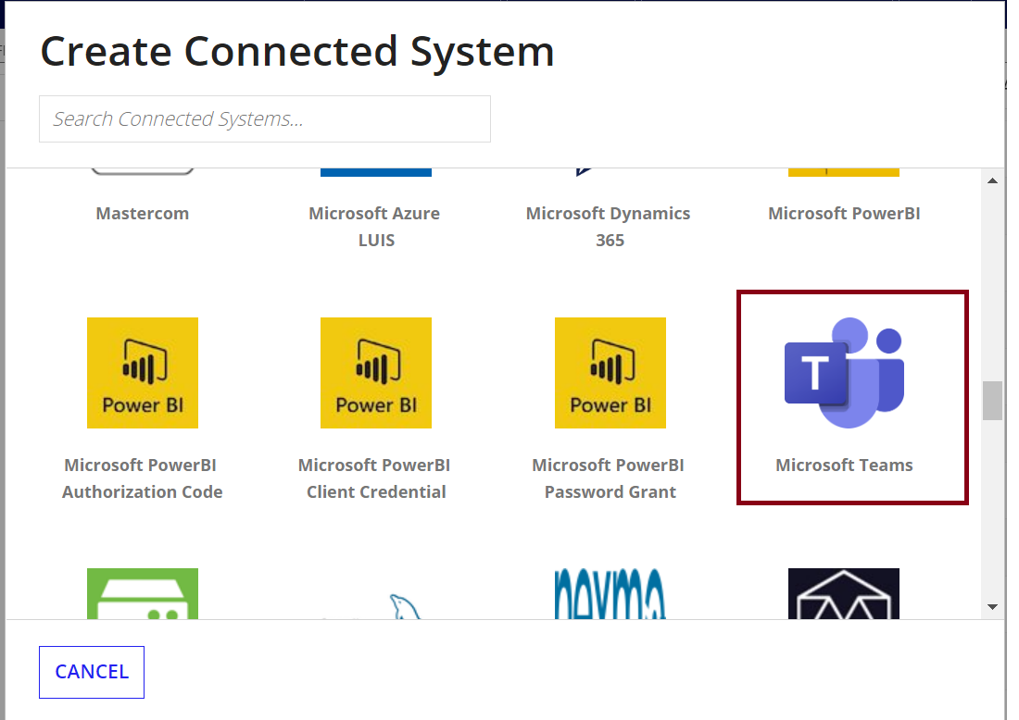
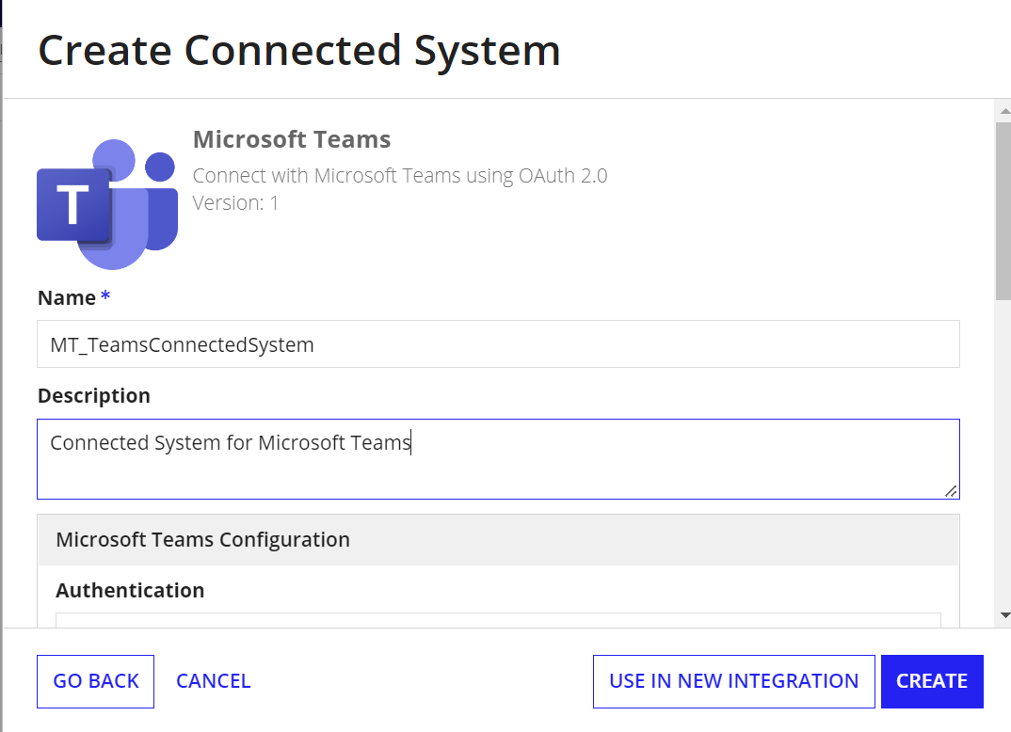

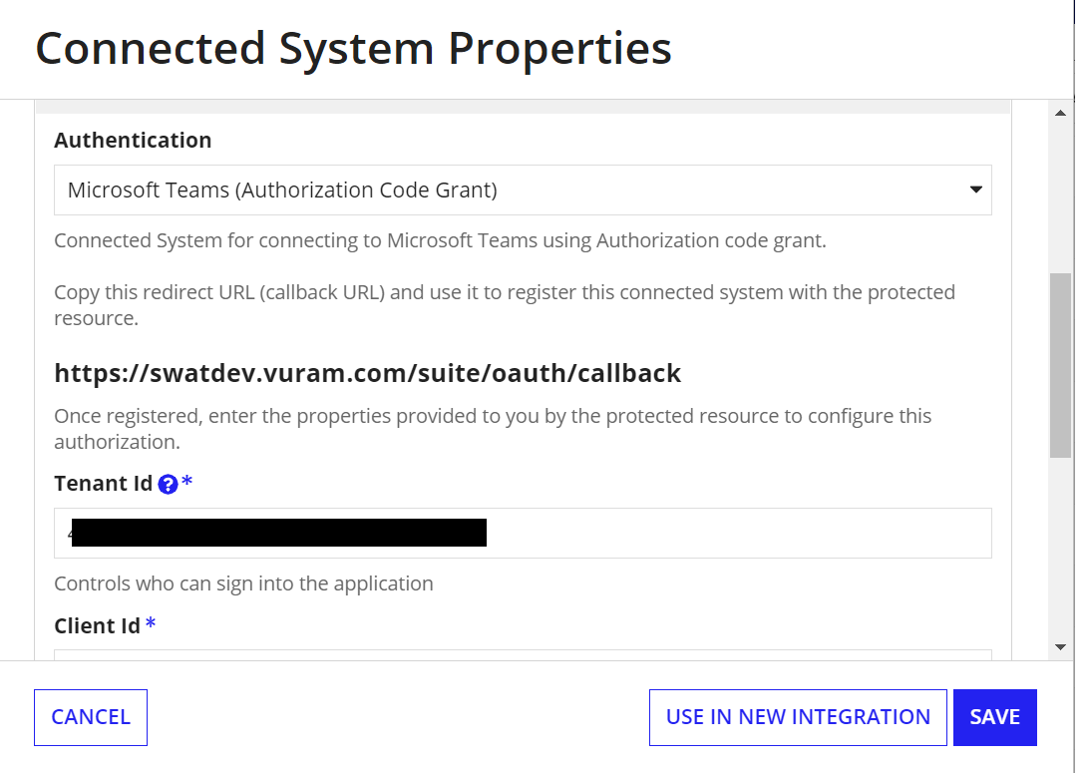

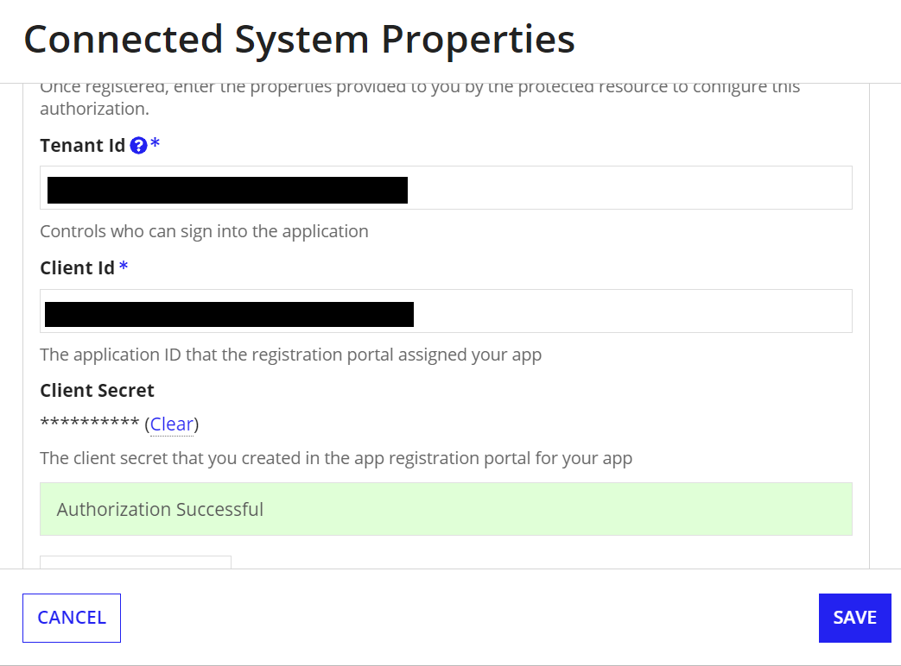

Example for Creating Integrations in Process Model
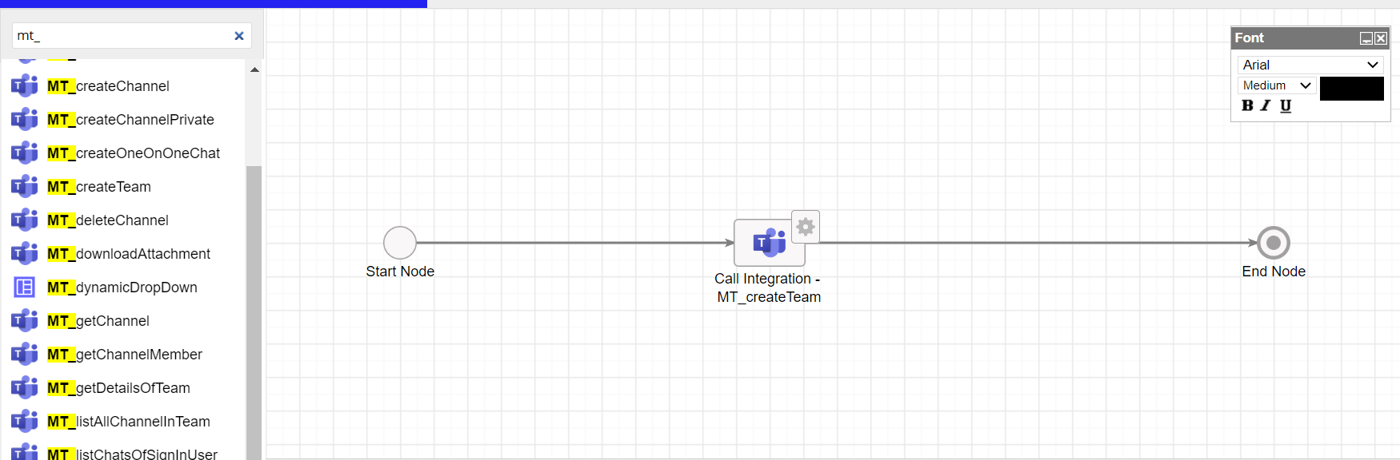

Integrations in Authorization Code Grant
These are the available integrations developed as part of this connected System

Chat Integrations

Create New One on One Chat

Creates a Chat between the Specified person and the Signed-In user.
Scope required: Chat.Create, Chat.ReadWrite
In the response, Id of the Chat will also be returned

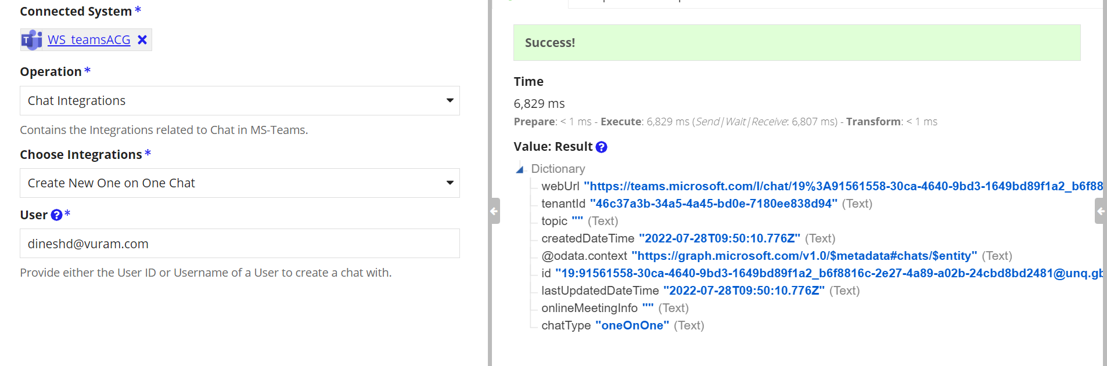
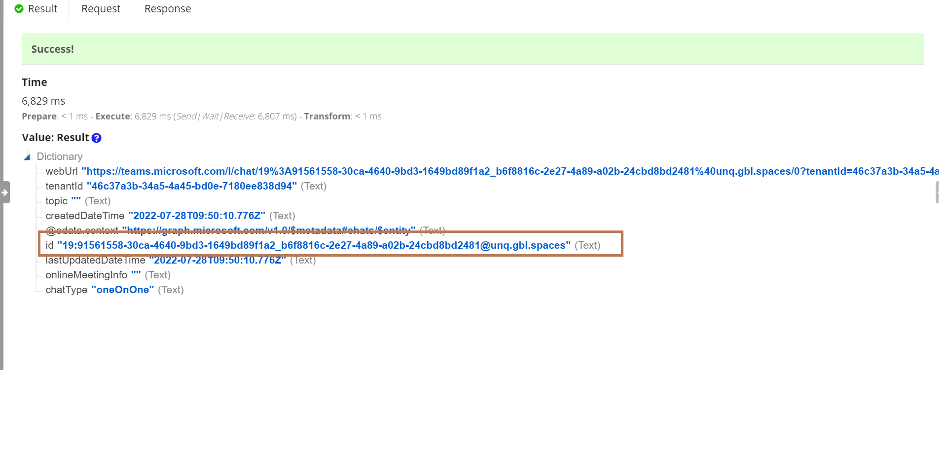
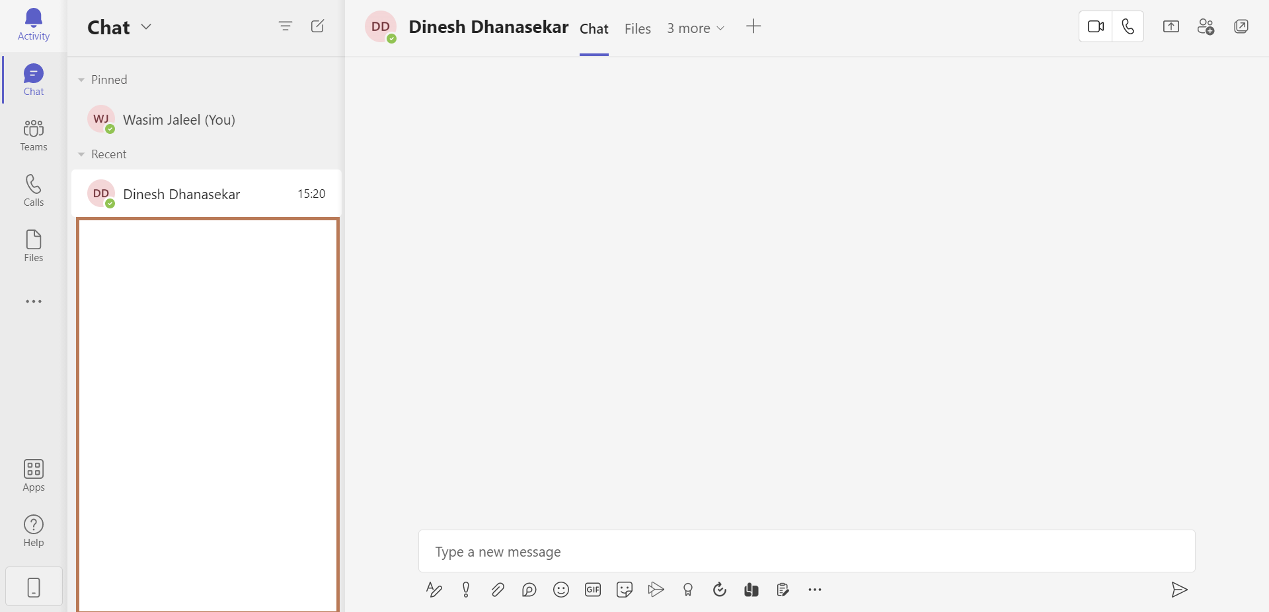

Create New Group Chat
Create Chat between the list of specified person and the Signed-In User
Scope Required: Chat.Create, Chat.ReadWrite

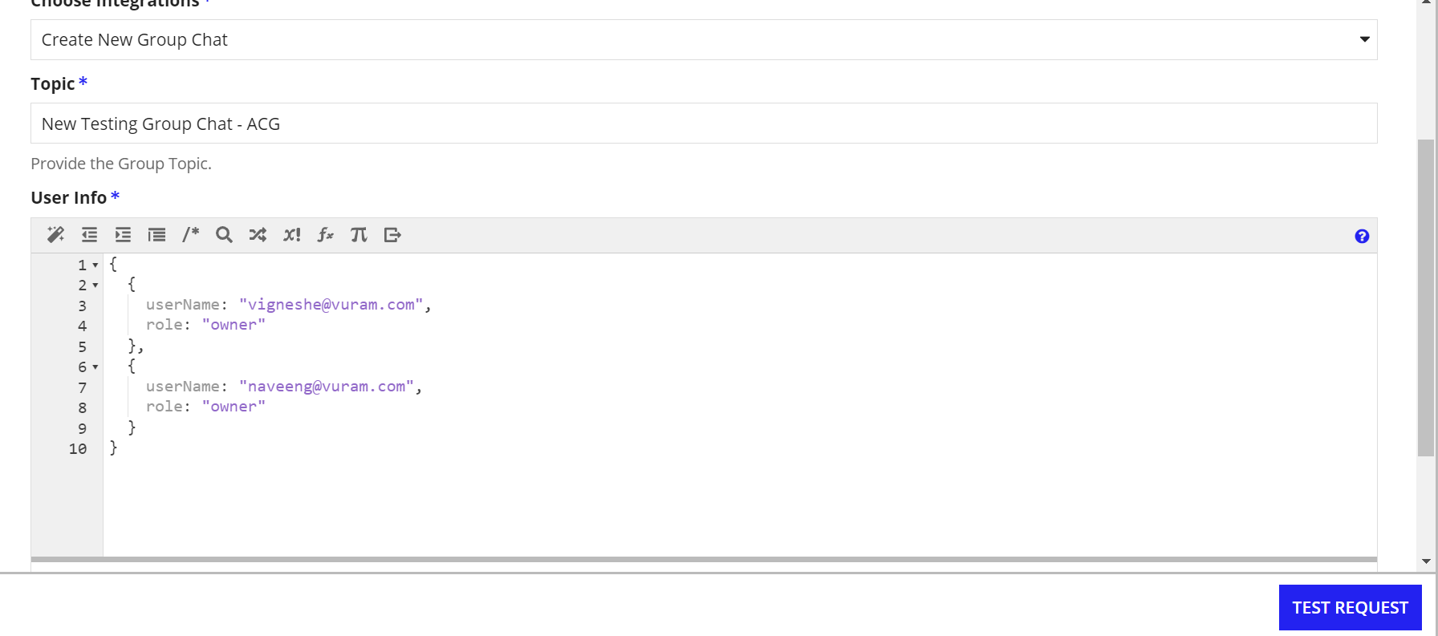
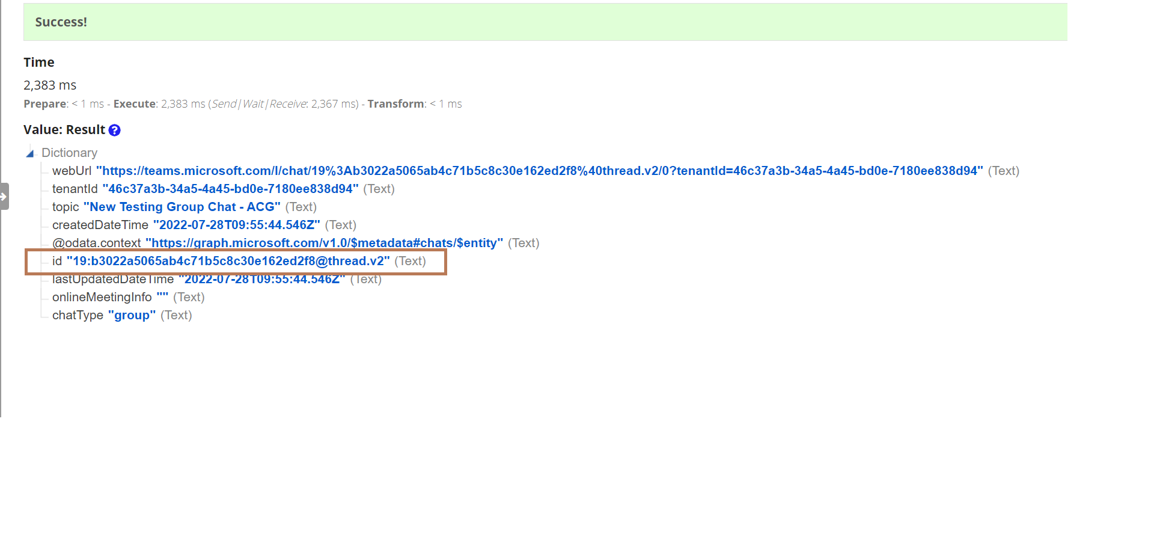
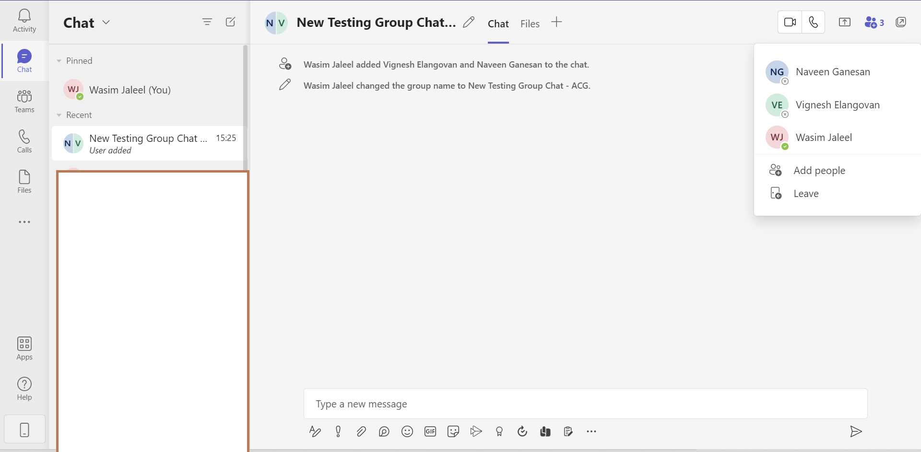

Format of User Info
{
{
userName: "abc@domain.com",
role: "owner"
},
{
userName: "def@domain.com",
role: "owner"
}
}

The available roles are owner and guest.
Note: Only the guest users in the organization can be added with the guest role.

List the Chats of the Signed-In User
Integration to list the chats of the Signed-in user
Scope Required: Chat.ReadWrite
No of Chats can be used to return the last N number of chats from the result set.
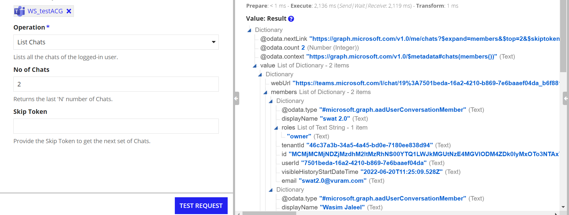
When No of Chats is provided, the result dictionary will return a Skip Token which can be used to retrieve the subsequent chats.
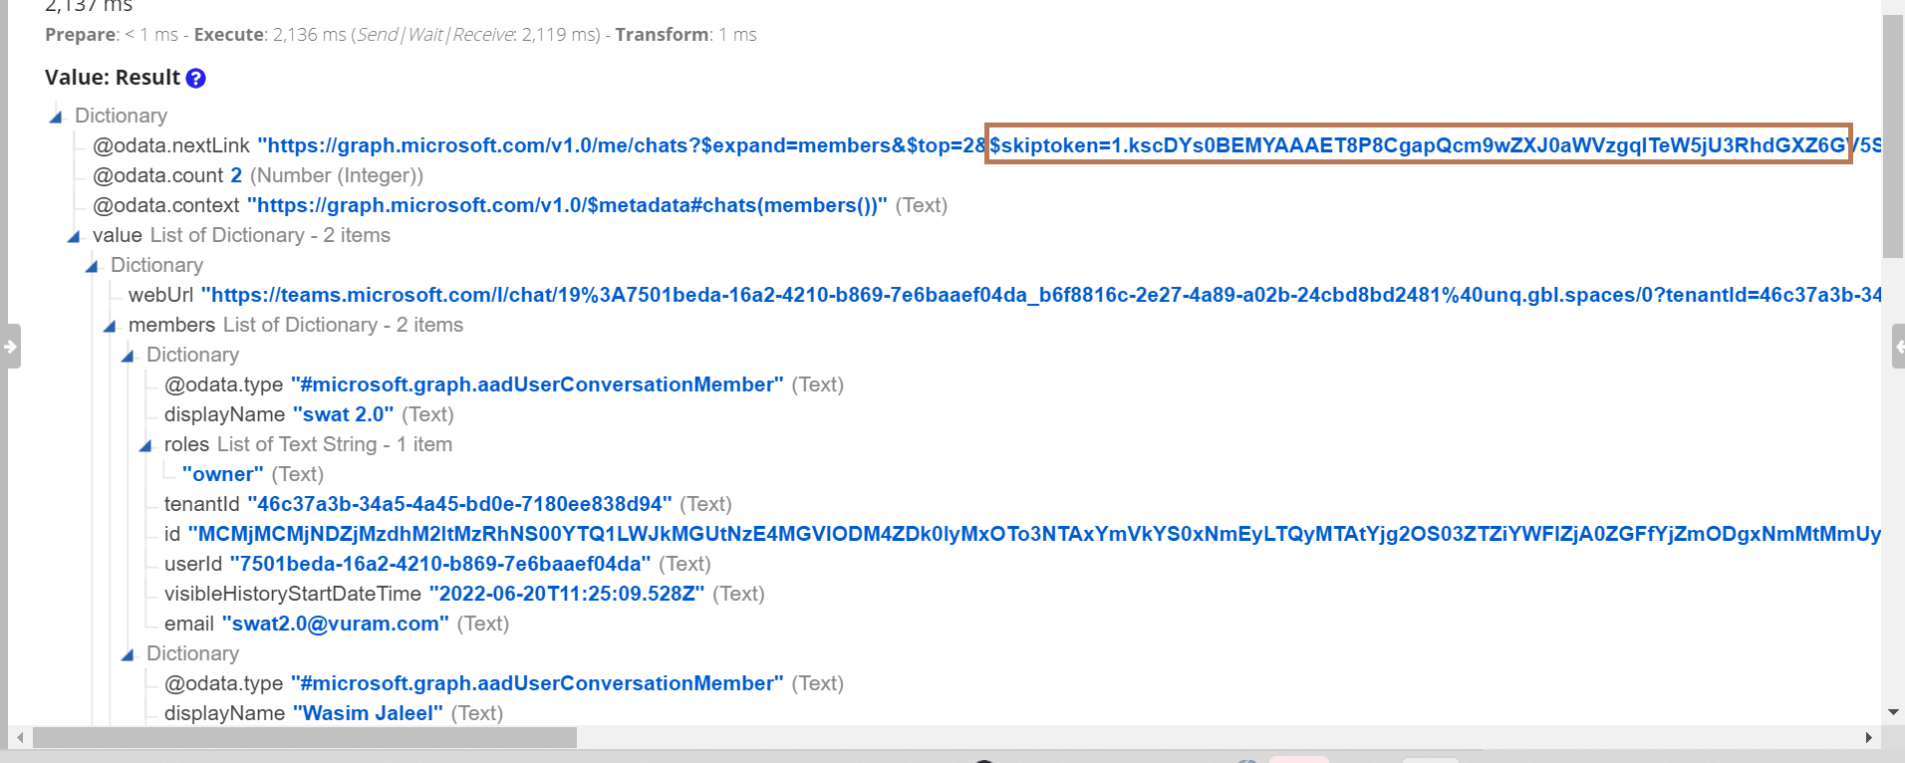

Skip Token is used to retrieve subsequent records from the result set. Copy and paste the skiptoken received in the result dictionary to the Skip Token parameter.
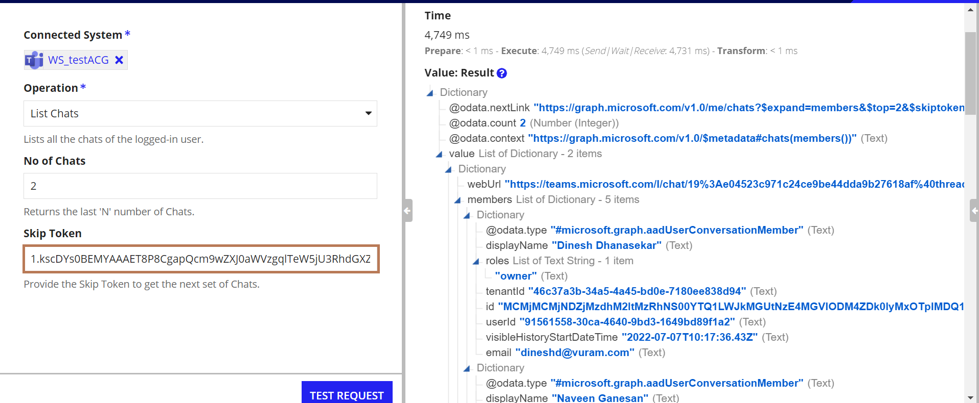

List Messages in Chat
Scope Required: Chat.ReadWrite
Integration to list the messages in a specified chat of the Signed-in user
Chat Id - This is the Id returned during the creation of the chat.
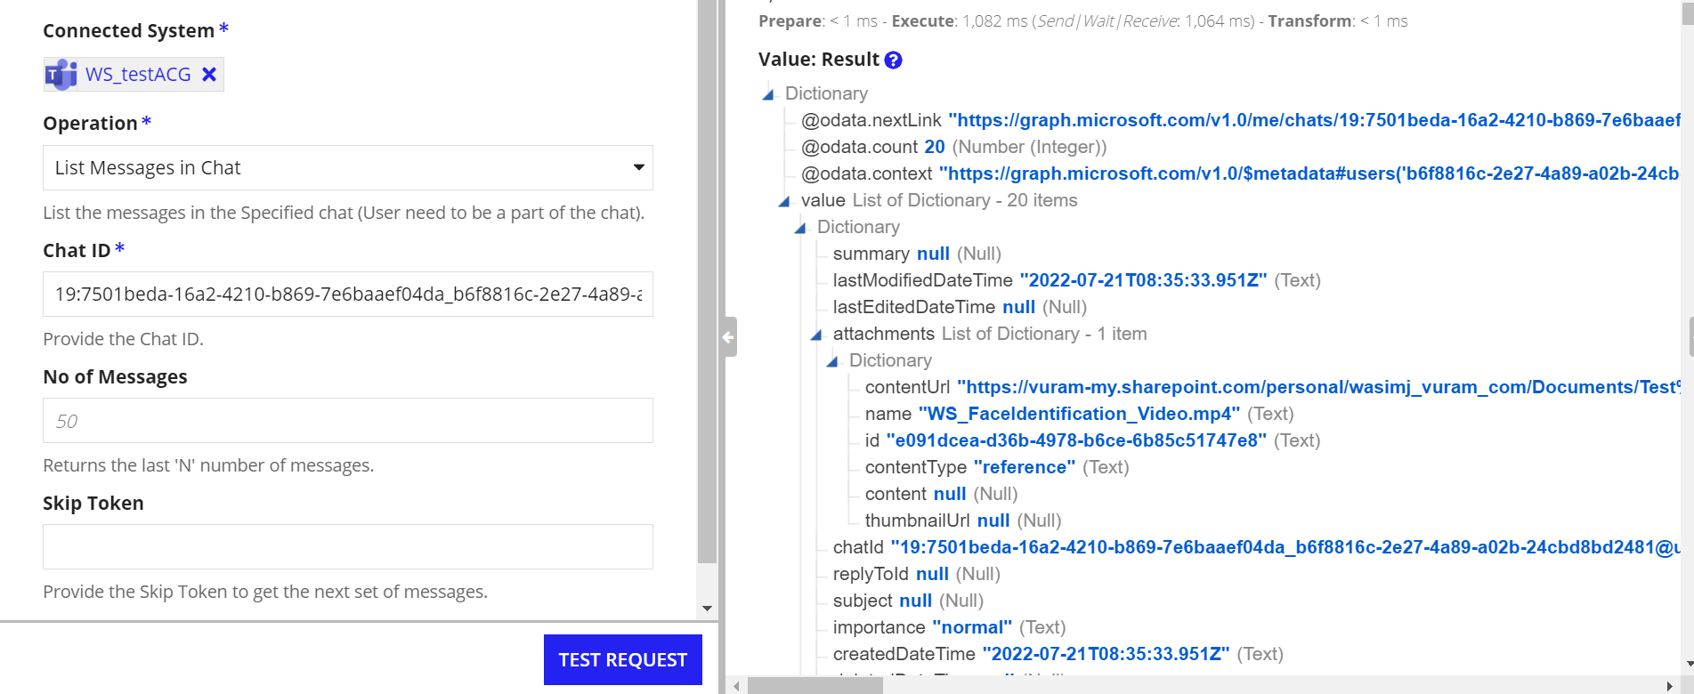

Send Message in Chat

Scope Required: Chat.ReadWrite, Sites.ReadWrite.All

Integration to send Message in Signed-in user’s specified chat.

Attachments can be added by setting the include attachment field as ‘YES’

If Folder Name is given, then the uploaded document will be stored in that folder under the root directory of one Drive. If not given, then the document will be stored in the default folder Appian_Chat_Files under root directory

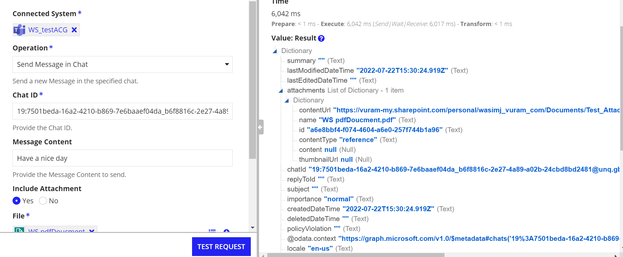
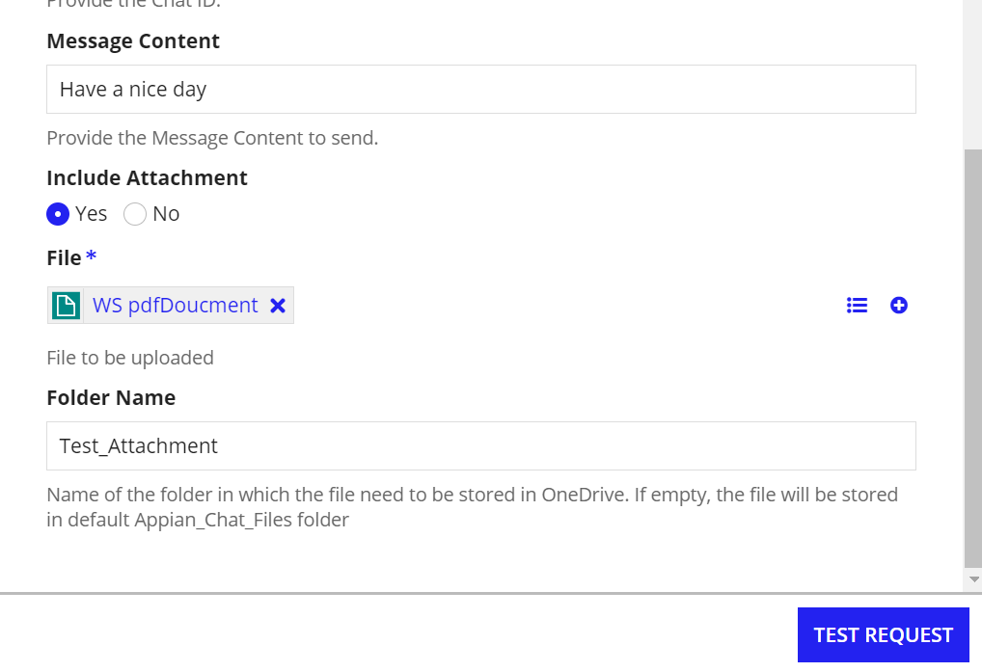
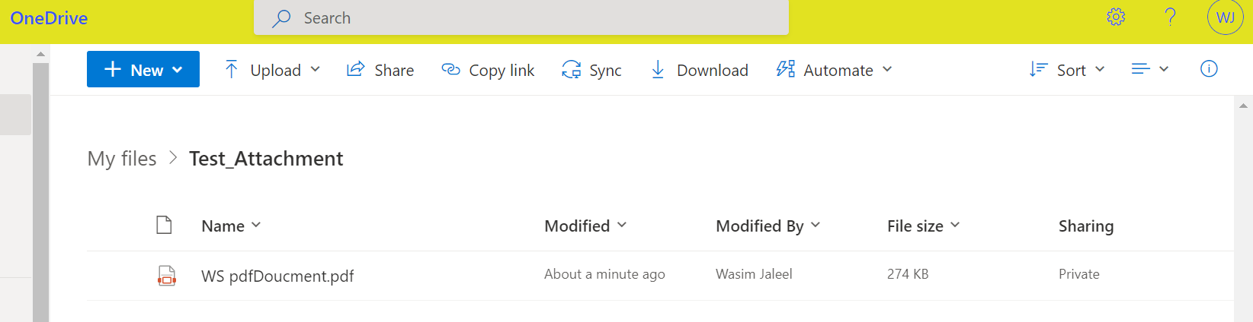

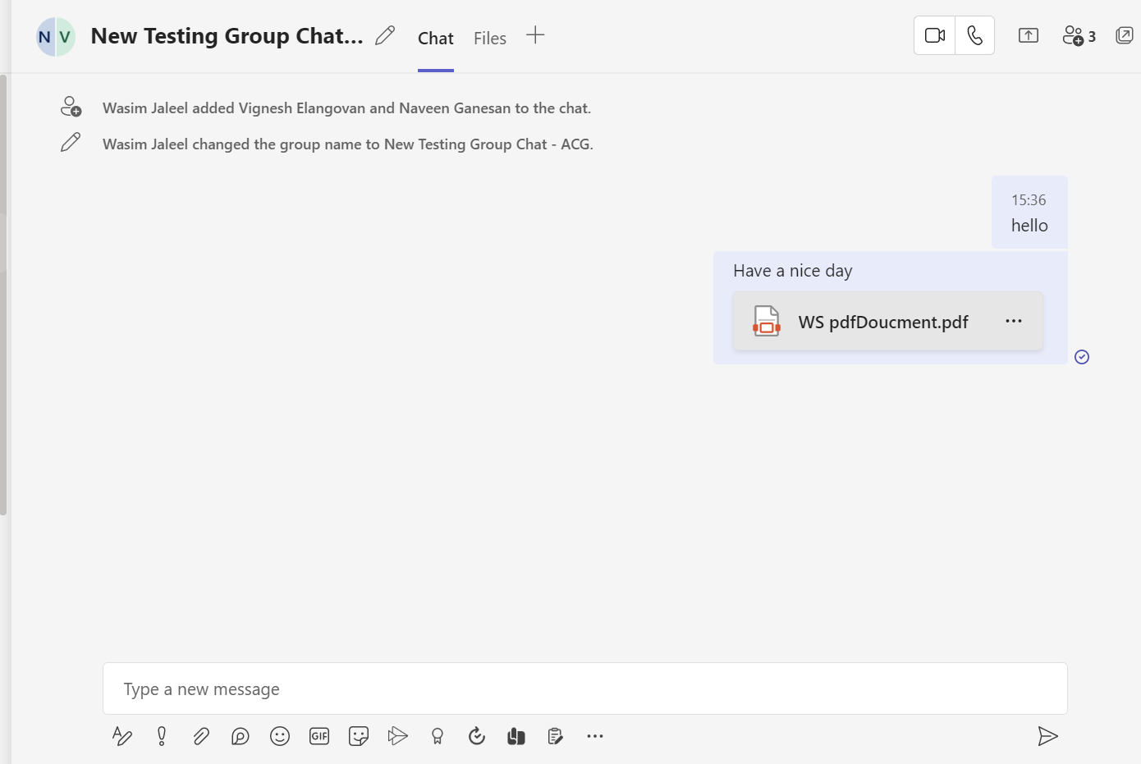

Team Integrations

Create Team

Create a Team with the specified name and description.
Scopes Required: Team.Create
On Success, the result will return the Team Id
Signed_In user will be added to the created Team
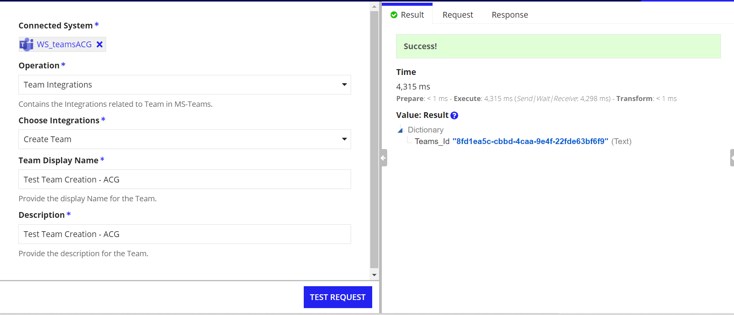

List All Teams
Integration to list all the teams in the organization
No of Teams and Skip Token can be used to iterate the list.

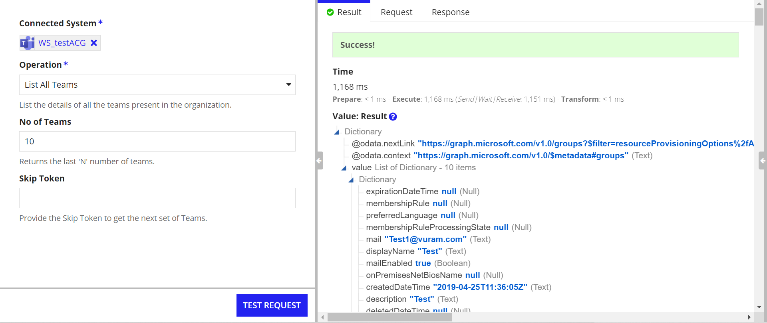

Get the details of a Team
Integration to get details about a particular team
Scope Required: TeamSettings.ReadWrite.All
Team Id - This is the Id returned during the creation of the Team.
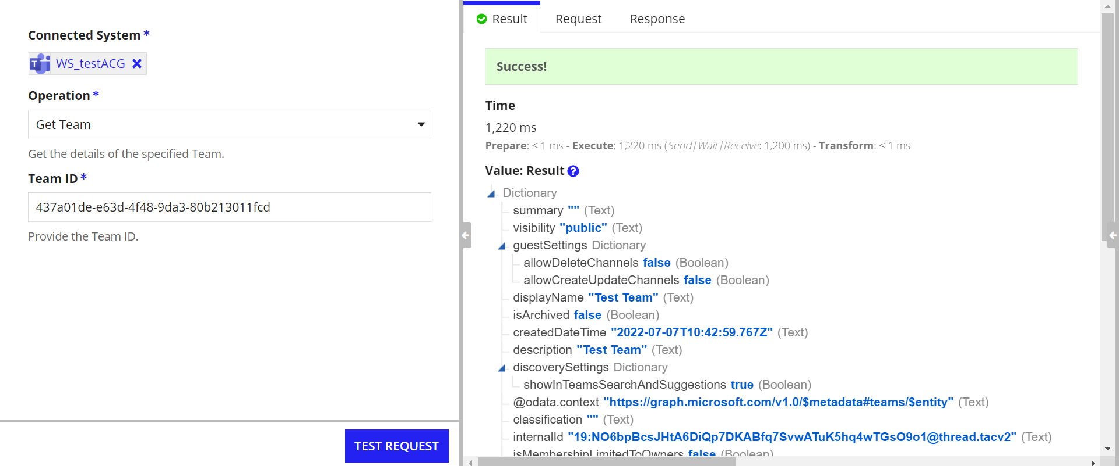

List the Teams of the Signed-In User
Integration to list the teams in which the signed-in user is a member.
Scope Required: TeamSettings.ReadWrite.All
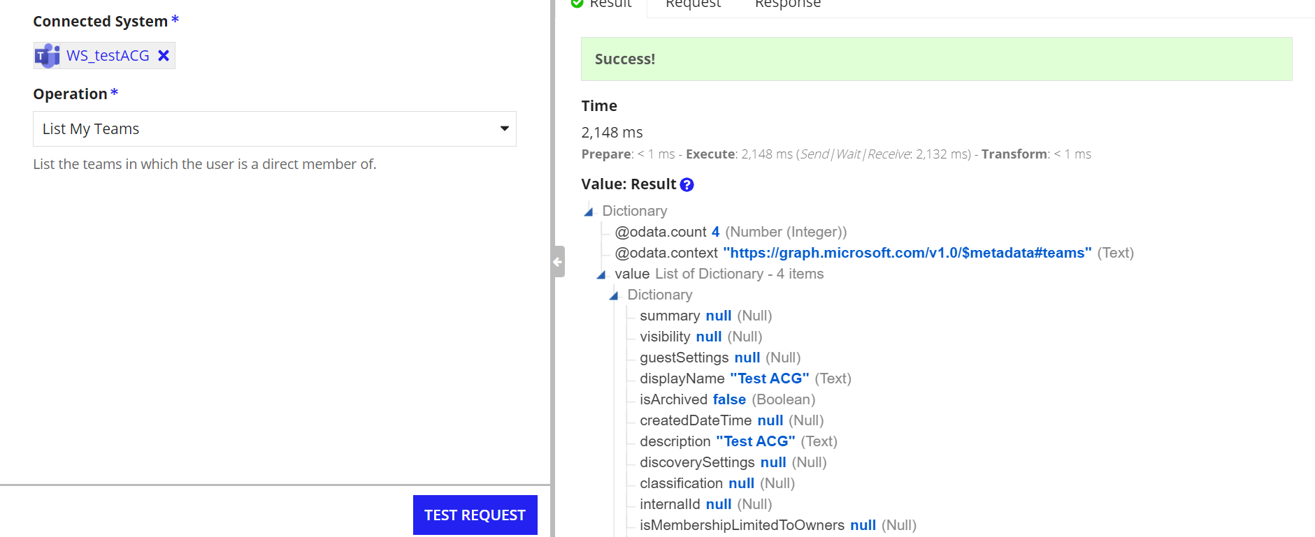

Add Members in Team
Add list of members to the specified team
Scope Required: TeamMember.ReadWrite.All
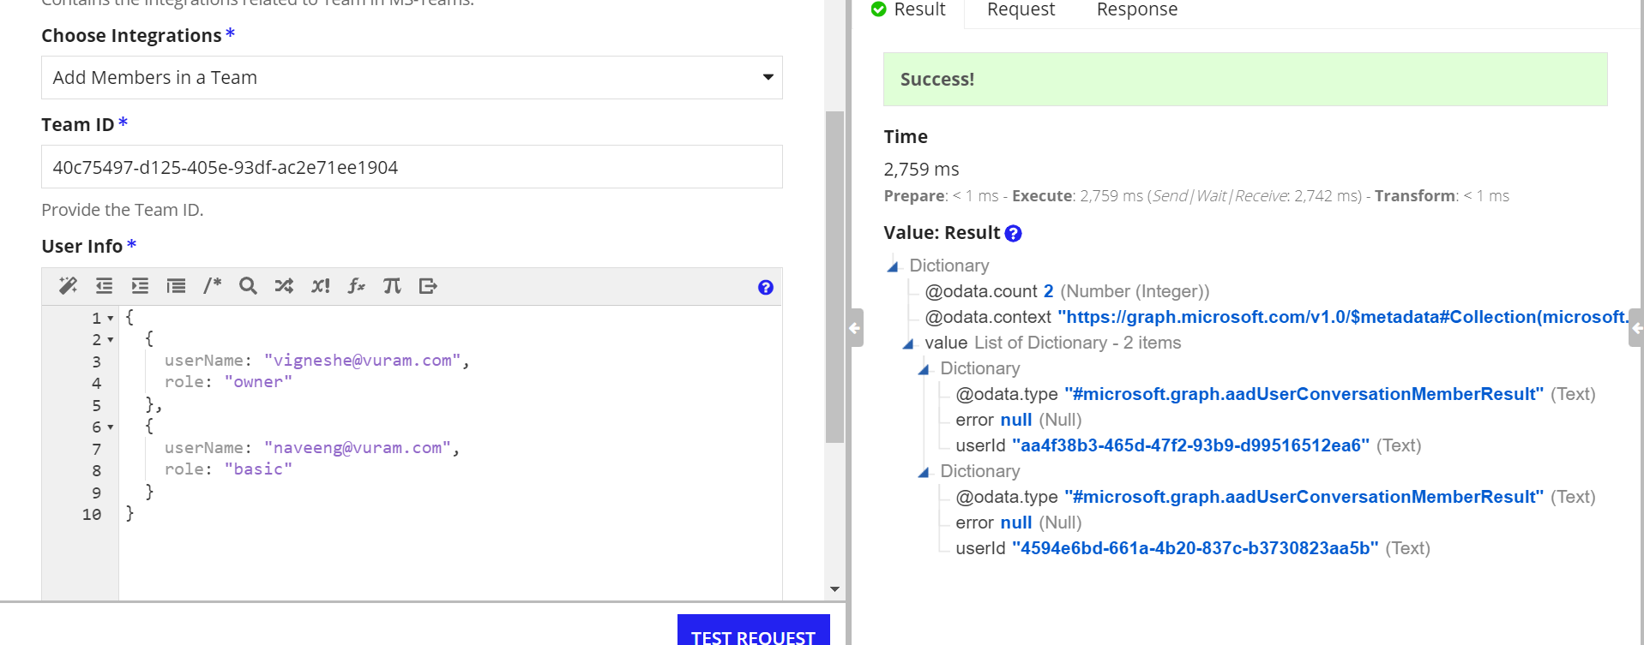
Format of User Info
{
{
userName: "abc@domain.com",
role: "owner"
},
{
userName: "def@domain.com",
role: "basic"
}
}
The available roles are owner, basic and guest.
Note: Only the guest users in the organization can be added with the guest role.

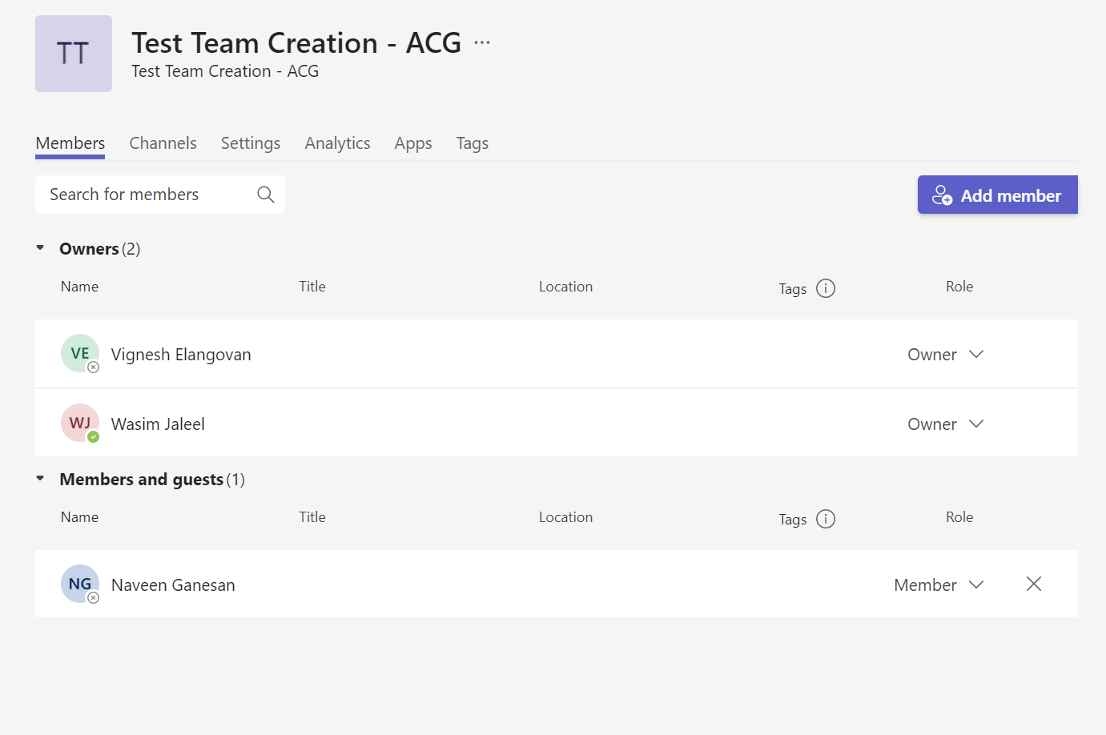

List Members in Team
List the members in the specified team.
Scopes Required: TeamMember.ReadWrite.All
Each member is identified by a Membership Id
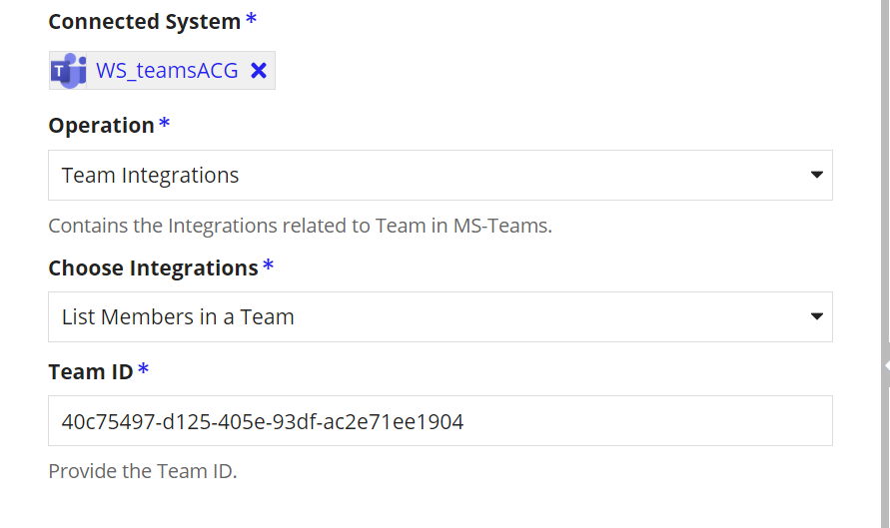
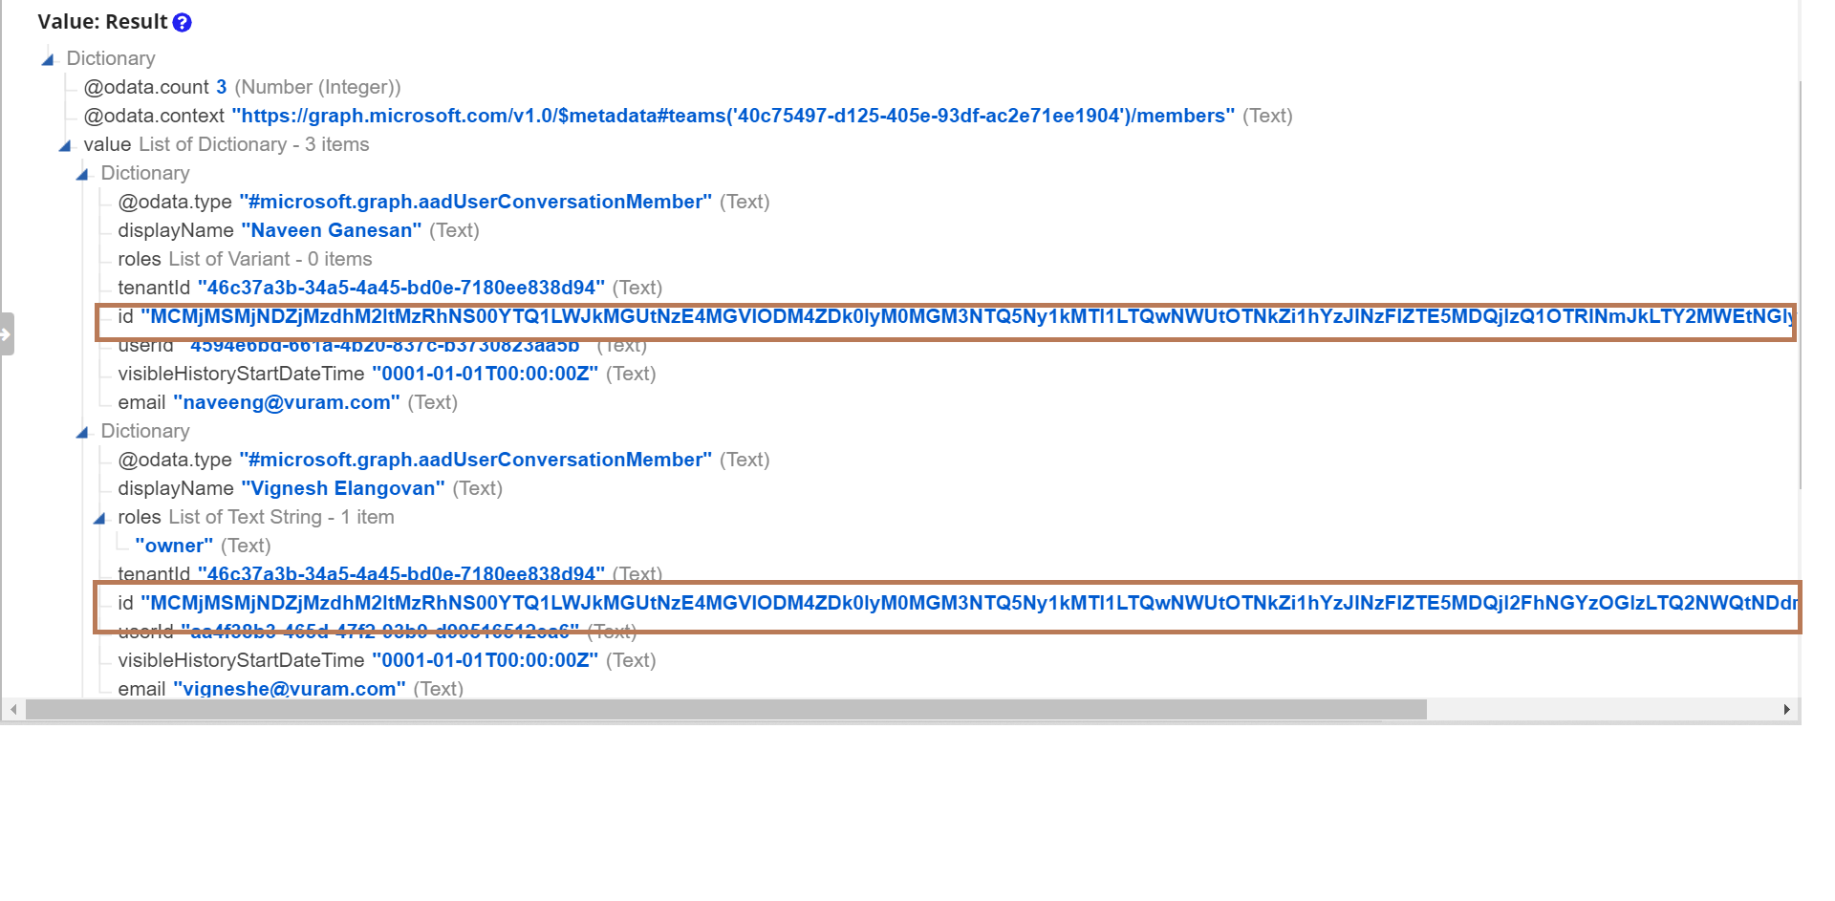
This Id returned is used to perform operations on the members of the team.

Remove Members from a Team
Remove the Specified member from the Team
Scopes Required: TeamMember.ReadWrite.All
Membership Id - Id of the team member.

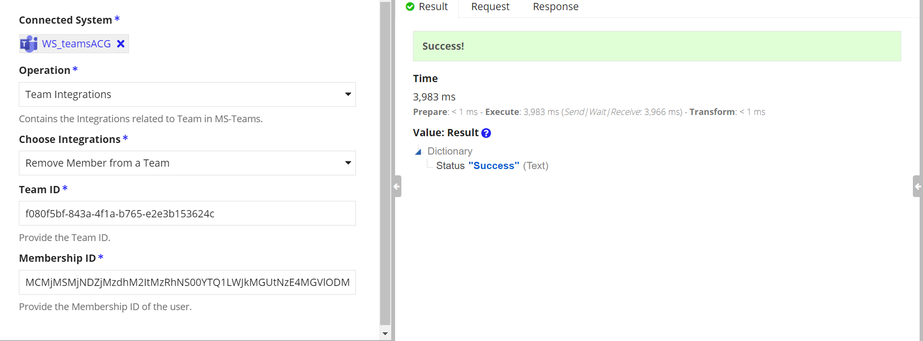

Archive Team
Archive the specified team.
Scopes Required: TeamSettings.ReadWrite.All

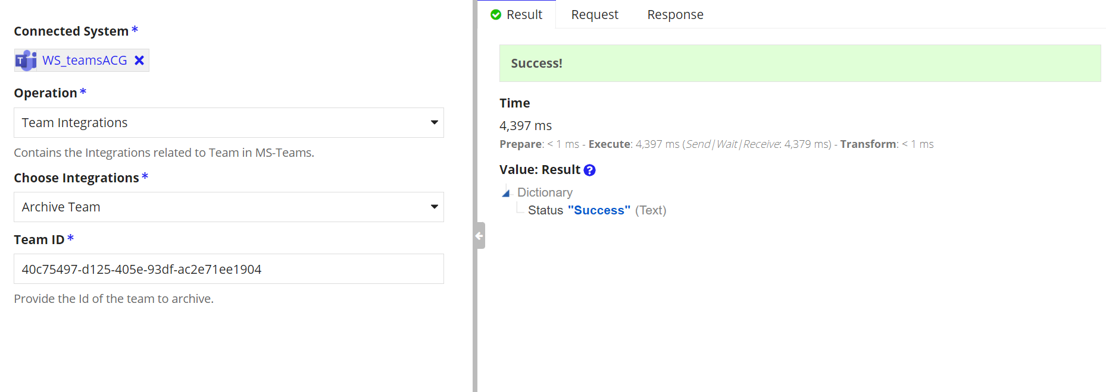

Unarchive Team
Unarchive the Specified team.
Scopes Required: TeamSettings.ReadWrite.All

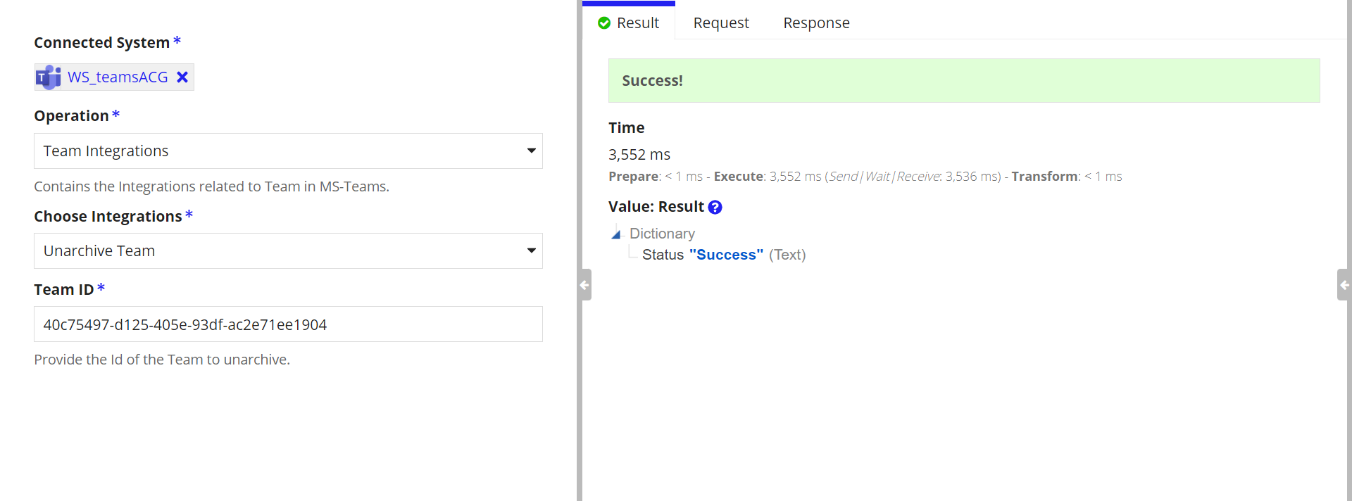

Delete Team
Integration to Delete a Team
Scope Required: Group.ReadWrite.All

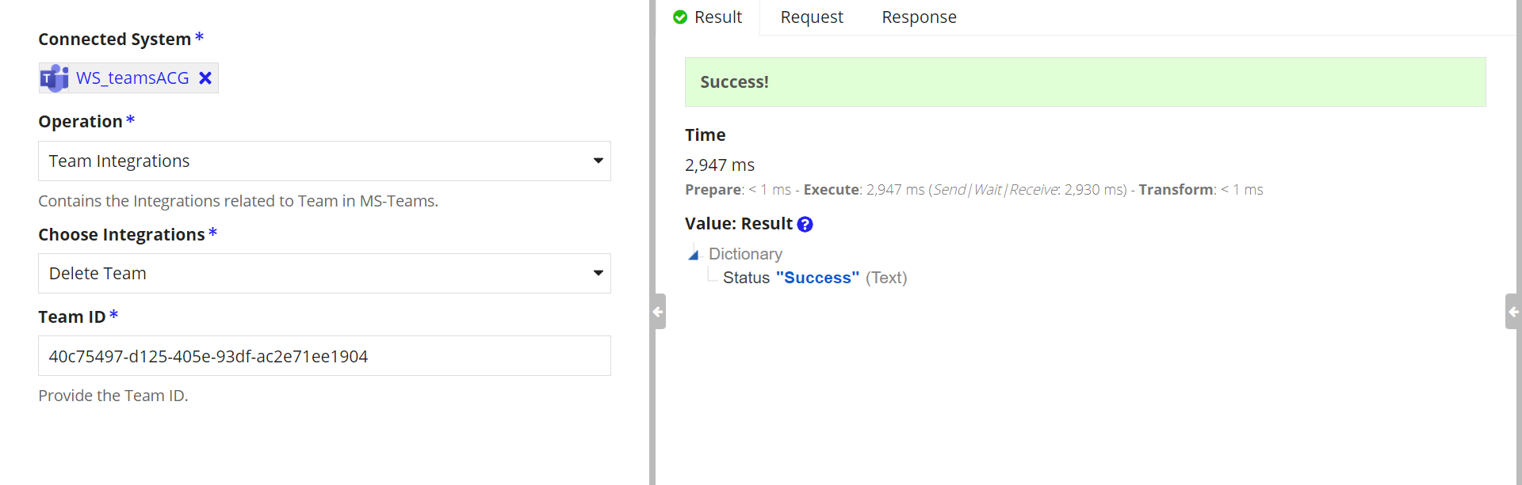

Channel Integrations

Create Channel in a Team

Create a channel in the specified Team. The channel can be either Private or Standard.
Standard - Inherits the members from the team.
Private - Need to add members manually.
Channel Id is returned in the output dictionary.
Scope Required: Channel.Create

Standard Channel Creation

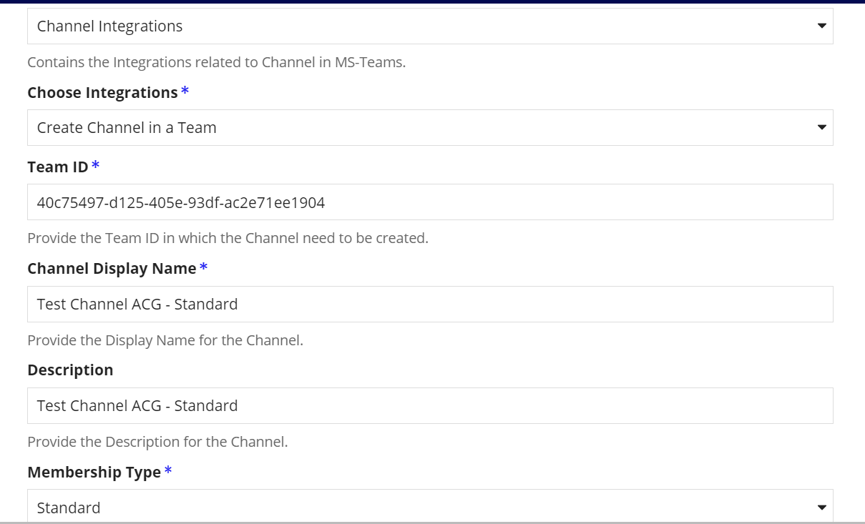
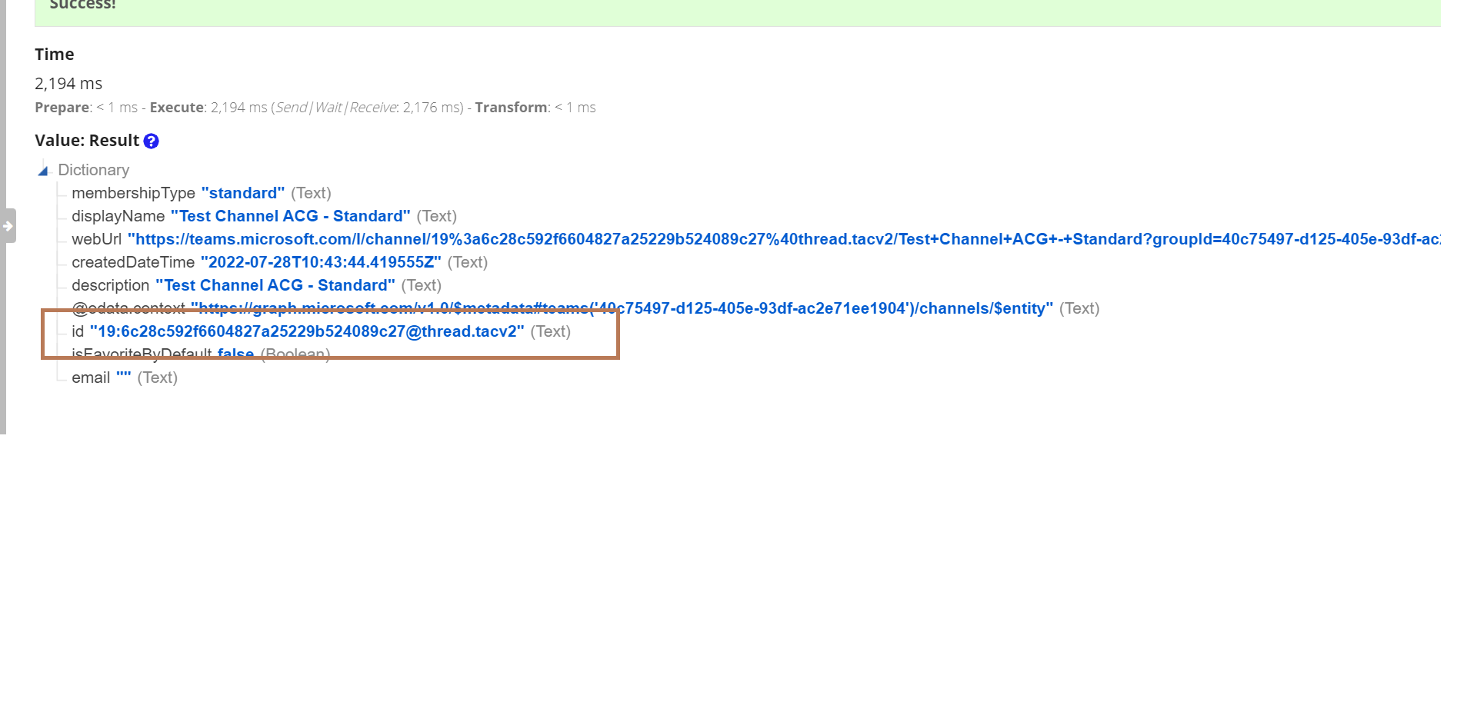
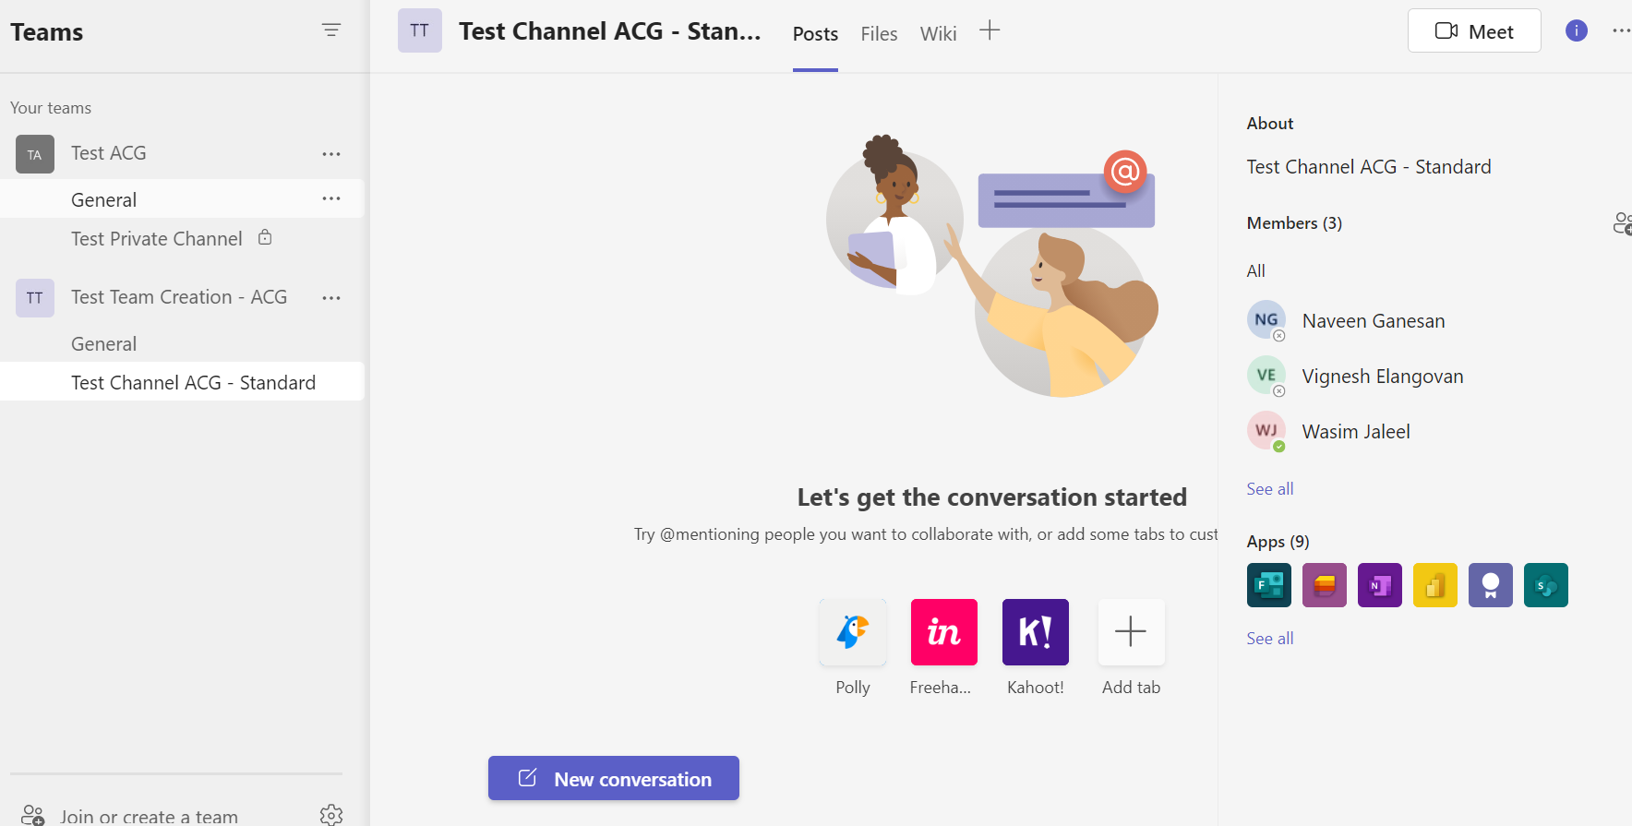

Private Channel Creation

Team members are not inherited in the private channel. We need to add the members manually.
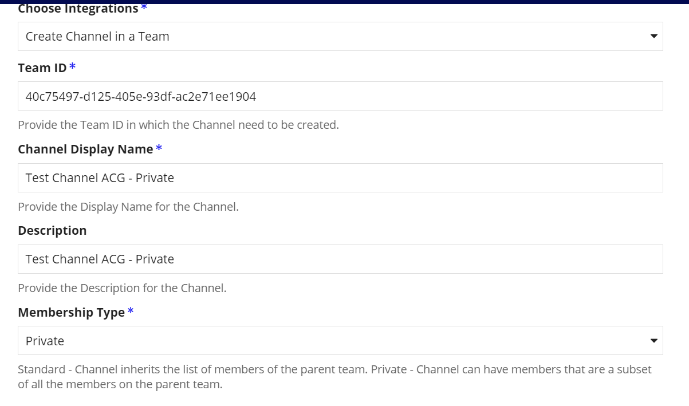
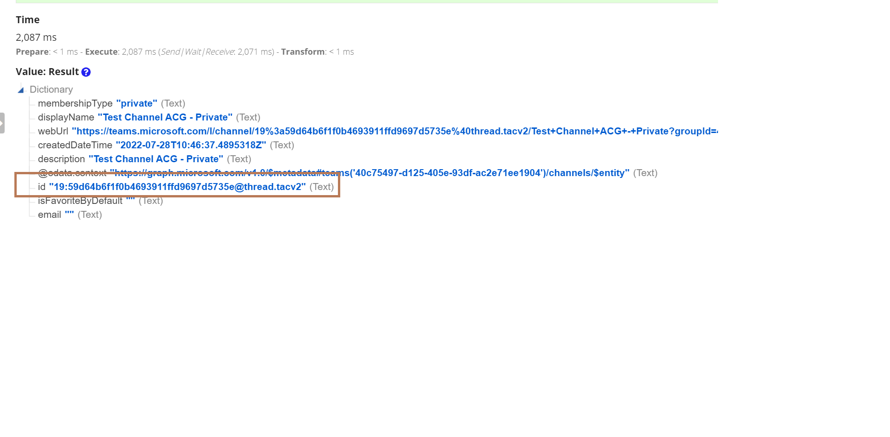
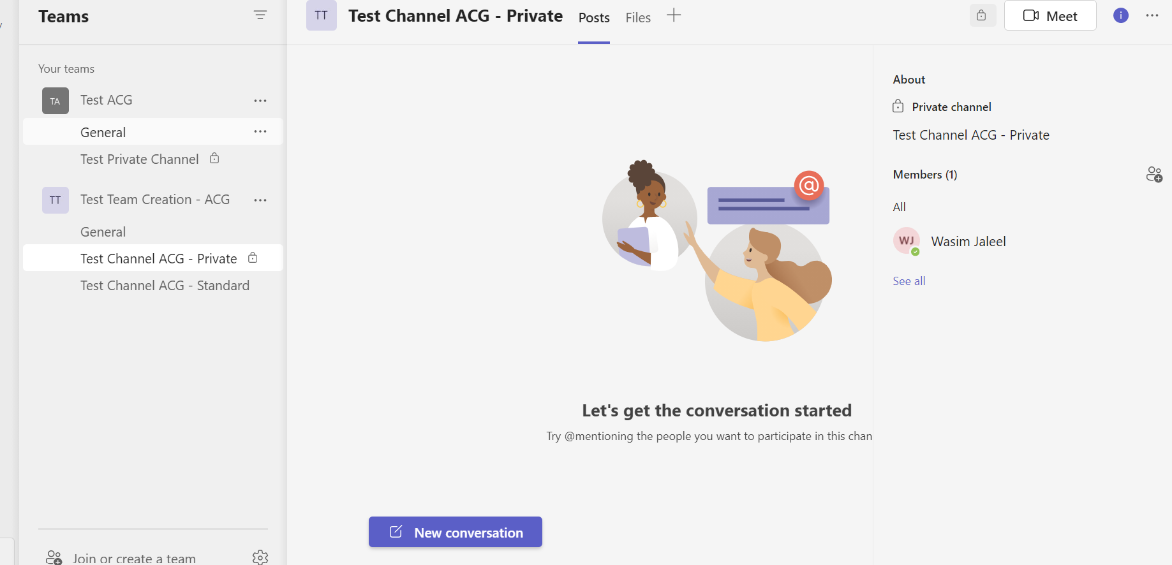

List the Channels in a Team

List the Channels in the team
Scope Required: ChannelSettings.ReadWrite.All,

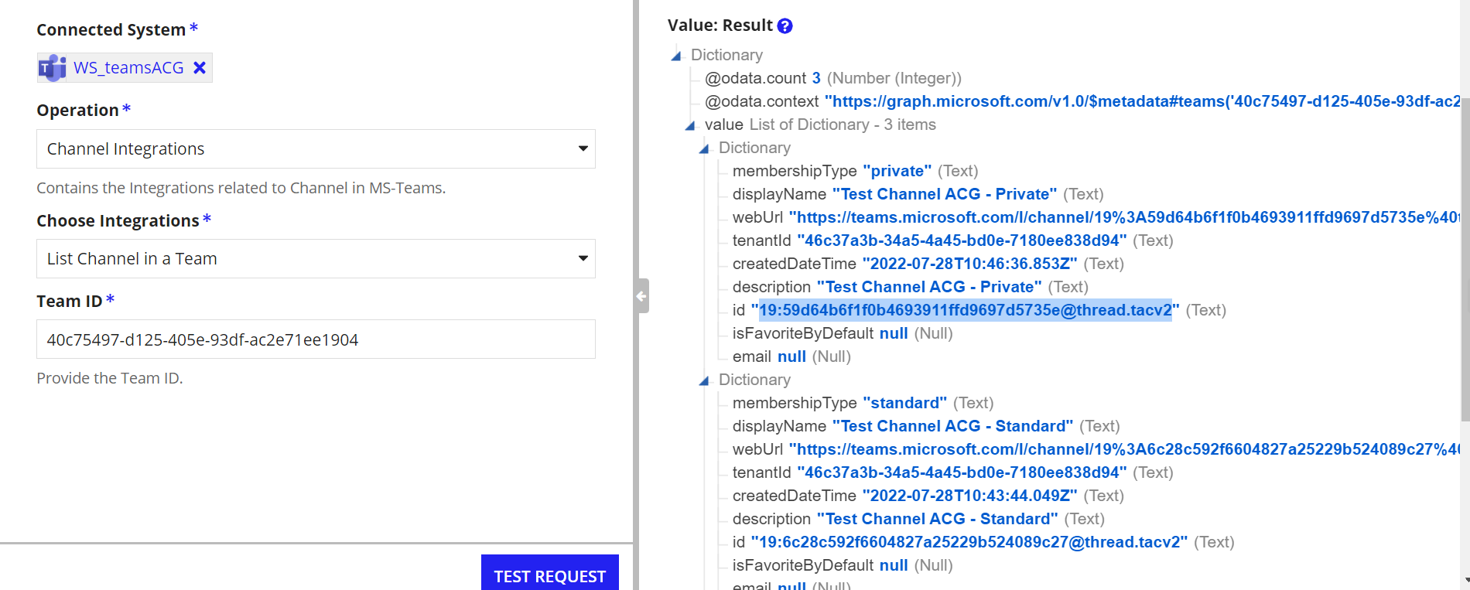

Get the details of a Channel in Team
Get the details of the specified channel in the team
Scope Required: ChannelSettings.ReadWrite.All
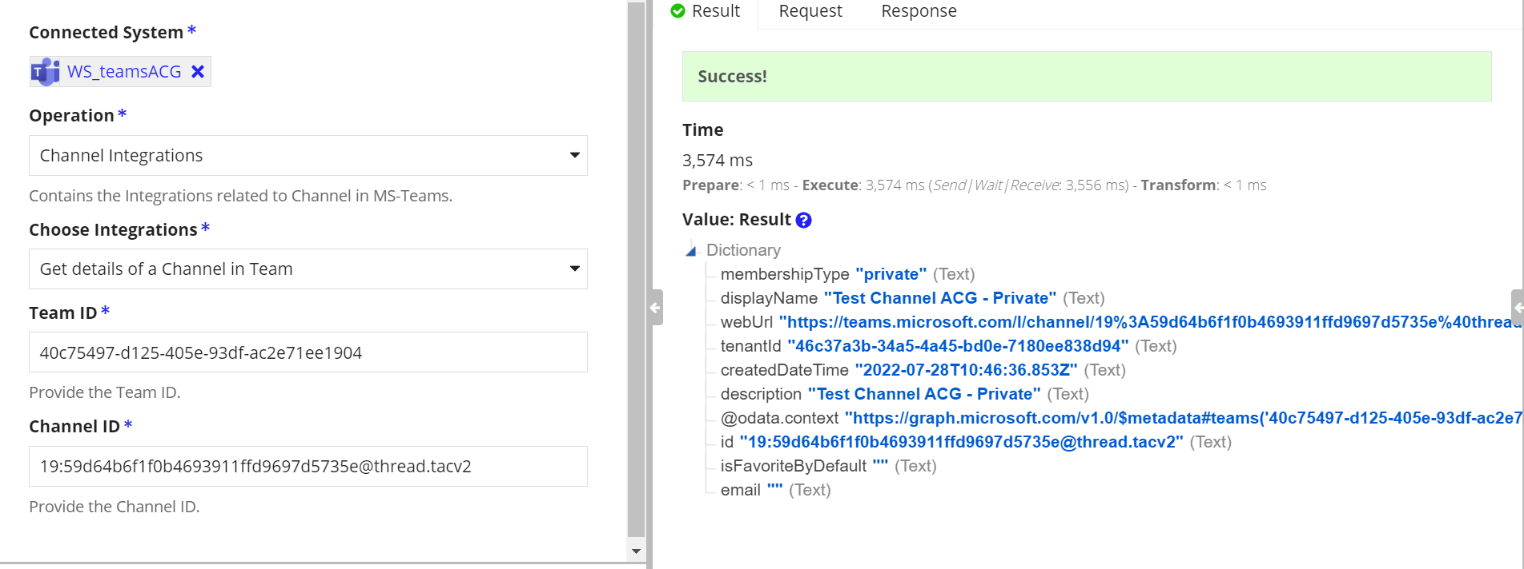

Add Members in Private Channel

Integration to add members in the private channel
Scope Required: ChannelMember.ReadWrite.All

Note: We cannot add or delete members in the Standard Channel. Also only the members of the team can be added as members in the private channel.
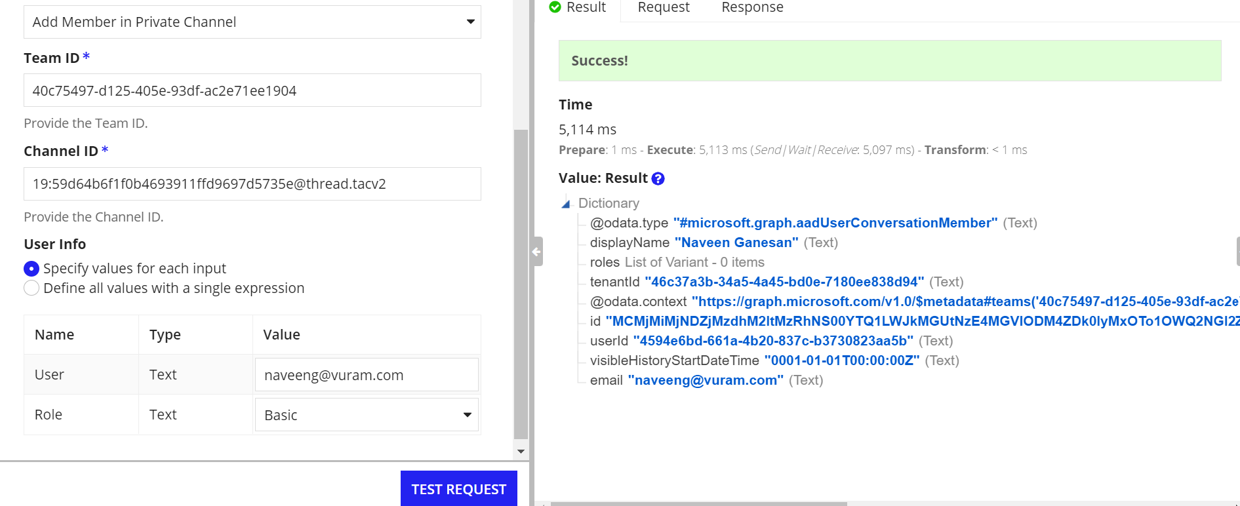
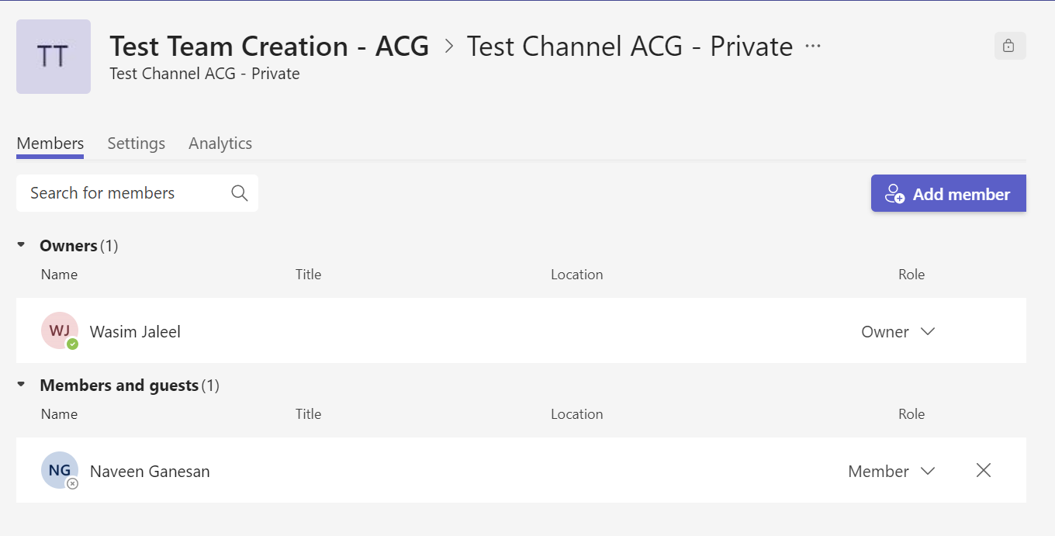

List Members in Private Channel

Integration to list the members in the private channel.
Scope Required: ChannelMember.ReadWrite.All
Each user is assigned with a Membership Id. That is also returned in the output dictionary
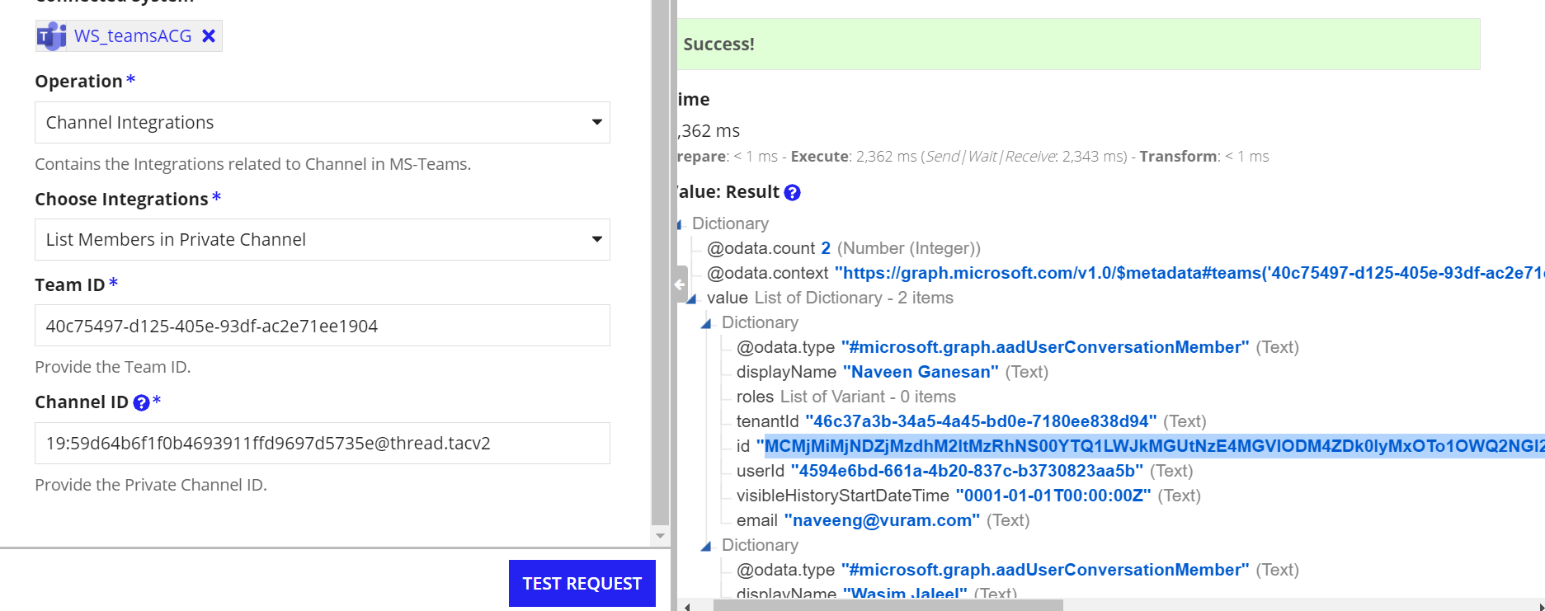

Get details of a Channel Member

Get the details of the specific channel member
Scope Required: ChannelMember.ReadWrite.All
Membership ID - Membership of the user
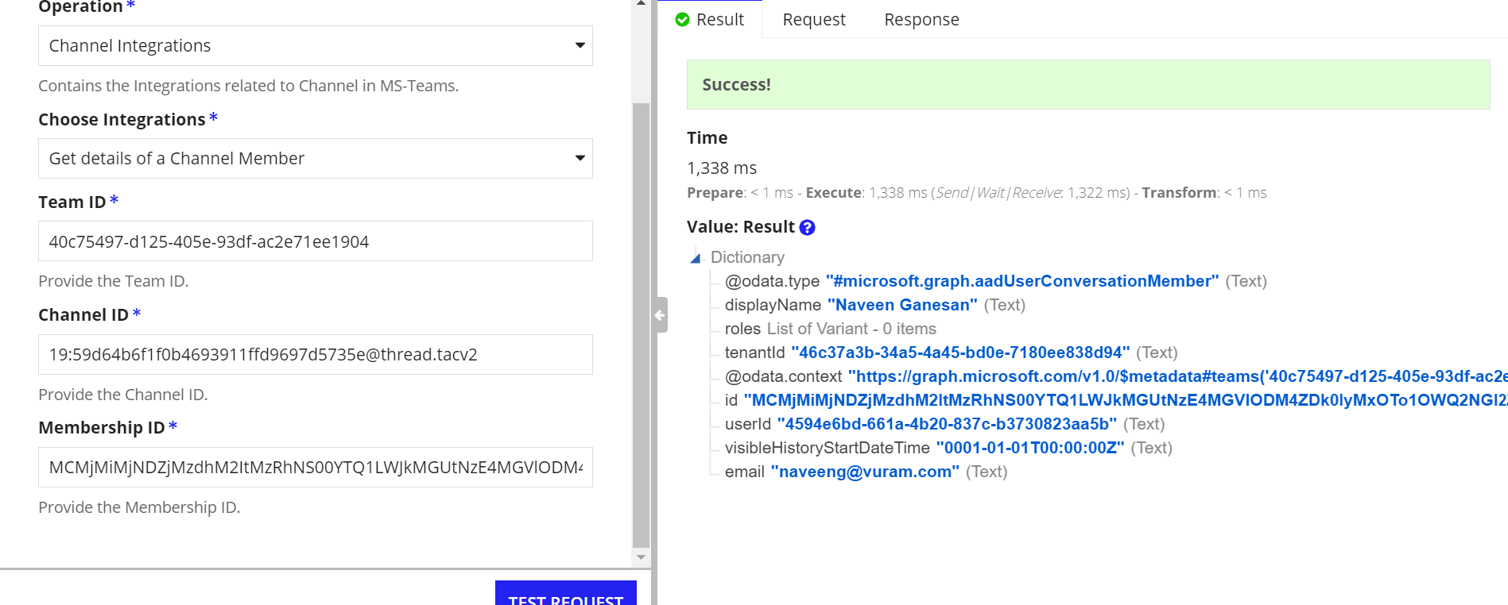

Remove Private Channel Member
Integration to remove the members from Private Channel
Scope Required: ChannelMember.ReadWrite.All
A Success status will be returned once the user is removed.
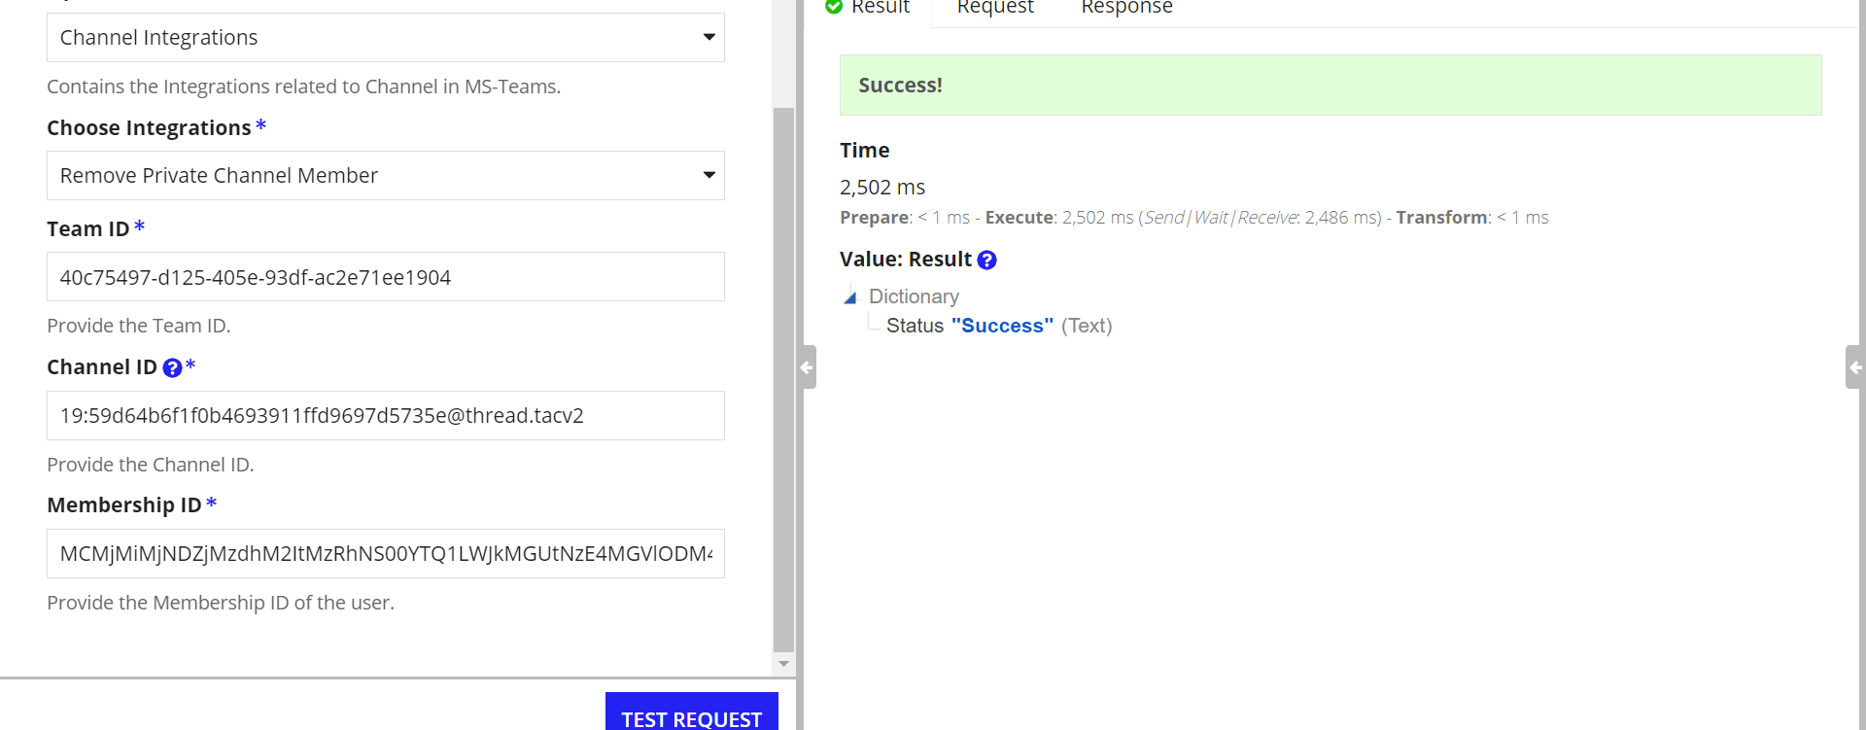

List Messages/Replies in a Channel
Integration to list the messages/replies sent in a channel
Scope Required: ChannelMessage.Read.All
No of Messages and Skip Token can be used to iterate through the messages
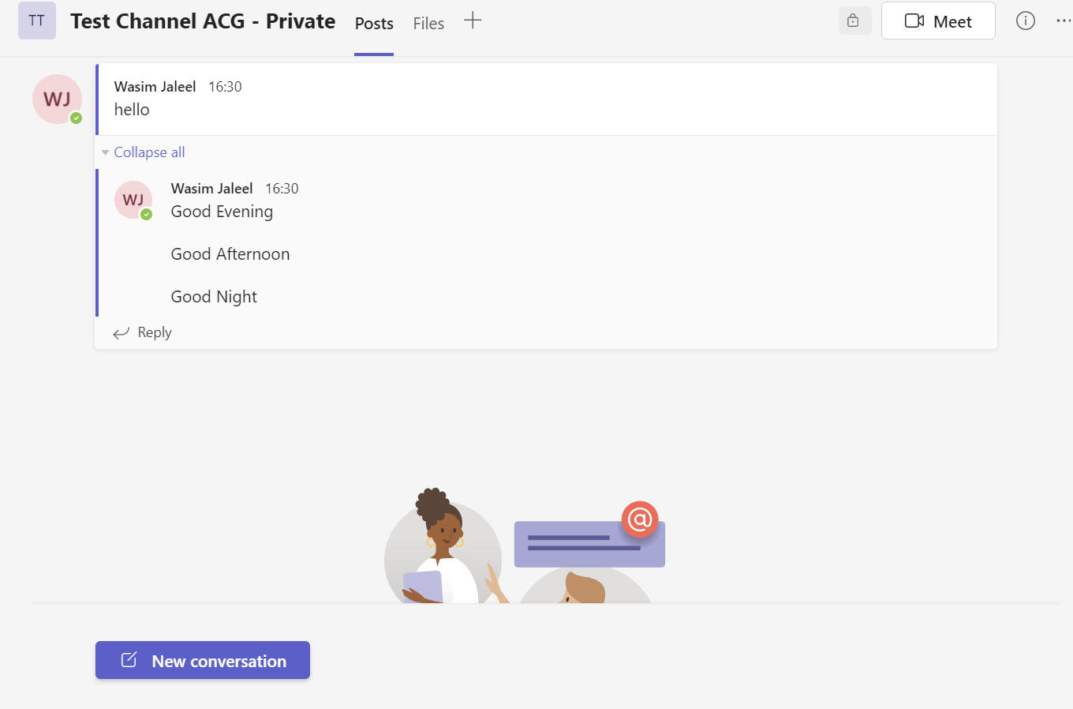

List Messages

Each message is identified by a message Id which can be used to get the replies sent to that particular message.
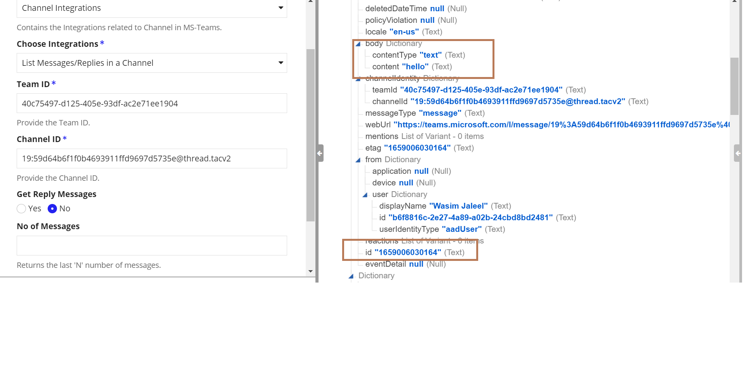

List Replies
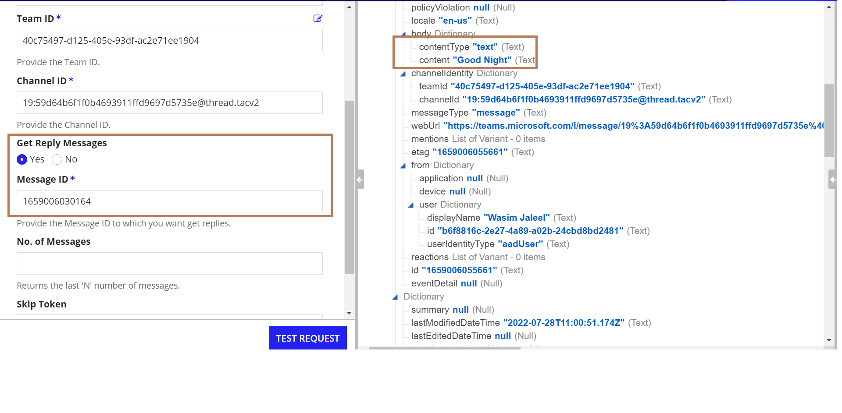

Send / Reply Message in Channel
Integration to send a message in the channel. If Message Id is provided then the message will be sent as a reply to that message.

Attachments can be added by setting the include attachment field as ‘YES’

If Folder Name is given, then the uploaded document will be stored in that folder under the root directory of one Drive. If not given, then the document will be stored in the default folder Appian_Chat_Files under root directory

Scope Required: ChannelMessage.Send, Sites.ReadWrite.All
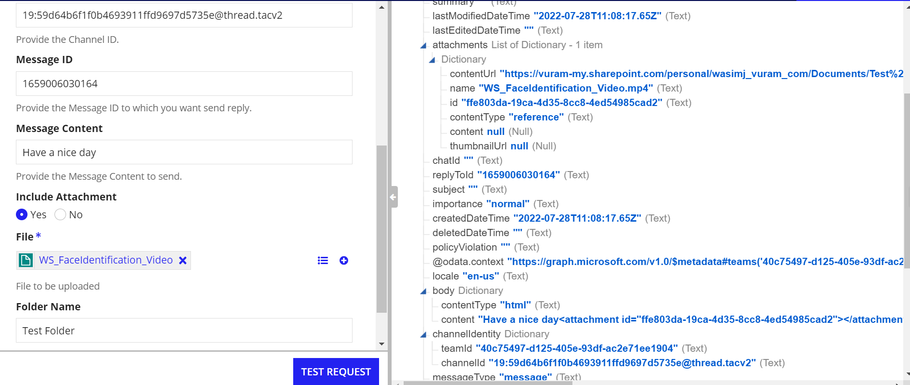
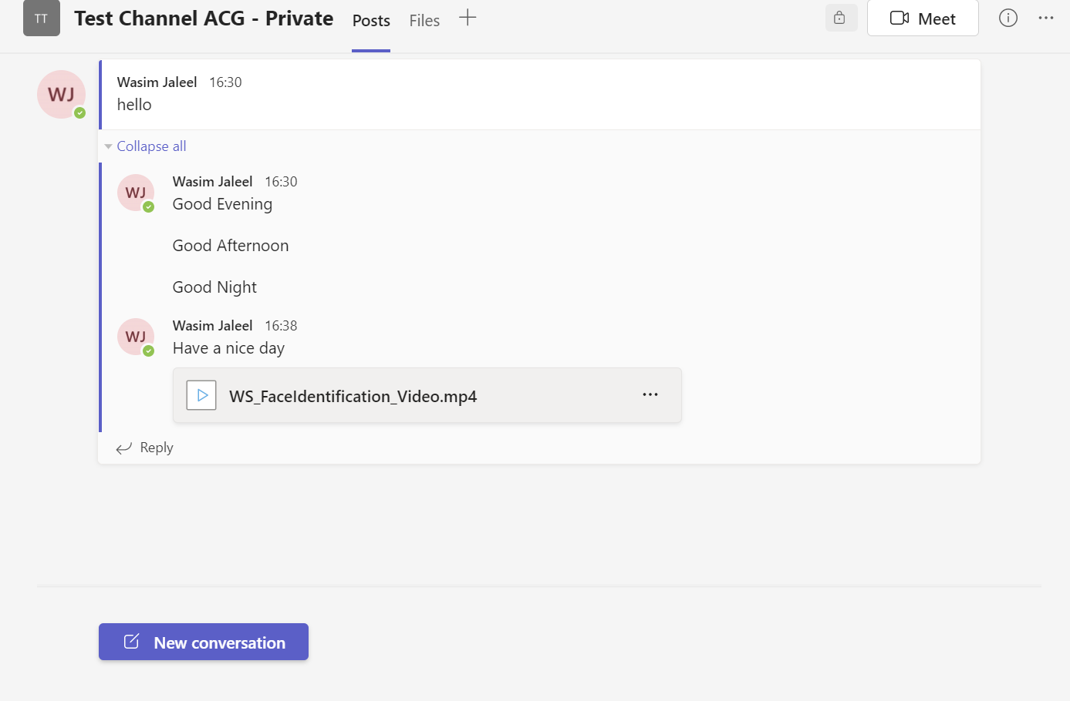

Delete Channel
Integration to delete a channel
Scope Required: Channel.Delete.All
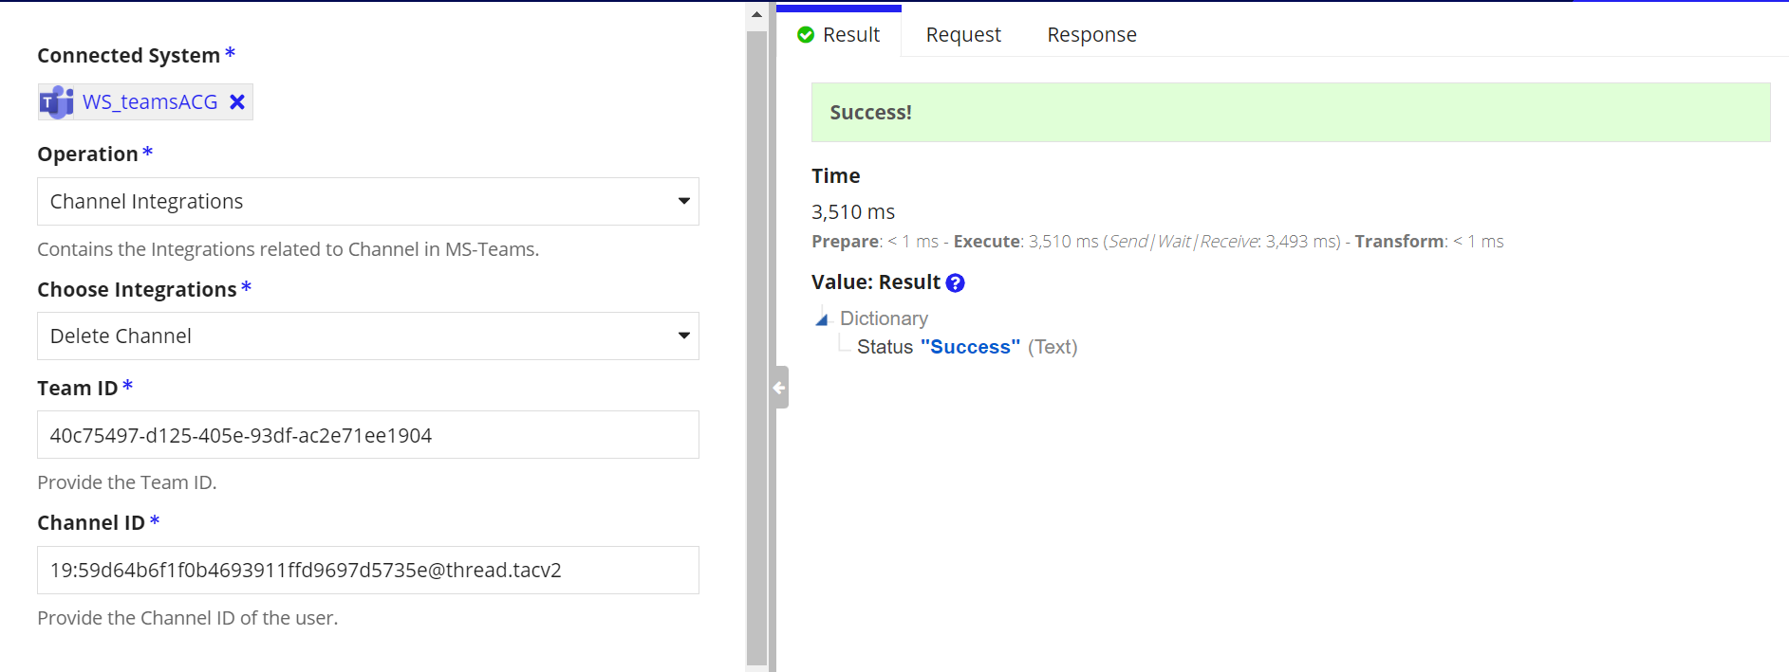

Miscellaneous Integrations

Download Attachment

Integration to download the attachment sent in chat / Channel. We need to provide the file Url for downloading. To get the file Url, first list the messages sent in the chat/channel. The output dictionary will contain the url of the file sent. Use the url to download the file
Scope Required: Sites.ReadWrite.All

List the Message in Chat / Channel
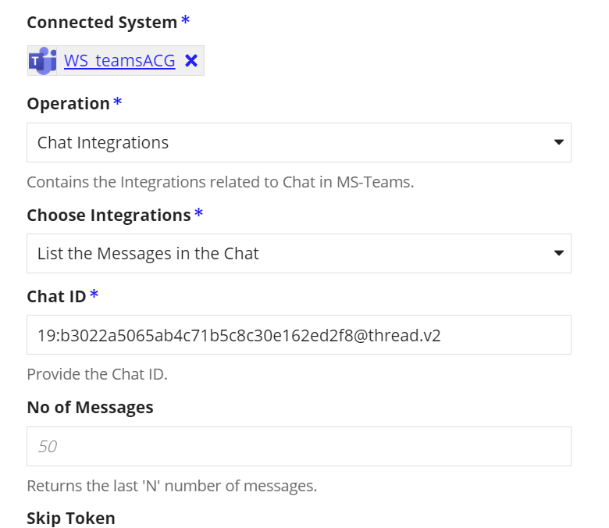

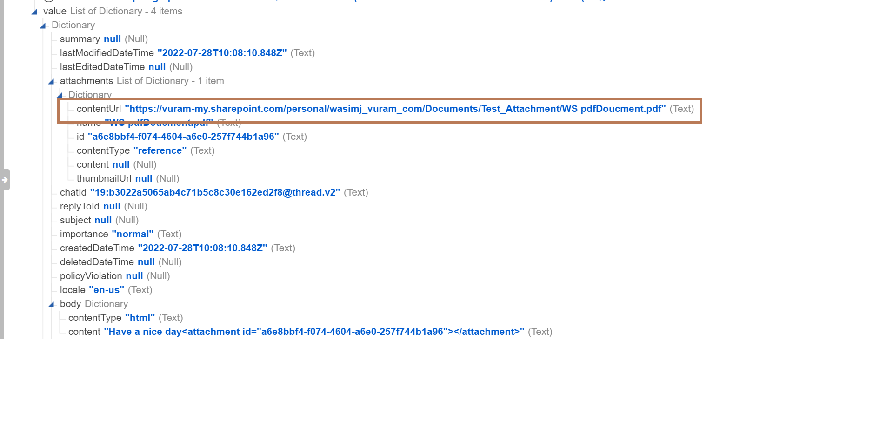

Download the Attachment
Use the Content Url to download the file
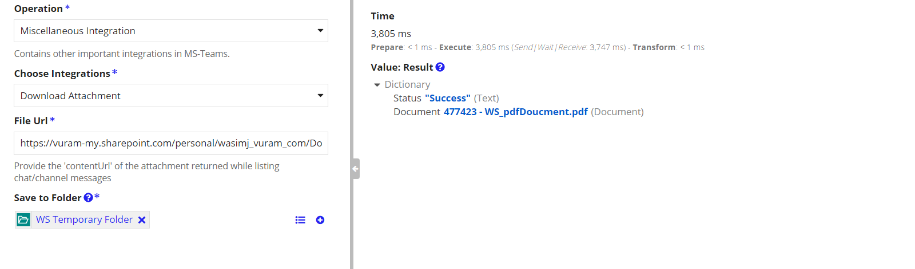

Send Invitation

Integration to send invitations for users outside the organization. Once the user accepts the invitation then they can access the organization teams as a guest user. A mail will be sent to the user
Scope Required: Directory.ReadWrite.All

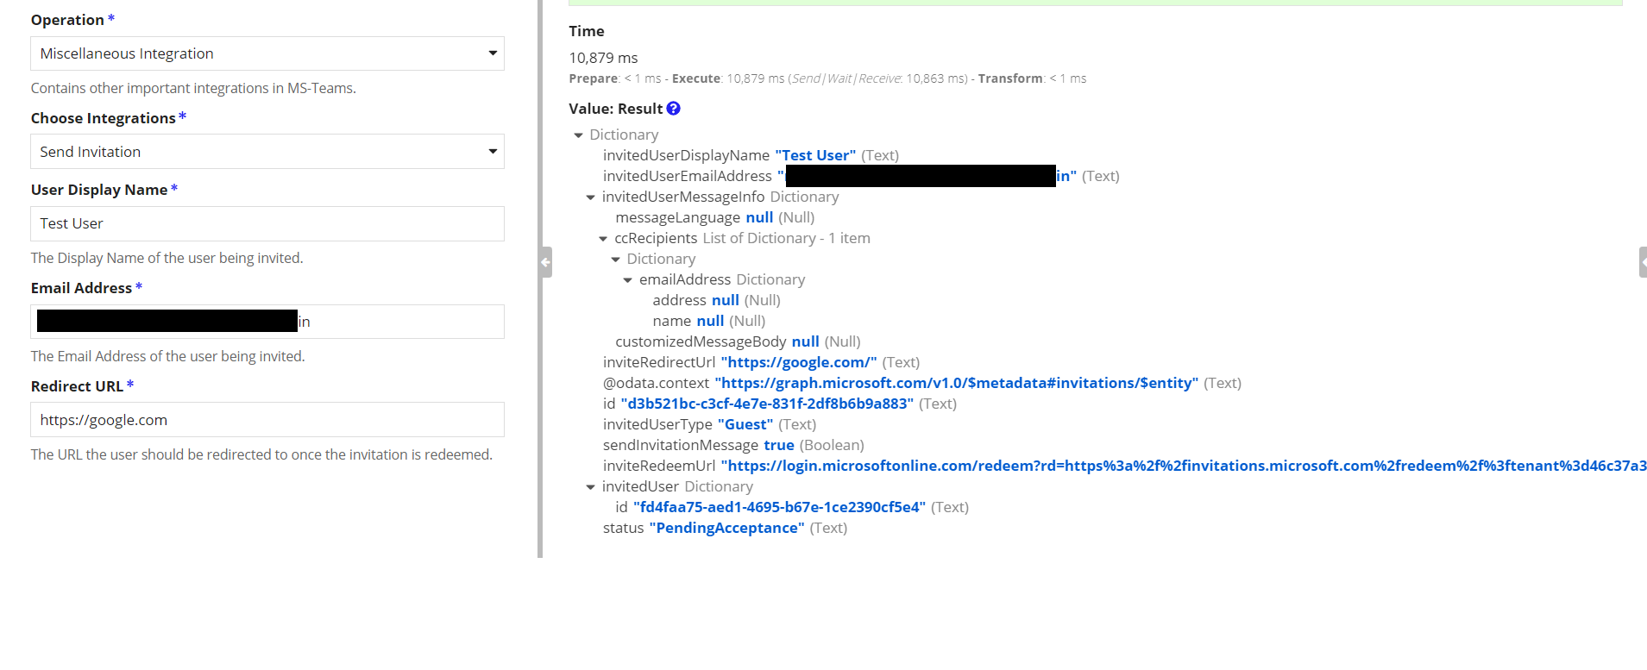
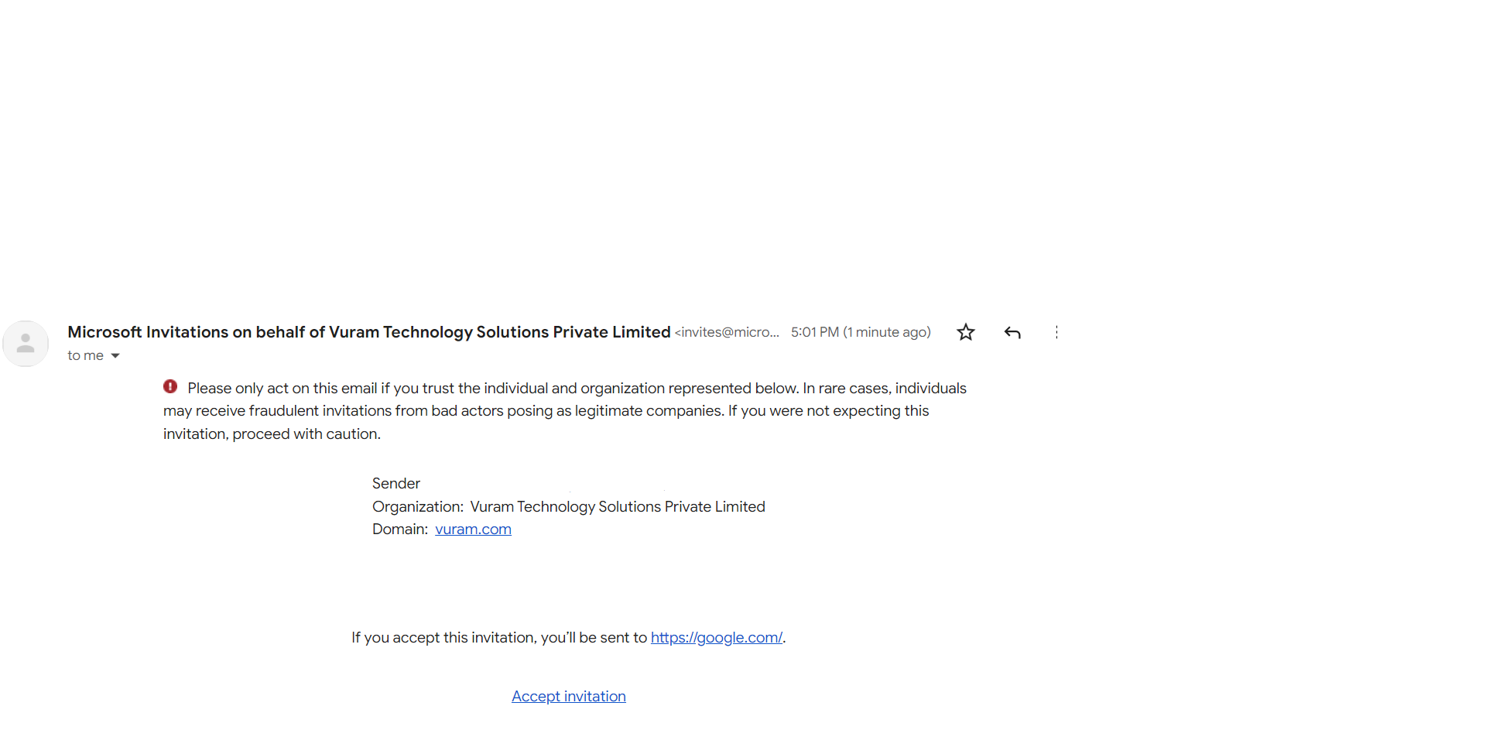

Integrations in Client Credentials
Create a Microsoft Teams (Client Credential Grant) connected system using the credentials from azure portal. Use the connected system to create Integrations.

Chat Integrations

Create New One on One Chat
Integration to create Chat between two users. This requires the id of two users.
The output dictionary contains the Id of the Chat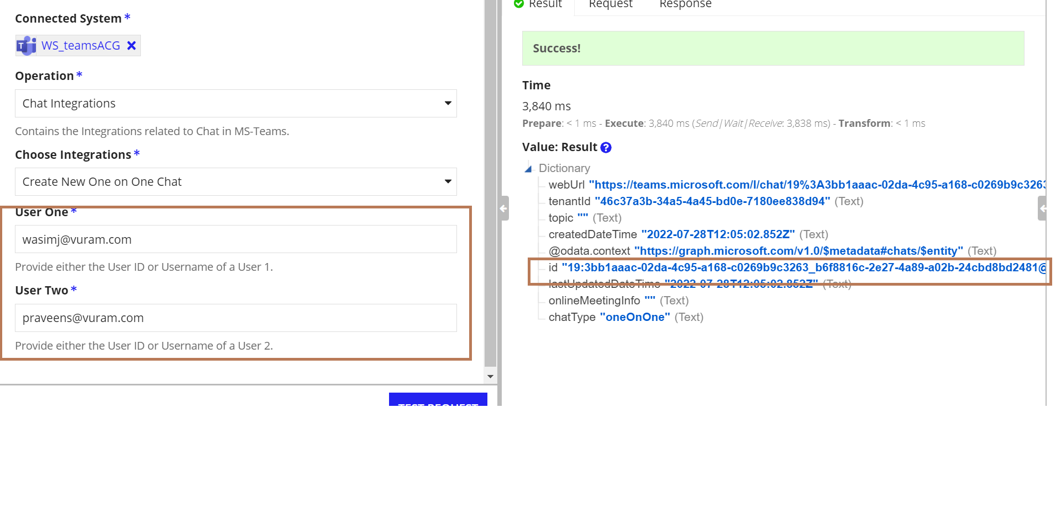
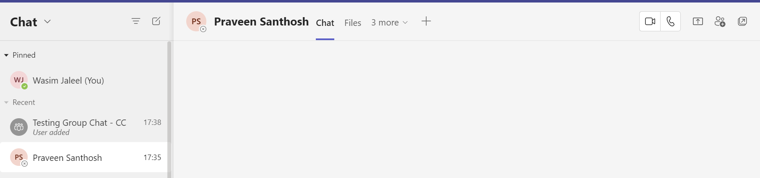

Create New Group Chat
In 'Client Credentials' the group chat is created among the given users. At Least one user should have an owner role.

Format of User Info
{
{
userName: "abc@domain.com",
role: "owner"
},
{
userName: "def@domain.com",
role: "owner"
}
}
The available roles are owner and guest.
Note: Only the guest users in the organization can be added with the guest role.

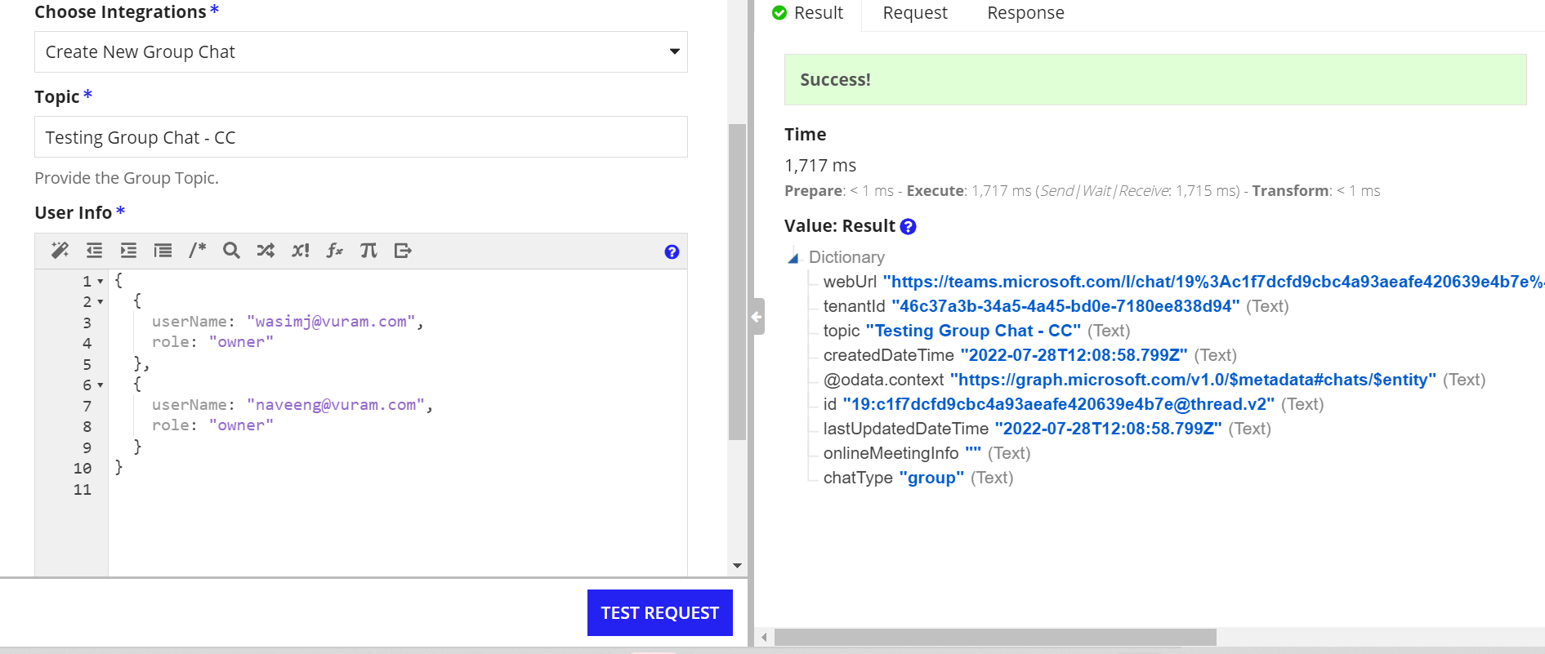
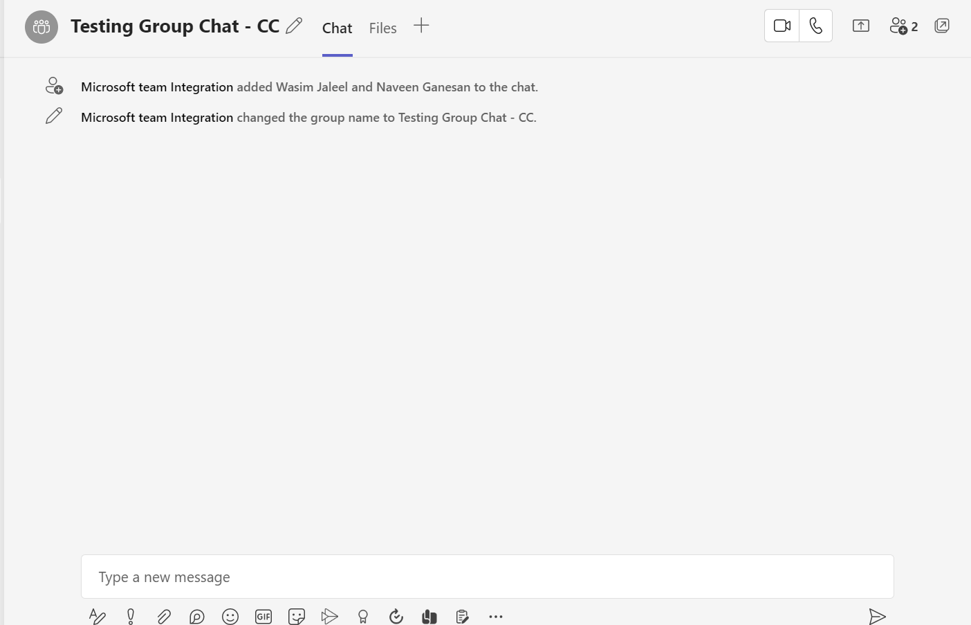

Team Integrations

Create Team
Integration to Create a new Team. In Client Credentials, a user Id is required to create a team which will be assigned with owner permissions
Scopes Required: Team.Create
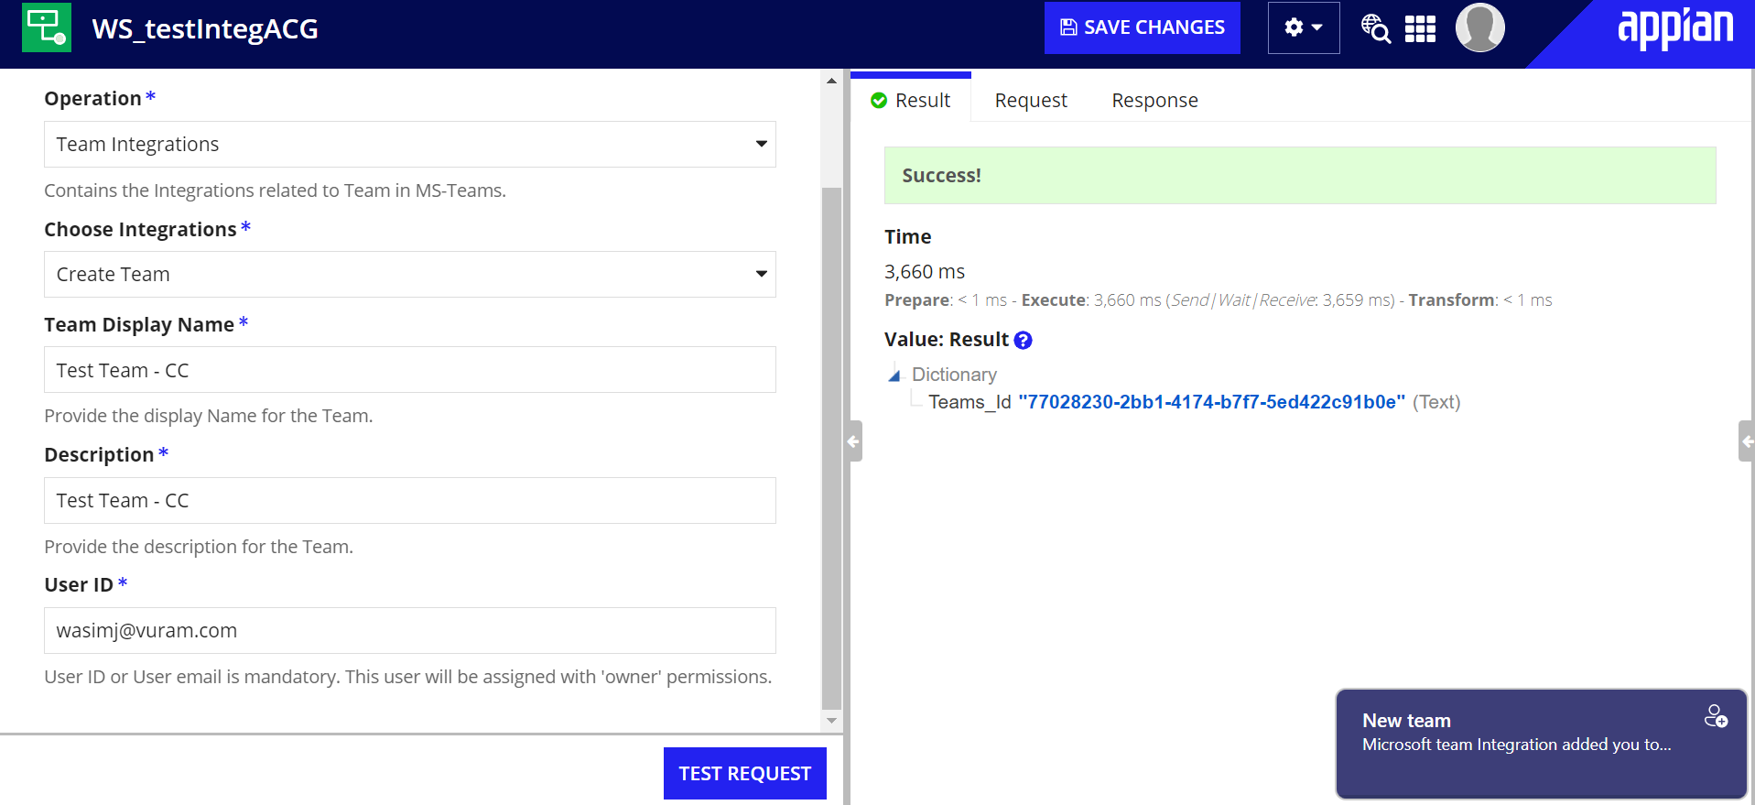
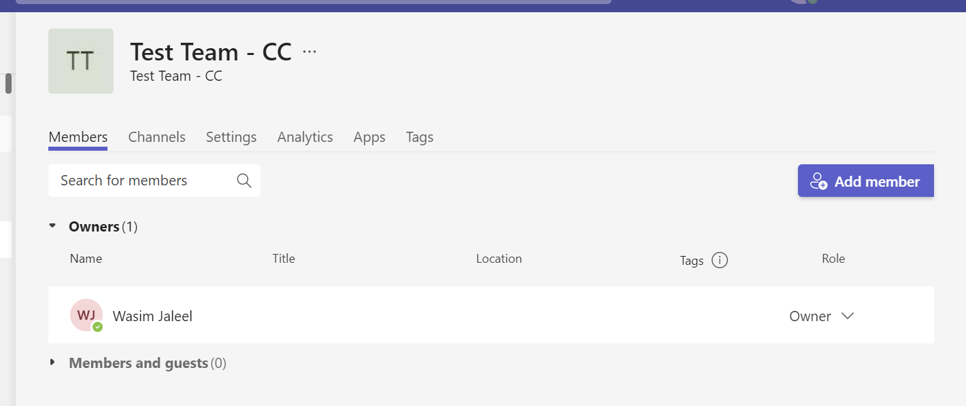

List All the Teams
Integration to list all the teams in the organization
No of Teams and Skip Token can be used to iterate the list.

Get details of a Team
Integration to get details about a particular team
Scope Required: TeamSettings.ReadWrite.All
Team Id - This is the Id returned during the creation of the Team.

Add Members in Team
Add list of members to the specified team
Scope Required: TeamMember.ReadWrite.All
Format of User Info
{
{
userName: "abc@domain.com",
role: "owner"
},
{
userName: "def@domain.com",
role: "basic"
}
}
The available roles are owner, basic and guest.
Note: Only the guest users in the organization can be added with the guest role.

List Members in Team
List the members in the specified team.
Scopes Required: TeamMember.ReadWrite.All
Each member is identified by a Membership Id
This Id returned is used to perform operations on the members of the team.

Remove Members in Team
Remove the Specified member from the Team
Scopes Required: TeamMember.ReadWrite.All
Membership Id - Id of the team member.

Archive Team
Archive the specified team.
Scopes Required: TeamSettings.ReadWrite.All

Unarchive Team
Unarchive the Specified team.
Scopes Required: TeamSettings.ReadWrite.All

Delete Team
Integration to Delete a Team
Scope Required: Group.ReadWrite.All

Channel Integrations

Create Channel
Create a channel in the specified Team. The channel can be either Private or Standard.
Standard - Inherits the members from the team.
Private - Need to add members manually.

Scope Required: Channel.Create

Creation of Standard channel doesn’t require us to add any members. But when creating a Private channel, we need to add at least one member to the channel.

Private Channel Creation
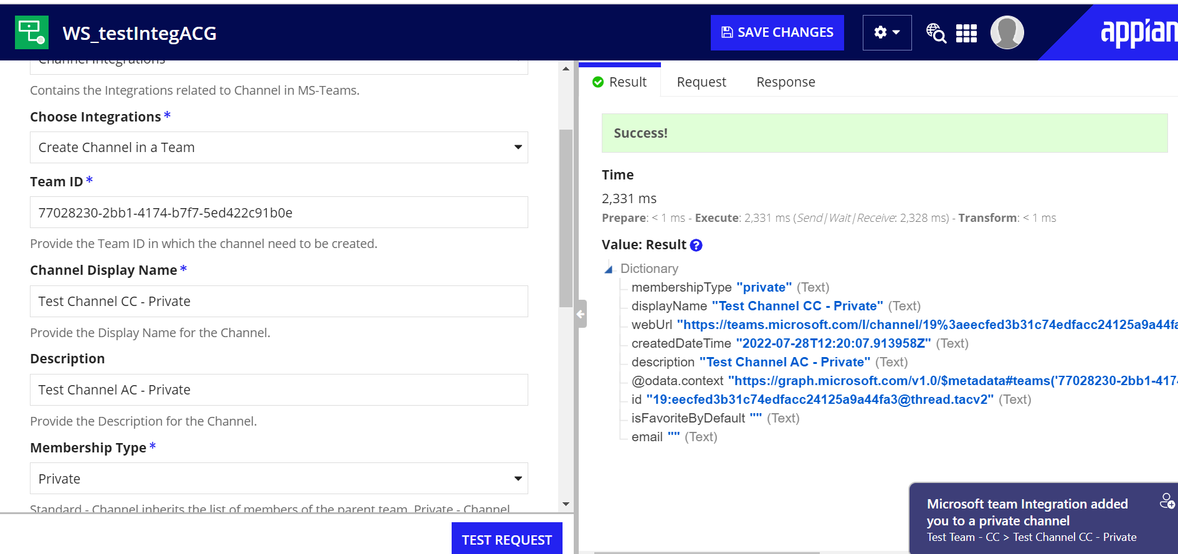
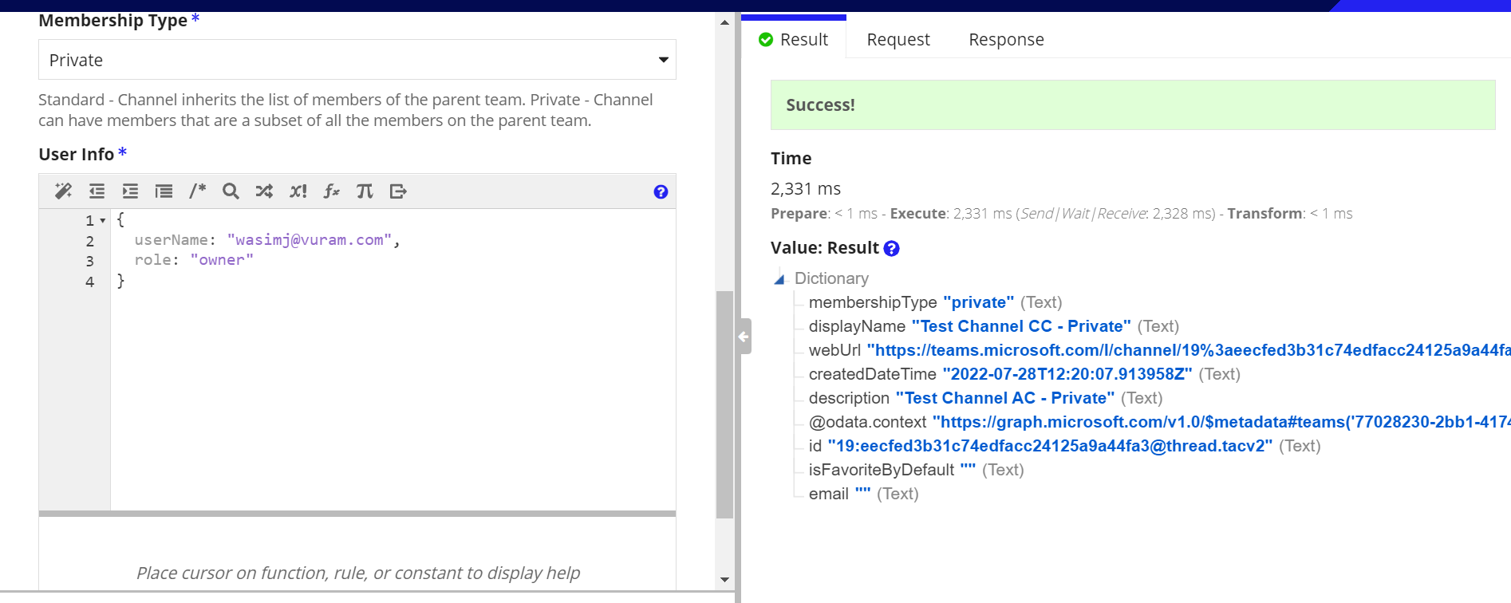

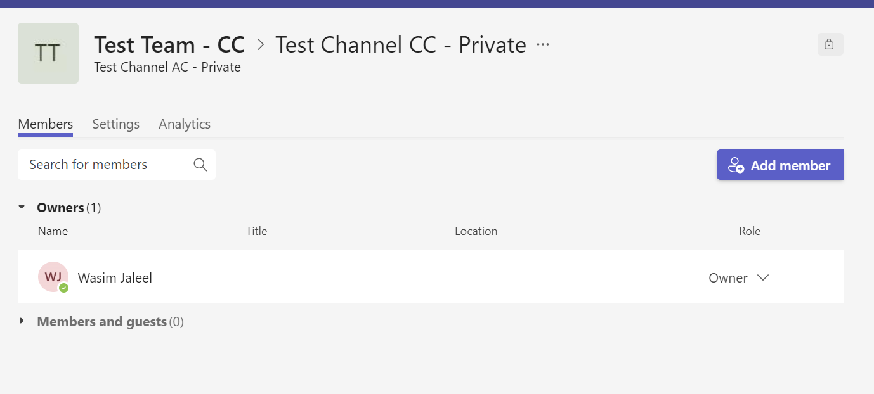

List Channels in a Team

List the Channels in the team
Scope Required: ChannelSettings.ReadWrite.All,

Get details of a Channel in Team
Get the details of the specified channel in the team
Scope Required: ChannelSettings.ReadWrite.All

Add Members in Private Channel

Integration to add members in the private channel
Scope Required: ChannelMember.ReadWrite.All

Note: We cannot add or delete members in the Standard Channel. Also only the members of the team can be added as members in the private channel.

List Members in Private Channel

Integration to list the members in the private channel.
Scope Required: ChannelMember.ReadWrite.All
Each user is assigned with a Membership Id. That is also returned in the output dictionary

Get details of Channel Member

Get the details of the specific channel member
Scope Required: ChannelMember.ReadWrite.All
Membership ID - Membership of the user

Remove Member from Private Channel
Integration to remove the members from Private Channel
Scope Required: ChannelMember.ReadWrite.All
A Success status will be returned once the user is removed.

Delete Channel
Integration to delete a channel
Scope Required: Channel.Delete.All

Miscellaneous Integrations

Send Invitation

Integration to send invitations for users outside the organization. Once the user accepts the invitation then they can access the organization teams as a guest user. A mail will be sent to the user
Scope Required: Directory.ReadWrite.All

