WhatsApp Business Connected System

**Overview**

WhatsApp allows users to send text and share images, documents, user locations, and other content. This Connected System allows developers to send messages(text, template,image and location) ,list associated phone numbers and view Message templates.

**Note:** This Connected System and its integrations are only meant for sending messages from WhatsApp Cloud API service accounts. Messages other than Template type will be received by the recipient only if the recipient had sent any message in the last 24 hours.

## **Connected System**

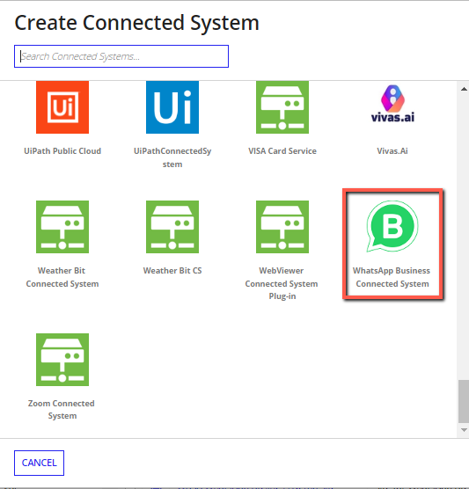

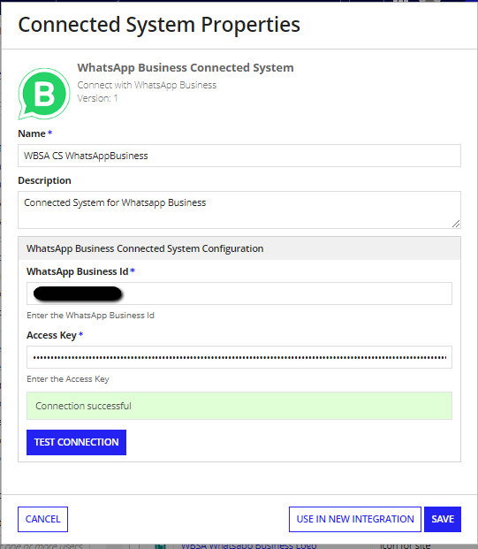

Steps to get WhatsApp Business Id:

Login to your [WhatsApp Business Manager](https://business.facebook.com/home/accounts/) and Go to Business Settings

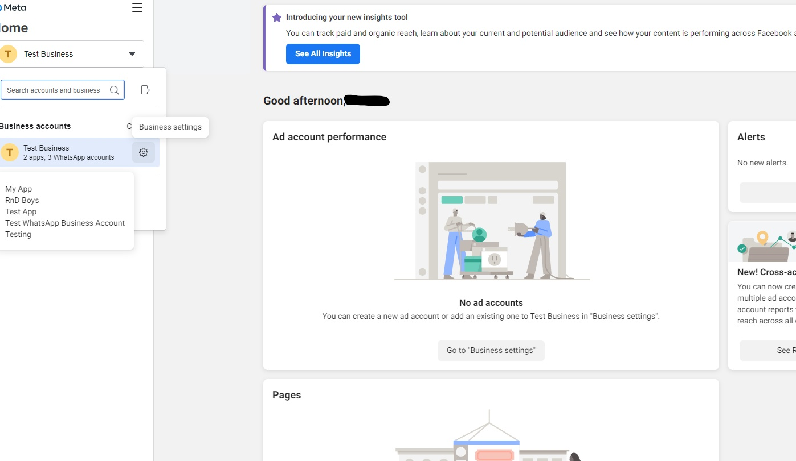

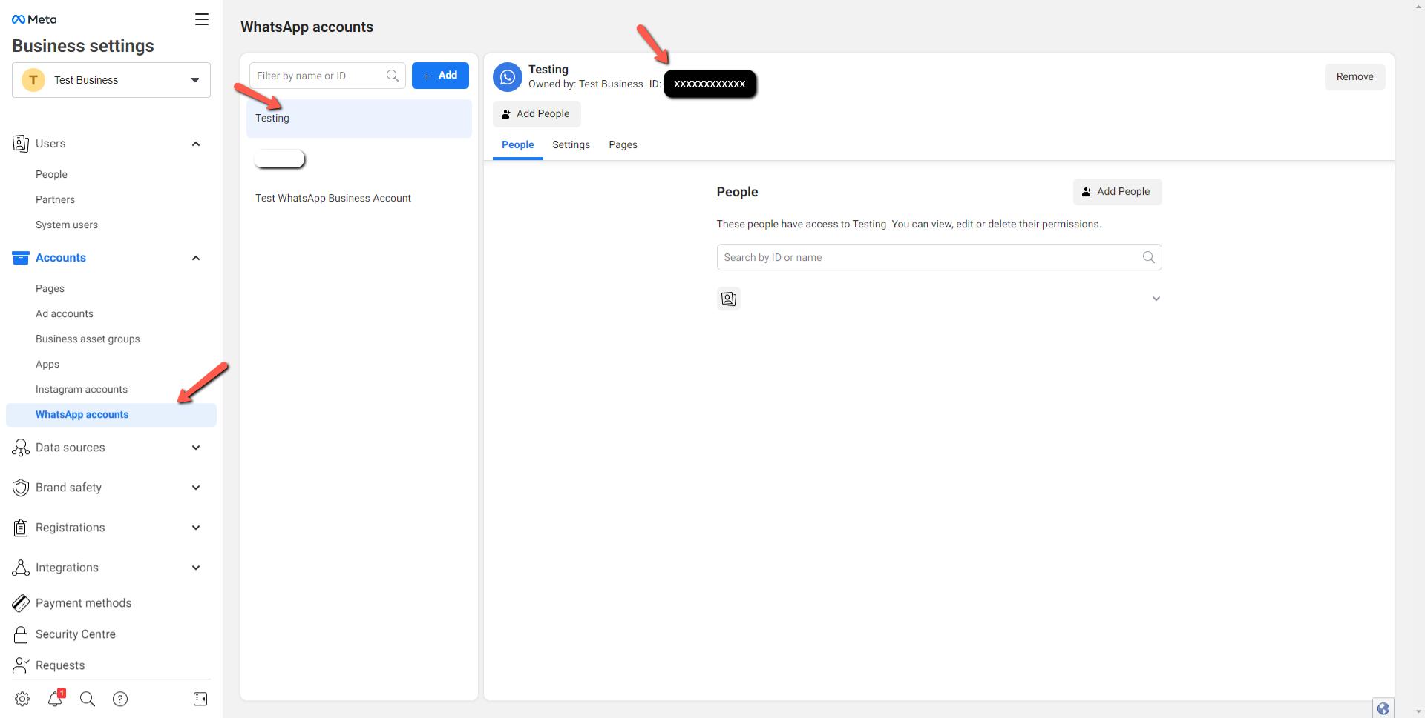

* WhatsApp Business Id will be shown as highlighted above. Copy and use it in the connected system. If there are no associated phone numbers with the account, follow the next steps.

Steps to get Add phone number:

* In the previous screen, click on the Add Button to add a new WhatsApp account.

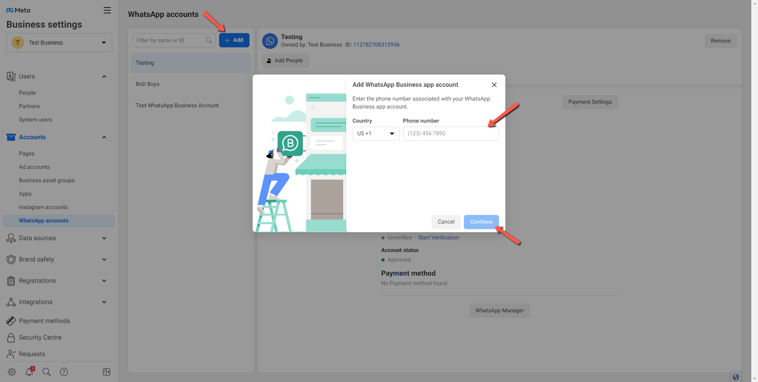

* Enter the number you want to send the messages from.

**Note:** The number should not be an existing WhatsApp account (Either WhatsApp messaging app account or WhatsApp business app account) . If that account has to be used, then that WhatsApp account should be deleted before adding it here.

* You will be receiving OTP to that entered number. Enter the OTP to verify and Business Id for that number will be displayed.

Steps to add multiple phone numbers to a Business Account :

* Click on the WhatsApp Manager as shown below

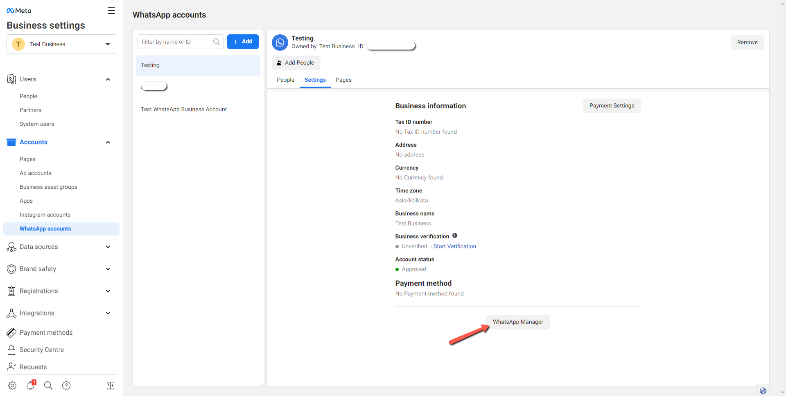

* Click on the business account name as shown below

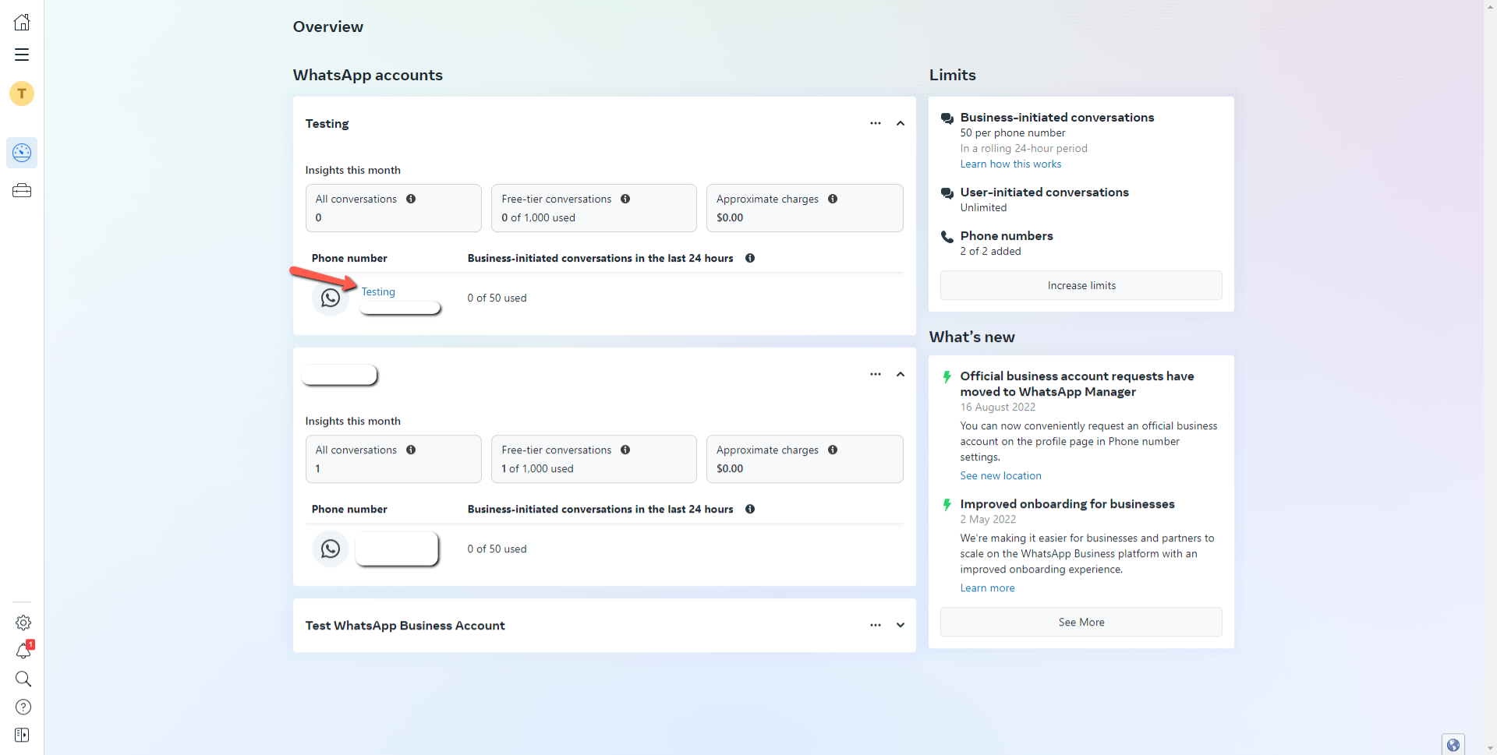

* Click on “Phone Numbers”

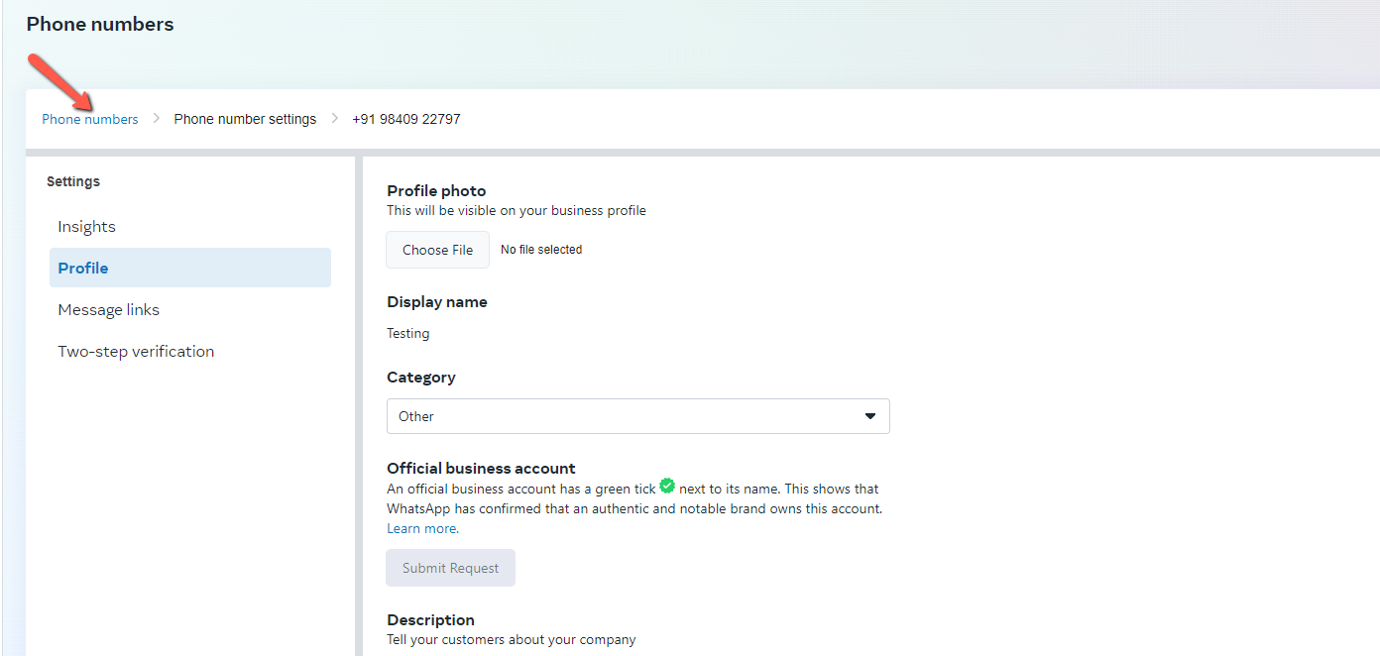

* Click on the “Add numbers” button to add more numbers to the account.

**Note:** Your business needs to be verified before adding the numbers. If not, the button will be disabled.

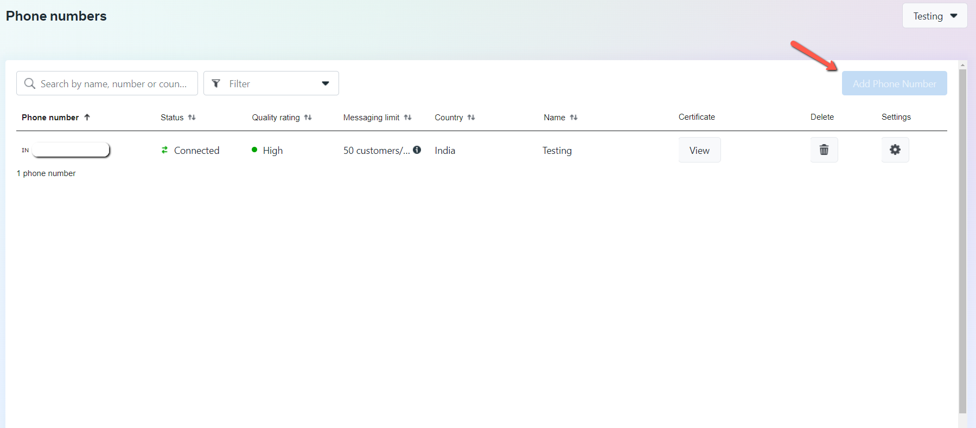

Steps to get Permanent Access Token:

* Go to the Business settings of the Business your app is registered with on the Meta/Facebook Developer Dashboard. Then in the Sidebar navigate to Users > System Users

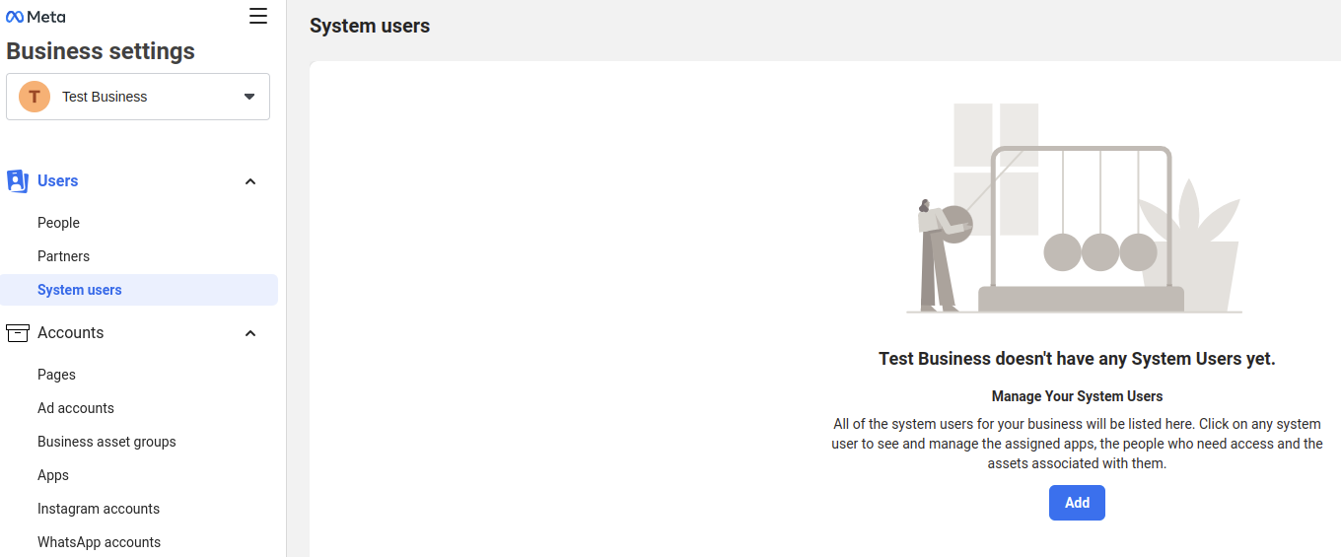

* Add a “System Username” and choose a role.

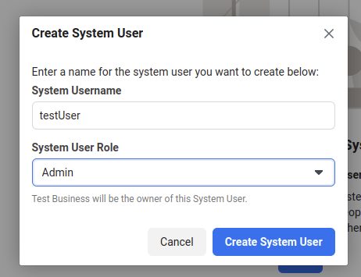

* Click “Add Assets” , Go to “Apps”, select the app and enable the “Manage App” option and save changes.

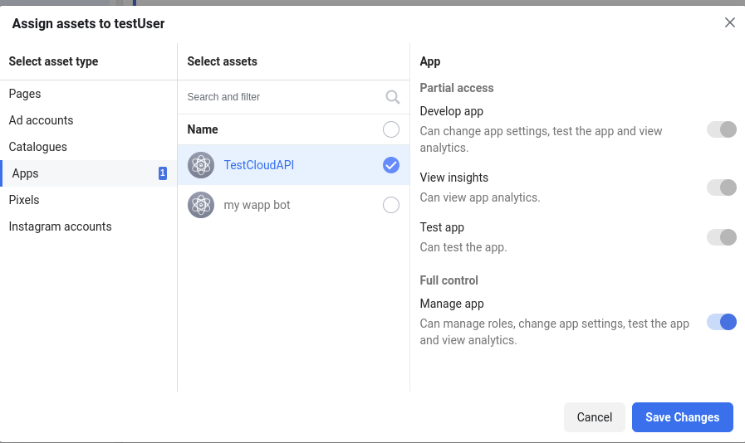

* Click “Generate Token” and choose the App you want to generate a token for.
* From available permissions choose “whatsapp_business_messaging” and “whatsapp_business_management” and click “Generate token”.

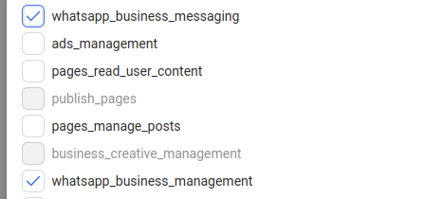

* Copy the generated token and save it for future use.

## **Integrations**

#### **Get Phone Number Ids**

Integration to list the phone number Ids associate with the business account.

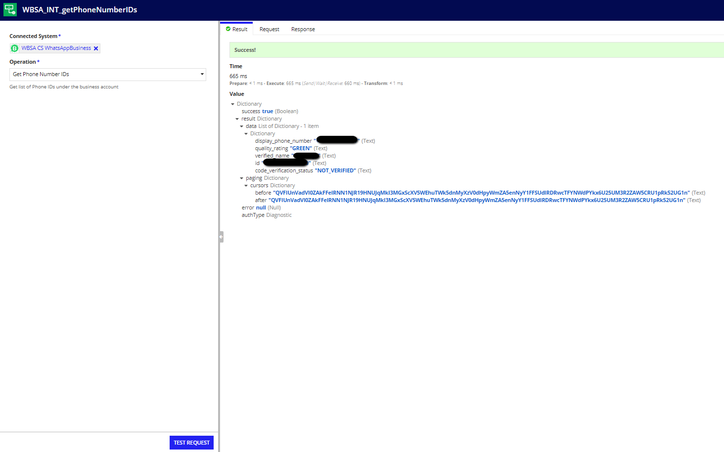

#### **List Message Templates**

Integration to list the message templates associated with the business account.

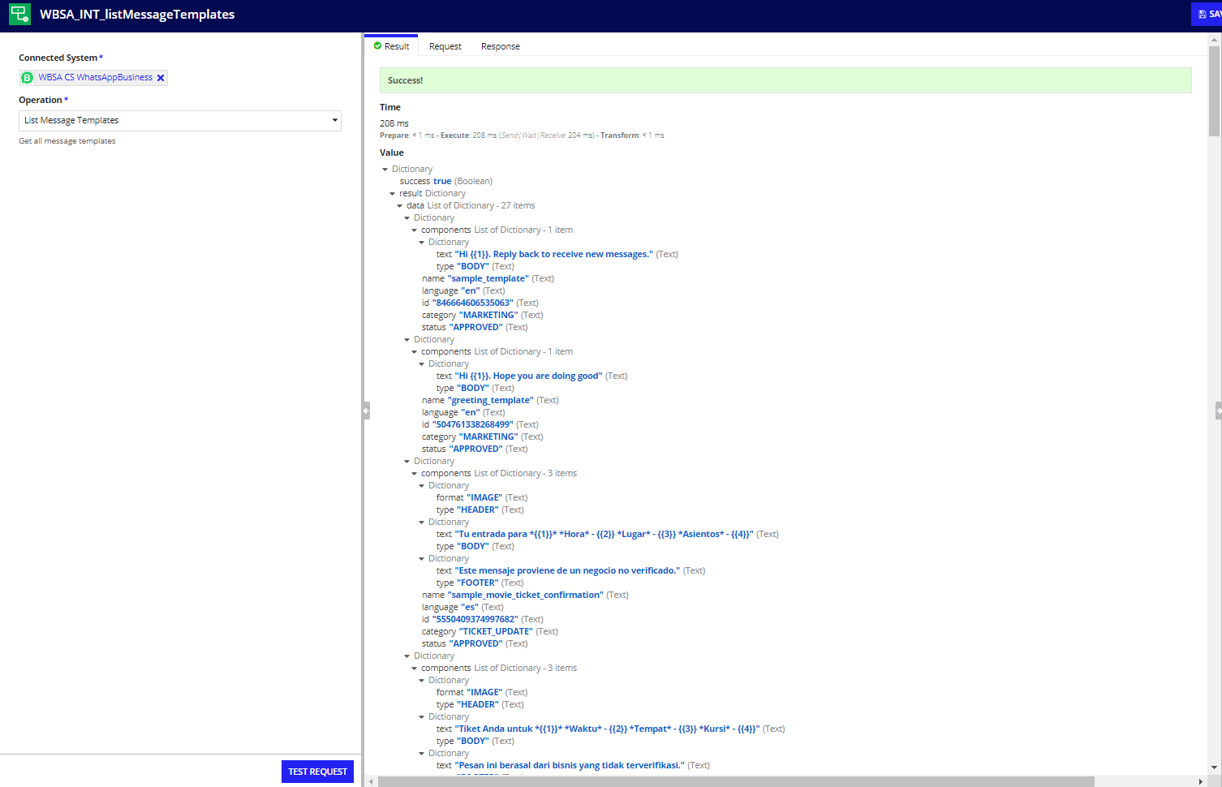

#### **Get Template Details**

Integration to get details of a template.

**Template Id** is required to get the specific template.

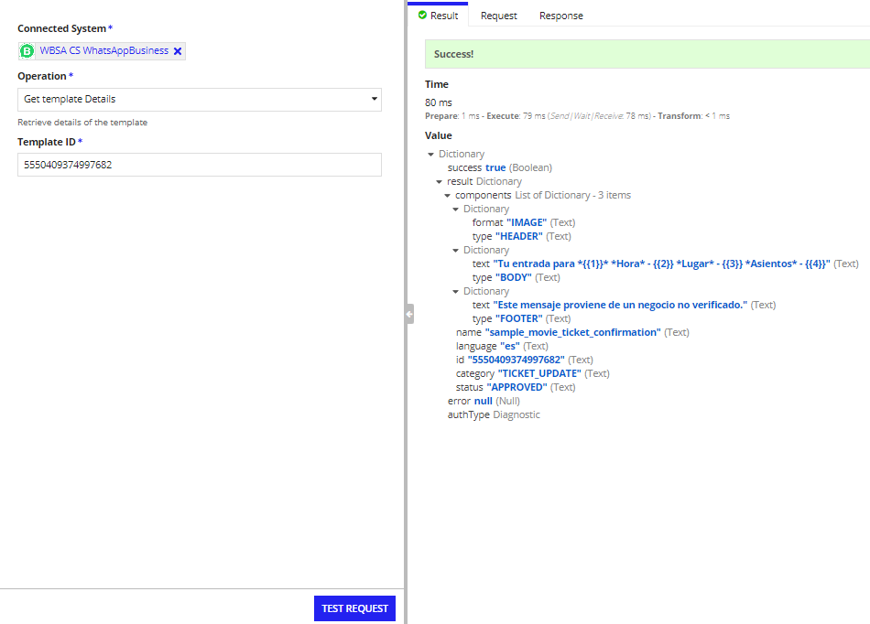

#### **Send Message**

Integration to send messages to a valid WhatsApp number.

Messages can be

* Text
* Template
* Image
* Location

**Phone Number ID** - This is the ID returned from the Get Phone Number IDs integration.

**Recipient Number** - This is the number to which the message will be sent. Country code should be appended to the start of the number without “+” symbol

**Message type** - This denotes the type of the message to be sent.

Valid values are: TEXT,TEMPLATE,IMAGE and LOCATION

**1.Text type Message**

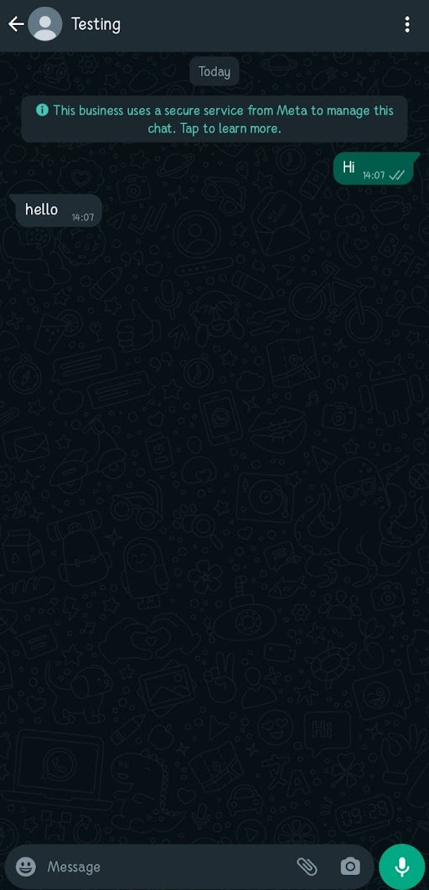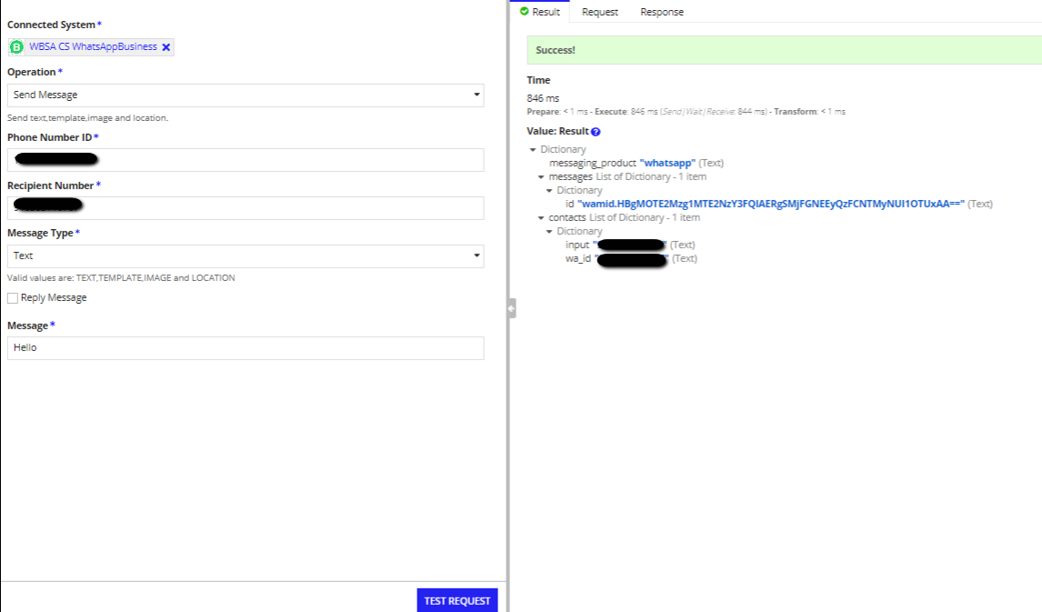

**Message** - text message to be sent.

**2. Template Type Message**

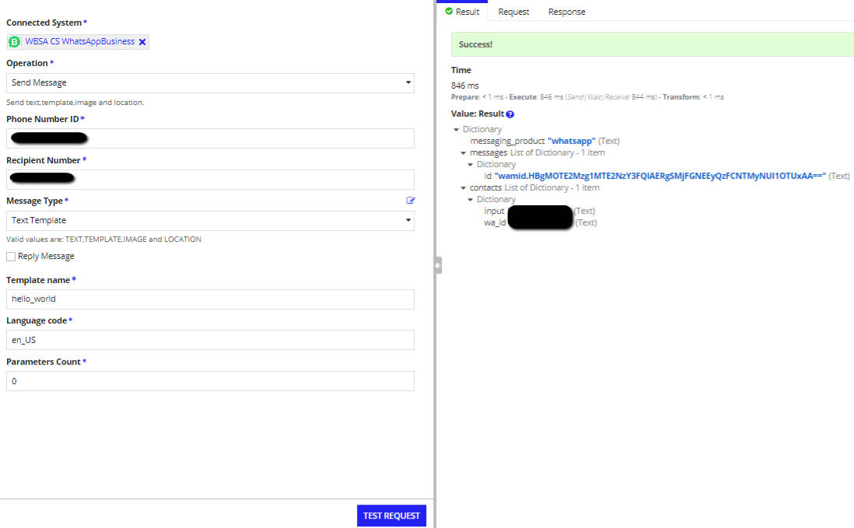

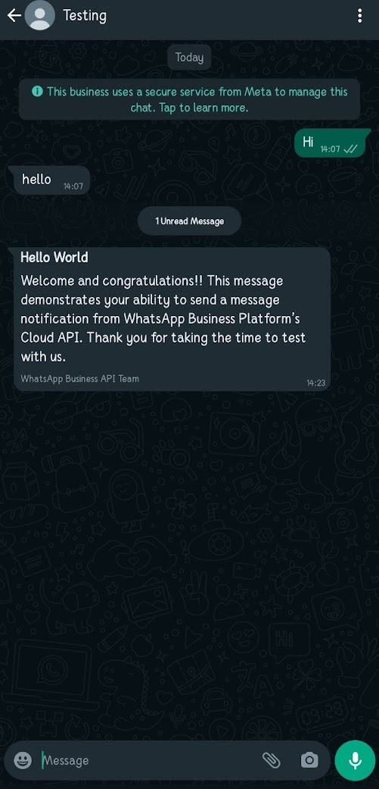

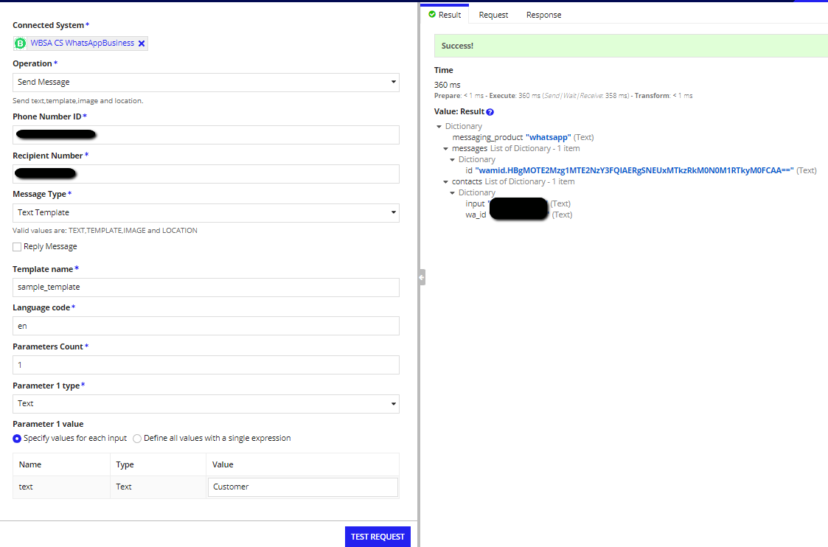

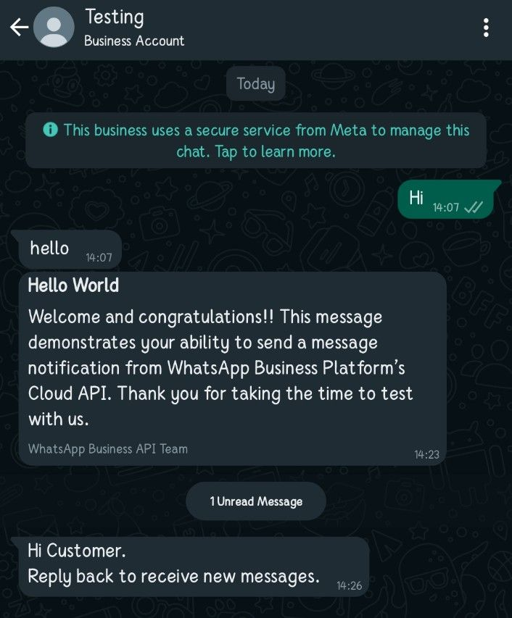

**Template name-** any name of one of the available templates.

**Language Code-** Language code of the template language. Eg: en_US

**Parameters Count-** Count of parameters present in the template

**3. Image Type Message**

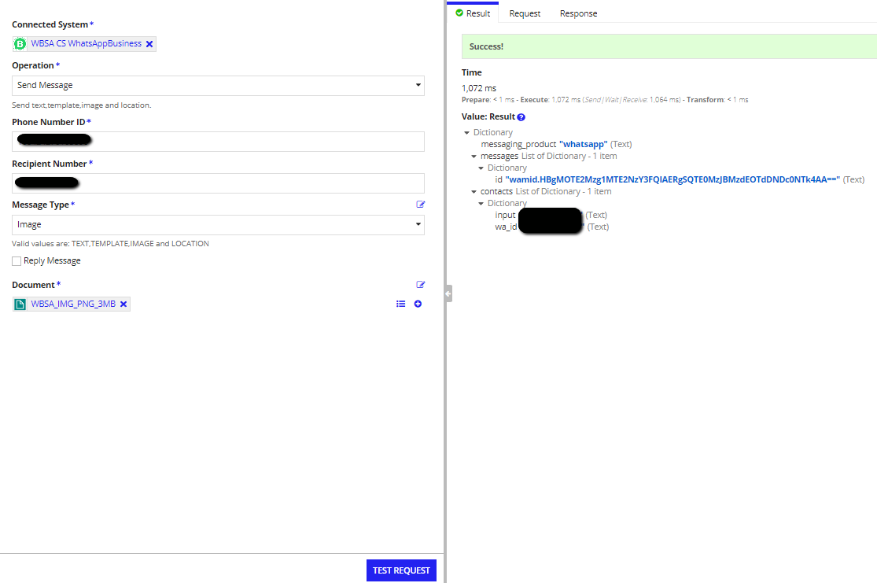

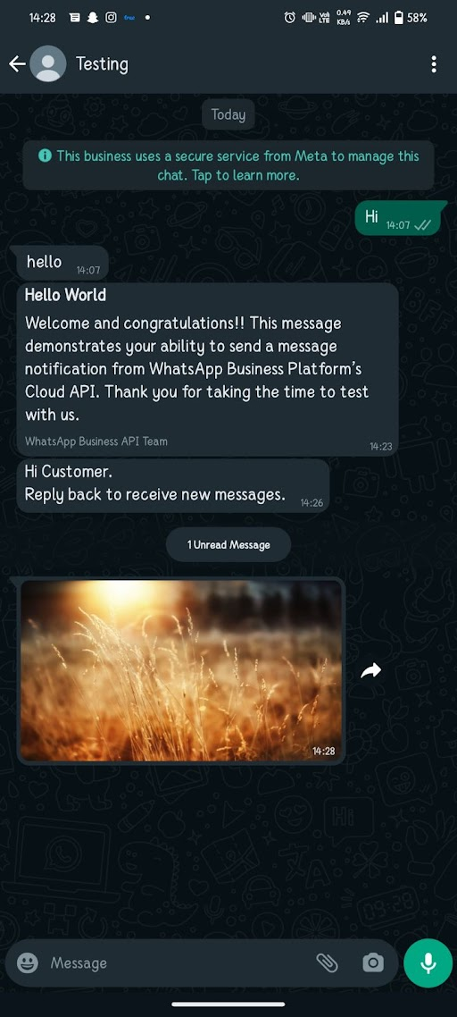

**Document -** Image documents with .jpg, .jpeg,.png extension. Maximum file size is 3 MB.

**4.Location Type Message**

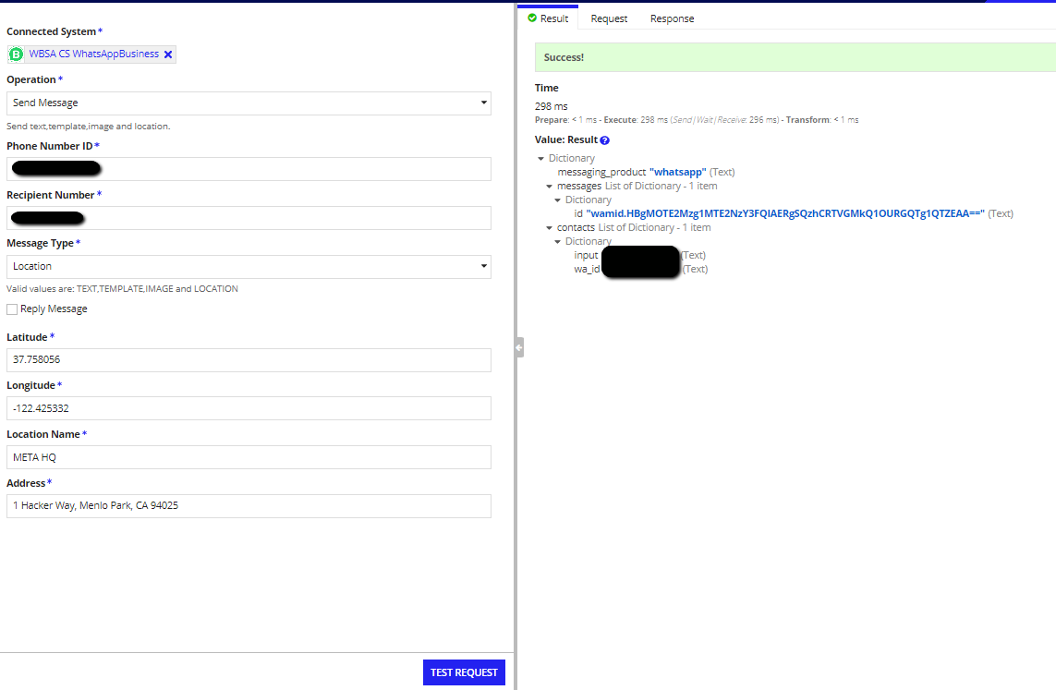

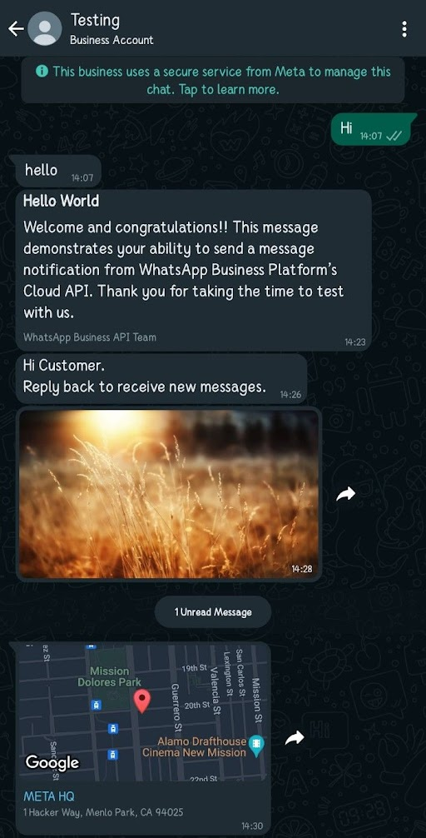

**Latitude** - Latitude of the Location

**Longitude** - Longitude of the location

**Location Name** - Name of the Location to be displayed in the message.

**Address** - Address to be displayed in the message.

**Reply message Example**

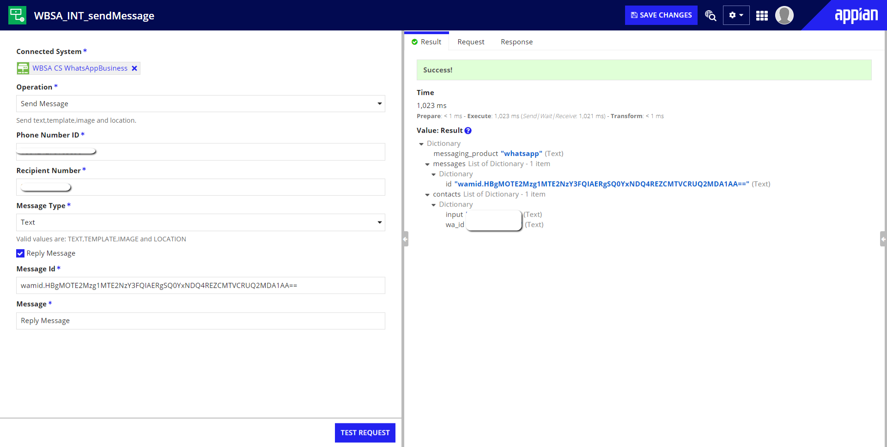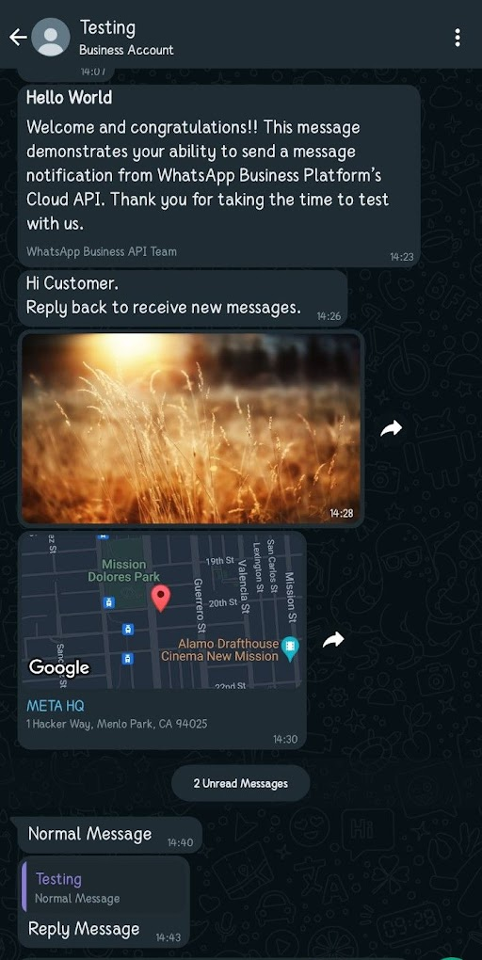

**Setting Up Sample Application**

* Edit the “Business ID” and “Access Key” in the import customization file before importing (Currently empty).
* Import the Sample Application zip file along with the import customization file.
* The Sample Application is now set up and open the “WhatsApp Business Demo” Site in your Application to test the integrations.

