Overview
The SAP SF application is a collection of helper utilites, integration objects, and more. This document is meant to highlight the major components and capabilities.

Helpful Resources
- SAP API Refence: https://api.sap.com/package/SuccessFactorsEmployeeCentral/all
- SAP OData Reference Guide: https://help.sap.com/doc/7efdca36492e47c7b20ab92c4ca6323c/2211/en-US/SF_EC_OData_API_REF.pdf

Pre-Requisites

Deploy Plug-ins
This utility requires the Date and Time Utilities plug-in from the App Market.

API Key
To get started, you will need a SAP Success Factor environment and API Key.
If you want to try things out, you can connect with the SAP Sandbox @ https://api.sap.com and an API Key can be generated @ https://api.sap.com/settings
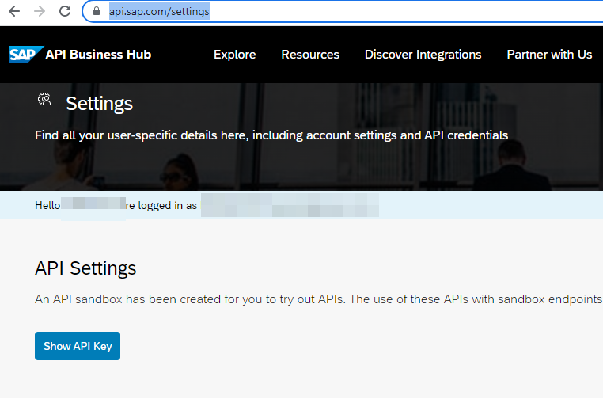

Import

Configure Import Properties
Property | Value | Notes
connectedSystem._a-0000e9b9-a17c-8000-d204-01ef9001ef90_1107016.baseUrl | Your SF environment endpoint | Use https://sandbox.api.sap.com/successfactors/odata/v2 to work against the SAP API Sandbox.
connectedSystem._a-0000e9b9-a17c-8000-d204-01ef9001ef90_1107016.apiKeyValue | Your SF API Key | Use the API Key from your environment or use a value generated from the SAP API Sandbox.

Import Package
Import the package SAP Success Factors with Groundswell v1.zip and include the custom properties file noted above.

Key Features

Core Integrations

rule!SAPWG_SF_EXT_GET_record (Integration)
This integration acts as a wrapper for making a GET call to an SF endpoint
Parameters | Description
record | Name of API endpoint to fetch (required)
search | (optional)
pagingInfo | Batch information to retrieve (optional – default is first 10 records)
fetchTotalCount | Determines if the call returns a count or data (optional, default false)
selection | Comma-separated fields to select from the results (optional)  Review the SF data model for more detail on options, but for PerPerson, you can include personIdExternal,perPersonUuid,createdOn,personalInfoNav/firstName to retrieve fields from this object, and also child object. See cons!SAPWG_SF_TEXT_RECORD_PERSON_DEFAULT_SELECTION for an example.
expand | Which child relationships (Nav objects) should be fetched, use in parallel (optional)  Review the SF data model for more detail on options, but for PerPerson, you can include personalInfoNav to retrieve that child object. See cons!SAPWG_SF_TEXT_RECORD_PERSON_DEFAULT_EXPANSION for an example.
filter | ODATA formatted filters to limit the data returned (optional)  rule!SAPWG_RULE_Person_simpleFilter shows a basic way format a simple list of OData “equals” filters.
format | Format of data to return (optional – default JSON)

rule!SAPWG_SF_EXT_POST_upsert (Integration)
This integration acts as a wrapper for making a GET call to an SF endpoint
Parameters | Description
body | One or more JSON representations of SF objects to create, update, or delete (required)
isDelete | Flag add a delete operator to all included body objects. Only use this if you want all incoming objects to be marked for deletion. (optional – default false)

Data Subset Management

Rule!SAPWG_SF_RULE_General_generateDatasubset (Expression)
This wrapper takes in integration results (from the GET call above) for total count and/or data pages and formats them to a common datasubset.
Parameters | Description
pagingInfo | Batch information to retrieve (optional – default is first 10 records)
fetchTotalCount | Determines if the call returns a count or data (optional, default false)
totalCountResult | Result of an integration call to Success Factors representing the total count (optional)
pageResult | Result of an integration call to Success Factors (optional)
identifierField | Name of body field that should act as the identifier in the datasubset

Example
This application includes multiple examples of usage, but looking at rule!SAPWG_SF_RULE_Employment_generateDatasubset:
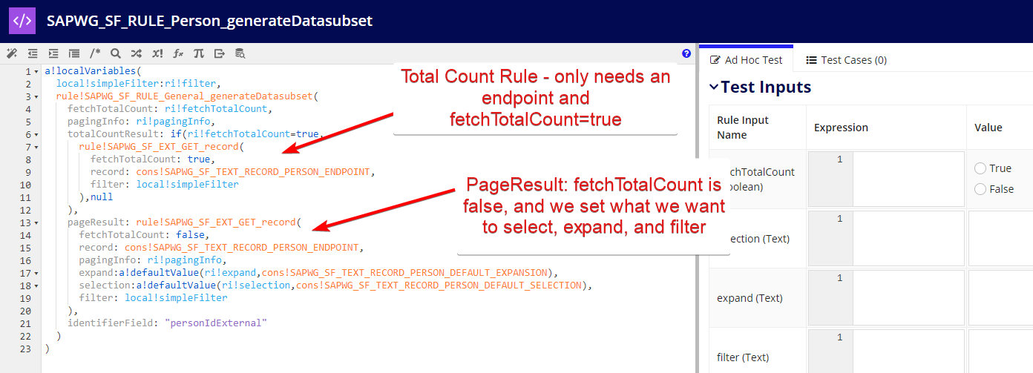

Timestamp Manipulation
The application includes several helper rules for dealing with SAP time formatting:
Rule | Use
SAPWG_RULE_Helper_convertDatetimeToISOTime | Converts an Appian datetime to an ISO-formated date string
SAPWG_RULE_Helper_convertDatetimeToEpoch | Converts an Appian datetime to SAP Epoch time
SAPWG_RULE_Helper_convertEpochToDatetime | Converts SAP Epoch time to an Appian datetime

Example Record
The SAPWG PerPerson record is a synched record pulling Peronal Information (PerPerson and PerPersonRelationship), and EmpJob information.
Core data source expression is handled by SAPWG_SF_PerPerson_recordDataSource.
Ad-hoc synching is handled by SAPWG_SF_PerPerson_recordSync.

Wizard Use Case
rule!SAPWG_SF_PAGE_exampleTwo_userCreation is a wizard that will drive a designer through the fundamentals of creating a User object in SAP/Appian. Its purpose is to be educational, with a detailed approach to each step; do not use this for a production project.

