Communication For Embedded - Plugin Component

Use Case
Some points to provide context to understand the use case:
- Santander Chile requires to build in Appian an integration with WhatsApp to receive and send messages between bank clients and the bank executive to solve questions about products, mortgages, doubts, claims, etc. The messages of the conversation would be displayed in an interactive chat implemented in Appian. An Appian report will contain that interface.
- At the same time, Santander has the requirement to embed this Report (the interactive chat) from their customized portal (NEO) which has not been implemented with Appian. Currently, NEO contains information about the bank clients (user profile), previous interactions and more.
- Santander needs their portal (NEO) stablishes a bidirectional communication with Appian to receive/send information based on the chat selected. So, to do this, it’s required a plugin component.
So, we would have the Santander Portal embedding Appian Report (Interface) and the Appian Interface using the Plugin Component to establish communication with the Santander Portal. When a chat is selected, we send the information about the chat (for example, name, user id, phone number, etc) to the customer portal where the information is used to display related information (user profile, products, previous interactions, etc).
Plugin Component
The plugin is intended to provide and prepare the Appian side to establish communication with a customer portal which embeds Appian. It’s intended to be independent of the functionality that you design in the Appian interface.
Note: Obviously, code is needed on the customer portal side which cannot be part of the plugin component. Could be the same idea and we provide a suggestion/example in this request too.

The plugin would have the following parameters:
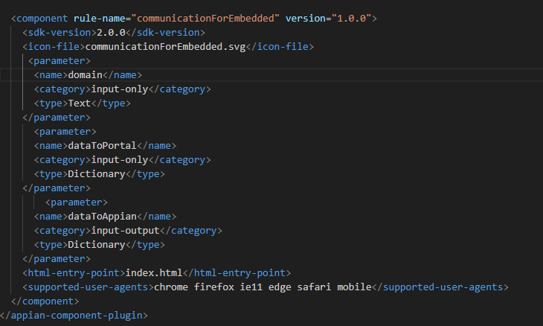

- domain (Input-only | Text): To specify the origin of the request. It would be the domain of the Appian environment. For example, in my local installation: http://5cg2434zs6.appiancorp.com.
- dataToPortal (Input-only | Dictionary): To specify a map/dictionary with the information that you can send to the customer portal.
- dataToAppian (input-output | Dictionary): To specify the local variable where the information that the customer portal send to Appian will be stored.
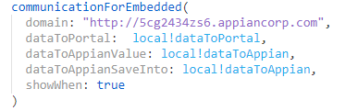

Code - Index.html (file attached in this pre-approval request too)
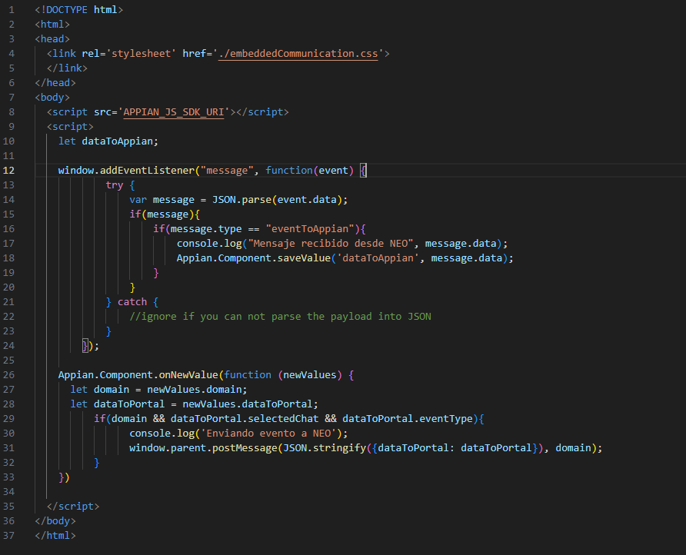

- Appian.Component.onNewValue: To receive the information/variables from the Appian interface.
- window.parent.postMessage: To send the event with the information to the customer portal which is embedding Appian Report.
- window.addEventListener: Listening the events sent from the customer portal to receive the information.
- Appian.component.saveValue: To save the information in the variable of plugin component.

Example Code – Customer Portal (It’s not part of the plugin component)
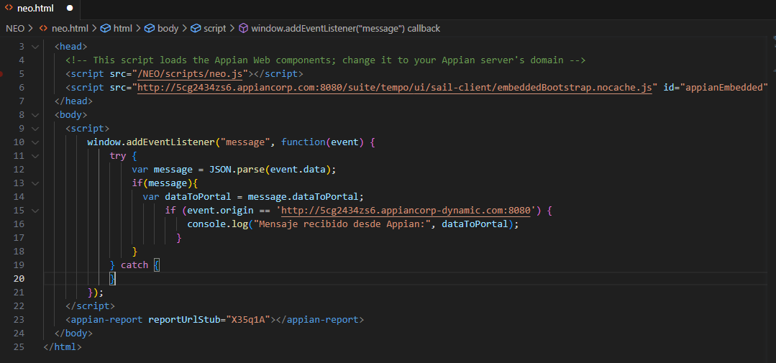
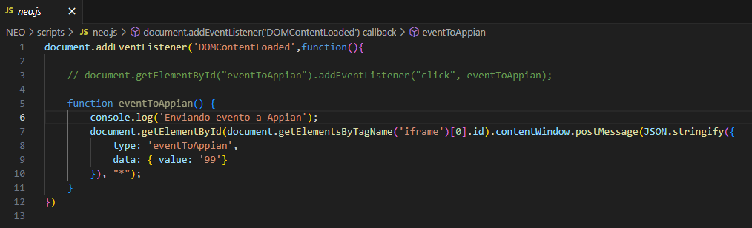

Screenshots – Santander Use Case
Regarding Santander use case, it would have a chat implemented in Appian and the plugin would allow the communication between the user interaction with the list of chats and the customer portal.
But the plugin component could be useful and work embedding other interfaces too.
