Setting up REST Services with Appian 1
1. Client Registration 1
Register Client 1
Edit Client 4
2. Integration System User (ISU) 4
Create ISU 4
Create Security Group 5
3a. Authentication: JWT Set-up 8
Deploy JWT Tools Plug-in 8
Set Up Third Party Credential Store 8
Configure Connected System 9
Verify 9
3b. Authentication: OAuth Auth Code Set-up 10
Outbound EIB 11
Create Appian “Service” Account 11
Create WebAPI that intakes a document 11
Create EIB 12
Edit Your EIB 14
Test Your EIB 15
Setting Up Custom Report For Integrations 17
Set-up 17
Permissions 18
Filtering 19

Setting up REST Services with Appian
To set up REST services between Appian and Workday, you will need:
- Register an API client with appropriate scopes
- An Integration system account with appropriate permissions
- Appian set-up for JWT

1. Client Registration

Register Client
As a Workday Admin, access the Register API Client task
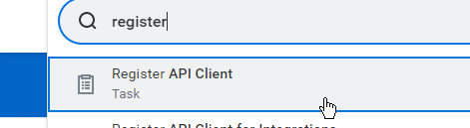
Use JWT as Grant Type by default. If you aren’t going to have users directly calling integrations, OAuth Auth Code might be a feasible alternative.
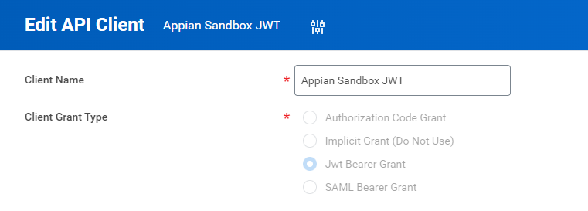
Create a certificate in Workday OR KeytoolOpenSSL to create an x509 compliant public/private pair. Example code:
- Keytool
  - keytool -genkey -keyalg RSA -alias Workday -keystore JWTkeystore.jks -storepass Workday123! -validity 360 -keysize 2048

- Openssl
  - openssl genrsa -out keypair.pem 2048
  - openssl rsa -in keypair.pem -pubout -out publickey.crt
  - openssl pkcs8 -topk8 -inform PEM -outform PEM -nocrypt -in keypair.pem -out pkcs8.key

Note: paste the FULL text of the keys in all boxes!
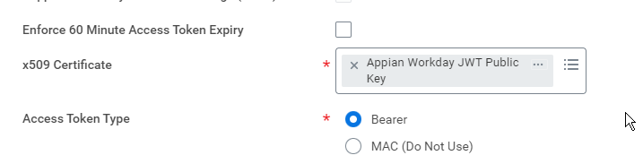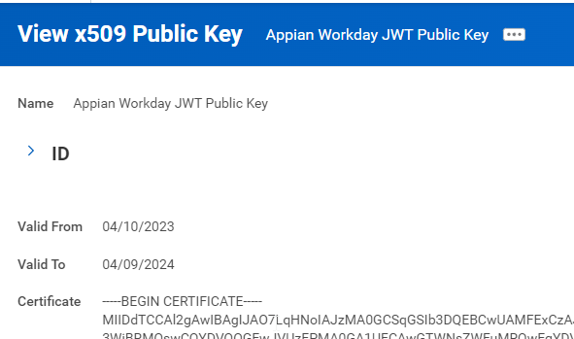
Set Scopes needed for the API. Use the REST Reference to determine basic families required for your needs:
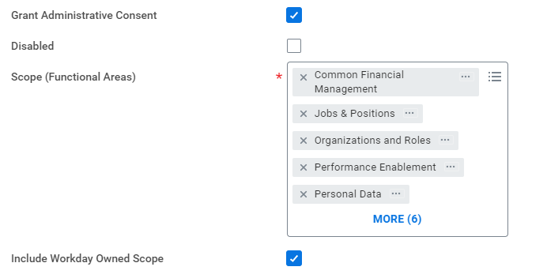
Save your ClientID and endpoints for future reference
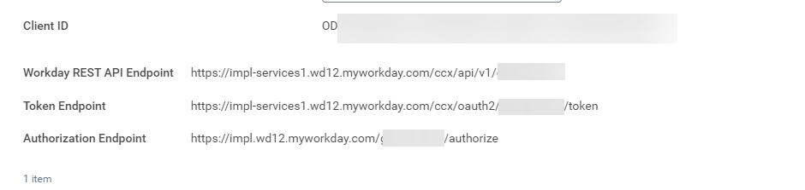

Edit Client
Access clients by running the View API Client report
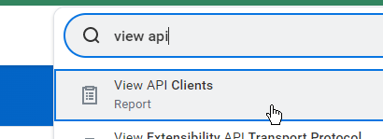
Select your client and edit where needed.

2. Integration System User (ISU)

Create ISU
JWT requires an ISU context so create one in Workday.
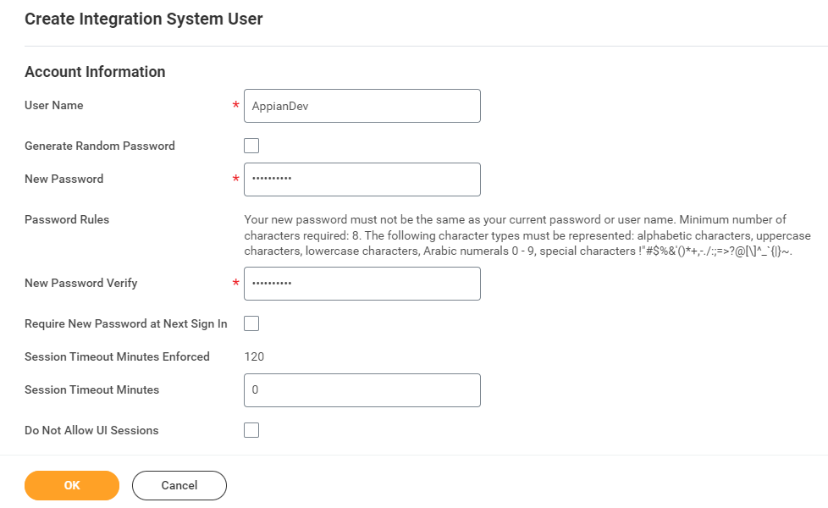

Create Security Group
Create a new security group. Can use Integration System Security Group for this example:
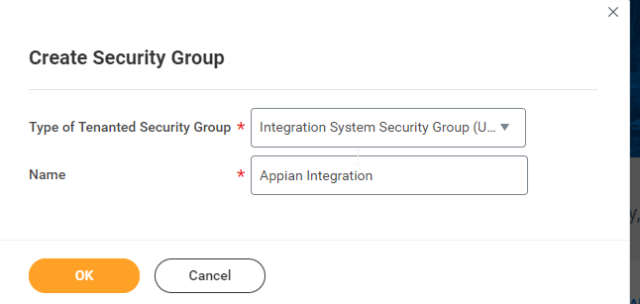
Edit the group and add your ISU as a user.
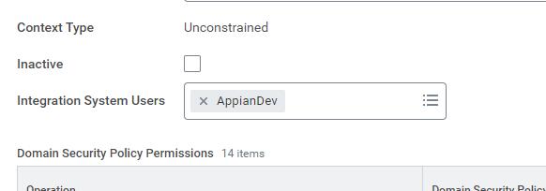
Edit Domain Permissions to include the appropriate security roles that align with the API needs/
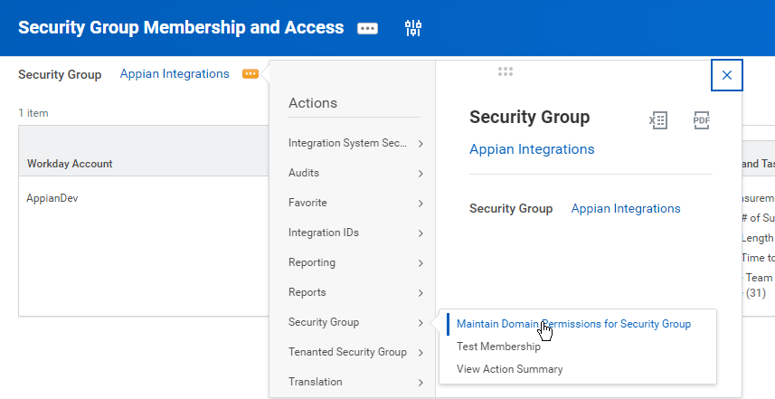
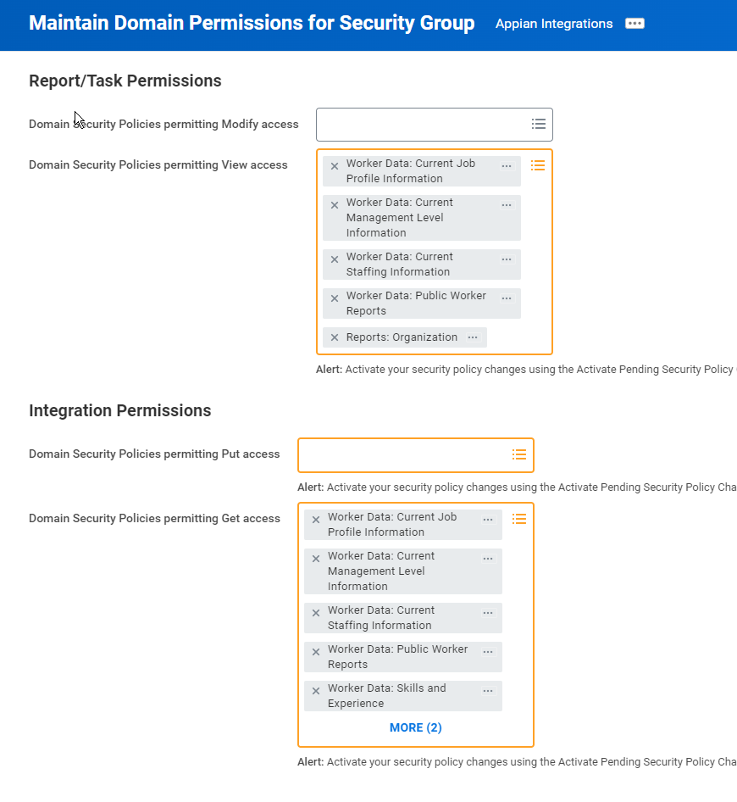
Run the Activate Pending Security Policy Changes task to enable/activate those permissions.
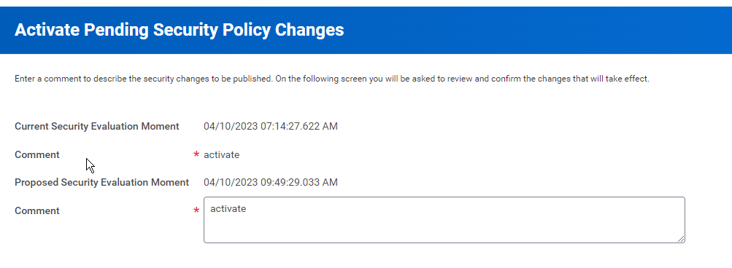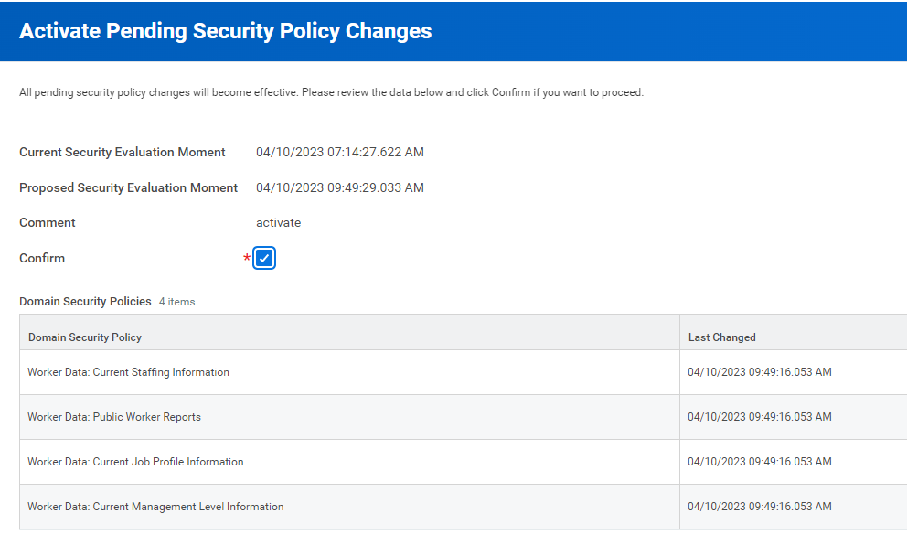

3a. Authentication: JWT Set-up

Deploy JWT Tools Plug-in
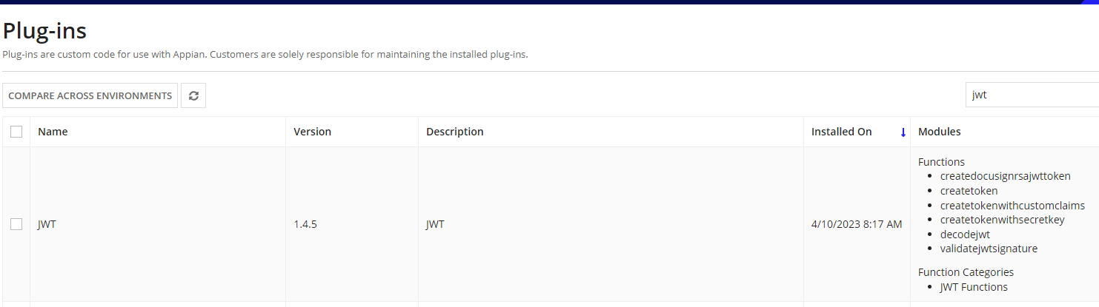

Set Up Third Party Credential Store
Using the JWT Tools plug-in, set up a credential store and enter your private key and password strings. Make sure to enable JWT plugin to access these credentials.
AppianPrivateKey – full text of private key
AppianPrivateKeyPassword – password for key
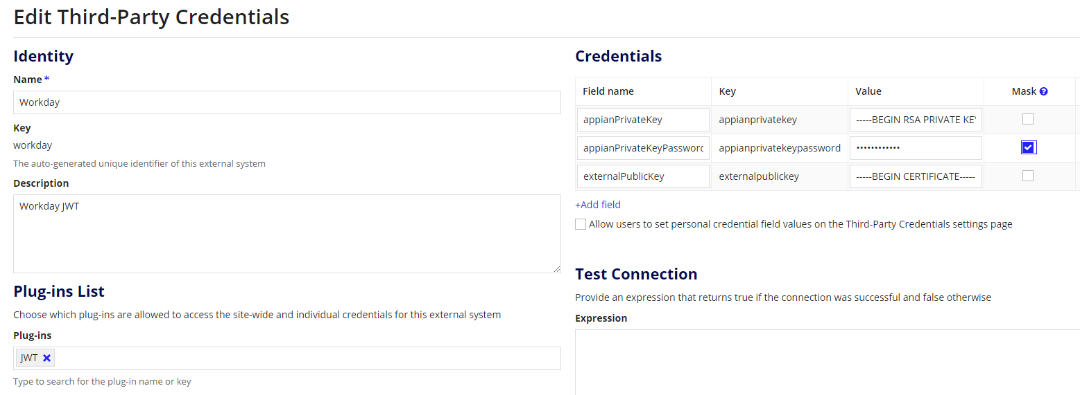Configure Helper Rules
- Constant GWD_TEXT_CLIENT_ID
  - Set to Client ID from Step 1
- Constant GWD_TEXT_SCS_KEY
  - Set to SCS key from previous step

Configure Connected System
- Constant GWD_TEXT_BASE_TENANT_URL
  - Your base environment URL (I.e. https://impl-services1.wd12.myworkday.com/ccx/)
- Constant GWD_TEXT_TENANT_ID
  - Your tenant (I.e. gswell_dpt1)
- GWD Workday (JWT)
  - 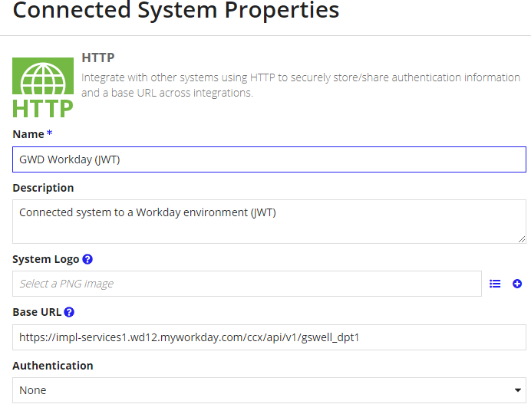

Verify
Execute GWD_JWT_EXT_GET_token to conform successful token retrieval. If you get an error, double check your client ID
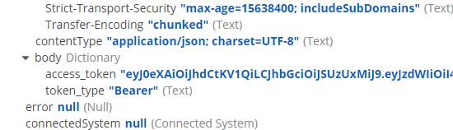

3b. Authentication: OAuth Auth Code Set-up
If using Auth Code, you can set up the GWD Workday Connected System instead and point integrations to that. The steps above are mostly the same except you select Auth Code in your Client API and store your ID/Secret in the CS:
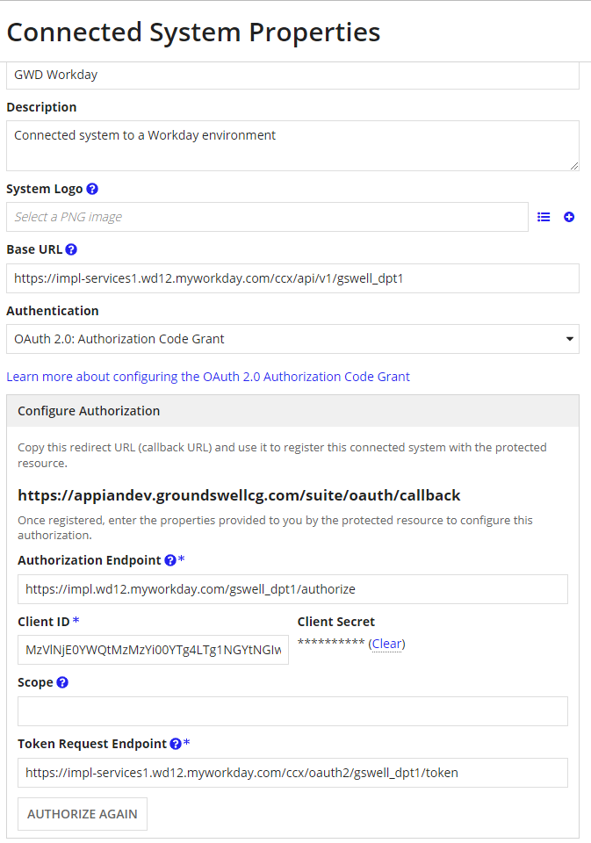

Outbound EIB
EIBs are useful for scheduling data pushes to Appian for purposes of data migration, triggering record updates, etc.

Create Appian “Service” Account
For Workday outbound EIBs, we need to use username/password authentication due to incompatibilities in Workday and Appian auth mechanisms for Web APIs.

Create WebAPI that intakes a document
Inbound EIBs send XML files by default. Example is like GWD Upload Document:
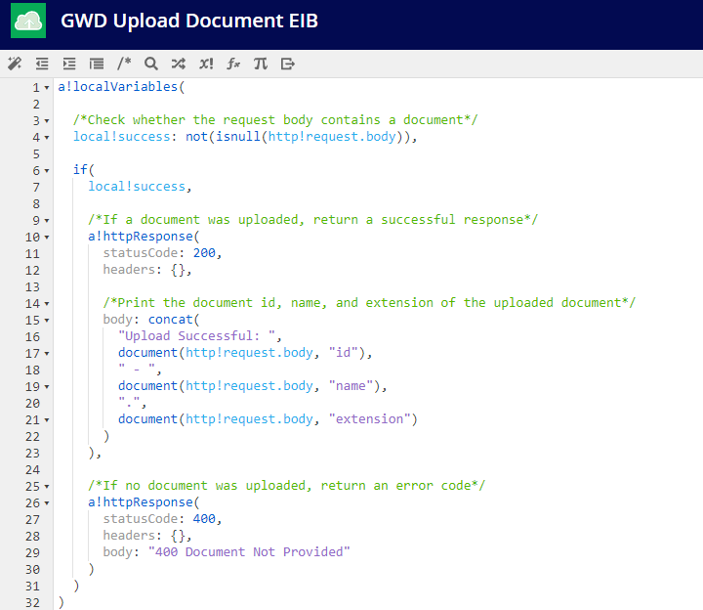

Create EIB
In Workday, access the Create EIB task.
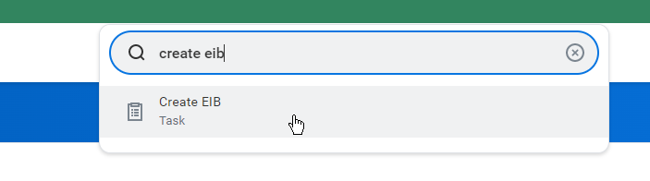
Mark the EIB as Outbound and give it a clear name.
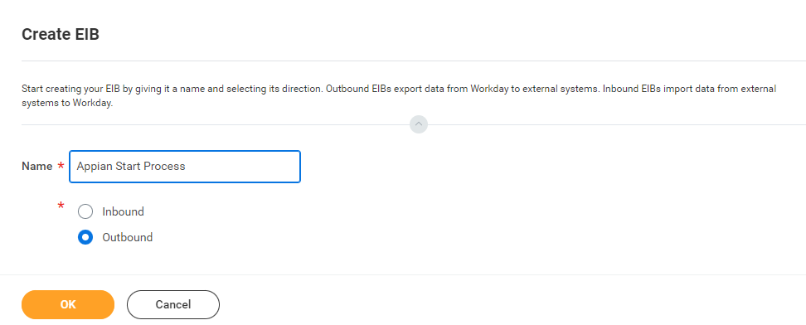
Update General Settings as needed.
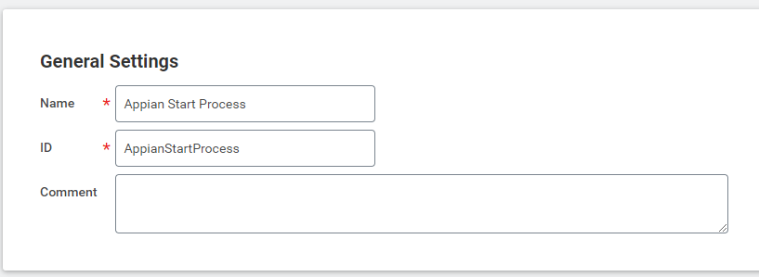
Set up the Data Source Type as Web Service, and identify which report you want to run.
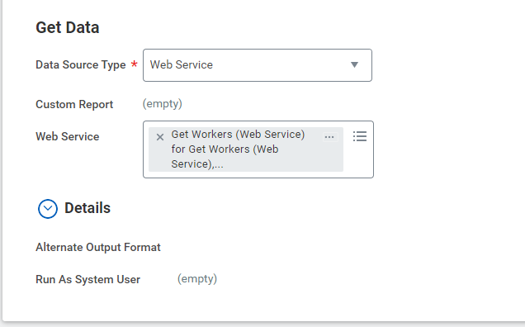
For simple cases, leave Transformation Type as empty.
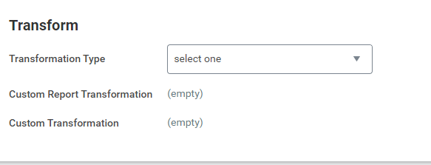
Configure delivery for HTTP and put in your WebAPI and credentials.
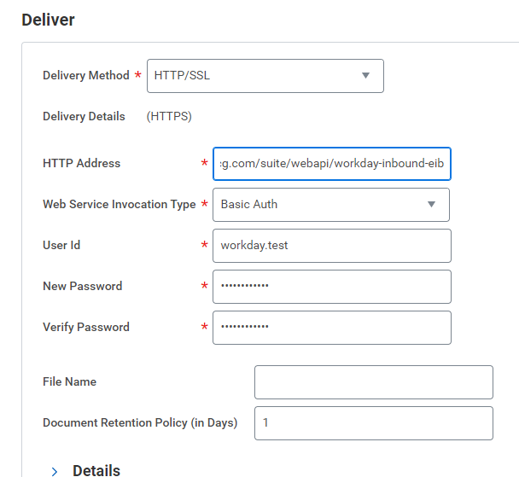
Complete review of settings and save your EIB.
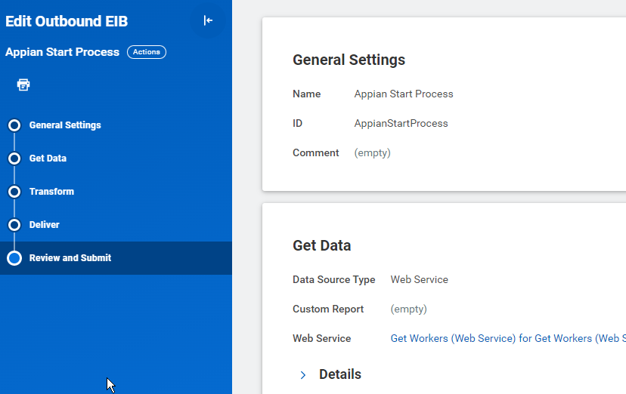

Edit Your EIB
If you need to edit your EIB, access the Enterprise Interface->Edit action from the Integration System object.
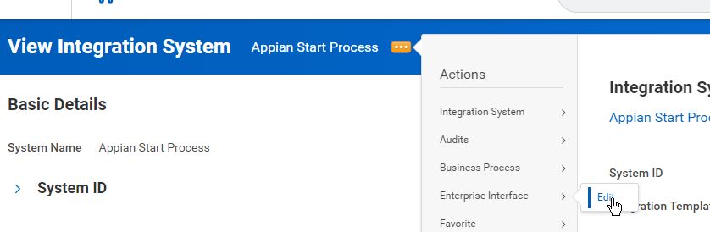

Test Your EIB
On-demand or scheduled launching can then be set-up from the Integration->Launch/Schedule action available from the EIB itself.
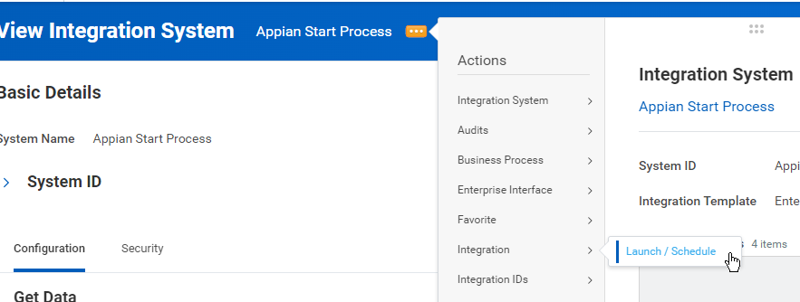
As a test, use the default settings where applicable, and set additional inputs that are applicable to your report. In this example, the Get Workers report needs a root organization
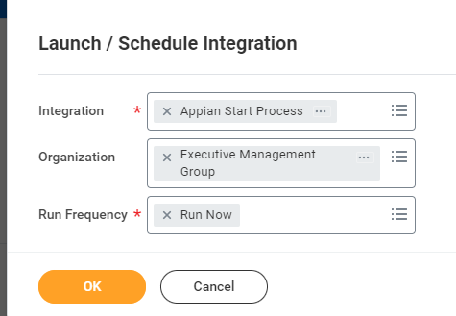
Continue with set-up, but default values can work for initial testing.
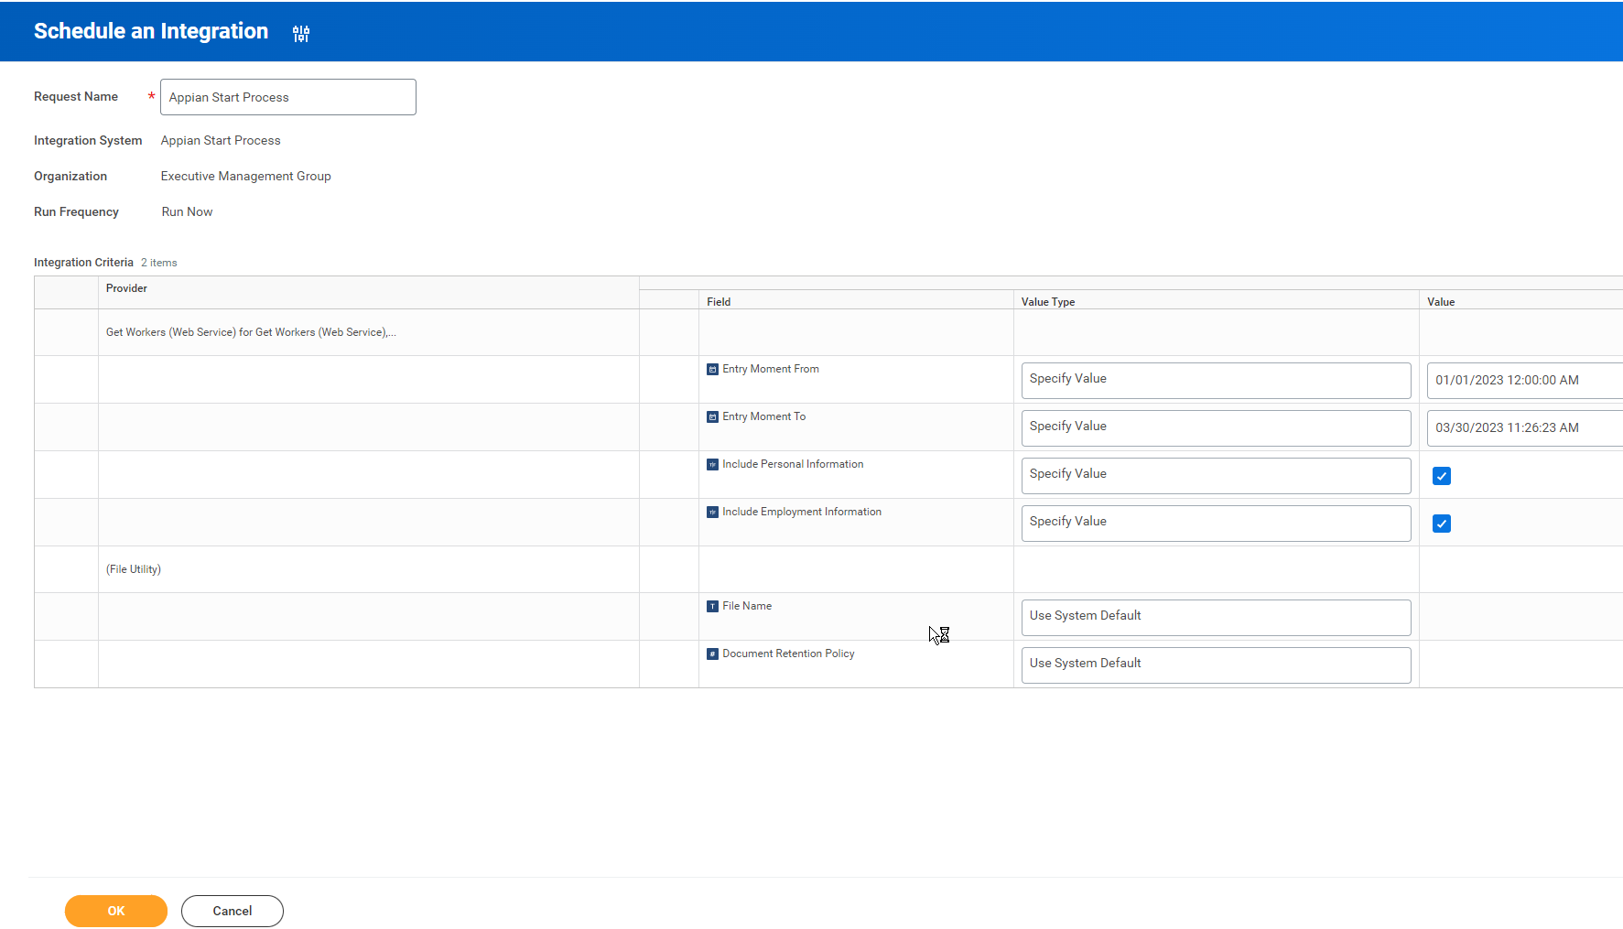
Click OK to launch and monitor from the resulting background process page:
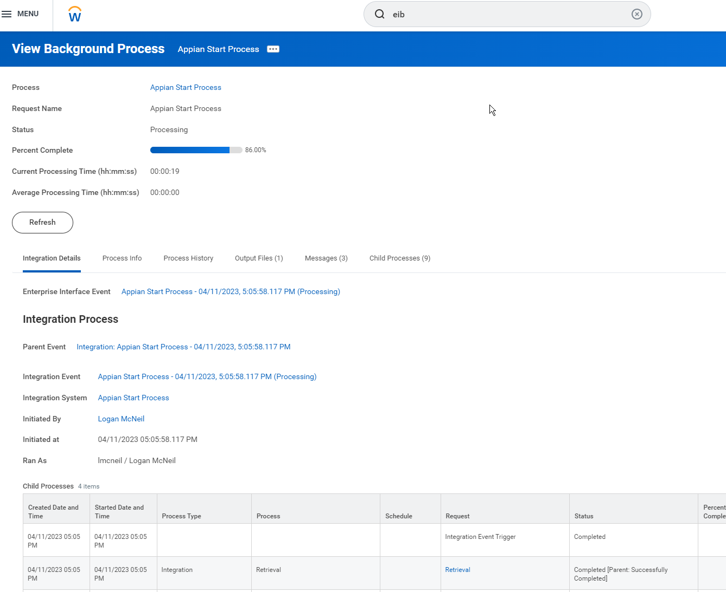

Setting Up Custom Report For Integrations

Set-up
Start the Create Custom Report task
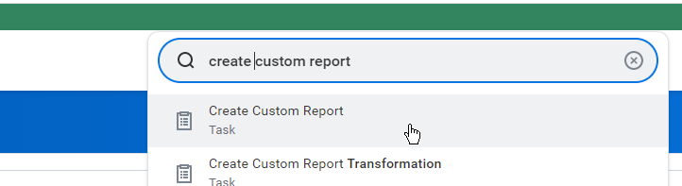
Complete the basic details
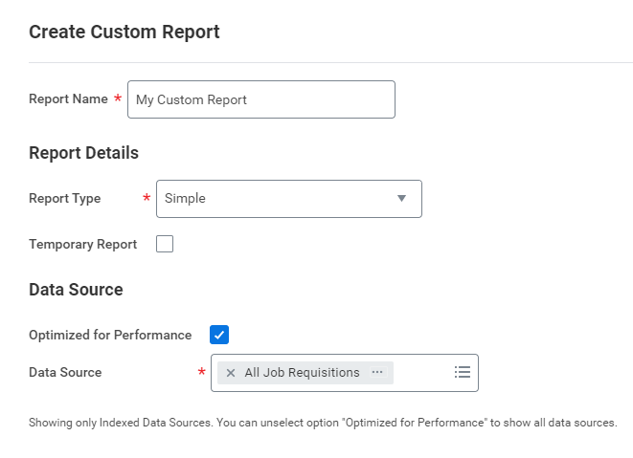
Confirm Baseline looks like
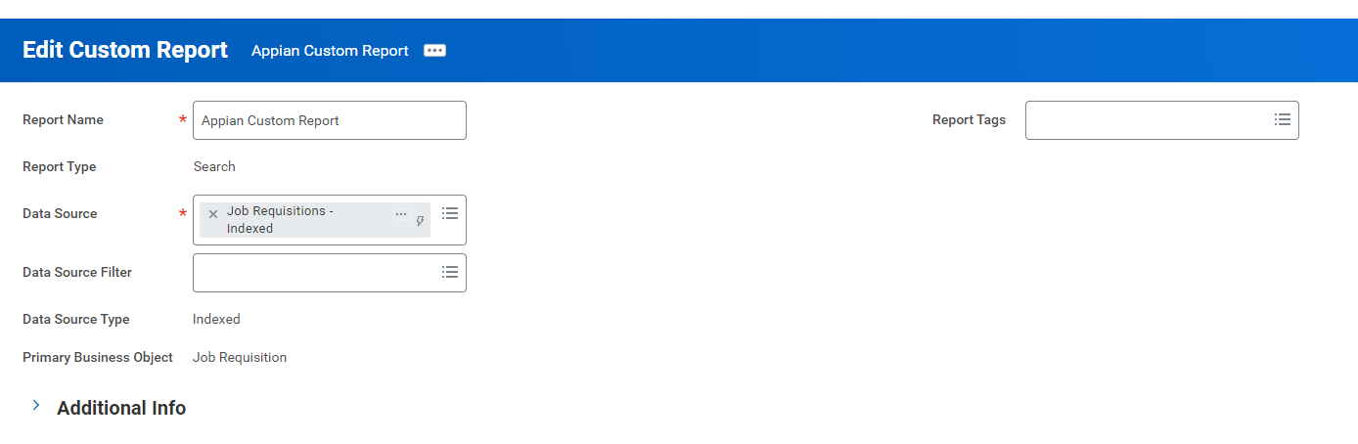
Configure Fields in your search results
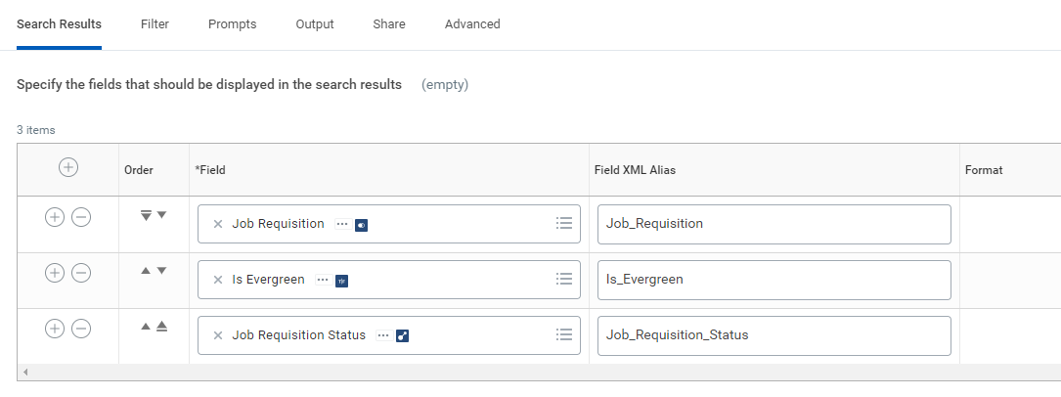

Permissions
Make sure your ISU has Report permissions on every field in your report. This can be view in the Custom Report Security Analysis tab
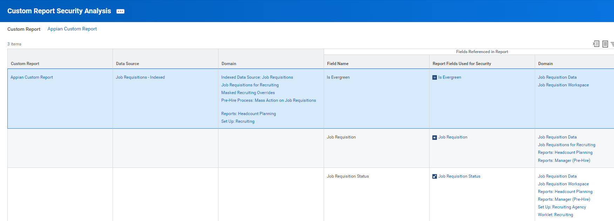
You will also need to share your report with your ISU (preferably via a security group)
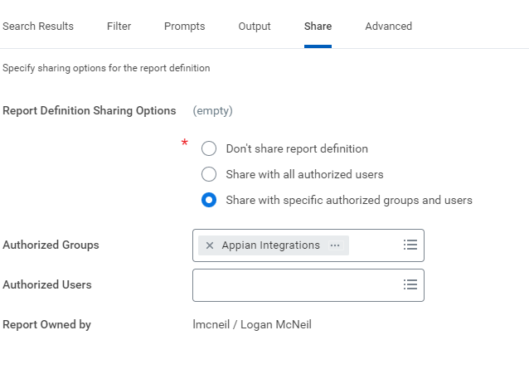

Filtering
Filtering can be accomplished by Query Parameters that map to Field XML Alias provided in report set-up. An Example is in GWD_EXT_JWT_Reporting_GET_customReport or GWD_JWT_EXT_Reporting_GET_customReportWithPaging.

You must provide valid filter value IDs based on the facet values returns at the top of a report result:
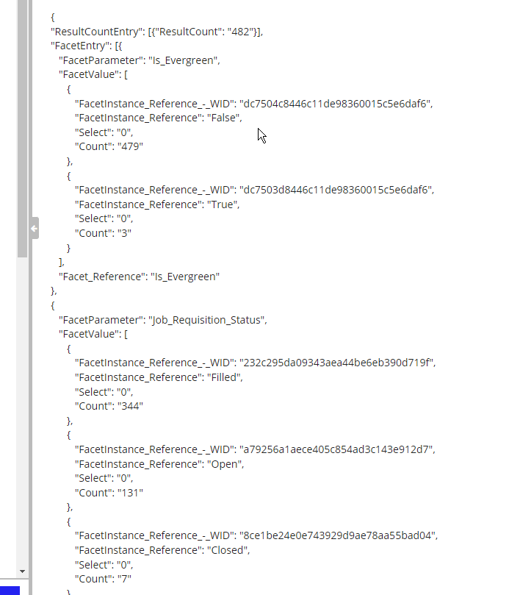

If filters are not clear, you can review a report configuration OR WSDL to get the key names (they should align with Prompt XML Alias):
